**Marine biodiversity and food webs**

**Ako: Learn about ecology and biodiversity**

**Teacher notes**

This document contains:

* Activity notes for students
* Marine organism questions
* Homegroup – summary of information from expert groups
* Marine food web diagram
* Marine good web diagram example
* Quiz questions
* Quiz answers

Edit or adapt the document to suit classroom needs.

**Activity notes for students**

In this activity, you will become an expert on a producer or consumer within a marine food web. After working as part of an expert group, you will take your knowledge to your home group and share the information with them. Once you have shared your information with your home group, the group will create a marine food web with the six marine species. The activity ends with quiz questions about marine food webs.

This is how home groups and expert groups work:

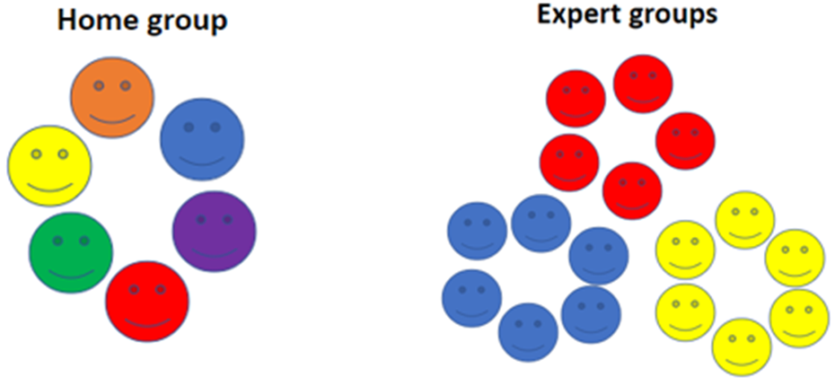

**Home groups and expert groups – hints and tips**

* You will need to know the information well enough to be able to report back to your home group about your organism.
* Use the Marine organism questions to guide your research.
* When you are back with your home group, you will report to your group. One person (not you) will record the information you provide in the Homegroup – summary of information from expert groups table. You will also have a turn at recording information for one of the other experts in your home group.
* When all experts have reported to the home group, your group will fill out a Marine food web diagram.
* Then we will have a quiz about some of the information you have gathered!

**Hua: Understanding about marine organisms and food webs**

* I know that living things affect each other and that their environments impact them.
* I understand that marine ecosystems consist of many living and non-living things. These living things depend on each other – forming a delicate ecosystem.

There are many, many producers and consumers in Aotearoa New Zealand’s marine environments – for this activity we will focus on these:

**Producers**

* Phytoplankton
* Neptune’s necklace – seaweed

**Consumers**

* Oyster or barnacle – filter feeder (choose one)
* Butterfish – browser
* Orca – top predator
* Cushion star or mud whelk – scavenger (choose one)

In your home group, choose/assign one of the marine organisms for each person. Move to your expert group – the people with the same number or colour as you.

Use the Marine organism questions to guide your research.

These resources provide background information:

* [Marine food webs](https://www.sciencelearn.org.nz/resources/143-marine-food-webs) – Science Learning Hub
* [Introducing marine ecosystems](https://www.learnz.org.nz/marinereserves191/bg-standard-f/introducing-marine-ecosystems#:~:text=Grazer%20-%20A%20type%20of%20herbivore,such%20as%20seaweeds%2C%20e.g.%20butterfish) – LEARNZ
* [Investigating marine ecosystems](https://www.doc.govt.nz/globalassets/documents/getting-involved/students-and-teachers/marine-reserves/marine-reserves-resource-activity-4.pdf) (pages 10–16) – Department of Conservation
* [Stars of a marine reserve](https://www.doc.govt.nz/globalassets/documents/getting-involved/students-and-teachers/marine-reserves/marine-reserves-resource-activity-3.pdf) (padlets digital information pages 6–9) – Department of Conservation
* [Plankton](https://www.sciencelearn.org.nz/resources/146-plankton) – Science Learning Hub
* [Sea stars](https://www.sciencelearn.org.nz/resources/149-sea-stars) – Science Learning Hub
* [Marine organisms and adaptations](https://www.sciencelearn.org.nz/resources/142-marine-organisms-and-adaptations) – Science Learning Hub

Once you’ve completed your research within your expert group, return to your home group. Fill out the Home group – summary of information from expert groups page and the Marine food web diagram (use the example to help).

**Marine organism questions**

1. Is your marine organism a producer or a consumer?
2. What is the difference between a producer and a consumer?
3. How does your organism gain energy? Does it eat?
4. If your organism eats, what does it eat?
5. Does something eat your organism?
6. Where does your organism live? What is its habitat?
7. Does your organism have adaptations that help it survive in this habitat? What are they?
8. Find out one fascinating fact about your organism.

**Home group – summary of information from expert groups**

|  |  |  |
| --- | --- | --- |
| **Seaweed – producer** | **Phytoplankton – producer** | **Oyster/barnacle – filter feeder** |
|  |  |  |
| **Butterfish – browser** | **Orca – top predator** | **Cushion star/mud whelk – scavenger** |
|  |  |  |

**Marine food web diagram**

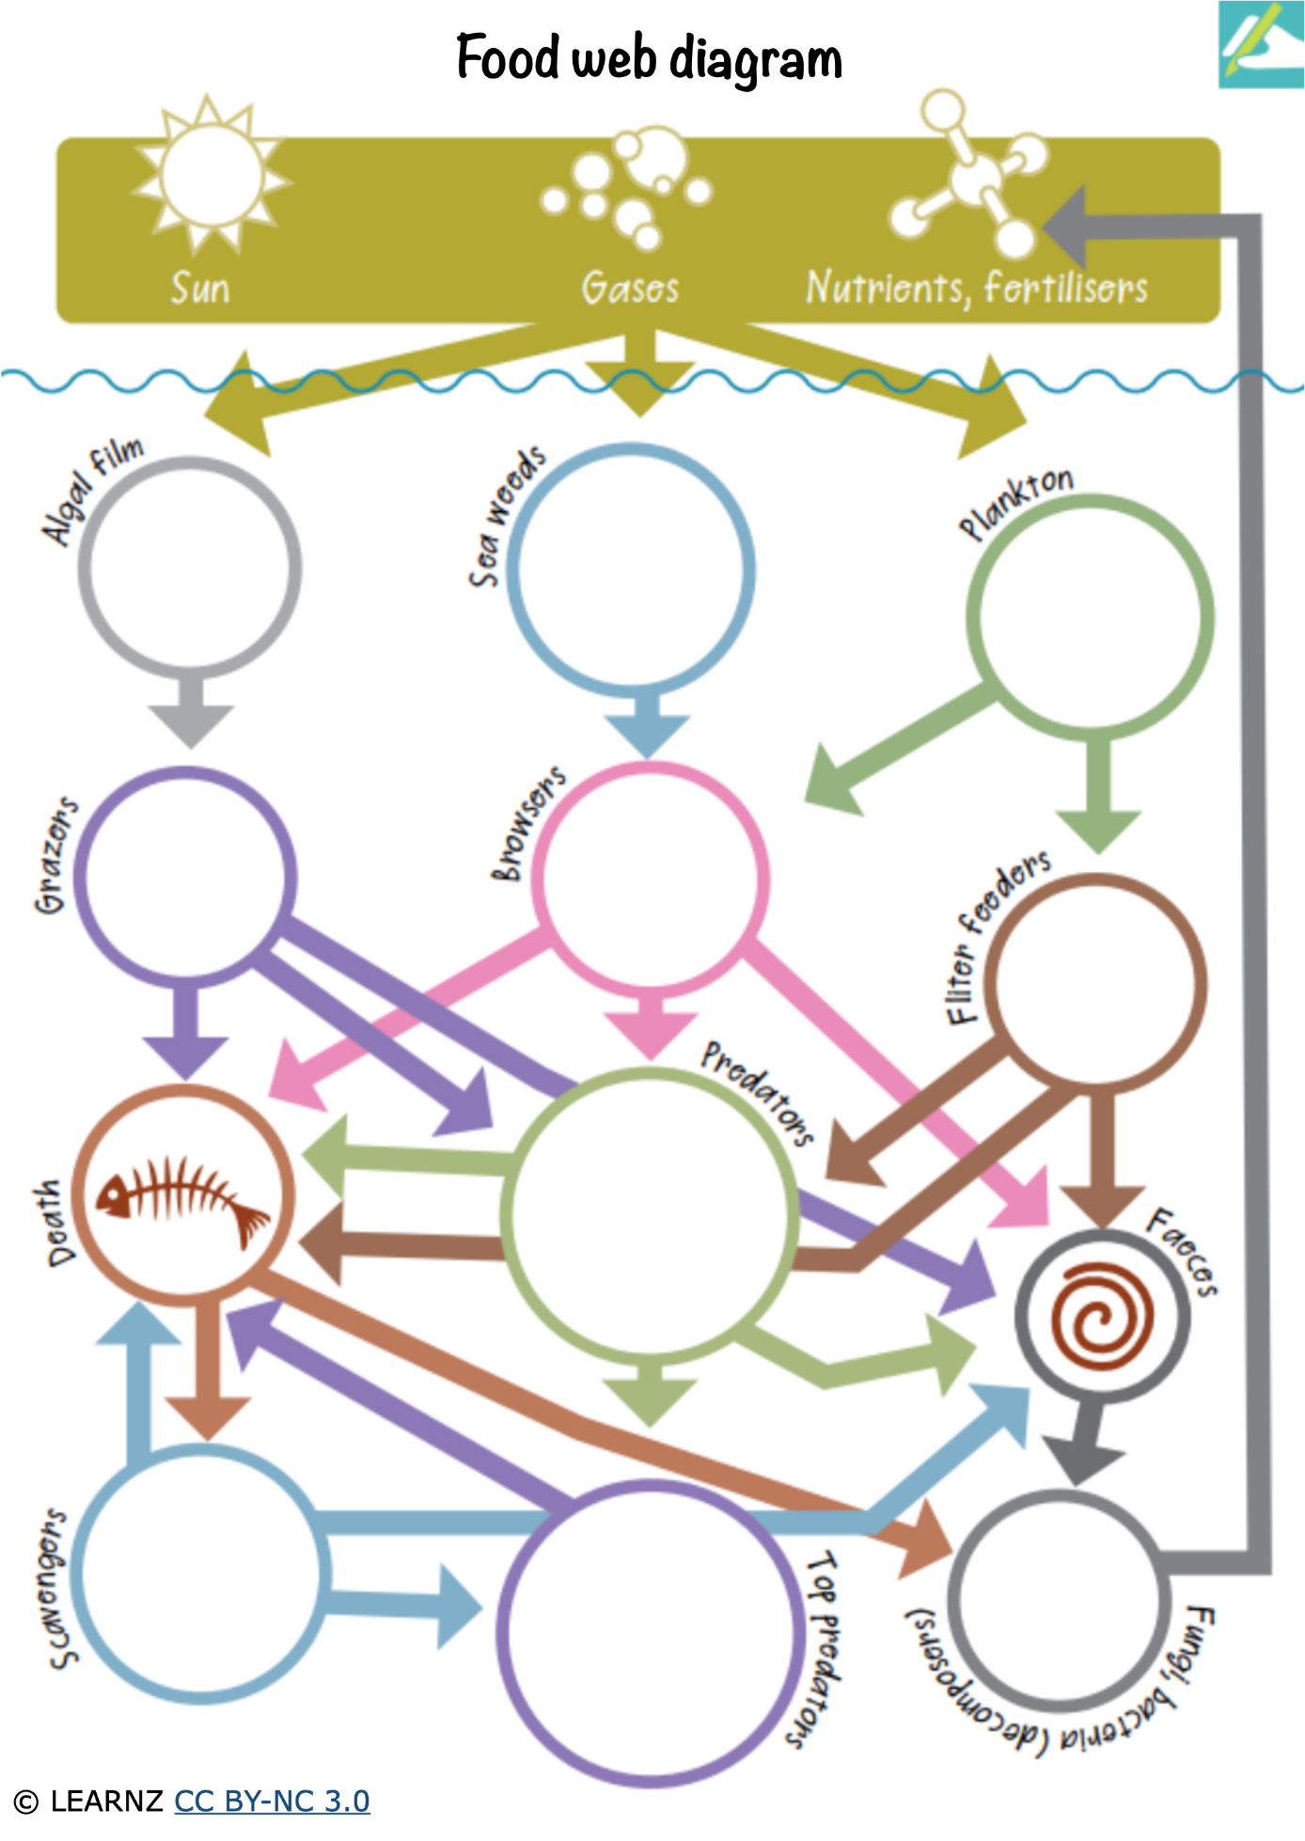

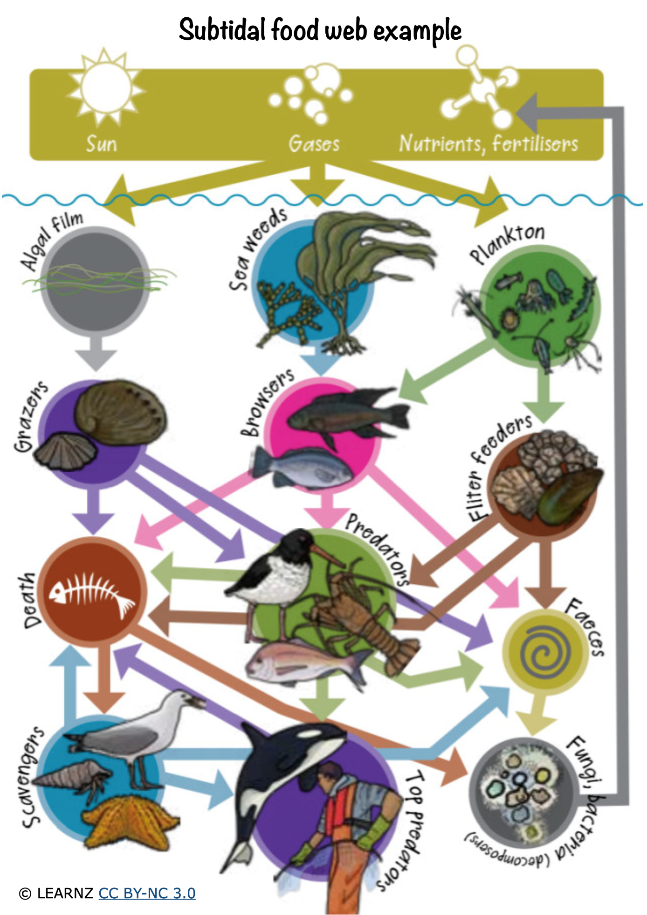

**Quiz questions**

1. What is a producer?

1. How do producers make their food/gain energy?

1. Neptune’s necklace is a type of seaweed. Where specifically in the ocean does it live? What type of habitat does it occupy?

1. Name an animal that eats Neptune’s necklace.

1. Name another organism (other than Neptune’s necklace) that is also a producer.

1. In a column of water, where would you find plankton? At the top, in the middle or at the bottom?

1. Photosynthesis is a process that generates food for producers. What is another product made through photosynthesis?

1. What type of consumers eat plankton?

1. There are different types of plankton. What are animal-like plankton called?

1. What type of consumer are oysters?

1. Explain how barnacles catch plankton from the seawater for eating. What body part do they use?

1. What is a bivalve?

1. For oysters, describe their specific habitat.

1. Explain what a browser is.

1. What pre-dates on butterfish?

1. Explain what a predator is.

.

1. What is a top predator?

1. Give an example of a top predator from the six expert groups.

1. Explain what a scavenger is.

1. Give an example of a scavenger from the six expert groups.

1. How many arms does a cushion star have?

1. Mud whelks have siphons. What function does the siphon have?

**Quiz answers**

1. What is a producer?

*An organism that makes its own food (often through photosynthesis).*

1. How do producers make their food/gain energy?

*Through photosynthesis.*

1. Neptune’s necklace is a type of seaweed. Where specifically in the ocean does it live? What type of habitat does it occupy?

*Rocky reefs.*

1. Name an animal that eats Neptune’s necklace.

*Kina, snail, crabs and some fish.*

1. Name another organism (other than Neptune’s necklace) that is also a producer.

*Phytoplankton*.

1. In a column of water, where would you find plankton? At the top, in the middle or at the bottom?

*At the top – it is lighter than water*.

1. Photosynthesis is a process that generates food for producers. What is another product made through photosynthesis?

*Oxygen*.

1. What type of consumers eat plankton?

*Filter feeders*.

1. There are different types of plankton. What are animal-like plankton called?

*Zooplankton – these are not producers*.

1. What type of consumer are oysters?

*Filter feeders*.

1. Explain how barnacles catch plankton from the seawater for eating. What body part do they use?

*Using their hairy legs, they kick their legs and plankton gets caught in the hairs. Then they bring their legs into their shell.*

1. What is a bivalve?

*A shellfish with two shells.*

1. For oysters, describe their specific habitat.

*On rocks or other hard surfaces where the current is strong, so they have access to more food*.

1. Explain what a browser is.

*A herbivore that eats seaweed*.

1. What pre-dates on butterfish?

*Sharks and fur seals*.

1. Explain what a predator is.

*A consumer that eats meat/other animals*.

1. What is a top predator?

*On top of the food chain. Nothing eats it*.

1. Give an example of a top predator from the six expert groups.

*Orca*.

1. Explain what a scavenger is.

*A consumer that eats dead plants and animals*.

1. Give an example of a scavenger from the six expert groups.

*Cushion stars and mud whelks.*

1. How many arms does a cushion star have?

*Five*.

1. Mud whelks have siphons. What function does the siphon have?

*It helps them smell and find food.*

**Acknowledgement:** This resource was written by Gerd Banke, Nayland School and is part of [Kaitiakitanga o te moana – a context for learning](https://www.sciencelearn.org.nz/resources/3384-kaitiakitanga-o-te-moana-a-context-for-learning).