**Classifying and identifying**

**Ako: Learn about how humans classify living things**

Humans have always given names to things that they see. We also group things according to common characteristics or how we view relationships and connections between things.

**Mahi: Watch and read**

As you watch this video, think about the following questions:

* What simple definitions are used for identification and classification?
* How does whakapapa provide a framework for relationships and connections?
* What are some of the classification systems shown in the video?
* How do keys help with classification?

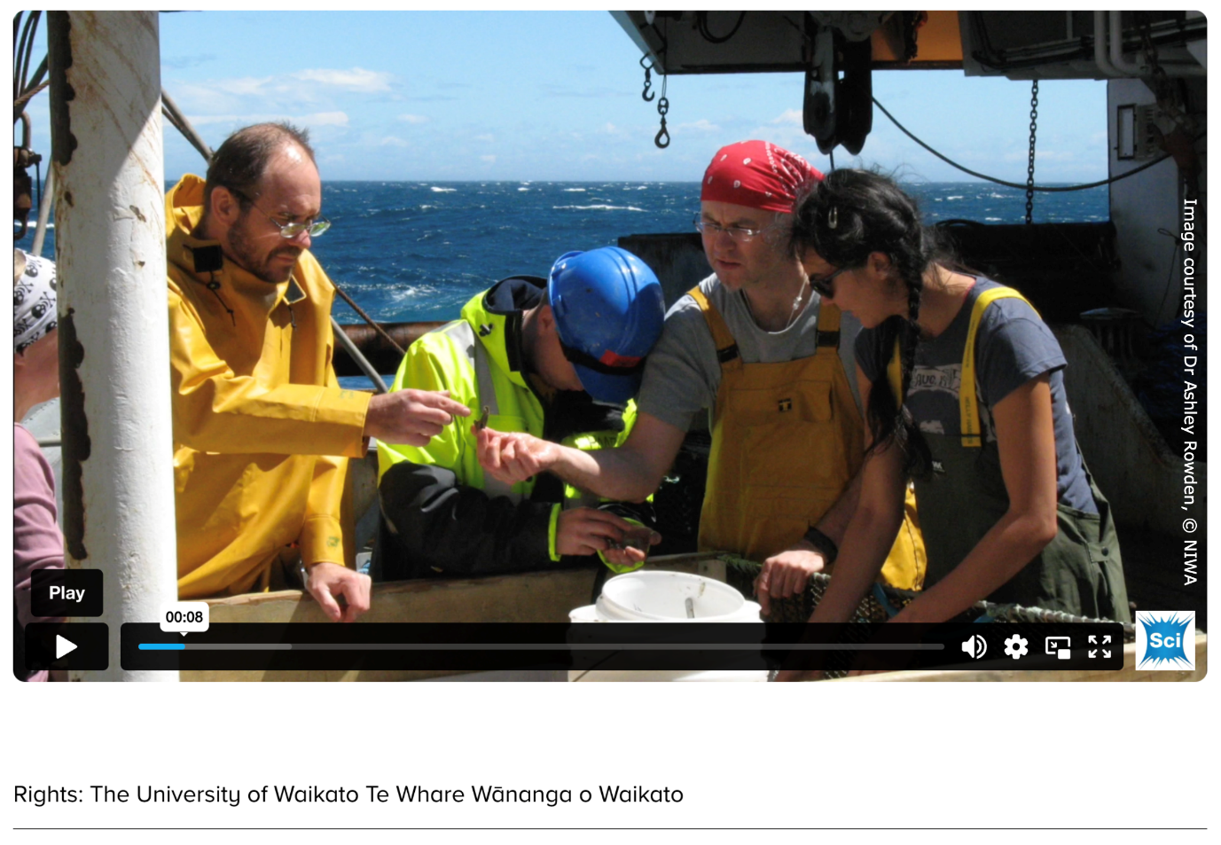

[**Classifying and identifying**](https://www.sciencelearn.org.nz/videos/2065-classifying-and-identifying)– video – Science Learning Hub

[Te tapa ingoa](https://docs.google.com/presentation/d/1zvq5C6WnWT9CgpwkxSw7CFZ1q7mpq6ylhzm2X2G1fFg/edit" \l "slide=id.p) is a *Connected* article by Priscilla Wehi and Hemi Whaanga. It explores how early Māori named and grouped the plants and animals they found around them. Discover what this process reveals about Māori ways of viewing the world and the framework provided by whakapapa.

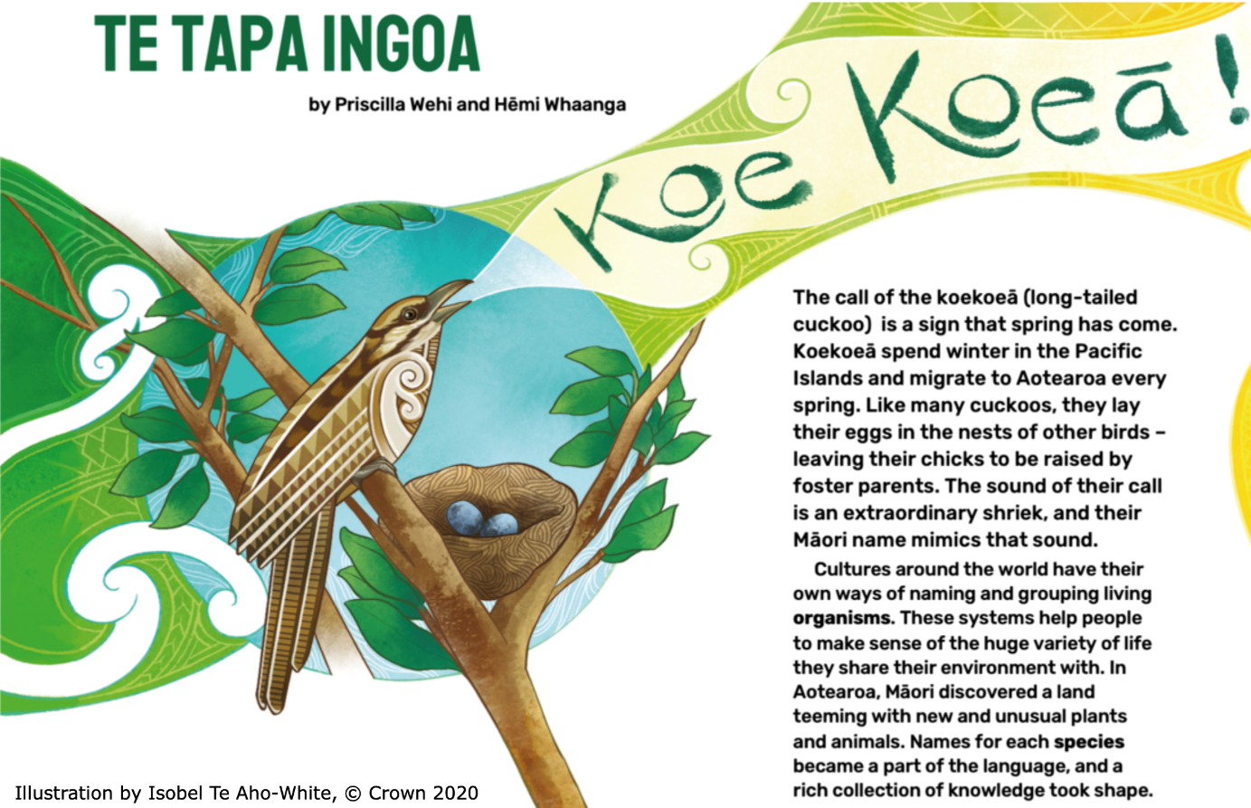

**Mahi:**

Use information from the text and online sources to complete the table.

* Make a list of the plants and animals discussed in the article.
* Pair up with someone else to find their names under the Linnaean classification system.
* Look at the scientific names of the species. What do you notice about the way the names are written? For example, use of upper and lowercase letters and font. Record the genus and species names.
* Research to find stories of the scientific name – the characteristics that are linked with its genus and species name.

|  |  |  |  |  |
| --- | --- | --- | --- | --- |
| **Māori name** | **English name** | **Genus name** | **Species name** | **Reason for the Linnaean names** |
| kūmara | sweet potato | *Ipomea* | *I. batatas* | Ipomoea is Greek for ‘worm-resembling’, which refers to the stem. Batata is Taino (Haitian) for sweet potato. |
|  |  |  |  |  |
|  |  |  |  |  |
|  |  |  |  |  |
|  |  |  |  |  |

**Explore similarities and differences between the Linnaean system and a whakapapa framework**

1. What are the similarities and differences between the two ways of naming and classifying plants and animals?
2. Why do you think these similarities and differences exist?
3. Why are there regional names for plants and animals in Aotearoa?
4. The writers say that Māori typically named birds after their appearance, behaviour or call. How does that compare with what happens in the Linnaean system?
5. What does this say to you about the different ways Māori and Pākehā interact with their environment?

**Acknowledgement:** This resource was written by Gerd Banke, Nayland School and is part of [Kaitiakitanga o te moana – a context for learning](https://www.sciencelearn.org.nz/resources/3384-kaitiakitanga-o-te-moana-a-context-for-learning).