**Living organisms – create a mihi**

**Ako: Learn about how humans classify living things**

When people from some cultures introduce themselves, they relate who they are to other people in their family and to the land where they live. Māori use this type of greeting – called a mihi – that describes their place within their whakapapa.

With some introductions, the person starts with their name and then describes their family tree, grandparents and important links. This is followed by placing themselves in the context of the land where they live, the main waterway (stream, lake or river) and the highest hill or mountain that are important to them and their whānau.

When scientists classify living things, they also give them names that show what the organism is related to and how closely.

Your mihi will introduce the organism in terms of its family and where it can be found in the landscape.

The example mihi used in this activity refers to the Linnaean classification of kihikihi wawa (chorus cicada). Within ao Māori animal groupings, its whakapapa calls to aitanga pepeke – the insect world. Pepeke refers both to bent legs and jumping ability.

**Mahi:**

Choose an insect or other living thing that you have found at school, home or as part of a stream or marine investigation. (If you use a live organism, remember that it should be collected in a container that meets its life needs but from which it cannot escape. You will need to return the organism to the place that you found it after using it for your study.)

Write an introduction, including the organism’s relationship to other living things and where it can be found in the landscape or marine environment.

**What to do**

1. Do some research on your organism.

* Manaaki Whenua – Landcare Research has identification keys and guides for [algae, fungi, plants, invertebrates and animals](https://www.landcareresearch.co.nz/tools-and-resources/identification/).
* Marine Metre² has identification guides for [sandy and rocky shore species](https://mm2.net.nz/resources/?resource-category=species-guides).

1. Once you have identified your organism, write down its scientific name – the long one in Latin. This will help you find out more about your organism.
2. Use resources to see if you can track back through the family of your organism. See if you can name its species, genus, family, order, class, phylum and kingdom. [Wikipedia](https://en.wikipedia.org/wiki/Main_Page) is a good place to start.

Here is an example for the chorus cicada, the most common species of cicada in Aotearoa:

Kingdom: Animalia

Phylum: Arthropoda

Class: Insecta

Order: Hemiptera

Suborder: Auchenorrhyncha

Infraorder: Cicadomorpha

Superfamily: Cicadoidea

Family: Cicadidae

Genus: *Amphipsalta*

Species: *A. zelandica*

1. Describe the environment where the organism comes from. Think about where you found it. Where does it live? What features are nearby? Freshwater? Saltwater? Mountains? Rocky reefs? List as many features as you can think of.
2. Write a mihi (introduction) for your organism. Here is an example of an insect mihi for a cicada found on a tree in an Auckland garden.

This mihi refers to the Linnaean classification of the chorus cicada – kihikihi wawa:

I am a chorus cicada – kihikihi wawa. My full name is *Amphipsalta zelandica*. I am related to all the Cicadidae in the world. I can trace my lineage back through Cicadoidea, Cicadomorpha, Auchenorrhyncha and Hemiptera to Insecta. This means that I am an insect and that I am related to all the other insects. Going back further, I am also a part of the Arthropoda phylum, which means I have jointed feet, and I am related to other animals like spiders and crabs. I am also related to all the animals that roam the Earth, but only very distantly. I was found in a garden in Auckland on a pōhutukawa tree. My home is near the stream that they call Lucas Creek. My land is that of the North Shore. My mountain is Rangitoto and my home is Aotearoa.

This mihi recognises the whakapapa of insects – te aitanga pepeke:

As kihikihi wawa, I whakapapa to te aitanga pepeke. I can trace my lineage beginning with Ranginui and Papatūānuku, to their descendants Tānemahuta and Hine-tūpari-Maunga. Tūteāhuru and Hinepeke are my parents.

1. When you’ve gathered all of the information you need about your organism, use an online graphic design tool to write up a mihi about your living thing.

Here’s an example:

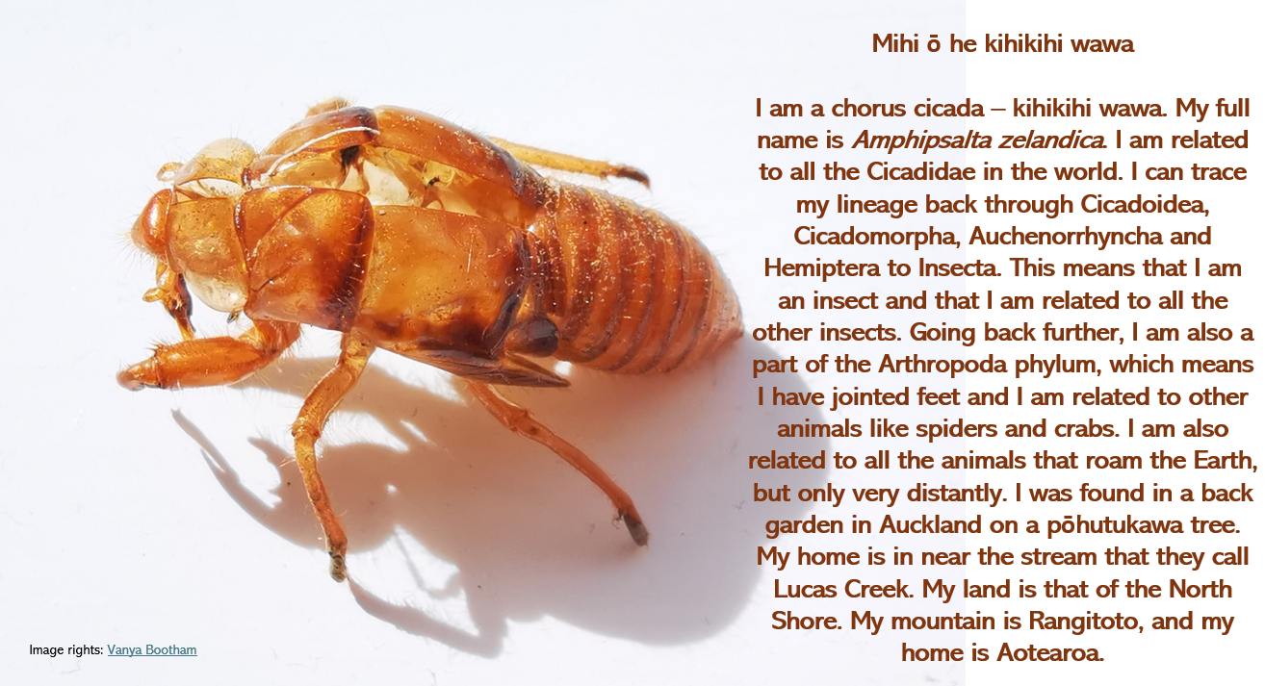

**Acknowledgement:** This resource was written by Gerd Banke, Nayland School and is part of [Kaitiakitanga o te moana – a context for learning](https://www.sciencelearn.org.nz/resources/3384-kaitiakitanga-o-te-moana-a-context-for-learning).