**What can DNA in the environment tell us about an ecosystem? – student questions**

**Ako: Learn about how humans classify living things**

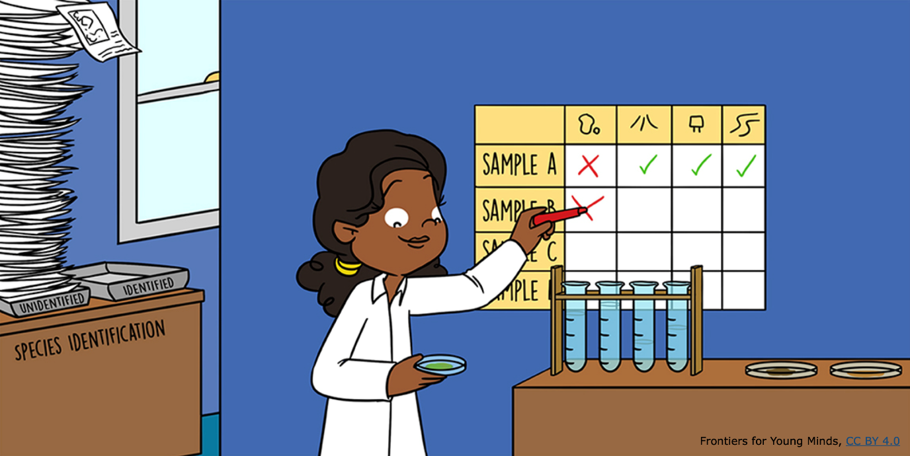

This activity uses the article [What can eDNA in the environment tell us about an ecosystem?](https://static.sciencelearn.org.nz/documents/files/000/001/342/original/What_Can_DNA_in_the_Environment_Tell_Us_About_an_Ecosystem.pdf?1742525880) published in the journal *Frontiers for Young Minds*. The article has been cut into six sections and the sections have been placed randomly around the room. There are questions for each section.

**Mahi:**

* Working in pairs, decide who will be the reader/writer and who will be the researcher. The reader/writer stays in their seat while the researcher moves around the room looking for information to answer the questions below. The researcher must remember the question and cannot take this question sheet with them.
* Once the researcher finds the answer to a question, return to the reader/writer and explain the answer so the reader/writer can record it.
* Focus on just one question/one piece of information at a time. For example, if there are multiple questions in the section, scan the text for the information you need to answer the question. Report it and then return to section to answer the next question.
* You can begin with any section you choose and work your way through all six sections in your own order.
* Remember to look for the section number on the article that matches the section’s questions.
* Swap roles halfway through the activity.

**Section 1: What can DNA in the environment tell us?**

Humans are disrupting natural ecosystems. Environmental DNA can help answer a lot of questions we have about these natural places.

1. How many species are there on our planet?
2. Why is it important we know which species are present in an area?
3. What is eDNA?

**Section 2: Monitoring biodiversity is important**

Technology enables scientists to use DNA to identify and monitor species.

1. What does the word **biodiversity** mean?
2. What are invasive species?
3. What do **taxonomists** do?
4. Why is the job of a taxonomist important? (Use the words **biodiversity** and **invasive species** in your answer.)
5. What does DNA look like and what are its building blocks?

**Section 3: What is eDNA? How can eDNA be used to identify the organisms in a community?**

DNA is made up of four bases (A, C, G and T). You could detect you had been in this classroom by extracting your DNA from stuff you may have left behind in the room.

1. What stuff do you leave behind in your environment? (For example, hair and what else?)
2. What is a community?
3. What does PCR do to the bits of eDNA left behind in an environment?
4. What does DNA sequencing do? What do DNA sequences tell us about an ecosystem? (Hint: look at Figure 1.)

**Section 4: What are the advantages of using eDNA to identify species?**

Environmental DNA (eDNA) is the DNA that species leave behind as they move around in their habitat. Before scientists started using eDNA to find out what species were living in an environment, they relied on taxonomers to identify the species for them.

1. Why is it tricky to identify different types of bacteria?
2. Why might taxonomers sometimes get their identification wrong?
3. Why might using eDNA may be a more accurate tool. (Hint: consider juvenile/adult stages, animals hiding.)

**Section 5: Conservation biology**

An invasive species is something not naturally found in an environment. Invasive species spread fast and can often outcompete native species.

1. What is conservation biology?
2. How does eDNA help scientists find out if a rare species is present even if they cannot find one? (Hint: use the example of leeches or mosquitoes.)
3. What are some advantages of using eDNA to detect invasive species?
4. What is another advantage of using eDNA to detect species living in an environment?
5. What are three advantages of using eDNA as a biodiversity detection tool compared to using taxonomy (Hint: look at Figure 2.)

**Section 6: Are there any problems with using eDNA?**

Scientists first extract the DNA from soil or water samples and then make copies of it using a technique called PCR. After that, they can sequence the DNA, which enables them to read the DNA and then identify which animal or plant the DNA has come from.

1. What is one of the issues associated with the PCR (copying) of the eDNA?
2. Would gathering eDNA be able to tell you how many kiwi were found in an area? Why or why not?

**Acknowledgement:** This resource was written by Gerd Banke, Nayland School and is part of [Kaitiakitanga o te moana – a context for learning.](https://www.sciencelearn.org.nz/resources/3384-kaitiakitanga-o-te-moana-a-context-for-learning)