**Learning from past scientists – video and focus questions**

**Ako: Learn about DNA and inheritance**

**Mahi:**

Read these focus questions:

1. Why is it important to learn from past scientists?
2. Why is it important to be a good science communicator?
3. What did the discovery of the structure of DNA lead to?

Think about these key words:

* **Genome** – all the genetic material in an organism​.
* **DNA sequencing** – mapping the DNA and the genes it contains.

Watch this video:

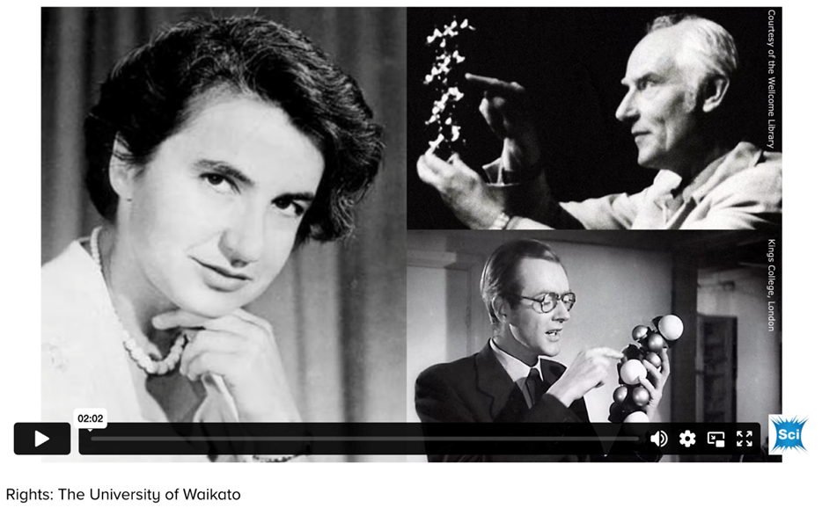

[**Learning from past scientists**](https://www.sciencelearn.org.nz/videos/662-learning-from-past-scientists)– Science Learning Hub

**Acknowledgement:** This resource was written by Gerd Banke, Nayland School and is part of [Kaitiakitanga o te moana – a context for learning](https://www.sciencelearn.org.nz/resources/3384-kaitiakitanga-o-te-moana-a-context-for-learning).