**DNA and scientific discoveries – teacher notes**

**Ako: Learn about scientific research and the structure of DNA**

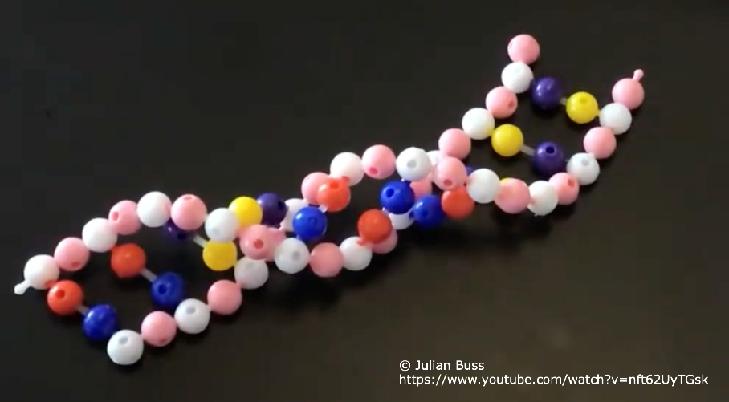

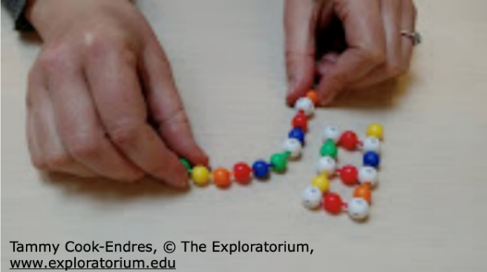This activity challenges students to use scientific research as clues to determine the structure of DNA.

Students use coloured beads to construct iterative models based on evidence provided to them. As more information becomes available, students change/rebuild their models – similar to how our understanding of inheritance and DNA has changed over time.

**Nature of science and the science capabilities**

The activity supports learning about the nature of science:

* The tentative nature of scientific knowledge – how knowledge is subject to change in the light of new evidence or new interpretation of existing evidence.
* Investigating in science – developing, exploring and using models.

It also provides practice with the science capabilities ‘Use evidence’, ‘Critique evidence’ and ‘Interpret representations’.

**Exploratorium resources**

This activity uses resources from [Exploratorium](https://www.exploratorium.edu/), created by Tammy Cook-Endres.

The resources are accessed [here](https://www.exploratorium.edu/education/teacher-institute/digital-teaching-boxes/genetics). Use Resource 7: DNA Structure Building Challenge.

**Exploratorium teaching resources**

Resources include:

* What is the Structure? Digging into DNA – background information, teaching notes, teaching instructions, questions and tips.
* DNA activity clues – numbered clues with scientific discoveries and student instructions for building/adapting models. There are seven clues for students to work through.
* DNA Structure Building Challenge – student instructions.
* Pop Bead DNA Subunit Key – explanations for what each of the coloured beads and the bead connectors represent.

**Time:** Two class periods (more if support is needed)

**Materials (per group):**

* 30 5-hole pop beads (white)
* 30 1-hole pop beads in each of five colours (yellow, orange, red, blue, green)
* 20 pop bead connectors
* Container to hold the beads
* Clue cards (see the Exploratorium’s [DNA activity clues](https://docs.google.com/presentation/d/1MXGJ6llYhB5Amw-VKNjS5C4LxRV-VlGk/edit#slide=id.p1) – PPTX via Google Drive)
* Challenge sheet (see the Exploratorium’s [DNA Structure Building Challenge](https://drive.google.com/drive/folders/1NtAK_Xa5vMMqoXfEydRpaad_2fbXKXHw) – PDF via Google Drive)
* Molecule key (see the Exploratorium’s [Pop Bead DNA Subunit Key](https://drive.google.com/drive/folders/1NtAK_Xa5vMMqoXfEydRpaad_2fbXKXHw) – PDF via Google Drive)

**BEANZ resources**

Educators who are members of [Biology Educators of Aotearoa New Zealand (BEANZ)](https://beanz.org.nz/) can access a version of this activity: Building a Mystery Molecule.

**Acknowledgement:** This resource was written by Gerd Banke, Nayland School and is part of [Kaitiakitanga o te moana – a context for learning](https://www.sciencelearn.org.nz/resources/3384-kaitiakitanga-o-te-moana-a-context-for-learning).