**DNA as taonga**

**Ako: Learn about DNA and inheritance**

**Hua: I understand that some DNA is considered a taonga and requires tikanga when handled**

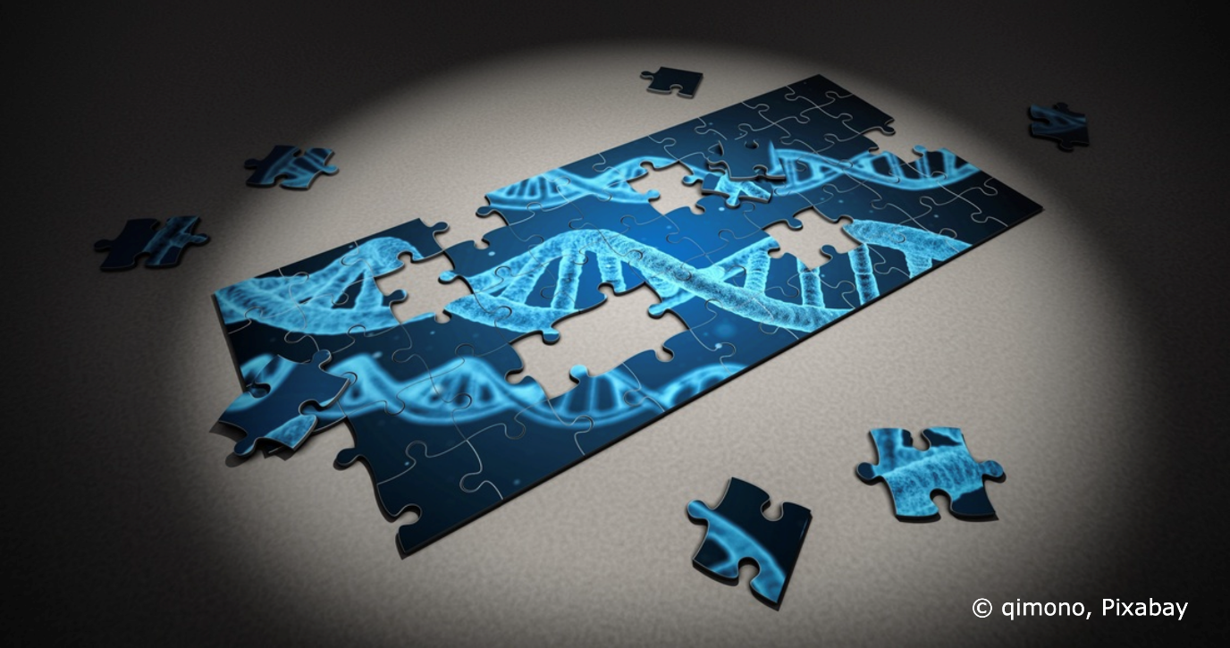

**Mahi:**

Read these terms from the Science Learning Hub article [RNA interference – key terms](https://www.sciencelearn.org.nz/resources/3250-rna-interference-key-terms). They explain ao Māori concepts regarding genetics.

**Ira tangata:** Ira is the life force or genes that exist within all living beings. Ira tangata represents the human life force element inherited from the parental generation through genes. Genes hold more than just biological significance – they possess a spiritual quality that enables Māori to establish a connection with the atua (Māori gods). Through whakapapa, Māori can trace the descent of living beings, including themselves, back to the Atua.

**Kaitiakitanga:** Referred to as guardianship. This is particularly relevant when taonga species are involved as it describes the responsibility to care for and manage these species in a reciprocal nature. Researchers also have a responsibility to identify and engage with the appropriate kaitiaki or representatives who can make decisions on behalf of the taonga.

**Mana:** The authority and power that exists within all living beings. It is closely linked with the concept of tapu and also relates to levels of control by Māori and their responsibilities for decision making in relation to taonga.

**Mauri:** This refers to the vital life essence found in everything, giving them an energy whether they are living or non-living. Preserving the mauri of an organism or system is important as it ensures the natural balance and wellbeing are upheld. Even the smallest biological parts, like the microbiome and bioactivity, have their own mauri.

**Rangatiratanga:** This can be referred to as self-determination or autonomy. Rangatiratanga should go beyond simply acknowledging Māori authority and should also emphasise the importance of inclusive processes that ensure Māori perspectives and voices are genuinely considered in decision making at various stages or levels in shaping the use of genetic technologies.

**Taonga:** Describes something of great significance or value and should be carefully preserved to maintain its integrity while also respecting the tapu (sacredness) it holds. Taonga can be abstract and extends to biological materials such as tissue samples, DNA and associated data.

**Tikanga:** Encompasses Māori customs and protocols. Tikanga helps guide ethical decision making by providing specific protocols and processes that uphold people’s values and principles. It serves as a framework for Māori to actively engage with ethical issues and consider how research may impact their values and relationships.

**Whakapapa:** Whakapapa is embodied in the DNA of organisms where the protection of whakapapa is crucial for Māori and the inherent responsibility in ensuring it remains intact for the survival of future generations.

[Te Nohonga Kaitiaki – Guidelines for Genomic Research of Taonga Species](https://www.genomics-aotearoa.org.nz/sites/default/files/2022-02/Te%20Nohonga%20Kaitiaki%20Guidelines%20for%20genomic%20research%20on%20taonga%20species.pdf) gives three guiding principles to inform thinking about genomic research:

* Kia tau te wairua o te tangata – acknowledge the spirit in which a taonga is shared and used.
* Kia pūmau te mana o te tangata – maintain the authority of kaitiaki to exercise their tino rangatiratanga.
* Kia hiki te mauri o te kaupapa – research considers the ecosystem as a whole and recognises ecosystemic balance.

It also has three operating principles:

* He whakapapa tō te taonga – taonga have relationships with people and place.
* He mauri tō te taonga – taonga are essential components of the ecosystem.
* He kaitiaki tō te taonga – taonga are protected through intentional action.

**Mahi:**

What connections can you make between the key terms, the guiding principles and the operating principles?

Use coloured highlighters, arrows or a numbering system to match some of the terms to the principles that they underpin.

**Acknowledgement:** This resource was written by Gerd Banke, Nayland School and is part of [Kaitiakitanga o te moana – a context for learning](https://www.sciencelearn.org.nz/resources/3384-kaitiakitanga-o-te-moana-a-context-for-learning).