**Biosecurity statements – Venn diagram**

**Ako: Learn about biosecurity and pest management**

**Hua: I can give a simple definition of biosecurity**

**Mahi:**

1. Read the three biosecurity statements below. They represent definitions of biosecurity from three different New Zealand organisations – Department of Conservation, Ministry for Primary Industries and Te Tira Whakamātaki.
2. Use the Venn diagram to get a clearer idea about what biosecurity is and how the different organisations may differ in their definition of biosecurity.

|  |
| --- |
| Purpose of the biosecurity system The biosecurity system prevents or manages risks from harmful organisms, like pests and diseases. The biosecurity system helps protect New Zealand’s economy, environment, human health, and a range of social and cultural values. It does this by:   * stopping pests and diseases before they arrive * dealing with any if they do enter the country.  **Biosecurity | Haumaru koiora** If harmful pests and diseases get into New Zealand, they can cause damage. Biosecurity focuses on stopping them at the border or getting rid of the ones already here.  Source: [Ministry for Primary Industries – Biosecurity New Zealand](https://www.mpi.govt.nz/biosecurity/) |
|  |
| A green and white sign with white text  Description automatically generated  Biosecurity helps to prevent damage caused by unwanted organisms. These include animal pests, weeds, didymo, and diseases like kauri dieback.  New Zealand has a unique ecosystem. Our native species once thrived without any native predators. However many introduced predators and pests arrived with humans, and threaten the survival of our native species.  Biosecurity helps to prevent or reduce any damage caused by unwanted organisms.  **What is biosecurity?**  Biosecurity is about keeping New Zealand free of unwanted organisms and for controlling, managing or eradicating them should they arrive in the country.  **Who is involved?**  DOC manages 8 million hectares of land, about 30% of New Zealand's land area. We are responsible for preserving and protecting these areas, including managing threats from invasive pests and diseases.  The [Ministry for Primary Industries](https://www.mpi.govt.nz/legal/legislation-standards-and-reviews/biosecurity-legislation/introduction-to-biosecurity-legislation/) (MPI) leads New Zealand's biosecurity system. It is tasked with a “whole of system” leadership role, encompassing economic, environmental, social and cultural outcomes.  Source: [Department of Conservation](https://www.doc.govt.nz/our-work/biosecurity/) |
|  |
| Te tira whakamātaki  Te Tira Whakamātaki (TTW) is a Māori environmental not-for-profit that translates to “the watchful ones” in English, as we use our skills and positions to seek out, empower, privilege, and protect Indigenous peoples and solutions in the fight to protect nature. In this, we address one of the most pressing threats to the climate and our ability to thrive in it – the diversity of life on earth (biodiversity).  We aim to restore balance to our natural world and re-establish a reciprocal relationship with Papatūānuku (Mother Earth) by embedding our ancestor’s knowledge of the environment, our Indigenous philosophies, and mātauranga (knowledge) in our work and organizational structure.  Source: [Te Tira Whakamātaki](https://www.ttw.nz/) |

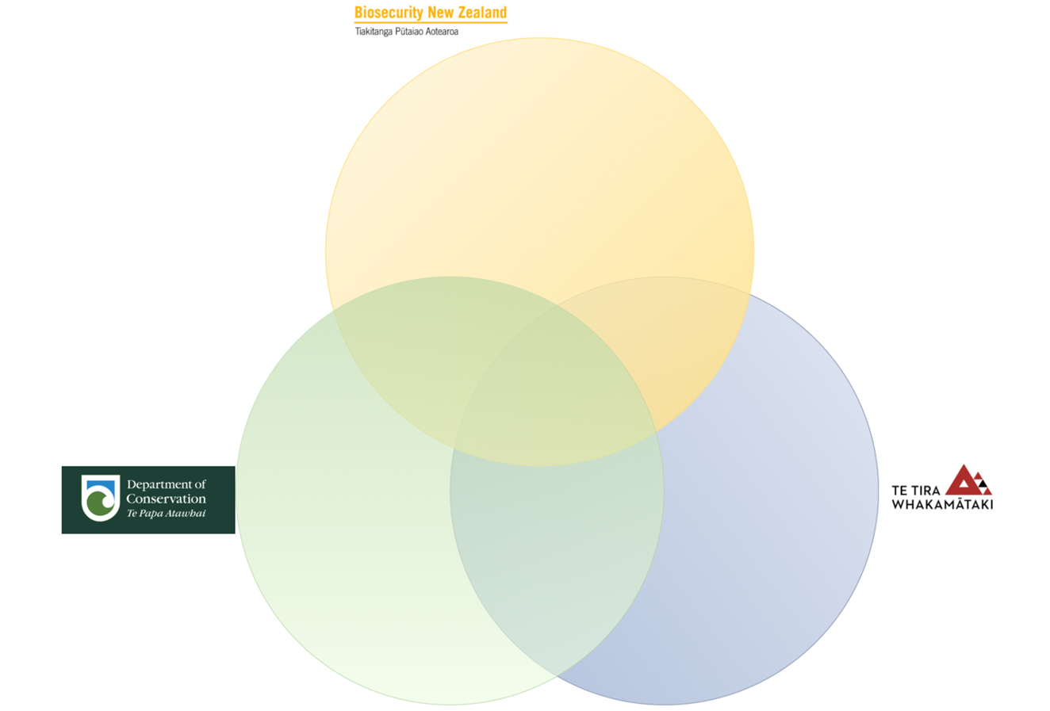

**Acknowledgement:** This resource was written by Gerd Banke, Nayland School and is part of [Kaitiakitanga o te moana – a context for learning](https://www.sciencelearn.org.nz/resources/3384-kaitiakitanga-o-te-moana-a-context-for-learning).