**Make a wanted poster**

**Ako: Learn about biosecurity and pest management**

**Hua: I understand what biosecurity is and I can list some New Zealand pests**

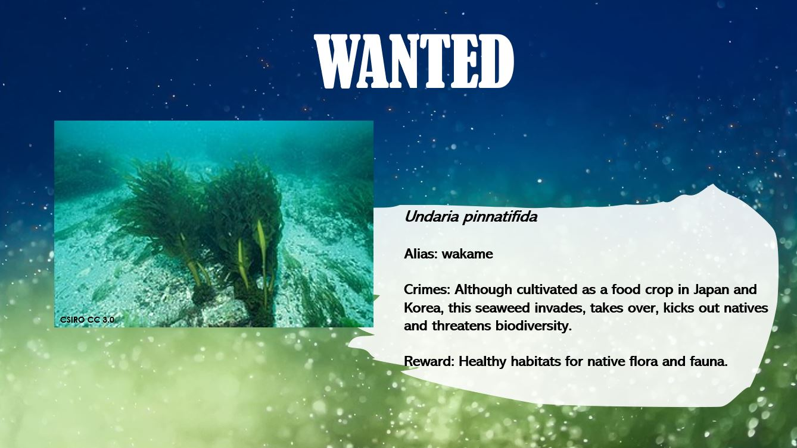

**Mahi: Make a wanted pest poster**

1. Look at the wanted poster. It is quite simple. How could you make it better and perhaps more informative? What addition information would be good to have about the specific pest?
2. Brainstorm a list of New Zealand pests.
3. Pick one pest and start researching information about the pest:
   1. Describe the pest
   2. Its origin – native country or world region.
   3. Why is it considered a pest in New Zealand? What damage is it causing?
   4. Where would you find it and how can you eradicate it?
4. Make a wanted poster about your pest.

**Acknowledgement:** This resource was written by Gerd Banke, Nayland School and is part of [Kaitiakitanga o te moana – a context for learning](https://www.sciencelearn.org.nz/resources/3384-kaitiakitanga-o-te-moana-a-context-for-learning).