**Native marine species versus pest marine species – teacher notes and student worksheets**

**Ako:**

* Learn about taonga/native species and pest species in our moana.
* Learn about the features of different types of species.

This series of activities encourages students to deepen their understanding about the importance of marine biosecurity to Aotearoa New Zealand. The activity uses information from [Clean Below? Good to go](https://www.marinepests.nz/). After reading why some introduced species become invasive pest species, students use two SOLO maps to organise the information, which is then used as part of a formative assessment. The assessment uses a PEEL (points, explain, examples, links) format to help students structure their responses.

**What you need**

* [What makes a pest, a pest?](https://static1.squarespace.com/static/631ac931f15f5e4155e43b53/t/633f24bf32583c00eed82368/1665082585816/Marine+Biosecurity_Education+Modules_Pt2-2.pdf) – PDF (pages 3–5)
* SOLO maps
* Points to add to the unistructural and multistructural SOLO maps regarding native and marine pest species
* Unistructural – categorising native marine and pest species
* Multistructural – compare and contrast features of marine species
* Are marine pests really that bad for our moana?

**What to do**

1. Use the information in pages 3–5 of [What makes a pest, a pest?](https://static1.squarespace.com/static/631ac931f15f5e4155e43b53/t/633f24bf32583c00eed82368/1665082585816/Marine+Biosecurity_Education+Modules_Pt2-2.pdf) to learn about how and why some introduced marine species become invasive pests.
2. Discuss the information in the SOLO maps, the PEEL structure and other questions students may have.
3. Complete the Unistructural – categorising native marine and pest species activity. Students can cut up and use the information in Points to add to the unistructural and multistructural SOLO maps regarding native and marine pest species, if desired.
4. Use this information to complete the Multi activity.
5. Challenge students to transfer and extend their learning by completing the formative assessment Are marine pests really that bad for our moana?

**SOLO maps**

**Where are you at?**

|  |  |  |  |  |  |
| --- | --- | --- | --- | --- | --- |
|  | **Prestructural** | **Unistructural** | **Multistructural** | **Relational** | **Extended  abstract** |
| **Ako:**  Communicate my understanding about native versus pest species using a PEEL-structured paragraph | I don’t know much about native and pest species yet | I know a few things about the two different types of species | I know a lot of things about the different types of species **and** I can compare and contrast the features of the two different types of species | … **and** I can demonstrate my understanding of the different features by writing a PEEL-structured paragraph | … **and** I can evaluate the features of pests that make them so successful compared to native species **and** I give examples where pest species can be a taonga species in one area and be a pest in another |
| **Mahi** | SOLO map (unistructural) | SOLO map (unistructural) | SOLO map (multistructural) | Complete the PEEL-structured paragraph | Complete the PEEL-structured paragraph |

*Teacher feedback:*

**Points to add to the unistructural and multistructural SOLO maps regarding native and marine pest species**

|  |  |  |  |
| --- | --- | --- | --- |
| Marine pests often produce many babies | Marine pests are often omnivores so will eat a wide range of food | If conditions are not right, marine pests will not just die, they may become dormant and just wait for better conditions | Marine pests have left their home area and have often left their predators behind |
| Native marine taonga species often produce fewer babies | Marine pests are not picky about where to live so can settle in many different areas | Native species often have specific habitat requirements (temperature/salt levels) | Native marine taonga species only reproduce a few times during the year |
| Marine pests can produce babies several times during the year | Marine pests can be aggressive and can quicky outcompete native marine species | Marine pests can survive in a wide range of habitats so are not so affected by changes in temperature | Native marine taonga species and pest species both live in our moana |
| Taonga species are often only found in Aotearoa | Māori can whakapapa to our taonga species | Our taonga species work as tohu or indicator species |  |

**Unistructural – categorising native marine and pest species**

**Ako: Learn about our taonga/native species and pest species in our moana.**

**Hua: I can state some facts about the two different types of animals/plants species.**

**Mahi:**

Use the information sheet to categorise some of the facts about the two different types of species

**Marine taonga species/native species Marine pest species**

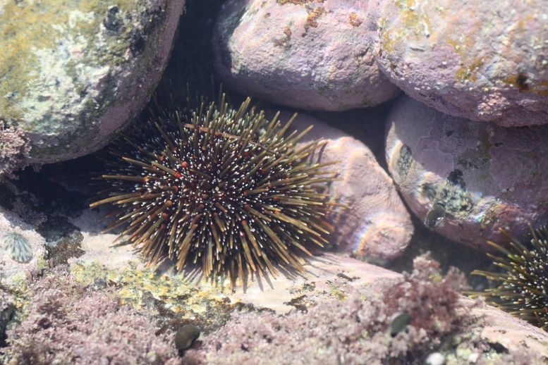**Multistructural – compare and contrast features of marine species**

**Ako: Learn about the features of different types of species**

**Hua: I can compare and contrast the features of our taonga species and our marine pest species**

**Differences**

*Pest species*

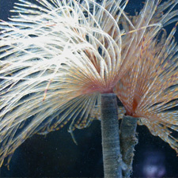

*Taonga species*

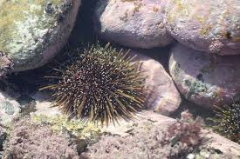

**Differences**

**Similarities**

Compare and contrast marine pests to our marine taonga species. Use the following **linking key words** and **sentence starters**:

**Key words**: whereas, in contrast to, compared to ...

**Sentence starter**: Marine pests have a large number of offspring **whereas** ...

Key words: where as, in contrast to, compared to...

Sentence starter: Plastic rope will last long in seawater where as...

**Are marine pests really that bad for our moana?**

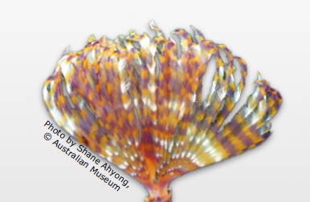

**Mahi:**

Compare and contrast the features about our taonga marine species and our pest marine species. Write a PEEL paragraph where you use the information gathered in the SOLO maps to argue how marine pests affect our marine taonga species.

* **P** **– Points or overall ideas.** Introduce the two different types of species (definition) and what this paragraph is about.
* **E** **– Explain.** Explain what you know about the two different types of species (use the unistructural SOLO map).
* **E – Examples.** Give examples of how the two species are different (compare and contrast the species using the sentences you created in the multistructural SOLO map).
* **L – Linking.** Refer back to the question. Evaluate **how** and **why** marine pests affect our taonga species. What is it about the marine pests’ **features** that make some so successful? Are all introduced species pests?

Here are some starter sentences that may be useful:

**P** – Native species have evolved naturally in the local environment but pests …

**E** – Sabella is an example of …

**E** – Pest species such as … have babies very quickly but a native species such as …

Pests can feed on lots of things but native species …

When the conditions are difficult pest species can … but native species …

**L** – Pests upset the balance of the local ecosystem because …

**Acknowledgement:** This resource was written by Gerd Banke, Nayland School and is part of [Kaitiakitanga o te moana – a context for learning](https://www.sciencelearn.org.nz/resources/3384-kaitiakitanga-o-te-moana-a-context-for-learning).