**Indigenous pest control**

**Ako: Learn about biosecurity and pest management**

1080, or sodium fluoroacetate, is a poison used to control pest species. It is an effective but controversial method. These articles provide information about 1080 and its use in Aotearoa New Zealand:

* [1080 – an overview](https://www.sciencelearn.org.nz/resources/2684-1080-an-overview) – Science Learning Hub
* 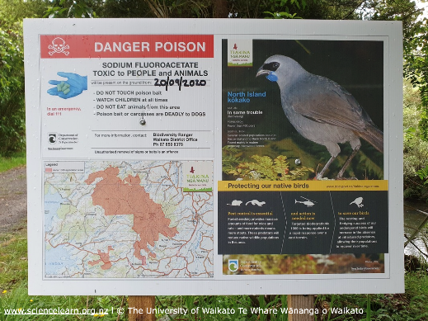[Alternatives to 1080](https://www.sciencelearn.org.nz/resources/2689-alternatives-to-1080) – Science Learning Hub

Tame Malcom (Ngāti Tarāwhai, Ngāti Pikiao) is an expert in indigenous pest management. His article [Is poisoning pests the Māori way?](https://www.sciencelearn.org.nz/resources/3369-is-poisoning-pests-the-maori-way) addresses claims made by those opposed to the use of 1080. Tame illustrates his reasoning with examples of indigenous pest control methods.

**Mahi:**

Read [Is poisoning pests the Māori way?](https://www.sciencelearn.org.nz/resources/3369-is-poisoning-pests-the-maori-way) and complete the following tasks.

1. Make a list of kupu Māori that you don’t know and look them up.
2. Choose three of Tame Malcolm’s arguments for the use of 1080 and summarise them.
3. List three natural toxins that come from native plants.
4. Tame writes, “But in my opinion, none is more controversial than the use of 1080 toxin to control pest species.” Have Tame’s arguments changed your thinking about this controversial issue? Record one or two of your thoughts.

**Acknowledgement:** This resource was written by Gerd Banke, Nayland School and is part of [Kaitiakitanga o te moana – a context for learning](https://www.sciencelearn.org.nz/resources/3384-kaitiakitanga-o-te-moana-a-context-for-learning).