**Mātauranga Māori and pest management – student worksheet**

**Ako: Learn about aspects of biosecurity and pest management based on mātauranga Māori – protocols and solutions**

**Mahi:**

In this activity, you will learn some aspects of mātauranga and tikanga as it pertains to biosecurity, pest management and the protection of te taiao. After working as part of an expert group, you will take your knowledge to your home group and share the information with them. Once you have shared your information with your home group, the group will have an opportunity to reflect and discuss what you’ve learned.

This is how home groups and expert groups work:

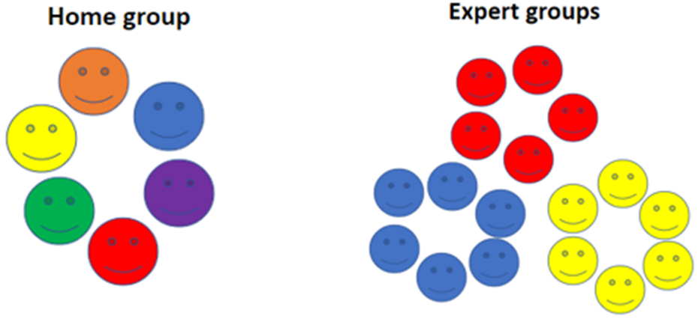  
**Home groups and expert groups – hints and tips**

* You will need to know the information well enough to be able to report what you’ve read about – the issues and solutions or insights offered by mātauranga.
* You can take short notes and write down kupu Māori.
* When you are back with your home group, you will report on what you’ve read. One person (not you) will record the information you provide in the Home group – summary of information from expert groups table. You will also have a turn at recording information for one of the other experts in your home group.
* When all experts have reported to the home group, discuss and record your answers to the reflection questions.

**Homegroup – summary of information from expert groups**

|  |  |  |
| --- | --- | --- |
| **Early pest management by Māori** | **Rāhui** | **Restoring the forest’s song** |
|  |  |  |
| **Is poisoning pests the Māori way?** | **A mātauranga Māori-based solution for kauri dieback** | **Tangaroa: atua of the sea** |
|  |  |  |

**Reflection questions**

1. How can looking at what was done in the past help us solve some of the issues we are facing today?
2. Are any of the issues you’ve read about affecting your local area? Which ones? If you are not sure, how can you find out?
3. What are some of the solutions that mātauranga has to offer? Are these solutions practical, social or a mixture of both? Give some examples to support your thinking.
4. What information resonates with you?
5. What information challenges your thinking?
6. Why might we need a mix of old and new ways of doing things to meet some of our biosecurity challenges?

**Acknowledgement**: This resource was written by Gerd Banke, Nayland School and is part of [Kaitiakitanga o te moana – a context for learning](https://www.sciencelearn.org.nz/resources/3384-kaitiakitanga-o-te-moana-a-context-for-learning).