**Mātauranga Māori and pest management – teacher notes**

**Ako: Learn about aspects of biosecurity and pest management based on mātauranga Māori protocols and solutions**

Biosecurity and pest management are not new concepts in Aotearoa. For centuries, Māori lived off the land. They were reliant on the food and resources that they could gather and harvest. People’s health depended on the health of te taiao. Mātauranga and tikanga were used to manage and protect these resources.

In recent years, the need for biosecurity and pest management has increased and there is no single solution to the problems we face. Looking at what was done before can aid our quest for answers to current issues.

In this activity, students use resource sheets to learn aspects of mātauranga and tikanga as it pertains to biosecurity, pest management and the protection of te taiao. After working as part of an expert group, individuals summarise and share this information with their home group. Home groups then can discuss issues and solutions and ideas that resonate with and/or challenge their thinking.

**Resource sheets**

* Expert group 1 – Early pest management by Māori
* Expert group 2 – Rāhui
* Expert group 3 – Restoring the forest’s song
* Expert group 4 – Is poisoning pests the Māori way?
* Expert group 5 – A mātauranga Māori-based solution for kauri dieback
* Expert group 6 – Tangaroa: atua of the sea

**What to do**

1. Print or distribute copies of expert group resource sheets around the classroom. Some of the expert sheets have links to online resources, which students will need to access.
2. Provide copies of [Mātauranga Māori and pest management – student worksheet](https://static.sciencelearn.org.nz/documents/files/000/001/359/original/M%C4%81tauranga_M%C4%81ori_and_pest_management_%E2%80%93_student_worksheet.docx?1742536606).
3. Split students into groups of six – these are the home groups. People within the home groups number off from 1–6.
4. Students use the expert group resource sheets to gain information about the specific topic.
5. When they return to their home group, each individual reports what they’ve read while another student records the information on the Home group – summary of information from expert groups page, which is part of the student worksheet. Each student takes a turn as a recorder.
6. Once the summary of information page is complete, each home group should move on to the reflection questions in the student worksheet.

**Acknowledgement:** This resource was written by Gerd Banke, Nayland School and is part of [Kaitiakitanga o te moana – a context for learning](https://www.sciencelearn.org.nz/resources/3384-kaitiakitanga-o-te-moana-a-context-for-learning).

**Expert group 1 – Early pest management by Māori**

The origin story of kūmara varies from one area to another. In a version that comes from the Mataatua region, the kūmara has a celestial origin involving two brothers: Whānui (the star also known as Vega) and Rongo-māui (the star also known as Sadr).

Little brother Rongo-māui needed to find food for his whānau. He heard about the wonderful qualities of the kūmara, who were the children of his older brother Whānui. Whānui lived in the sky, so Rongo-māui climbed into the sky and asked his brother if he could take some of the kūmara back to Earth as food. Whānui refused, but Rongo-māui wouldn’t take no for an answer. Rongo-māui waited until he was out of Whānui’s sight and crept back up to where the kūmara were kept and stole them. He brought the stolen kūmara back to Earth and gave them to his wife Pani-tinaku (the star Deneb), who became the mother to all kūmara on Earth today.

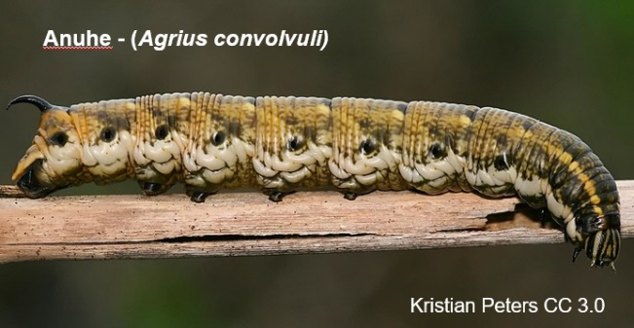When Whānui found out what had happened, he was very angry. As punishment for the theft, he sent down some of his other children – the moth caterpillars Anuhe, Toronū and Moko – to attack the kūmara crops.

This story reveals the special status of kūmara as a vital food source shaped by our atua. It also speaks of the many relationships, or whakapapa, between plants and animals, people and their ancestors, and actions and consequences.

**Managing pests**

Māori managed kūmara growing with great horticultural skill, making use of the ideal growing climate. One way of eradicating the kūmara caterpillar was with the use of tamed black-backed seagulls to sit in the plantations and eat them.

However, early Māori didn’t see the caterpillars so much as pests but more as a lesson against theft. Another way of getting rid of the caterpillars was to burn them to send their spirits back up to Whānui – remembering Rongo-māui stole the kūmara from his big brother Whānui.

At some pā sites, tūpuna would line their kūmara pits with rarauhe (bracken fern). Kiore (Polynesian rats) that would try to burrow into the kūmara pits would have to gnaw through the toxic plant to get to the kūmara, thus getting poisoned.

Kawakawa was also used to kill insects. A known insecticide, it would be buried in the ground around kūmara gardens – adding poison to the whenua to deter insects.

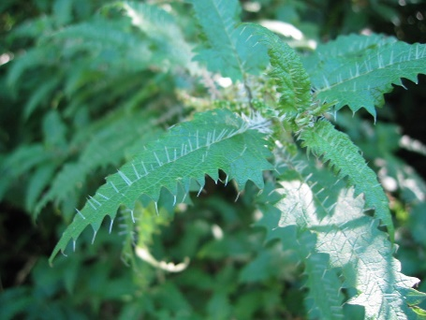Tūpuna would also translocate ongaonga (stinging nettle) and place it in areas from which they wanted to deter unwelcome visitors.

Many Māori might think that pest management puts the needs of the environment above the needs and wants of humans. Our kaumātua and whānau have taught us that the environment is number one. If you don’t take care of the environment, it will not take care of you.

**References**

<https://www.kumara.co.nz/>

<https://issuu.com/nataliescott1/docs/teakaaaaa>

<https://teara.govt.nz/en/kumara/page-4>

<https://teara.govt.nz/en/photograph/17362/anuhe-kumara-moth-caterpillar>

[www.sciencelearn.org.nz/resources/3080-tame-malcolm-indigenous-pest-management](http://www.sciencelearn.org.nz/resources/3080-tame-malcolm-indigenous-pest-management)

<https://instructionalseries.tki.org.nz/Instructional-Series/Connected/Connected-2020-Level-3-Kaitiakitanga/Te-Tapa-Ingoa>

[www.sciencelearn.org.nz/resources/3369-is-poisoning-pests-the-maori-way](http://www.sciencelearn.org.nz/resources/3369-is-poisoning-pests-the-maori-way)

**Expert group 2 – Rāhui**

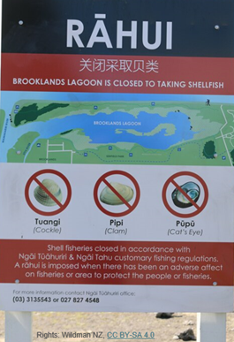In Māori culture, a rāhui means there is no access to or use of an area or resource. Rāhui may be placed on land, sea, rivers, forests, gardens, fishing grounds and other food resources. Today, the Ministry for Primary Industries can, by law, place a rāhui over an area.

Rāhui may be put in place for many reasons. Sometimes it is done because the plants or animals in the area are not doing well due to too much hunting or gathering. The rāhui then gives the area or the resources a chance to recover without human disturbance. If a person dies in an area, that area may become tapu. A rāhui is placed upon the area out of respect for the dead and to prevent the gathering of kai there for a specified period.

Today, most rāhui are set down in law. For example, there is a rāhui in place in Maunganui Bay at the request of local tangata whenua. Rāhui can be put in place if the closure will improve availability or size of fisheries resources in the area. A sign or physical symbol may be displayed to show a rāhui has been imposed. Sometimes a carved or decorated wooden stick or pou is placed in the ground. Natural features of the landscape can indicate the boundaries of the area under restriction.

Pre-colonisation, Māori lived off the land. They were reliant on food and resources that they could gather and harvest. People’s health depended on the health of the land and its resources such as kai moana, kūmara, harakeke and resources from the forests. Sustainable food gathering and hunting practices were very important. If an area was in decline, a rāhui would be placed to allow the area to recover. It was considered bigger and more important than the people’s right to gather resources to survive. If you broke the rāhui and entered the area you could be killed or the person who was meant to be guarding the place could be killed too.

In the Southland region, Ngāi Tahu preserved resources through a number of restrictions. A traditional Ngāi Tahu example of a natural rāhui is the call of the bird called hākuai. The hākuai is considered by some as the guardian of the tītī (muttonbird). When the people hear the hākuai call in the night, it foretells the end of the season for taking tītī. The rāhui then remains until the following year.

**Reference**

<https://teara.govt.nz/en/kaitiakitanga-guardianship-and-conservation/print>

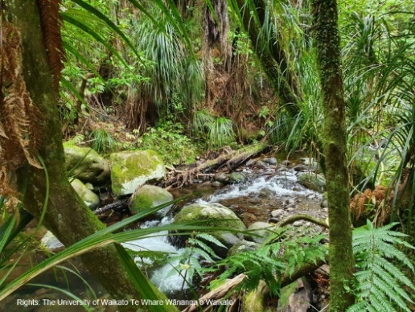**Expert group 3 – Restoring the forest’s song**

Read [Restoring the forest’s song](https://ndhadeliver.natlib.govt.nz/webarchive/20220622093355/https://sciblogs.co.nz/matau-taiao/2021/05/24/restoring-the-forests-song/) – an article by Rosemary Rangitauira, published in Sciblogs.

This article features an interview with Tame Malcolm. Tame is interested in pest management designed and implemented from ao Māori perspectives. One of his key goals is to reinstate the mauri of the ngahere (forests) in Aotearoa.

A few highlights from the article:

* Each forest has a unique language and ecosystem.
* Kawa, tikanga and tapu need to be considered.
* Trials using mātauranga Māori have shown increased success in trapping rates.

The article provides information about these highlights and about other aspects of kaitiakitanga.

**Expert group 4 – Is poisoning pests the Māori way?**

Read [Is poisoning pests the Māori way?](https://www.sciencelearn.org.nz/resources/3369-is-poisoning-pests-the-maori-way) (The article on the Science Learning Hub has been republished from [The Spinoff.)](https://thespinoff.co.nz/)

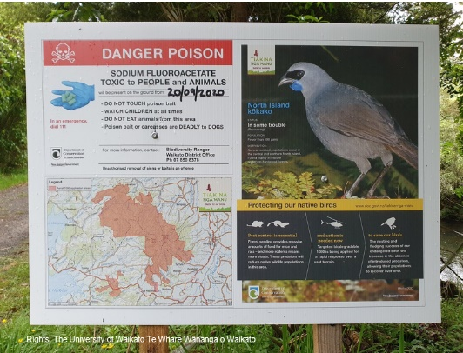This article is written by Tame Malcolm. Tame is an expert in indigenous pest management. Tame addresses claims about the use of 1080 poison to control pests as being ‘un-Māori’. He unpacks each of these claims, arguing that, to the contrary, protecting the environment is at the heart of whakaaro Māori.

Tame’s article highlights a number of ways in which mātauranga has been/is used to manage and protect te taiao.

**Expert group 5 – A mātauranga Māori-based solution for kauri dieback**

[New Zealand’s Biological Heritage National Science Challenge](https://bioheritage.nz/) worked to protect Aotearoa New Zealand’s biodiversity, improve biosecurity and enhance resilience to harmful pests, weeds and diseases.

One of its research programmes was Oranga – Wellbeing.

*“Te mauri o te rakau, te mauri o te ngahere, te mauri o te tangata: Mātauranga Māori based solutions for kauri dieback and myrtle rust.”*

**Te Reo o te** **waonui a Tāne (the language of the domain of Tāne)**

Te Reo o te waonui a Tāne (the language of the domain of Tāne) is a research project carried out under the Oranga programme.

Prayer and spiritual healing play a role in medical systems of many non-Western countries, but their relevance in environmental management has not been fully explored. In Aotearoa, the closest ‘spiritual management tool’ that has some acceptance is rāhui – stopping people from entering an area and/or using certain resources.

Dr Valance Smith led an investigation into the concept of ihirangaranga.

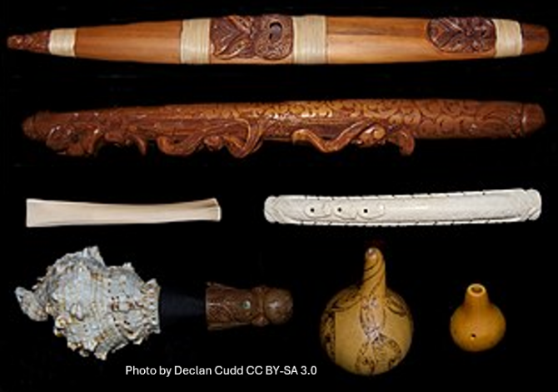Ihirangaranga (soul vibrations) is sound enhanced by taonga pūoro (pre-colonial Māori instruments) and sometimes singing of contemporary and original Māori sacred songs in the tradition of mōteatea (chants) – the vibrations and frequencies that carry te reo and the soundscape within the forest – in relation to native forests, mainly those with a high proportion of kauri trees.

As traditional waiata and karakia were written at a time when our ngahere was healthy and had its mauri intact, it is thought that the sound of these waiata carry the soul vibrations of a healthy forest. An unhealthy forest suffering from kauri dieback may have its mauri restored by hearing what a healthy forest would sound like through waiata and karakia.

The research team also recorded the soundscape of ailing kauri trees to gather and examine vital baseline data, enabling continuous monitoring and tracking of their healing progress.

These were the team’s main research questions:

* How can the soundscape of native forests inform us of the health and vitality of the forest?
* Do traditional Māori kupu (words), karakia (prayers) and waiata (songs) provide insight into forest health at the time of when they were composed?
* Do the soundscapes of the native forests and reo Māori overlap?

**Reference:**

<https://bioheritage.nz/research/oranga/>

**Expert group 6 – Tangaroa: atua of the sea**

In many cultures, it is thought that all life began in the sea where people and other lifeforms evolved from fish.

In the Māori creation story, Tangaroa is the son of Papatūānuku, the Earth mother, and Ranginui, the sky father. However, according to some versions, Tangaroa is the husband of Papatūānuku and a rival of Ranginui.

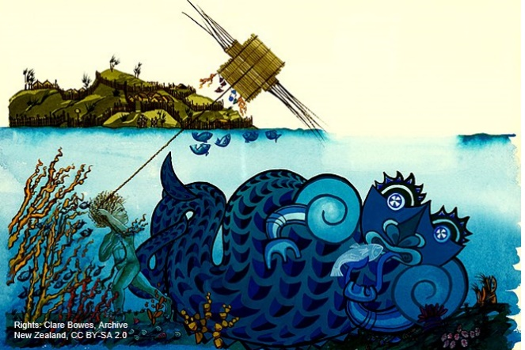Tangaroa created the animals of the sea and is responsible for the tides and water flow. He is also the kaitiaki or guardian of rivers and lakes and all life within.

Water is considered to have energy, and this energy is also called tangaroa. Depending on the amount of energy water has, it can either be life-giving and calm or destructive and powerful.

Listen to or watch a video of a song called *Tangaroa Whakamautai* by Maisey Rika. It provides a sense of the power of Tangaroa.

While listening to or watching Maisey sing, make notes of phrases or kupu that describe Tangaroa, the sea and connections to kaitiakitanga and biosecurity.

* [Tangaroa Whakamautai](https://maiseyrika.bandcamp.com/track/tangaroa-whakamautai) – audio version with lyrics in reo Māori and English
* [Tangaroa Whakamautai](https://www.youtube.com/watch?v=yblB87dpJGc) – YouTube video with English subtitles

**References**

[www.doc.govt.nz/globalassets/documents/getting-involved/students-and-teachers/marine-reserves/marine-reserves-resource-activity-5.pdf](http://www.doc.govt.nz/globalassets/documents/getting-involved/students-and-teachers/marine-reserves/marine-reserves-resource-activity-5.pdf)

<https://teara.govt.nz/en/tangaroa-the-sea>

<https://maiseyrika.bandcamp.com/track/tangaroa-whakamautai>

[www.youtube.com/watch?v=yblB87dpJGc](https://www.youtube.com/watch?v=yblB87dpJGc)