**5-Minute Volcano and the science capabilities**

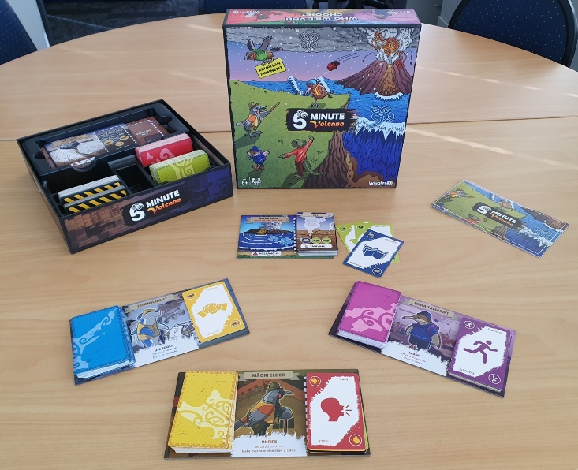

[5-Minute Volcano](https://www.sciencelearn.org.nz/resources/5-minute-volcano) is a fast-paced co-operative game that develops teamwork and communication skills and encourages discussions about volcanic eruptions and disaster preparedness.

This teaching resource uses the science capabilities to further enhance teaching and learning opportunities offered through 5-Minute Volcano.

After playing a few rounds of 5-Minute Volcano to learn its gameplay and become familiar with its imagery, use some of the following suggestions to practise the science capabilities.

**Gather and interpret data/Interpret representations**

The volcano mats and challenge cards feature Māori and western imagery. Use them to make observations and inferences and to interpret representations. The taniwha icons and the volcanoes/volcanic events they represent are explained on page 8 of the [Teacher’s Guide](https://www.datocms-assets.com/117510/1749533532-5-minute-volcano-teacher-guide.pdf).

***Observing and interpreting the volcano mats***

*Questions for discussion*

1. What taniwha/hazard(s) are associated with each volcano?
2. How does the graphic depict the type of hazard(s) associated with each volcano?
3. How would the game designer know about the hazards – for example, mātauranga Māori, pūrākau or seismic testing?
4. Each volcano requires different knowledge cards to overcome it. What inferences can you draw from this – for example, do all volcanoes require people to evacuate?

***Observing and interpreting the challenge cards***

Begin by sorting the challenge cards into groups: person, obstacle, taniwha.

*Questions for discussion*

1. How is the challenge pictured on each card?
2. What visual clues provide information about the challenge?
3. What text provides clues about the challenge?
4. Do the person cards feature challenges, helpers or a mixture of both?
5. How might the knowledge types (research, evacuate, teach, support and environment) help people meet or overcome the challenge?

**Critique evidence**

Each character has special abilities they can use to help the team:

|  |  |
| --- | --- |
| **Character** | **Knowledge type and ability** |
| Volcanologist | Research  More research |
| Seismologist | Research  Use tools |
| Māori elder | Support  Inspire |
| Mayor | Support  Encourage |
| Kura tamariki | Evacuate  Learn |
| University student | Evacuate  Develop skills |
| Emergency manager | Environment  Raise awareness |
| Conservation worker | Environment  Inform |
| Teacher | Teach  Guidance |
| Journalist | Teach  Report |

*Questions for discussion*

1. Why do you think the knowledge type and ability are assigned to each character?
2. Is there evidence to support these strengths and abilities?
3. Do you agree with the choices the game designer made?
4. What other types of knowledge and abilities might these characters have?
5. What evidence do you have to support your choices?

**Engage with science – extending the learning with local information**

The [National Emergency Management Agency](https://www.civildefence.govt.nz/) has information about [local civil defence groups](https://www.civildefence.govt.nz/find-your-civil-defence-group). Explore potential hazards in your local area and how they are managed.

Create a local map with information about community gardens and/or community fruit harvests for help when the kai runs out. Your local Enviroschools programme and Citizens Advice Bureau may be able to help with this information.

Choose a taniwha to investigate. Research what it is, how it is caused and where in Aotearoa you can find evidence of it happening in the past and/or where it might happen in the future.