**ACTIVITY: Spotting misinformation**

**Activity idea**

In this activity, students are presented with statements containing logical fallacies. Through discussion or discovery, they work through the statements, identify specific vocabulary or characteristics, and match the statement with a common logical fallacy technique.

By the end of this activity, students should be able to:

* read a statement and identify what aspect of it might be distorted or dishonest
* discuss what the person behind the statement is/may be doing to distort the facts
* identify key words or phrases that identify the statement as a fallacy
* locate information that disproves or refutes the statement
* match the statement with one or more common fallacy techniques
* use what they’ve learned to create a fallacious statement of their own for others to interpret and call out.

**For teachers**

***Introduction/background***

Logical fallacies are intentional or unintentional mistakes in reasoning that undermine the validity of an argument. They often involve flawed logic, misleading tactics or irrelevant points. They can make an argument appear convincing even though it isn’t. Being able to spot logical fallacies is essential for critical thinking – evaluating the strength of an argument and then potentially providing a clear, rational response. Knowing about logical fallacies can also help us avoid using them in our own conversations, debates and writing!

***Things to think about***

This activity explores different types of logical fallacies. The vocabulary and/or jargon used to name the fallacy is likely to require explanation. This activity provides statements that young people have likely encountered. They are generic in nature. The student handout is in Word – please edit the document to include statements that may be more pertinent to your local situation.

Observe student interactions while doing the activity. Although each statement has inaccuracies, some may reflect community and/or family thinking. Create safe spaces for discussion – [Managing classroom discussions](https://www.sciencelearn.org.nz/resources/198-managing-classroom-discussions) contains helpful suggestions.

***What to do***

There are different ways to use this activity.

*Direct instruction*

* Introduce the [Common logical fallacies](https://www.sciencelearn.org.nz/image_maps/common-logical-fallacies) interactive.
* Discuss the title – each of the three words carries important information.
* Discuss the titles on the buttons – they contain vocabulary and jargon that may be unfamiliar to some learners.
* Click on each button and use the image as the context for learning about the specific type of fallacy. Types of logical fallacies provides a summary.
* Provide students with copies of the student handout to work through.

*Student discovery*

* Introduce one of the statements and use think/pair/share to discuss what the statement is trying to say, how it sets out the argument, whether it is trying to manipulate the reader into thinking a certain way and if anyone has information that refutes the statement.
* Introduce another statement, using the same questions to interrogate the text.
* Discuss similarities and differences in how the arguments are presented.
* Continue with the statements, scaffolding responses to build understanding.
* Provide students with copies of the student handout to work through.

***Extension idea***

Assign one of the common fallacies to a small group or ask the group to choose a fallacy of interest. The group is responsible for coming up with their own definition or explanation of the fallacy. Students source a few memes that exemplify the fallacy in action or call out the fallacy. Use student work to create a wall display.

**For students**

Following are statements that may contain misleading information. Read each statement and decide if it contains misinformation or disinformation or is trying to manipulate you to think a certain way.

***Statements***

1. NCEA rates would soar if students/schools did not have such high truancy rates.
2. Cycle lanes are a waste of money because I never see anyone using them.
3. Sea-level rise is fake news – Antarctic sea ice actually increased for 5 years.
4. It’s OK to mine Aotearoa New Zealand’s stewardship land because it’s not conservation land – like national parks or scenic reserves.
5. Electric cars cause more pollution than petrol or diesel cars due to the rare earth mining needed for their batteries.
6. Removing pies and fizzy drinks from the school canteen will mean a drop in income for the school and less money for the sports teams.
7. Librarians fill school libraries with controversial books to support their personal agendas.
8. I’d have passed the test if my teacher knew the subject better and knew how to teach it.

***Questions for consideration***

If you think the statement is using a logical fallacy – an intentional or unintentional mistake meant to mislead the reader, consider these questions:

* What is misrepresented?
* How would I fact check the information?
* What was said to create the misrepresentation?
* Has information been left out?
* Does the statement use outdated information?
* Are there words in the statement that seem like red flags?
* Does an online search show different information or inaccuracies in the statement?
* If the statement is unintentional – a mistake because the person making it either didn’t think it through or doesn’t have all of the information required – how might you rewrite the statement to make it accurate?
* If the statement is an intentional mistake to pass along misinformation or disinformation, what might be the intention or purpose behind this?
* Who might benefit from misinformation or disinformation and why?
* What happens if you or someone you know agrees with the statement? Does everyone need to have the same opinion?

***Types of logical fallacies***

Humans have been using logical fallacies for centuries. Aristotle wrote about them – as did Hindu philosophers before him!

Following are some of the common logical fallacies, which are explained more fully in this [interactive](https://www.sciencelearn.org.nz/image_maps/common-logical-fallacies). The interactive also has ideas on how to spot the particular fallacy.

Once you’ve become familiar with the types of fallacies, see if you can match them up with the statements. Some of the statements may be underpinned by multiple fallacies.

[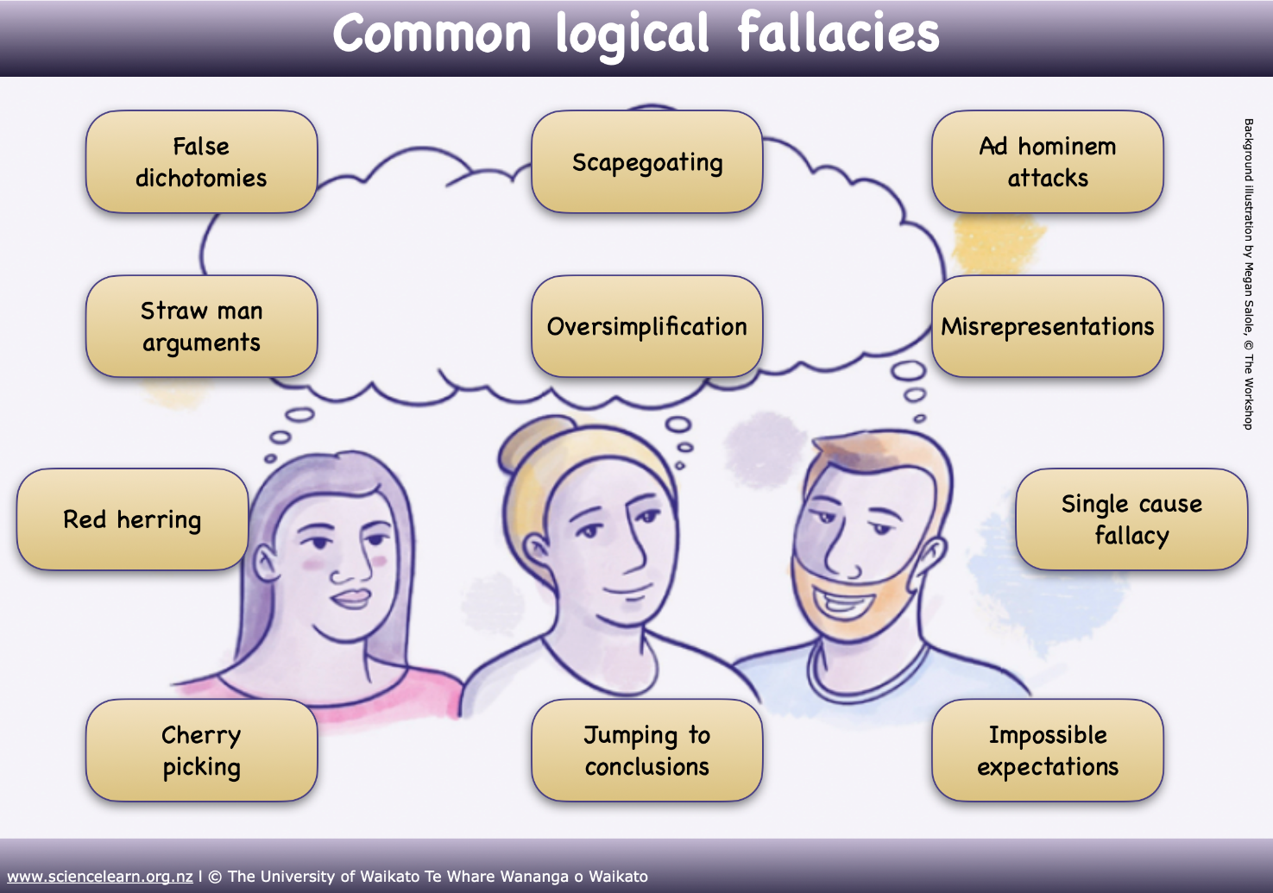](https://www.sciencelearn.org.nz/image_maps/common-logical-fallacies)

**False dichotomies**

These are also known as the either/or fallacy. It is when a limited number of choices are presented as mutually exclusive when, in reality, more options are available. This type of argument often reduces complex issues to a binary decision.

**Scapegoating**

This is when an individual or group is selected to take the blame for a problem.

**Ad hominem attacks**

This is when the person, group, organisation or business making an argument is attacked rather than their argument. An ad hominem attack can use past history, bring up associations with others (a ‘guilty by association’ type of argument) or it could attack the personality or personal attributes of an individual.

**Straw man arguments**

This is when the argument being refuted is not actually the argument or issue that is being discussed.

**Oversimplification**

This is when issues or arguments are made to appear simpler by ignoring any complexities involved. Sometimes oversimplification occurs because people making arguments are simply not aware of the related complexities.

**Misrepresentations**

This is when someone twists, alters or presents a false or misleading version of another’s argument, position or evidence to distort understanding of the issue.

**Red herring**

A red herring is an argument that aims to divert attention by bringing in irrelevant or unrelated arguments.

**Single cause fallacy**

The single cause fallacy is when one thing is blamed for an issue that has many contributing factors.

**Cherry picking**

Cherry picking is the selective reporting of research or data.

**Jumping to conclusions**

This means forming a general conclusion without considering all of the variables involved.

**Impossible expectations**

This occurs when someone dismisses an argument, claim or solution by setting unrealistic or unattainable standards of proof or perfection. It undermines valid ideas by demanding evidence or results that cannot reasonably be achieved, even when there is sufficient evidence or practical merit.