**ACTIVITY: Manipulation tactics – create an inoculation campaign**

**Activity idea**

In this activity, students watch videos and use a template to analyse the inoculation messages they explain. Students then use the template to plan and create their own inoculation campaigns.

By the end of this activity, students should be able to:

* watch the videos to gain information about common manipulation techniques
* discuss and clarify the meaning of vocabulary, jargon or phrases used in the videos
* discuss how the videos use the fictional characters to get their messages across to the viewers
* discuss examples of the techniques they have countered in online content
* use a template to analyse the videos and record their ideas
* use the same template to plan an inoculation campaign of their own using a context of their choice.

**For teachers**

***Introduction/background***

Fake news – disinformation and sensationally misleading headlines – has been around for a long time. This [drawing from 1894](https://www.loc.gov/resource/ppmsca.29087/) shows a newspaper editor sitting next to cascading profits and surrounded by reporters rushing in with stories and manipulated headlines designed to attract readers’ attention and elicit emotional responses. The [cropped image](https://commons.wikimedia.org/wiki/File:The_fin_de_si%C3%A8cle_newspaper_proprietor_(cropped).jpg) displays the phrases ‘humbug news’, ‘fake news’ and ‘cheap sensation’.

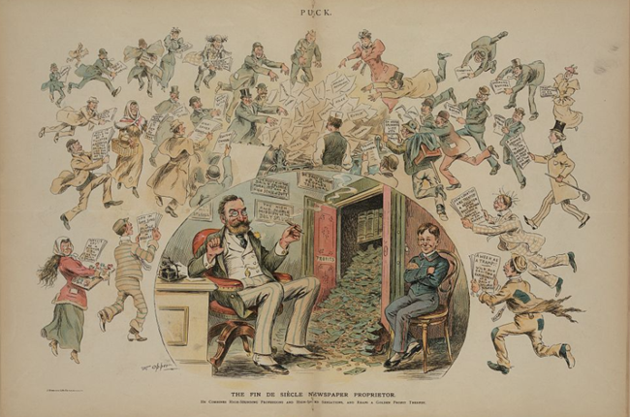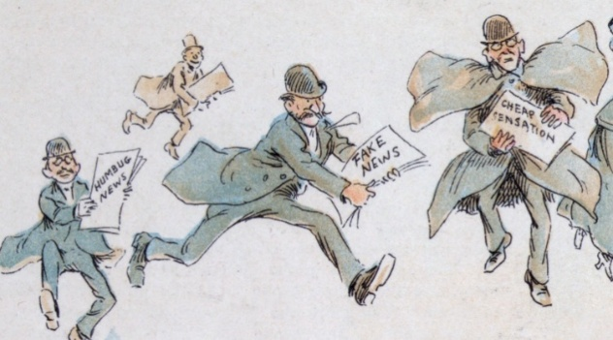

Fast forward a century, and we can add social media and artificial intelligence to conventional forms of media. They’ve amplified the spread of misinformation and the use of sensational headlines, topics and manipulation techniques to gain and keep our attention.

Inoculation theory and prebunking – a form of inoculation theory – is a way to help students (and everyone) become resistant to techniques designed to manipulate how we think. When we know what to look for, we can become more critical consumers of online and offline content.

***Things to think about***

There’s a lot of jargon associated with calling out misinformation and it may require explanation. The article [Countering false information – key terms](https://www.sciencelearn.org.nz/resources/countering-false-information-key-terms) highlights some of the words and phrases students are likely to encounter.

The activity [Spotting misinformation](https://www.sciencelearn.org.nz/resources/spotting-misinformation) introduces students to logical fallacies. The interactive [Common logical fallacies](https://www.sciencelearn.org.nz/image_maps/common-logical-fallacies) provides additional information on the techniques and how to watch out for them.

Some of the videos use clips from *The Simpsons*, *Family Guy* and *South Park* to illustrate a misinformation technique or logical fallacy. The clips are humorous and harmless, but it’s recommended that you watch the videos prior to using them in the classroom.

***What to do***

1. Introduce the activity with the [cropped image](https://commons.wikimedia.org/wiki/File:The_fin_de_si%C3%A8cle_newspaper_proprietor_(cropped).jpg) and discuss the text and the images. Follow this with the [full image from 1894](https://www.loc.gov/resource/ppmsca.29087/). Choose a few aspects for discussion – for example, the money (profits) cascading from the cupboard or the motto ‘Morality and a High Sense of Duty’.
2. Discuss the concept of inoculation theory and its analogy to medical inoculation/vaccination – immunising ourselves to build resilience against misinformation.
3. Watch the video [Manipulation Technique #1: Emotional Language](https://inoculation.science/inoculation-videos/emotional-language/).
4. Watch the video a second time and pause to discuss words or phrases or points of interest.
5. If appropriate, discuss real-life examples of emotional language manipulation that students have encountered.
6. Use the template to analyse the inoculation message (a completed example is provided here).
7. Continue to work through the videos as a class or in small groups.
8. Invite students to plan an inoculation campaign. They can create a generic campaign using the Inoculation Science videos as examples. Alternatively, students can choose a topic of interest to them or to a local issue, for example:

* vaping – safety, age restrictions, flavours or advertising techniques
* buy now, pay later systems – advertising techniques, ethics or usefulness
* websites that promote fast fashion or overconsumption – advertising techniques, ethics, peer pressure, sustainability
* video games – violence or aggression, obesity/lack of exercise, antisocial behaviours.

1. Use the planning template to create an inoculation campaign. Students can use it to bullet point ideas or create a transcript for a video.

**For students**

***Template for analysing an inoculation message***

Use this template analyse the manipulation techniques videos from [Inoculation Science](https://inoculation.science/):

* [Manipulation Technique #1: Emotional Language](https://inoculation.science/inoculation-videos/emotional-language/)
* [Manipulation Technique #2: Incoherence](https://inoculation.science/inoculation-videos/incoherence/)
* [Manipulation Technique #3: False Dichotomy](https://inoculation.science/inoculation-videos/false-dichotomy/)
* [Manipulation Technique #4: Scapegoating](https://inoculation.science/inoculation-videos/scapegoating/)
* [Manipulation Technique #5: Ad hominem Attacks](https://inoculation.science/inoculation-videos/ad-hominem-attack/)

Consider and record how the video was designed to do the following.

|  |
| --- |
| **Warn**  **Warn people that they are likely to be exposed to false information about the issue.** |
| **Describe tactics**  **Describe the strategies and tactics that people who create and spread false information engage in.** |
| **Name motivations**  **Name the motivations of people involved in creating false information.** |
| **Finish with the facts**  **End by giving people accurate information about the topic.** |

***Example analysis of an inoculation message***

An example analysis for [Manipulation Technique #1: Emotional Language](https://inoculation.science/inoculation-videos/emotional-language/)

|  |
| --- |
| **Warn**  **Warn people that they are likely to be exposed to false information about the issue.**  Playing into emotions – especially negative ones such as fear, anger or contempt – is a trick to get you to pay attention to something when perhaps you wouldn’t overwise do so. |
| **Describe tactics**  **Describe the strategies and tactics that people who create and spread false information engage in.**  Use of emotional language in the first sentence. Using emotionally charged words in headlines – i.e. disgusting instead of disagreeable. |
| **Name motivations**  **Name the motivations of people involved in creating false information.**  The content creators want to get people’s attention to watch a video, read an article or interact with content. |
| **Finish with the facts**  **End by giving people accurate information about the topic.**  If the content uses fear mongering or other highly emotional language, they might be trying to manipulate you! |

***Create an inoculation campaign – planning template***

Use this planning template to create an inoculation campaign. You can bullet point your ideas or create a transcript for a video on a topic of your choice.

**Our topic:**

|  |
| --- |
| **Warn**  **Warn people that they are likely to be exposed to false information about the issue.** |
| **Describe tactics**  **Describe the strategies and tactics that people who create and spread false information engage in.** |
| **Name motivations**  **Name the motivations of people involved in creating false information.** |
| **Finish with the facts**  **End by giving people accurate information about the topic.** |