ACTIVITY: Spider parachutes

Activity idea
In this activity, students make a parachuting spider to explore the concept of ballooning and animal dispersal.

By the end of this activity, students should be able to:
- describe the process of spider ballooning
- use scientific terms relating to spider ballooning
- discuss why spiders disperse
- discuss the differences between animal dispersal and animal migration
- use skills of scientific observation and research to figure out how to make their spider parachute further.

For teachers

Introduction/background

Tiny baby spiders – called spiderlings – create triangular shaped parachutes from fine threads of silk. The parachutes catch the breeze, and using air currents and the Earth’s electrostatic field, the spiderlings are lifted into the air and carried away. They use ballooning to disperse – to move away from where they were born. This form of dispersal is called passive dispersal because spiderlings don’t have much control over where they go. The spiderlings disperse to avoid competing with their hundreds of siblings for food and a place to live. Dispersal differs from migration. Dispersal is like a one-way ticket to a new location whereas migration is the regular, seasonal movement from one habitat to another and back again.

This activity provides opportunities for students to consider how and why spiderlings balloon and the role of models in science.

The teacher notes include questions to deepen student understanding and content vocabulary. They have been organised to reflect the phases within the New Zealand Curriculum.

Key science concepts for this activity

These science concepts underpin the activity:
- Animal dispersal – the movement of an organism from its birth location to a different location. Read the article Animal dispersal for more information.
- Spiderling ballooning – the passive dispersal method used by some species of spiders. Read the article Spiderling ballooning for more information.
- Earth’s electrostatic field – the Earth’s atmosphere holds a positive electric charge, while the Earth’s surface holds a negative electric charge. This creates an electric field and allows the small spiderlings to defy gravity. The YouTube videos How spiders use electricity to fly (National Geographic) and Flying spiders! (BBC Earth) explain how electrostatic fields help spiders fly. The article Static electricity and electrical charge has simple, effective images that illustrate electrostatic forces.
- Models in science – a model is a representation of an idea, an object or a process that describes and explains phenomena that cannot be experienced directly. Read the article Scientific modelling for more information.

Key content vocabulary for this activity

These are some of the scientific terms related to spider ballooning:
- Active dispersal – when an organism moves from its birth location to a different location using its own power and choosing the direction – usually by swimming, walking or flying.
- Ballooning – a dispersal method used by spiderlings that involves creating a silk parachute.
- Dispersal – when an organism moves to a new place.
- Electrostatic field – when objects have different electrical charges, an electrostatic field exists between them.
- Spinnerets – an organ spiders use to spin webs.
- Migration – the regular, seasonal movement of an animal population from one habitat to another and back again.
- Passive dispersal – when an organism relies on an external, non-living force to disperse/move to a new location – for example, being carried away by the wind.
- Scientific model – a representation of an idea, an object or a process.
- Spiderling – young spiders that emerge from an egg sac. They look similar in shape to the adult spider but are much smaller.
- Trichobothria – fine hairs on spiderlings’ legs that sense air flow and electrical conditions in the environment.

What you need

- Balloon for demonstrating static electricity/electrostatic field
- Paper muffin/cupcake cases
- Fine yarn, string or dental floss
- Small plastic spiders or pipe cleaners to make small spiders
- Tape, stapler or hole punch
- Ruler
- Scissors
- Blu-Tack

What to do

- Observe the images Spiderling silk in the morning fog and Pasture covered in ballooning threads. Discuss what students notice.

- Discuss the concept of animal dispersal.

- Discuss the concepts of active and passive dispersal.

- Discuss and, if appropriate, act out actions that fit into active and passive dispersal categories – for example, flying, swimming, walking, slithering, floating, hitch-hiking or rolling.

- Discuss the difference between animal dispersal and animal migration.

- Bring the discussion back to the images the students observed earlier. Ask the students to make inferences – what they think is happening – in the images.

- Watch one or both YouTube videos How spiders use electricity to fly (National Geographic) and Flying spiders! (BBC Earth).

- Demonstrate an electrostatic field by asking a volunteer to rub a balloon on their hair.
- Observe how the hair stands on end and moves as the balloon moves.
- Discuss how the electrostatic field created by the balloon models the Earth’s electrostatic field, which helps spiderlings to ‘fly’.
- Note: The Flying spiders! video begins with an effective visualisation of this demonstration.

- Observe the image Spiderlings preparing to balloon. Discuss the behaviour and the role of trichobothria, if appropriate.

- Watch the video(s) a second time, taking note of key content vocabulary and pausing the video to discuss the terms.

- Use the student worksheet Making spiderling parachutes to construct the model. It is a Word document – edit the document to add questions from the Questions to deepen student understanding section, if desired.

- Test the spiderling parachute models to see how they fly. Use observation, questioning and research to make the parachutes more effective for dispersal.

- Use the student worksheet Using models in science to take a closer look at models in science and to practise using content vocabulary. It is a Word document – edit the document to suit student abilities.

Extension ideas

- Think about human dispersal. It is likely that some students have moved from their town/country of birth to where they live now. This is an example of dispersal. Contrast their family’s move to a new country to the concept of animal migration, which is the seasonal movement of animals from one place to another followed by a return. Ask your students whether their family has ‘dispersed’ from where they were born and discuss the reasons why families disperse.

- Ask students to think about their favourite animal. What stages of its life cycle might it disperse and where does it go? Is it active or passive during dispersal?

- Invite and/or discuss how students might study the dispersal behaviour of a chosen animal. What kinds of variables might they be able to measure and how might they do this?

Questions to deepen student understanding

These questions are ordered by complexity. Choose those most suited to your learners’ needs.

Animal dispersal
- What is animal dispersal?
- Why do animals move away from where they were born?
- What are the potential benefits of moving away from their birth location?
- What are the potential risks of moving away from their birth location?
- What is active dispersal?
- What are some animals that use active dispersal?
- What movements can you use to imitate how these animals move?
- What adaptations does the animal have that aid active dispersal?
- What is passive dispersal?
- What are some animals that use passive dispersal?
- How can you imitate how these animals move?
- Why do you think the animal uses passive dispersal instead of active dispersal?
- What is the difference between dispersal and migration?
- Why might some animals use dispersal instead of migration?
- What are the benefits and risks?
- How might you study animal dispersal? What kinds of variables could you measure and how?

Spiderlings – adaptations and behaviours for ballooning
- Why do scientists refer to baby spiders as spiderlings?
- Do you think the spiderlings are big or small? Are they fully grown?
- What do you know about the spider’s body – for example, how many legs does it have and where are they attached?
- What is a spinneret?
- How does a spiderling use this part of its body to aid the ballooning process?
- Why does a spiderling climb to a high point like the tip of a plant or a fence post to balloon?
- What are trichobothria?
- How does a spiderling use this part of its body to aid the ballooning process?
- Why does a spiderling raise its legs into the air as part of the ballooning process?
- How does the spiderling know to do these things?

Ballooning
- How does ballooning help spiderlings disperse?
- Why might people call this flying?
- Is it flying or is it something else?
- What two natural occurrences do spiderlings use to launch themselves into the air?
- What physical actions do spiderlings take to help them disperse? (For example, using their spinneret and trichobothria.)

Models in science
- How is the plastic/craft spider similar or different to a real spiderling?
- Will shorter or longer strings impact the parachute and how it moves?
- How can you find out how long actual spiderling-made silk threads might be?
- Why did we rub a balloon on someone’s hair?
- How is the electrostatic demonstration similar or different to the Earth’s electrostatic field?
- How do these models represent/explain a concept or process?
- Why do we need to use these models rather than observing the ballooning process ourselves?

Student activity: Making spiderling parachutes

What you need

- Paper cupcake case
- Fine yarn, string or dental floss
- Small plastic spider or pipe cleaners to make a spider
- A way to attach the string – for example, tape or stapler or hole punch
- Ruler
- Scissors
- Blu-Tack

What to do

- Choose a plastic spider or make one with the pipe cleaners. If you make a spider, think about its body shape and now many pairs of legs it will need.

- Use a ruler to measure three pieces of string so they are 20–30 cm in length (or choose your own length).

- Cut the string.

- Attach the string evenly around the edge of the cupcake case.
- If you use tape or staples, use extra to reinforce the string.
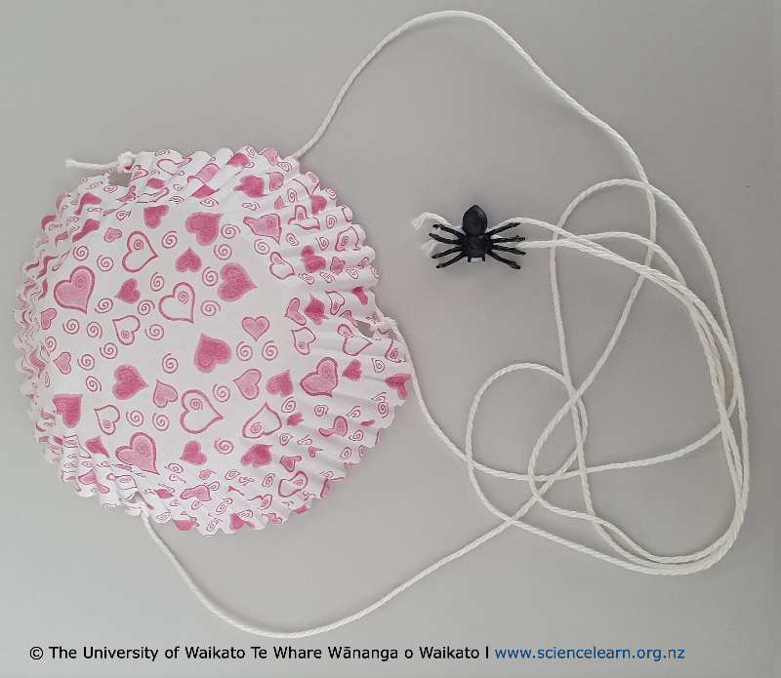
- If you use a hole punch, tie the strings in the holes. Reinforce the holes with tape.

- Tie the ends of the three pieces of string together.

- Attach the spider to the string. Use Blu-Tack if the spider is very small.

- Test the spider parachute to see how it moves.
- Toss it in the air.
- Drop it from a height – for example, standing on a chair.
- Take it outside in the breeze.

- Discuss how the parachute models the ballooning process.

Student activity: Using models in science

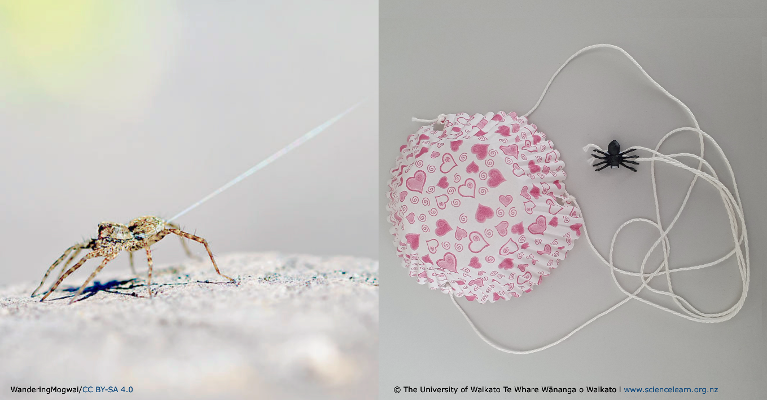

Use the images to write or draw your answers to the following questions.

Observe the image on the left. What do you notice?

Observe the image on the right. What do you notice?

What are some similarities?

What are some differences?

Why did you make a model? What is its purpose?

Scientific terms
ballooning dispersal parachute silk spinnerets spiderling trichobothria

