Limewater activity
Turning limewater (Calcium Hydroxide) milky is the classic test for CO₂. The Carbon (C) comes from the food we eat. The Oxygen (O₂) comes from the air we breathe and water (H₂O) we drink.
Materials needed:
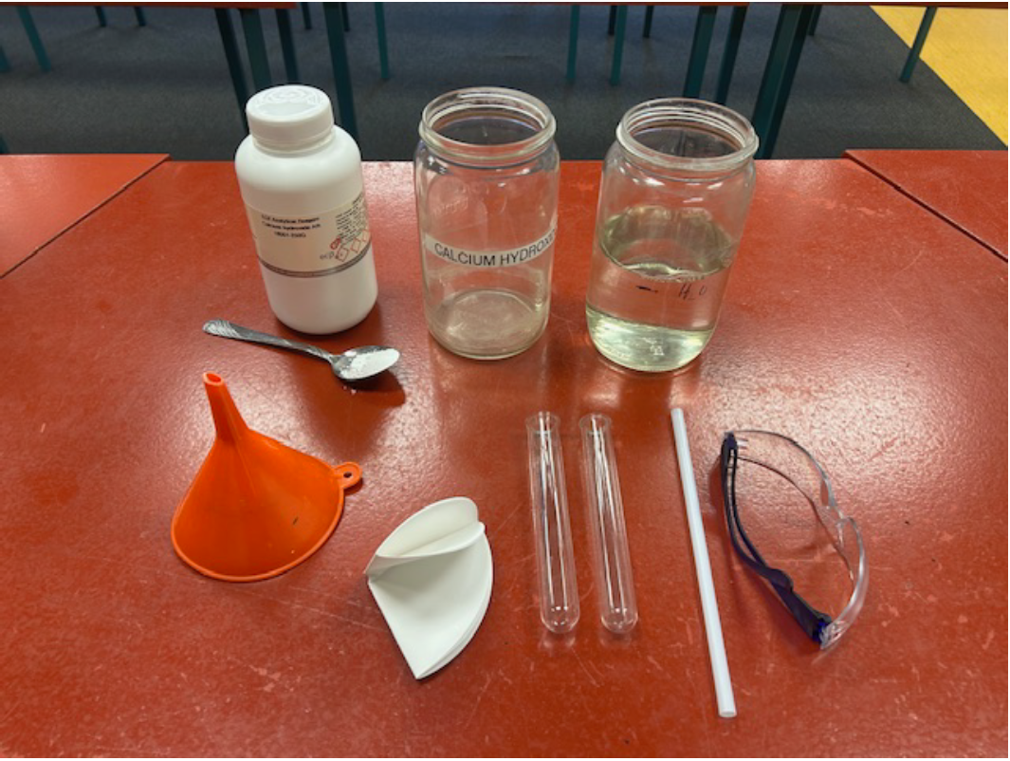
- Calcium Hydroxide – about 1/2 tablespoon. Can be purchased from Delta Educational https://deltaed.co.nz/collections/chemicals?page=2
- Water – about 1/2 AGEE jar
- 2 AGEE jars
- 2 test tubes (medium/large) or small jars
- Straw
- Safety glasses
- Filter paper
- Funnel

Method:
**Wear safety glasses**. The limewater will hurt the eyes.
- Add 1/2 tablespoon of Calcium Hydroxide to a half‑filled AGEE jar of water and stir well.
- Leave the mix to settle for about half an hour.
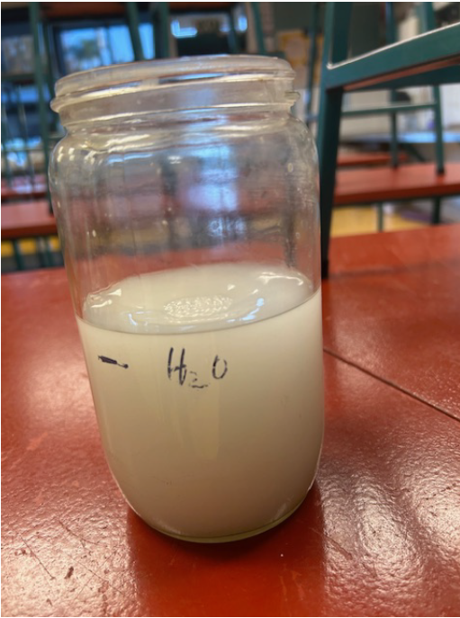 |  | 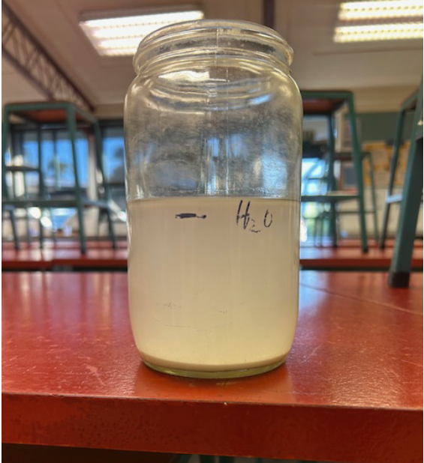
- Decant the liquid slowly through a filter/funnel into the other AGEE jar. This is the limewater ready to be used. This will last for the day but must be made fresh each day; it cannot be stored.
- Pour the limewater into 2 test tubes no more than 1/4 full.  One of the test tubes is the control/comparison. The liquid is clear. | 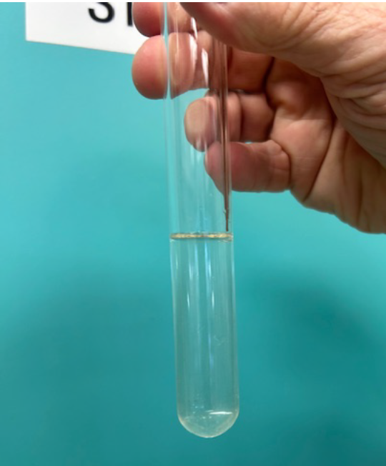
- Place the straw in the other test tube. Cup your finger and thumb around the straw at the top of the test tube so that the entrance is blocked. This prevents any limewater splashing into the eyes (see webinar recording for another option). | 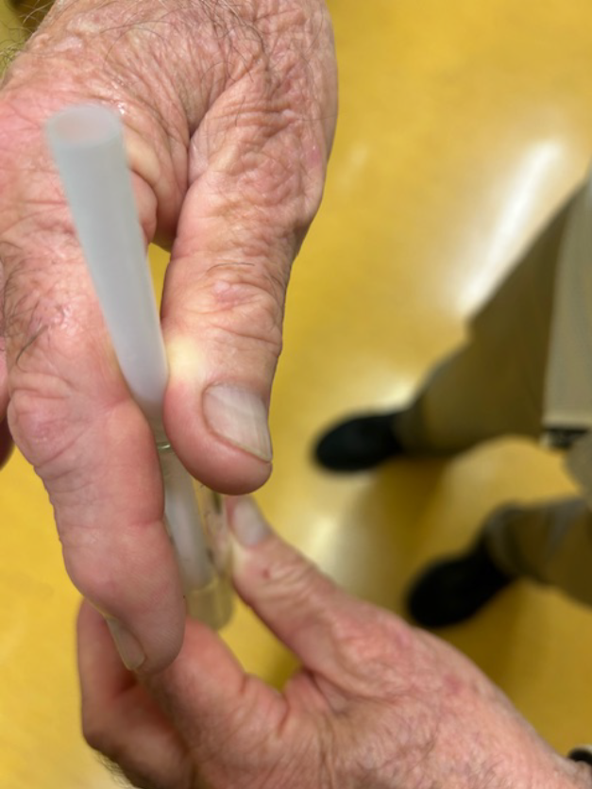
- Blow GENTLE bubbles into the liquid until the liquid is murky/white. | 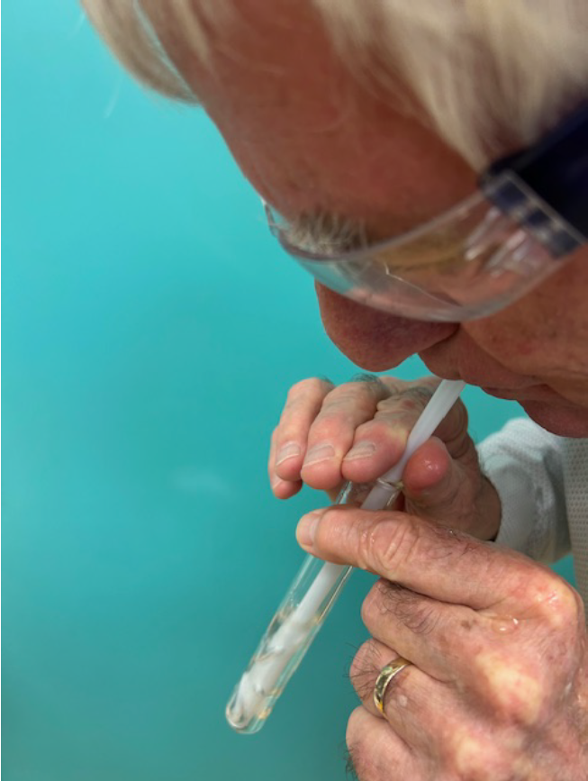
- Compare this test tube with the control. | 