ACTIVITY: Labelling the freshwater kōura

Activity idea

In this activity, ākonga use online and/or paper resources to identify and label some of the physical structures of the freshwater kōura.

The activity helps ākonga build their scientific literacy with the reading and interpretation of diagrams.

By the end of this activity, ākonga should be able to:
- identify and label some of the key physical structures of freshwater kōura
- consider the functions of these structures
- discuss how these functions help kōura survive
- use literacy skills to learn about kōura anatomy and associated terminology.

For teachers

Introduction/background

Freshwater kōura are taonga species for Māori and an indicator species for ecosystem health. There are two species of kōura in Aotearoa New Zealand: northern kōura (Paranephrops planifrons) and southern kōura (P. zealandicus). Their anatomies are similar with small differences – the northern kōura species are smaller and their chelae (pincer-like claws) are not as hairy. Both species are endemic and have adaptations that enable them to feed and stay safe within dynamic freshwater environments.

The activity helps ākonga build their scientific literacy with the reading and interpretation of diagrams.

Questions to deepen student thinking

Questions regarding kōura and their physical characteristics:
- Kōura are freshwater creatures. Looking at the diagram, how do you think they navigate underwater?
- What structures might kōura use to sense their environment?
- What structures might kōura use for defending themselves from predators?
- What structures might kōura use as predators or scavengers?

Questions regarding interpreting diagrams:
- This diagram uses a simplified drawing instead of an image.
  - What are the benefits of using a drawing?
  - What are the drawbacks of using a drawing?
  - What structural information is overlooked in this simplified drawing?
  - What could you add to the drawing to help with this?
- This diagram does not indicate the size or length of a kōura.
  - Why might this information be important?
  - What could you add to the diagram to indicate the size of its body?

What to do

- Use the article Freshwater kōura for background information on kōura, their habitats, roles within the ecosystem and adaptations for life in dynamic freshwater environments.

- Discuss what life is like as part of the freshwater food web – as scavengers and hunters living among terrestrial and aquatic predators.

- Discuss the role of adaptations and how they enable kōura to function within freshwater ecosystems.

- Complete the interactive Label the freshwater kōura or use the paper-based version in the student handout.

Extension ideas

Freshwater kōura are an important source of mahinga kai. Explore food and resource-gathering traditions practised by Ngāi Tahu whānau in Te Waipounamu in the interactive Mahinga kai – natural resources that sustain life.

Create your own 3D kōura using papercraft.

If you want to observe live kōura, the activity Building a tau kōura has instructions for making whakaweku (bundles of bracken fern) that are lowered into waterways. Kōura hide in them and can be collected for observation.

Label the freshwater kōura – answers

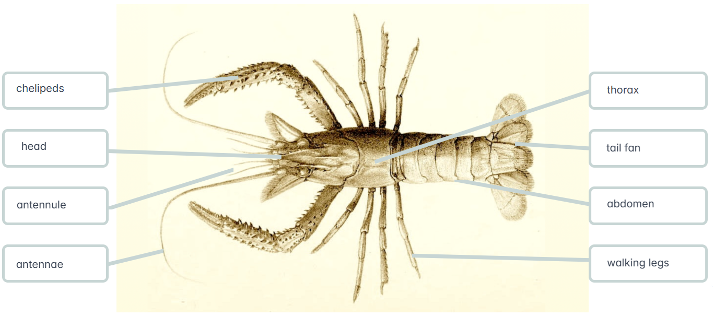

For students

Label the freshwater kōura

Use the labels to identify parts of the freshwater kōura.

Label | Description | Label | Description
abdomen | Lower part of the exoskeleton | chelipeds | First pair of legs and claws – used for protection and food gathering
antennae | Sensory organs for orientation and co-ordination | head | The fore (top) section of the body
antennule | Sensory organs for chemical information – food, gender | tail fan | Used for steering, stability and backwards propulsion
thorax | The midsection – connects to walking legs | walking legs | Four pairs – used for movement

