ACTIVITY: Freshwater animal species – views and values

Activity idea

In this activity, ākonga discuss statements regarding their personal views about native and introduced freshwater animal species.

By the end of the activity, ākonga should be able to:
- use a graphic organiser to sort statements according to personal values and views
- select and use scientific information and mātauranga Māori to develop and justify their views
- reflect on their experiences or personal values and how this might influence their perceptions
- consider multiple perspectives and respect the views and values of other people
- consider how information and discussion have potentially influenced or shifted their thinking.

For teachers

Introduction/background

Many of Aotearoa New Zealand’s native freshwater animal species are in trouble. Some are threatened with the risk of extinction, while others are at risk from habitat loss or degradation.

We lose more than just biodiversity when native populations shrink – cultural practices and connections are also impacted. Our people, places and freshwater species are intertwined. One factor crucial to improving the future of native freshwater animal populations is understanding how people value and relate to them.

This activity is designed to initiate discussions about how freshwater species are valued, whose knowledge should be used to guide decisions and how we might be able to help.

Prior to conducting this activity, teachers may find it useful to read the article Managing classroom discussions. It provides helpful tips for creating a positive climate for discussion.

Teaching suggestions

The student handout has three images for observation and discussion:
- Papangoko/torrentfish (Cheimarrichthys fosteri) – the only species in the family Cheimarrichthyidae in the world.
- Freshwater kōura (Paranephrops planifrons) – mahinga kai, food source. Mahinga kai connects people with place, tangata with whenua – sustaining local mātauranga and cultural practices.
- Rainbow trout (Oncorhynchus mykiss) – introduced to Aotearoa in the 1880s. While trout have had significant and ongoing impacts upon native freshwater ecosystems, their value as sport fish can positively influence freshwater conservation efforts.

Use the images to begin a conversation about students’ relationships or perspectives with freshwater animals.

Complete the graphic organiser – online or in the student handout. Use the resource links to gain further information and revisit the graphic organiser to consider how discussion and information have changed any views.

For ākonga

Papangoko/torrentfish | Freshwater kōura | Rainbow trout
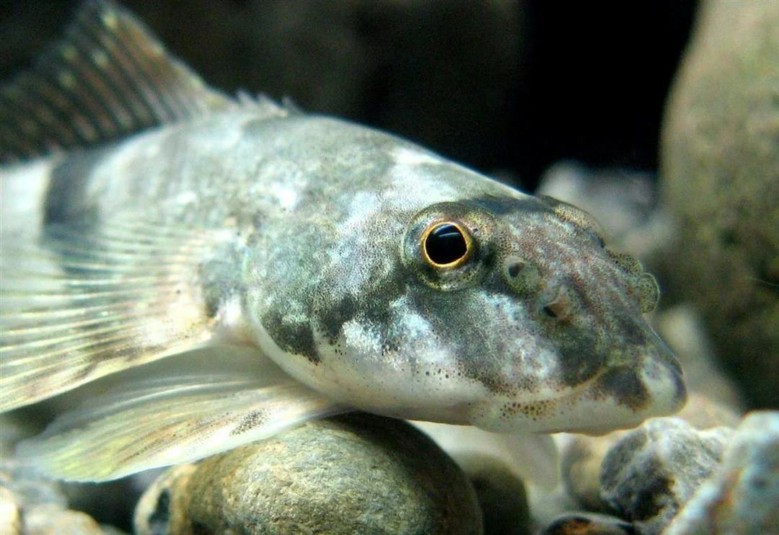 | 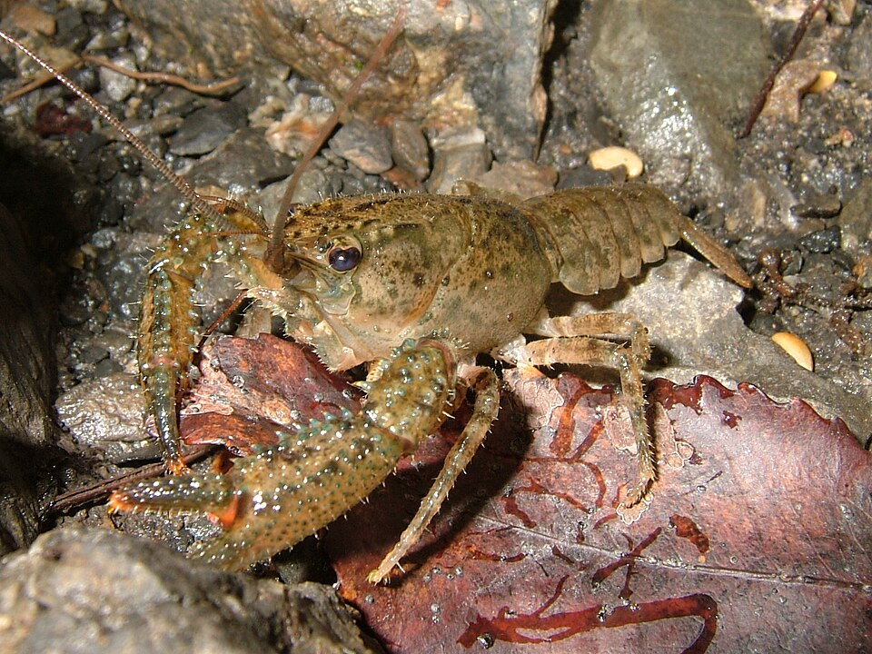 | 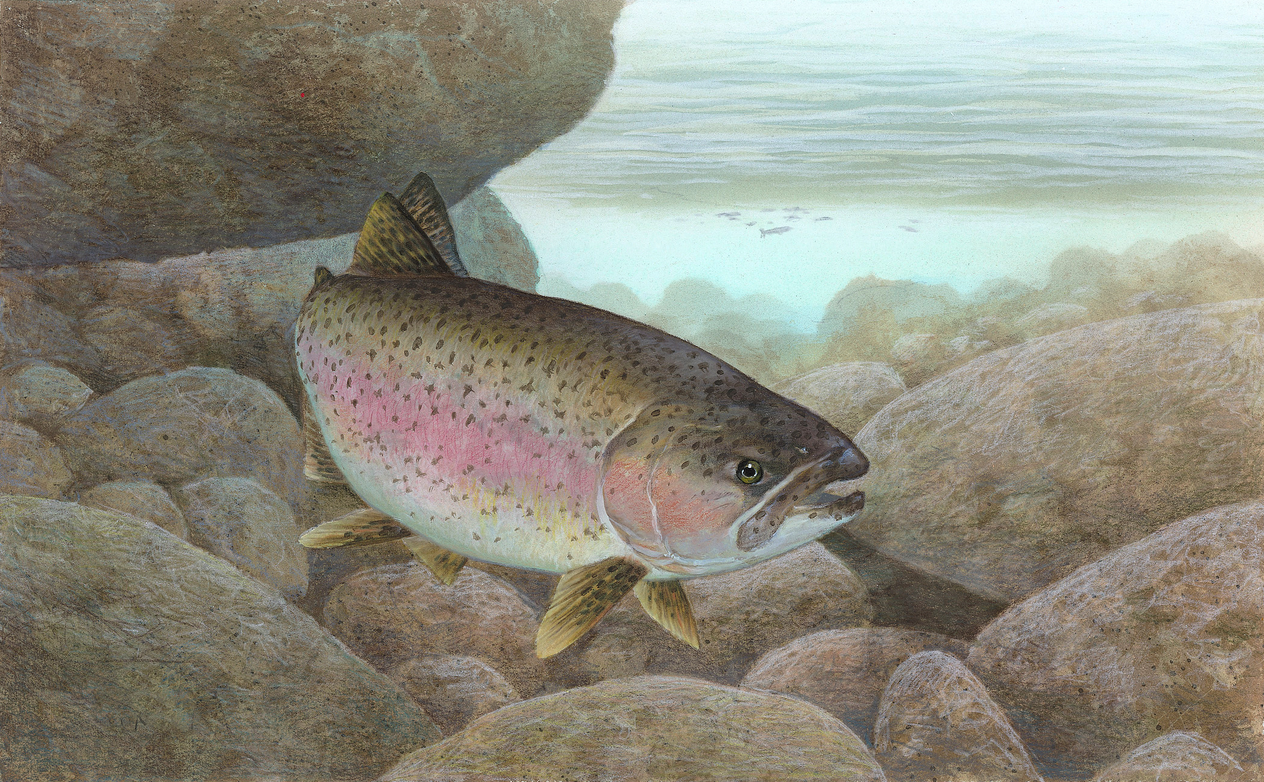
Endemic to Aotearoa, it is the only species in the family Cheimarrichthyidae in the world.  © Stella McQueen CC BY 4.0 | Kōura are mahinga kai – connecting people with place and sharing kōrero and local mātauranga. | Introduced to Aotearoa, it’s had ongoing impacts on native ecosystems but is valued as a sport fish.

Aotearoa New Zealand’s native freshwater animal species are not often seen, and many species are in trouble. An important factor in improving the future of their populations is understanding how people value and relate to them.

Resource links

- Fish Futures – flourishing futures for Aotearoa New Zealand’s freshwater fish
- Native freshwater fish restoration Freshwater fish of New Zealand
- Ngā ika taketake wai māori o Aotearoa
- Freshwater kōura
- Morihana – a taonga species
- Gold clam invasion in New Zealand
- Do our biases affect what we protect?

Freshwater animal species – views and values

Cut out the statements and place them on the graphic organiser according to your values and views. There are no right or wrong answers.

All creatures have mana and are of value | It’s up to experts like the Department of Conservation to look after species | Introduced species, like sport fish, add value to lakes and rivers | We value and protect species like kiwi and kea because they are cuter than fish
Koi carp and gold clams are so widespread it’s not worth the effort to control them | Fishing connects people to place and shared practices, passing on knowledge | Native freshwater species have more value than introduced species | Fish, kōura and other kai species are for us to catch whenever we wish
Trout and Chinook salmon are introduced species that disrupt natural ecosystems | Iwi and local groups need to be included in freshwater resource decisions | Morihana (introduced wild goldfish) is a designated taonga species and should be protected | We should focus on ‘fixing’ ecosystems rather than individual species

