ACTIVITY: Labelling the human respiratory system

Activity idea

In this activity, ākonga use online and/or paper resources to identify and label parts of the human respiratory system.

By the end of this activity, students should be able to:
- identify and label some of the main structures in the respiratory system
- understand the function of the main structures in the respiratory system
- use literacy skills to learn about and discuss the functions of the structures
- consider how the respiratory system works with other body systems to maintain a stable internal body environment.

For teachers

Introduction/background

The respiratory system moves air into and out of the body – supplying us with the oxygen we need to live. Our bodies are made up of countless cells all requiring oxygen to carry out the important process of respiration. In this process, cells use oxygen gas and produce carbon dioxide gas – a waste product that must be removed from the body. The process of breathing allows these gases to be exchanged between the blood and lungs.

The respiratory system works in conjunction with other body systems. Two that are specific to this activity are the cardiovascular system and the musculoskeletal system.

This activity can be used as a formative or summative tool for learning.

What to do

- Watch the ABC Education video Respiratory system.

- Play the video a second time, but instead of watching it, use it as a voiceover to accompany the written transcript below the video.

- Circle or highlight key content vocabulary in the transcript for further discussion.

- Use the respiratory system diagram from Quizlet. It is not labelled. Challenge students to use content vocabulary to identify some of the structures. Discuss the purpose of the structures.

- Complete the interactive Label the human respiratory system or use the paper-based version in the student handout.

Extension idea

Use the article Body systems and the image The body’s systems to explore how the respiratory system works in conjunction with other systems.

Label the human respiratory system – answers

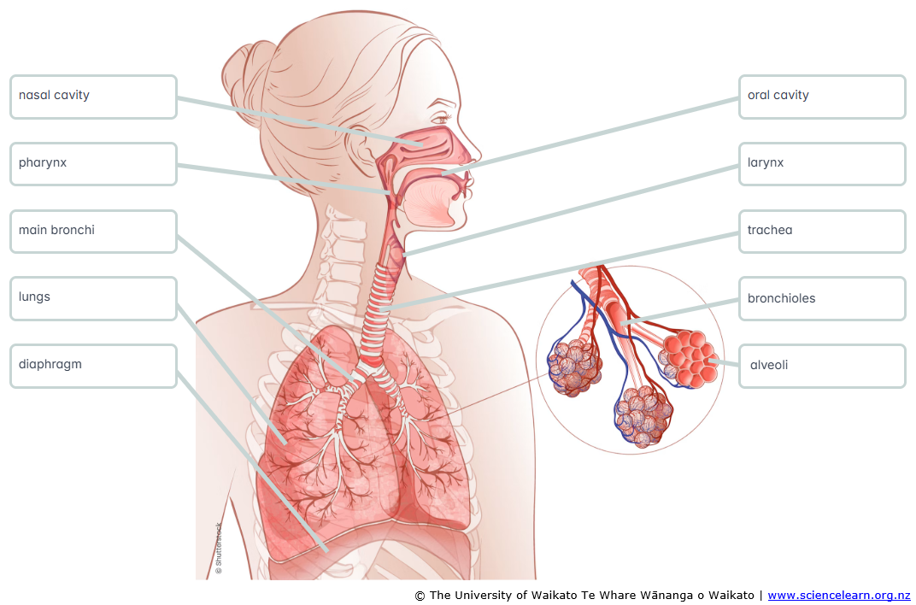
For students

Label the human respiratory system

Use labels to identify parts of the human respiratory system.

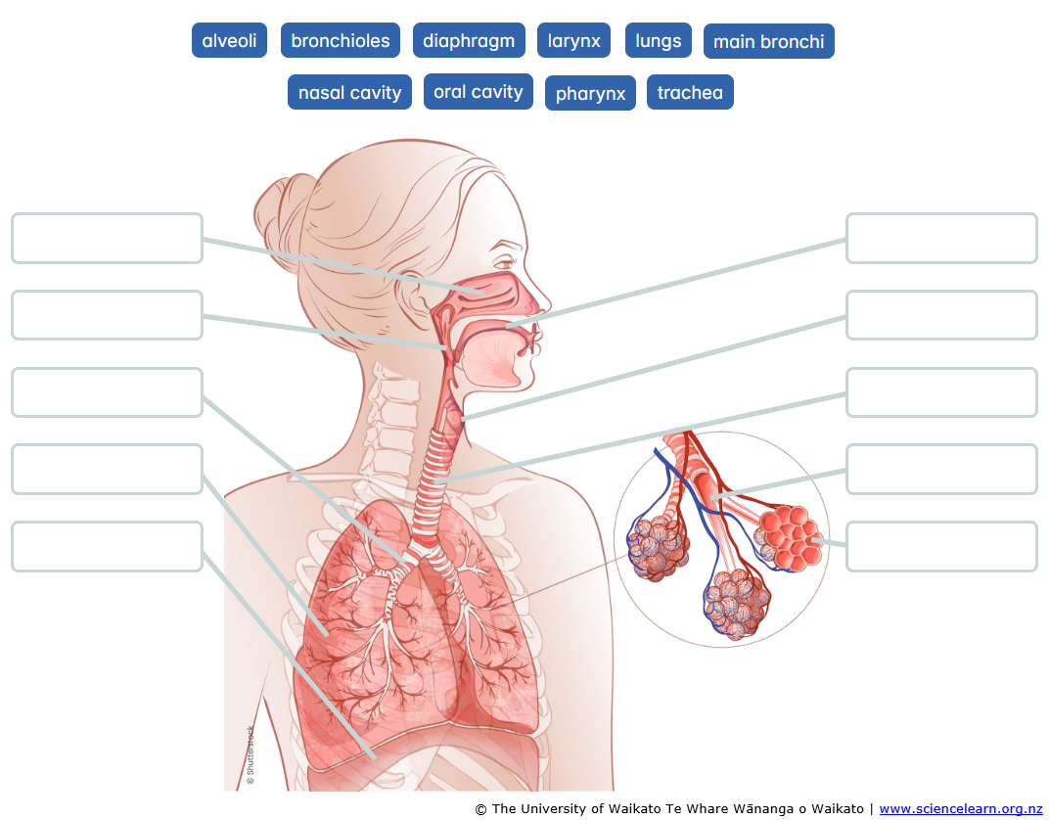

Labels | Description
alveoli | Tiny air sacs enabling gaseous exchange with blood
bronchioles | Small tubes that branch from a bronchus
main bronchi | Tubes that carry air from the trachea to the lungs and back out
diaphragm | Primary muscle for breathing – inhaling and exhaling
larynx | Protects the airway from food and contains the vocal cords
lungs | Organs that supply oxygen and remove carbon dioxide
nasal cavity | Warms, moistens and traps dust and allergens entering the body
oral cavity | Entry point for respiratory and digestive systems
pharynx | Muscular tube that moves air from the nose and mouth to the larynx
trachea | Main airway for breathing, moving oxygen in and carbon dioxide out

