Copy Master 1: Ontario Enquiry Model

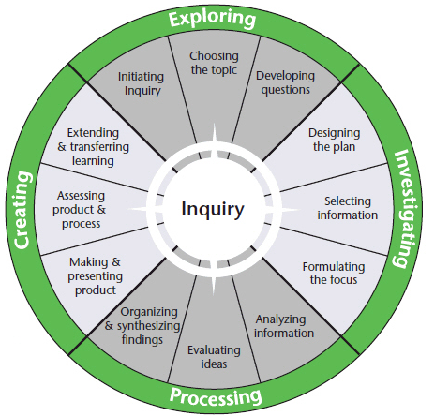

Copy Master 2: Reflection Key

Reflection Key
+ | PLUS  What were the positives? What worked well and why? What did I like and why?
- | MINUS  What were the negatives? What didn’t work well and why? What didn’t I like and why? What didn’t I understand?
:) | INTERESTING  What did I find interesting or different? What was new to me?
? | QUESTIONS  What questions do I now have? I wonder….

Copy Master 3: Images

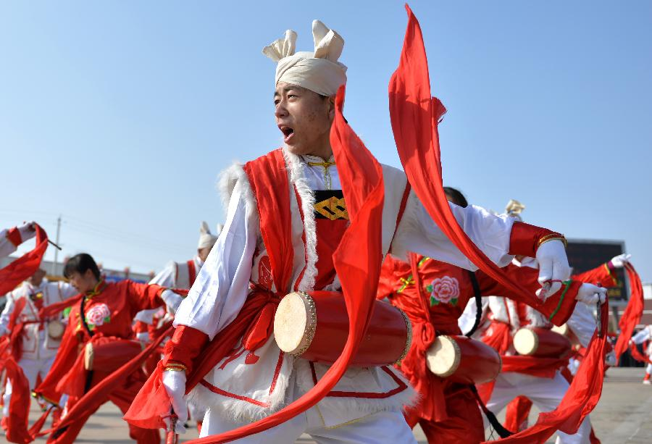

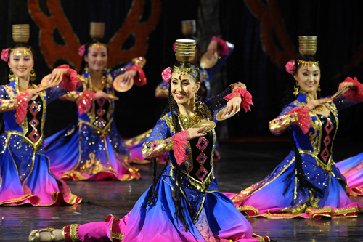

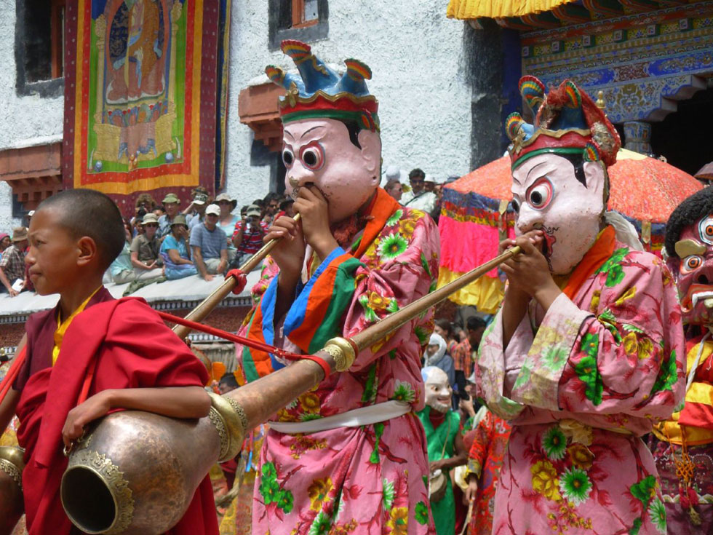

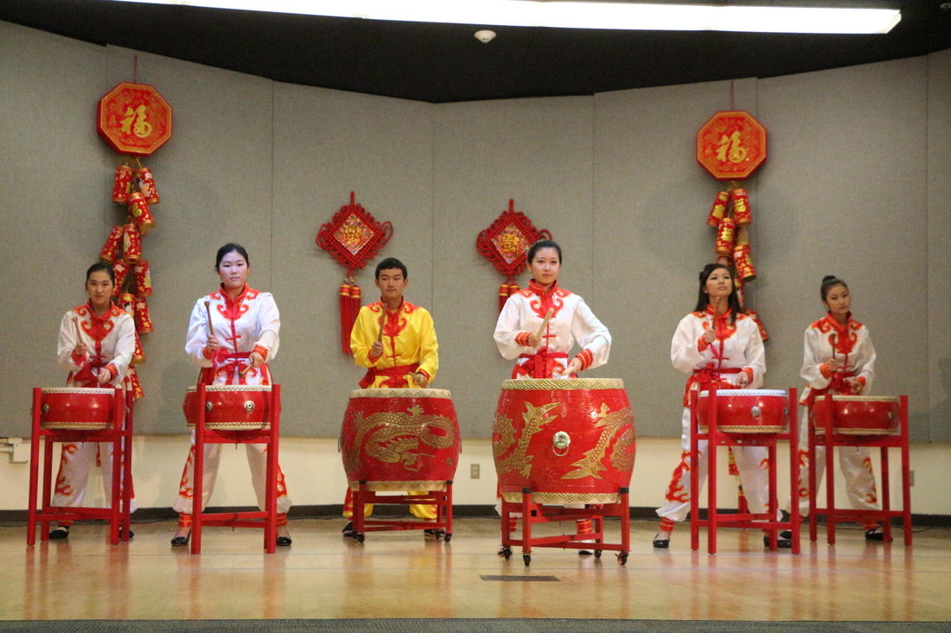

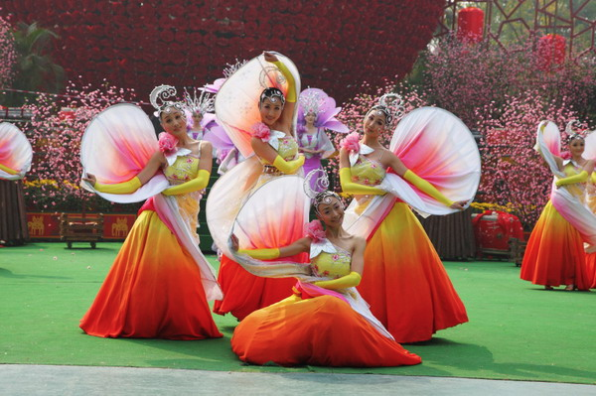

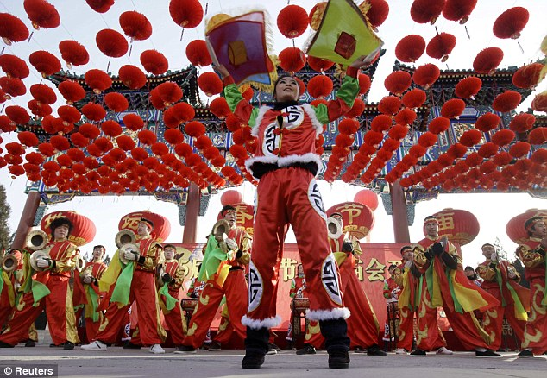

Copy Master 4: Card template

Copy Master 5: Traditional Chinese Music Reading

Traditional Chinese Music
Traditional Chinese music can be traced back 7,000 - 8,000 years based on the discovery of a bone flute made in the Neolithic Age. In the Xia, Shang and Zhou Dynasties, only royal families and dignitary officials enjoyed music, which was made on chimes and bells. During the Tang Dynasty, dancing and singing entered the mainstream, spreading from the royal court to the common people. With the introduction of foreign religions such as Buddhism and Islam, exotic and religious melodies were absorbed into Chinese music and were enjoyed by the Chinese people at fairs organized by religious temples.
In the Song Dynasty, original opera such as Zaju and Nanxi was performed in tea-rooms, theatres, and showplaces. Writers and artists liked it so much that Ci, a new type of literature resembling lyrics, thrived. During the Yuan Dynasty, qu, another type of literature based on music became popular. This was also a period when many traditional musical instruments were developed such as the pipa, the flute, and the zither.
During the Ming (1368 - 1644) and Qing Dynasties (1644 - 1911), the art of traditional opera developed rapidly and diversely in different regions. When these distinctive opera styles were performed at the capital (now called Beijing), artists combined the essence of the different styles and created Beijing Opera, one of three cornerstones of Chinese culture (the other two being Chinese medicine and traditional Chinese painting) which continue to be appreciated even in modern times.
Besides these types, Chinese peasants were clever enough to compose folk songs, which also developed independently with local flavor. Folk songs described working and daily life such as fishing, farming, and herding and were very popular among the common people.
Traditional Musical Instruments
They can be divided into four categories: stringed instruments, percussion instruments, plucked instruments, and wind instruments.

Copy Master 6: Traditional Chinese Instruments

Horse-Headed Fiddle
The Horse-headed fiddle is a bowed stringed-instrument with a scroll carved like a horse's head. It is popular in Mongolian music. With a history of over 1,300 years, it even influenced European string music when Marco Polo brought one back from his travels through Asia. Its wide tonal range and deep, hazy tone color express the joy or pathos of a melody to its fullest.
The Mongolian people bestowed upon their beloved horse-headed fiddle a fantastic legend: during horse-racing at the Nadam Fair -- their featured grand festival--a hero, Su He, and his white horse ran the fastest, which incurred the envy and wrath of the duke. The cruel duke shot the horse dead, and Su He grieved so much that he met his horse in a dream. In the dream, the horse told Su He to make a fiddle from wood and the hair of a horse's tail, and to carve the head of the fiddle in the shape of a horse's head. The lad followed the horse's advice and when he finished, the fiddle produced an extremely vivid sound. From then on, people loved this instrument and composed many songs for it.

Lute (Pipa)
Originally named after the loquat fruit, the earliest pipa known was found to have been made in the Qin Dynasty (221 BC – 206 BC). By the the Tang Dynasty (618 - 907), the pipa had reached its summit. It was loved by everyone--from the royal court to the common folk--and it occupied the predominant place in the orchestra. Many well known writers and poets created poems and mentioned it in their works. Bai Juyi, the master poet, vividly depicted the performance like this: rapid and soft notes mingled were just like big and small pearls dropping onto the jade plates.
Afterwards, the pipa underwent improvement in playing techniques and structure. Players then changed from holding the pipa transversely to holding it vertically, and from using a pick to using the fingers to pluck the strings directly. In modern times, the volume and resonance has also been improved. The traditional work 'Spring Moonlight on the Flowers by the River', which has a history of over one hundred years, has brought harmony and a sense of beauty to untold numbers of people.

Erhu
The Erhu, also called 'Huqin', was introduced from the western region during the Tang Dynasty. During the Song Dynasty (960 - 1279), it was refined and improved and new variations appeared. It was also an important instrument for playing the melody of Beijing Opera.
When playing, the player usually stands the Erhu on his lap, and moves the bow across the vertical strings. The well-known music 'Two Springs Reflect the Moon' was created by the blind folk artist Liu Yanjun, also named A Bing by the people. Though he could not see anything of the world, he played his Erhu using his heart and imagination. This melody conjures up a poetic night scene under the moonlight and expresses the composer's desolation and hope.

Flute
The earliest flute was made from bone over 7,000 years ago. In the times since then, most flutes were made of bamboo, which allowed even common people to play it. By covering the holes and blowing through the side hole while moving the fingers flexibly between the six holes, a sound will be produced that is leisurely and mellifluous like sound from far away. This always reminds people of a pastoral picture of a farmer riding on a bull while playing a flute.

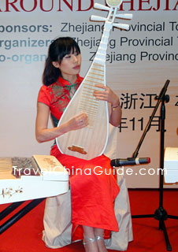 | 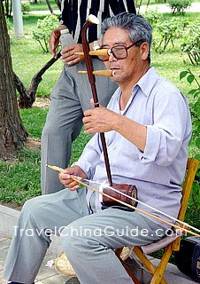
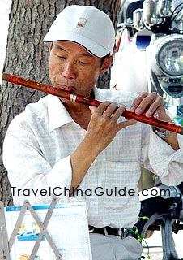 | 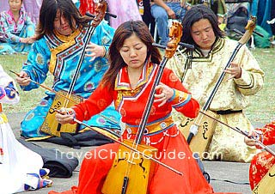

Copy Master 7: An Introduction to Modern Chinese Music

An Introduction to Modern Chinese Music
Today's Chinese music is very similar to modern Western music. Like young Westerners, young Chinese adults attend the concerts of famous Chinese pop stars. Modern Chinese orchestras still play adapted versions of traditional pieces, but they also play classical and modern symphonic compositions. Popular modern music incorporates many aspects of Western music from electric keyboards to guitars. Much of today's popular music can be classified as soft rock, rock, or dance music.

Though many aspects of popular Chinese music are similar to those of popular Western music, many traditional facets to modern music remain. Many traditional Chinese instruments are used in conjunction with popular instruments of Western cultures. The mixing of traditional instruments with other instruments creates a wide variety of euphonious sounds and rhythms. In addition, the mixing of traditional instruments with Western styles of singing creates unique Chinese sounds. Many modern artists also incorporate traditional Chinese melodies into their songs, so even music using only popular Western instruments sounds different. The mixing of Western styles and Chinese styles with traditional Chinese instruments and other instruments allows for the creation of an endless scope of expression with modern Chinese music.

Many modern instrumental music pieces incorporate traditional instruments while adapting a more modern style. However, instrumental music is still very traditional. Many works of traditional music are still played by small quartets and large orchestras. Chinese melodies are quite unique and incorporate into many modern compositions. Chinese instrumental music has changed because it is no longer restricted to the traditional format. Even non-traditional instruments such as the piano are used in creating modern works.

Copy Master 8: Dance and Drama Combine

Dance and Drama Combine
Chinese dance can be divided into two major styles: minjian wudao (folk dance) and gudian wudao(classical dance). In folk dances, the inclusion of theatrical elements such as mime and drama often depict a short plot. Today's classical dance is an attempt to reconstruct the dance of the past based on the present day's understanding and knowledge of that vocabulary.
A third style of Chinese dance is minzu wuju (national dance drama), which usually features new choreography combining both Chinese and western dance vocabularies, and may reflect either historical or contemporary events. The Magic Lantern and The Butterfly Lovers are two examples of minzu wuju.

In China, musical dance with elements of drama can be traced back to the Western Zhou Dynasty (1066-771BC). The well-known Dawu (a famous dance from the Zhou Dynasty), which was put as China's very first grand dance with a plot in historical records, was a grand dance that incorporated the art forms of dance, music and poetry together in depicting Emperor Wu's expedition to overthrow the Shang Dynasty. After the Ming (1368-1644) and Qing (1644-1911) Dynasties, dance and drama blended together.

Copy Master 9: Lion Dancers

Lion Dancers - Chinese Youth Club
What is the purpose behind a Lion Dance?
What are some of the reasons why the CYC dancers are a part of the club and Lion dancing?
How is visual art linked to the Lion Dance? What materials are used?
How are music and drama incorporated?

Copy Master 10: Lion Masks

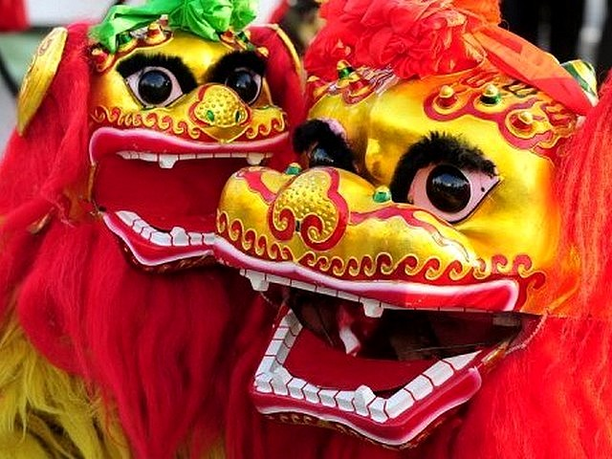

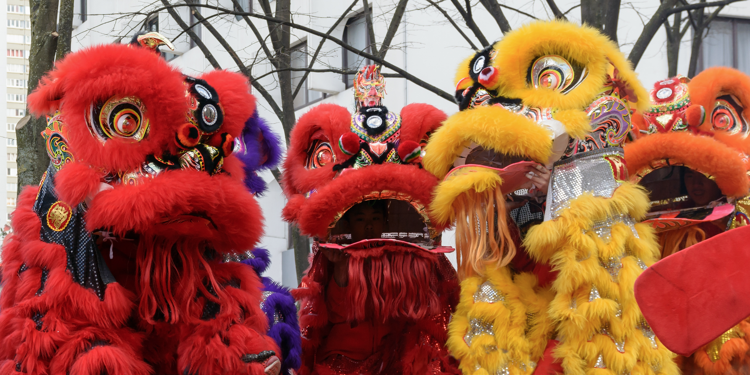

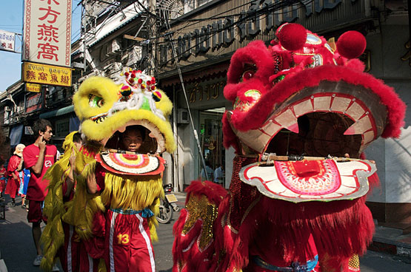

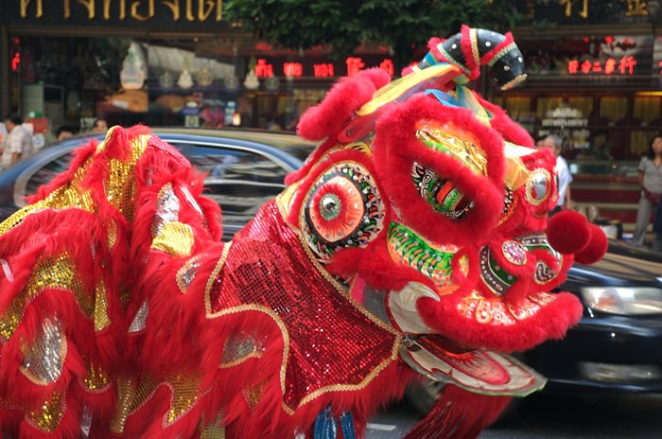

Copy Master 11: Sorting Key Questions

Sorting my inquiry questions
Are they Lookers, Drivers, Snoozers or Keepers

KEY
Drivers - Questions that are both generative and genuine to drive my inquiry
Lookers - Questions that are genuine but quick to look up
Snoozers - Questions that are not compelling nor overly useful
Keepers - Questions that are generative but low interest which may be kept for later
Drivers | Lookers
Generative - How likely is my question going to generate insight, creative action, deeper understanding, and new possibilities?
←---------------------------------------------------------------------------------------------------------------------------->
Snoozers | Keepers

Copy Master 12: Summative Task

Chinese culture: Then and now

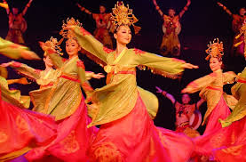
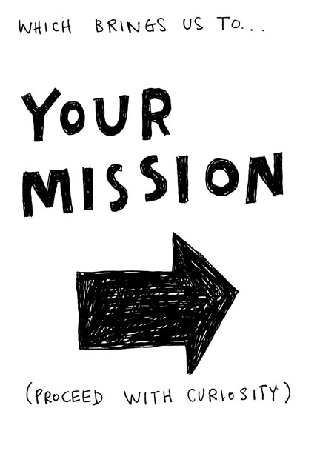 | Describe the traditional characteristics of a chosen art form - dance, drama, music or visual arts.  Explain how it has changed over time and adapted within a more modern context.  Create a visual representation of an aspect of this art form that represents the changes from traditional to modern. This might by visually, through digital media, through music or through a physical presentation i.e. a dance or drama.  Language  Include Chinese vocabulary and phrases where relevant and provide definitions of these.

Copy Master 13: Summative Task Rubric

Summative Task Rubric - Success Criteria
 | Needs Development | Developing | Achieved | Exceeded
Describe -  Characteristics | Further research of chosen art form would have provided more understanding of characteristics. | Evidence of some characteristics of chosen art form were recognised. | Evidence of research and understanding of the characteristics of chosen art form. | Clear and relevant evidence of research and understanding of the characteristics in chosen art form.
Explain -  Change | Some elements of how the chosen art form has changed over time, were identified. | Some elements of how the chosen art form has changed over time, were identified and explained. | Elements of how the chosen art form has changed over time were identified, explained and supported with justification. | Clear explanation of how the chosen art form has changed over time was evident, and supported with relevant justification.
Create -  Presentation | Aspects of the presentation were relevant to the chosen art form. More links to change over time were required. | A visual representation of chosen art form was presented, that displays an aspect of the change from traditional to modern. | A visual representation of chosen art form was presented, that displays the changes from traditional to modern. | A visual representation of chosen art form was presented, that displays the changes from traditional to modern. This supports the explanation well.
Language | No Chinese vocabulary or phrases were included. | Some Chinese vocabulary or phrases were included. | Relevant Chinese vocabulary or phrases were included where possible. | Relevant Chinese vocabulary or phrases were included effectively.
Peer feedback:

Self-assessment:

Teacher feedback:

Copy Master 14: Strategic Searching Tips

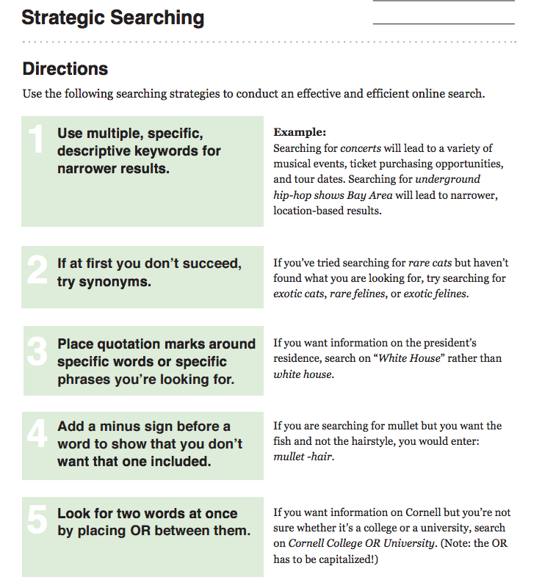

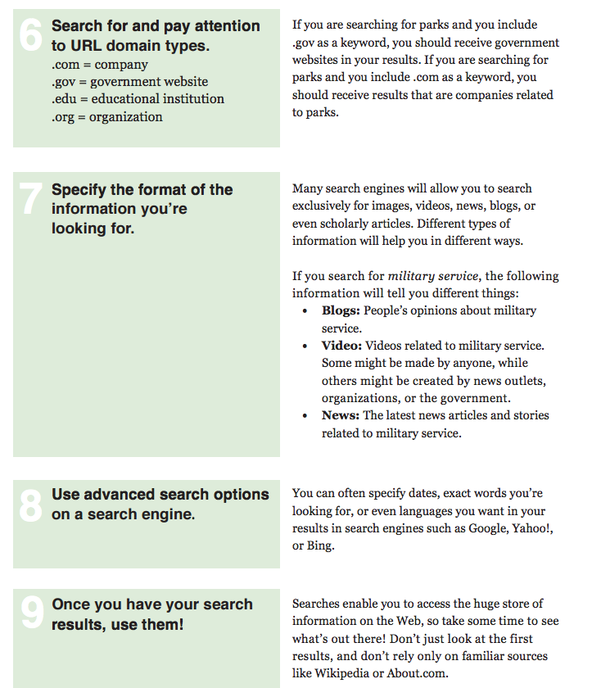

Copy Master 15: Research Organiser

RESEARCH ORGANISER
SOURCE: WHERE I FOUND THIS INFORMATION
POINT-FORM NOTES
DIRECT QUOTATIONS
MY SUMMARY/NEW UNDERSTANDINGS

Copy Master 16: WWWWH & So What?

WHO
WHAT
WHEN
WHY
WHEN
HOW
SO WHAT?

Copy Master 17: Chinese Culture: Then and Now Unit Reflection

Chinese Culture: Then & Now Unit Reflection
Characteristics - Explain what you know about the characteristics of different Chinese art forms. Provide examples.
Change over time - Explain some of the traditional influences behind different Chinese art forms (ie. beliefs or rituals) and how they have changed over time.
What questions do you still have?

What would you do differently in regards to your inquiry/presentation next time? Why?

So what? How could you or how did you use your new knowledge and understandings?

