Chinese Inventions

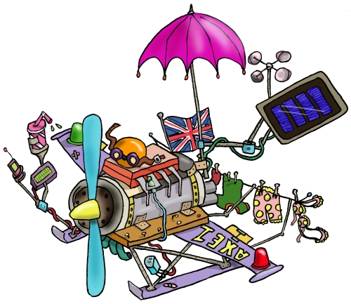

This booklet belongs to:

Task: Your group is an advertising agency hired to convince people to buy one of the major inventions of Ancient China. Your group must prepare an advertising campaign that "sells" the class your Ancient Chinese invention.

Research Process – Teacher Check in

At the end of each stage, you need to self-assess yourself against the success criteria then conference with your teacher, each stage signed and dated by your teacher BEFORE you go to the next stage.

Stage 1: Brainstorming  We can find out what we already know about the invention.  We found lots of different ways that the invention had been advertised. | Stage 2: Questioning  We thought about questions that could guide our research.  We can describe what makes a good advertisement. | Stage 3: Finding Out  We found out all the information we could about the invention we chose.  We found advertisements that appealed to us.
Stage 4: Creating  We came up way to ‘sell’ our invention to our audience. | Stage 5: Sharing  We worked as a group to present our advertisement to the class. | Stage 6: Reflecting  We self assed our advertisement.  We listened to the feedback of others and refined our ideas using this.

Stage One: Brainstorming

WALT find out what we already know about the invention.
We will be successful when we can: | ☺ | 😐 | ☹
- draw and label the invention
- identify what the invention does

This is what the invention look like:

This is what the invention does:
Stage One: Brainstorming

WALT find more than one way that the invention had been advertised.
We will be successful when we can: | ☺ | 😐 | ☹
- talk about where the invention is advertised
- identify who the invention is intended for

Sketch or cut and paste different advertisements that have been used to market the invention you are researching.

Comment on what you like about these, what you don’t like about these.

Stage Two: Questioning

Stage Two: Questioning

WALT ask questions that could guide our research.
We will be successful when we can: | ☺ | 😐 | ☹
- list 4 questions that we don’t know the answer to
- underline the key words of our questions
- use the questions can be used to guide my research
- discuss how I am going to find the answers to my questions

Record the questions you would like to investigate in the space below.

The key words that will guide my research are:

I am going to find the answers to these questions by:

Stage Two: Questioning

WALT describe what makes a good advertisement.
We will be successful when we can: | ☺ | 😐 | ☹
- use 5 different sources to find information
- talk about the similarities and differences that we found

Source | What does it claim makes a good advertisement? | Reliable?  Yes/No | Why?
1

2

3
4
5

Stage Three: Finding out

WALT investigate one Chinese invention.
We will be successful when we can: | ☺ | 😐 | ☹
- find the history of the invention
- state how it works
- discuss how it has changed the world
- write a description about a Chinese invention

Research Notes:
The history:

Sketch:

How it works:

Its impact on the world:

Other useful information:

Description of the invention

Create a survey to find out what advertisements people like and the reasons why.
Survey at least 10 people.

Person | Advertisement they like | Because

Conclusion:

Stage Four: Creating

WALT design an effective advertisement.
We will be successful when we can: | ☺ | 😐 | ☹
- describe, draw and explain the 3 advertisements for the invention (in the space below)
- complete a PMI for each of the advertisements

Advertisement idea One
Describe, draw and explain the first advertisement here:

PLUS | MINUS | INVESTIGATE
Stage Four: Creating

Advertisement idea Two
Describe, draw and explain the second advertisement here:

PLUS | MINUS | INVESTIGATE
Stage Four: Creating

Advertisement idea Three
Describe, draw and explain the third advertisements here:

PLUS | MINUS | INVESTIGATE
Stage Five: Sharing

In the speech bubbles below, write 3 pieces of feedback that your group was given.

Stage Six: Reflection

My Evaluation of the process and outcome

