Product information:
Product Name | BATTERY-MAIN
Product Model Number | 12V12.5Ah
Product Category | SLI
Batch or Serial number | P6608307668#T2502280000001#V710003#
Product Description | The battery provides power to the vehicle's 12V electrical network for car starting, lighting, and electronic equipment
Product image | 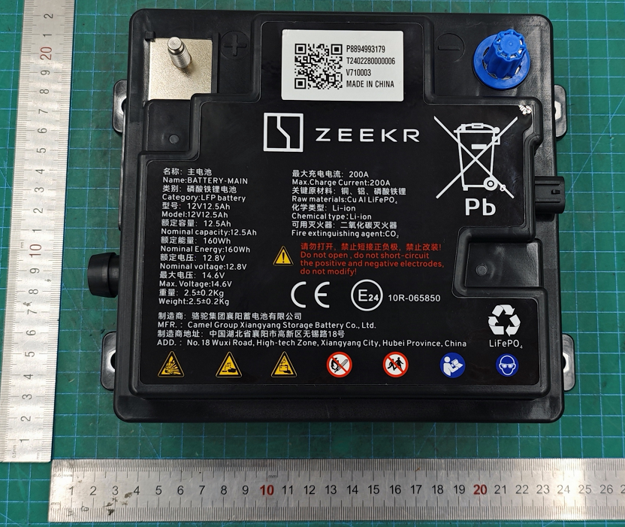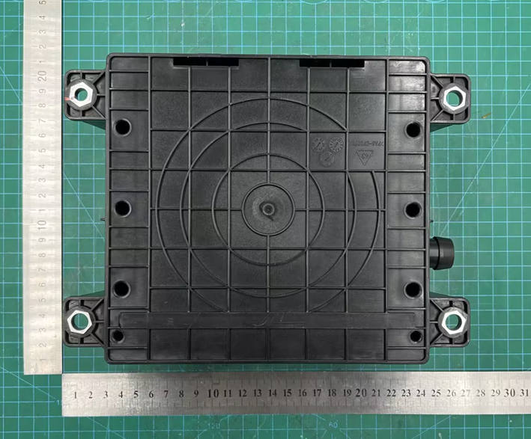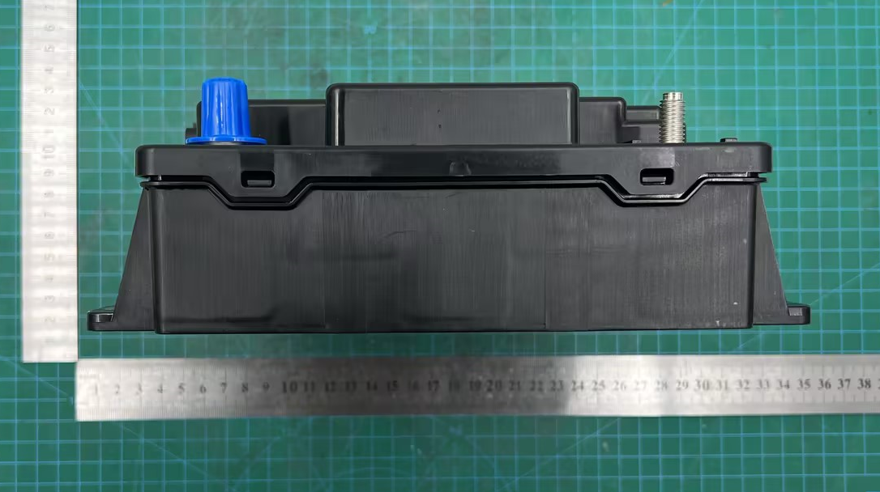
Manufacturer Information:
Company Name | Camel Group Xiangyang Storage Battery Co., Ltd
Company Address | No. 18, Wuxi Road, High-tech Zone, Xiangyang City, Hubei Province
As the product manufacturer, we hereby declare under our sole responsibility that the above product is in conformity with the following European Union harmonisation legislation:
- Regulation (EU) 2023/1542 of the European Parliament and of the Council of 12 July 2023 concerning batteries and waste batteries.
- Restrictions of substances set out in Annex XVll to Regulation (EC) No 1907/2006
- Restrictions of substances set out in Article 4(2), point (a), of Directive 2000/53/EC
- ECE R10 standard for battery electromagnetic compatibility requirements
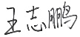
Date : 4/3/2025
Signature:
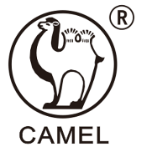
www.camelbatt.com
Identification number of the declaration: XYXDCC1020
EU DECLARATION OF CONFORMITY

