POSTOPERATIVE INSTRUCTIONS – OTOPLASTY

These instructions are given to patients and family members to answer as many questions as possible about the healing phase after otoplasty.

Immediately after surgery the head is wrapped in a large soft bandage for at least 24 hours. You will usually seen in the office on the first postoperative day where the bandage is removed, and the ears are cleaned and antibiotic ointment is applied. Swelling of the ears is perfectly normal, as is some bruising. After dressing removal, a stretch headband, typically used for winter sports/skiing (example shown below) should be worn as much as possible around the clock for 1 week, then at night only for another 2 weeks. This should be purchased prior to surgery to be ready to use. It is useful to have multiple headbands as they may need to be washed frequently to remove ointment/blood.

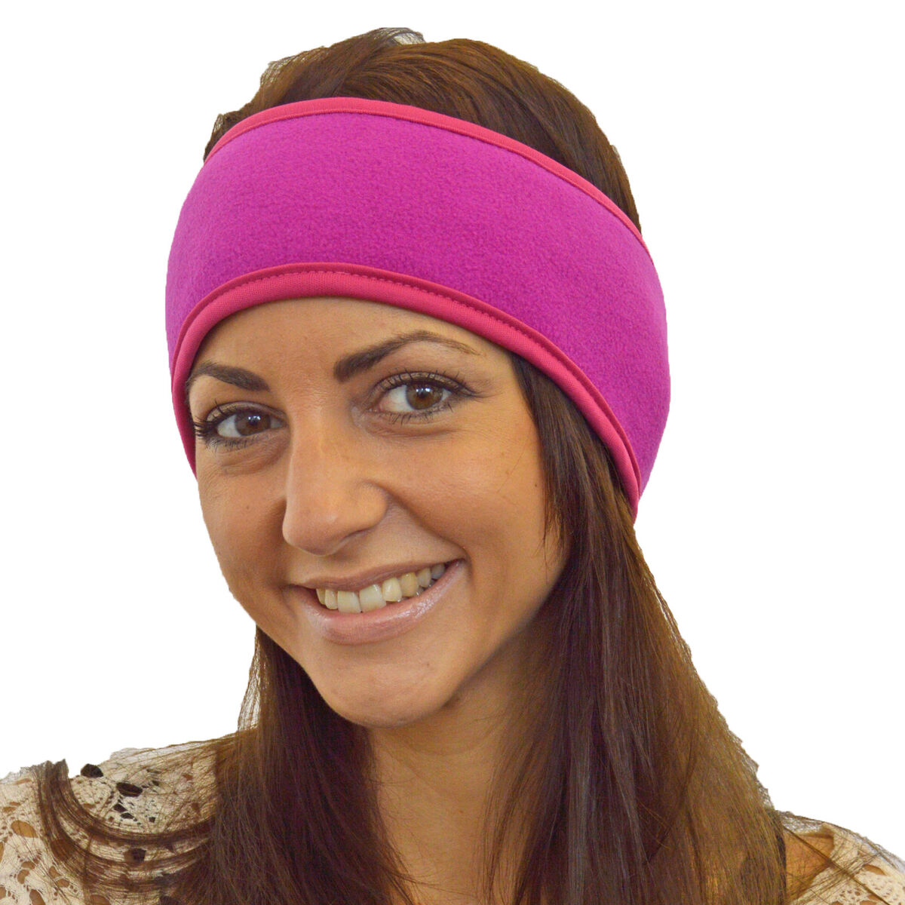

Medications that will be prescribed/provided for your surgery:

Medication Name | Type | When to Start
Cefdinir (Bactrim, alternative if allergic to PCN/cephalosporins) | Antibiotic | The day after surgery if performed in the OR  The morning of surgery if performed in the clinic
Medrol Dose Pak (methylprednisolone) | Oral steroid | The day after surgery
Hydrocodone/Acetaminophen | Pain medication | The day of surgery as needed
Bacitracin or Mupirocin | Ointment to apply to incisions | The day of surgery or after any dressing is removed
Zofran (ondansetron) | Anti-nausea | The day of surgery as needed

Activity
The average patient can return to work or school approximately 1 week after surgery. No strenuous activity is recommended for 4 weeks after surgery. Contact sports should be avoided for 6 weeks or until the doctor gives the OK. Swimming is not recommended for 3 weeks after surgery. If you have any questions about whether an activity should be resumed, please ask the office.

Sleeping
The position of the ears during the healing phase is of the utmost importance. If possible, sleeping on your back with the head elevated is recommended to avoid pulling the ear forward and to minimize swelling. Wearing the headband at night until the ears are healed is extremely important to avoid injury.

CLOTHING
Wear clothing that doesn’t have to be pulled over the head for two weeks.

Finally
Remember that surgery of any kind causes swelling. The ears will be swollen when the bandages are removed, and some swelling will remain for several weeks. Bruising also occurs but fades as well. If pain worsens or the incisions/ears become red or if there is discharge from the incisions, notify the office.

You will be instructed in cleaning the incision with peroxide and applying antibiotic ointment. This is extremely important and must be done diligently.

Please come for the follow-up appointments as scheduled. If you have questions between appointments, do not hesitate to call us 24 hours a day at (804) 378-7443.

