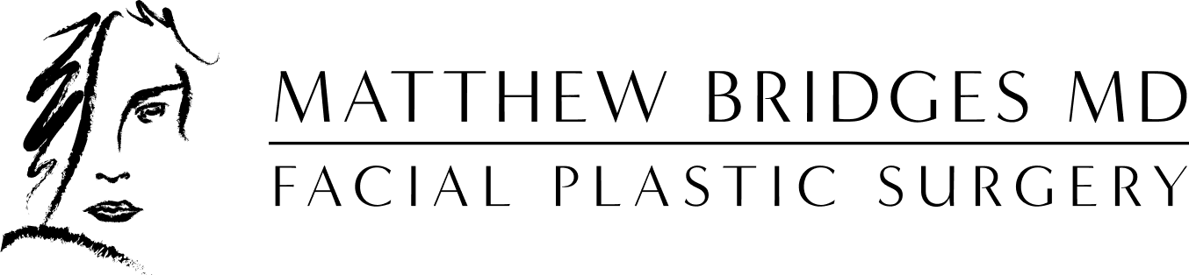

Postoperative Instructions for Septoplasty +/- Inferior Turbinate Reduction

Nasal airway obstruction can be alleviated through an operative procedure that straightens the septum and reduces the size of the inferior turbinates. The septum is the internal structure of the nose that divides one nostril from the other and can become crooked or deviated, causing airway obstruction. Inferior turbinates are structures inside the nose that warm and humidify the air. They can become enlarged due to nasal allergies, and therefore impinge upon the airway. There are three sets of turbinates that make up part of the airway, but the inferior turbinates are the ones that are most commonly obstructive.

SWELLING
Every operation, no matter how minor, is accompanied by swelling of the surrounding tissues. The degree of swelling varies from person to person, and with the amount of surgery required.

Staying upright (sitting, standing, walking around) as much as possible is important after you leave the hospital. Avoid bending over or lifting heavy objects for at least one week as it may aggravate swelling or cause bleeding.

Avoid hitting or bumping your nose.

Sleep with the head of the bed elevated for approximately 3-5 days. You may place an additional pillow under your head to accomplish this.

Avoid “sniffing,” that is, forcibly attempting to pull air through the nose. This will not relieve the sensation of blockage. As the swelling of tissues decreases, your airway will improve.

Avoid rubbing the nostrils and base of the nose as this may cause infection or bleeding. Use the “moustache” gauze dressing if discharge is excessive. The moustache gauze dressing may have to be changed as often as every thirty minutes. This is not abnormal and will significantly lessen in the next twelve-hour period. You will usually have clear plastic tape on your cheeks with the moustache dressing taped over it. Leave the clear tape in place until you do not need the moustache dressing anymore (usually 24-48 hours). This avoids irritating the skin from frequent moustache dressing changes.

SPLINTS AND BLEEDING
Soft silicone tube splints may be placed on either side of your septum to help stabilize the septum after surgery. These will be removed in the office at your first postoperative visit. Please be aware that during the postoperative time, you may have some minimal bleeding. Often blood-stained mucus coming from the nose will be seen, and this is not unusual. Nevertheless, if you should find that you are bleeding excessively from either nostril, it is important to contact the office as soon as possible.

PAIN
This is usually very little actual pain, and what pain you have can be alleviated with the prescribed medication or Tylenol. Please do not take aspirin or any aspirin containing medication. It is also best to avoid NSAIDS (non-steroidal anti-inflammatory drugs) like Ibuprofen (Motrin) or Aleve, as these medications can cause more bleeding and bruising.

MEDICATIONS
Please be sure to verify your pharmacy prior to your surgery to make sure that medications are sent to the correct location for you to pick up before your surgery.

You will usually be prescribed pain medication, antibiotics, a steroid pack, anti-nausea medication, ointment, and nasal saline. Your medications will be called into your designated pharmacy 1-2 weeks prior to your scheduled surgery. If you need to change pharmacy or did not pick up your medications, please contact the office. Nasal saline can be obtained over the counter. Sealed, pressurized saline spray, such as Simply Saline or Nasamist, is preferred. Any antibiotic ointment, such as bacitracin, can be used.

Medications that will be prescribed for your surgery:

Medication Name | Reason for taking | When to Start
Cefdinir (Bactrim, alternative if allergic to PCN/cephalosporins) | Antibiotic | The day after surgery
Medrol Dose Pak | Oral steroid | The day after surgery
Hydrocodone/Acetaminophen | Pain medication | The day of surgery as needed
Simply Saline Nasal Spray  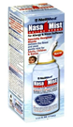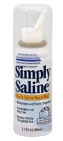 | Nasal spray | The day of your surgery
Bacitracin or Mupirocin | Ointment to put inside of nose, apply 2-3x/day | The day of surgery
Zofran (ondansetron) | Anti-nausea | The day of your surgery as needed

CLEANING THE NOSE
The saline solution and ointment should be used to clean the nose and keep crusting to a minimum. The saline solution should be used every few hours during the day. The ointment should be placed 2-3 times a day. Avoid blowing your nose for at least 2 weeks. After using the prescribed ointment for 1 week, it can be helpful to use saline gel (AYR is one brand available) to help keep the nose from becoming too dry.

RESUMING ACTIVITIES
Your exercise regimen must be lessened to some extent for the first few weeks following surgery. Upper body exercise is especially prohibited, as it is more likely to cause bleeding. Walking is always permissible. PLEASE CHECK WITH THE OFFICE BFORE RESUMING ANY OTHER EXERCISE OR ATHLETIC ACTIVITY.

YOUR FIRST POSTOPERATIVE OFFICE VISIT
Your first post-operative appointment should be made prior to your surgery and will be approximately 5-6 days after surgery. At this appointment, any splints that were put in will be taken out.

RETURN TO WORK OR SCHOOL
The average patient can return to school or work three to five days following the surgery. Physical activity will be curtailed, as discussed above.

LONG-TERM CARE
Please realize that the nose may require six full weeks for complete healing. Often there will be crusting at the healing sites that will need to be removed by the doctor. This may require multiple visits for the first six weeks. This is normal and should not be cause for alarm. The crusts may interfere with proper breathing, so it is important to keep these visits. Continued use of saline irrigation and ointment or saline gel will aid in reducing the amount of crusting.

If you have any questions, please call us at (804) 378-7443. We are always happy to answer your questions, and if you should have a problem, this number is answered 24 hours a day.

