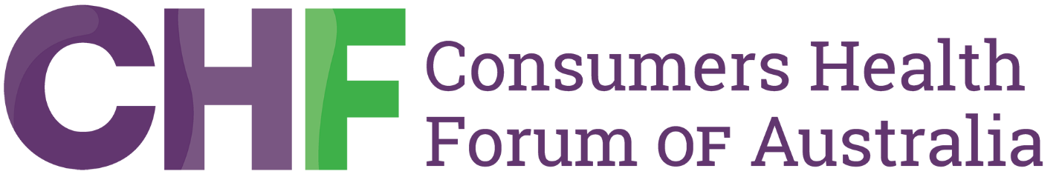

Consumers win affordability gains

2 January 2025

The Consumers Health Forum of Australia today welcomed the Australian Government’s decision to freeze the maximum amount all people will pay to fill a PBS prescription.
On 1 January, for the first time in more than 25 years, the maximum amount people pay for PBS medicines didn't rise with inflation, for all Australians.
As the national peak body representing the interests of consumer health organisations, the CHF has been hearing consistently from consumers that keeping up with healthcare costs is becoming harder. This is particularly the case for those consumers who live with one or several chronic conditions.
CEO Dr Elizabeth Deveny “…sees this as a win for consumers, who place access to and affordability of health care at the top of their 2025 wishlists.”
Dr Deveny acknowledged that “this move builds on earlier government efforts to make medicines more affordable, such as through its 60-day dispensing program and the introduction of the bulk billing incentive”.
She cited recent data released by the Australian Bureau of Statistics (ABS) showing one in ten Australians, living in areas of most socio-economic disadvantage, delayed or went without prescription medication when it was needed, due to the cost.
"When we talk to consumers about affordability, we hear that when compared to paying the rent or putting petrol in the car to get to work, buying medicine or seeing a doctor is seen as a discretionary choice.”
Dr Deveny noted that CHF has previously called for a freeze on the PBS copayment.
“This is a long awaited but nevertheless welcome initiative. We urge the government to continue to ensure that Australians can afford the medicines they need.”
Media contact
Consumers Health Forum
0461 545 392

