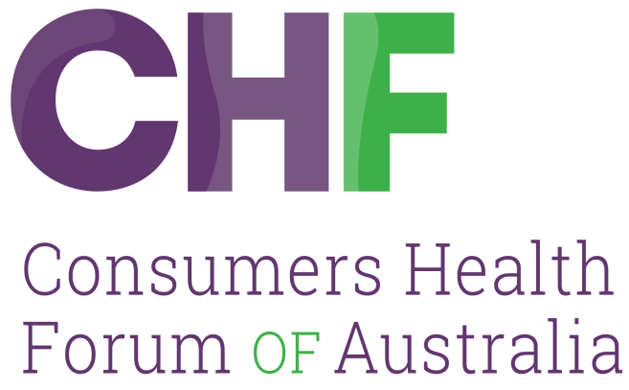



**SUBMISSION**

**National Stigma and Discrimination Reduction Strategy**

**Consultation draft**

February 2023

Consumers Health Forum of Australia (2023) Submission to the National Mental Health Commission: National Stigma and Discrimination Reduction Strategy: Draft for consultation

**P:** 02 6273 5444  
**E:** [info@chf.org.au](mailto:info@chf.org.au)

[twitter.com/CHFofAustralia](http://twitter.com/CHFofAustralia)   
[facebook.com/CHFofAustralia](http://facebook.com/CHFofAustralia)

**Office Address**  
7B/17 Napier Close,  
Deakin ACT 2600

**Postal Address**  
PO Box 73  
Deakin West ACT 2600

*Consumers Health Forum of Australia is funded by the Australian Government as the peak healthcare consumer organisation under the Health Peak and Advisory Bodies Program*

## Consumers Shaping Health

## Consumers Shaping Health

**CONTENTS**

# Contents

Introduction 4

Priority 1 Foundational actions 5

Legislative change and use 5

Lived experience leadership and workforce 5

Priority 2 Structural stigma and discrimination 6

Information and support 6

Priority 3 Reduce public stigma 6

Media 6

Community stigma 7

Priority 4 Reduce self-stigma 7

Concluding comments 7

# Introduction

CHF is the peak body representing consumers of health services in Australia, regularly consulting with, and working with, consumers to develop and advocate for policies, programs and initiatives to improve practices and shape a consumer centred health system.

The Consumers Health Forum (CHF) thanks the Mental Health Commission for the opportunity to respond to the consultation draft of the National Stigma and Discrimination Strategy.

CHF has consulted consumer representatives and advocates with community networks throughout Australia, including members of CHF’s Mental Health Consumers Special Interest Group. Their experiences and perspectives are reflected in this submission.[1]

*Researching changing stigma is really difficult, so I think this idea of having an overarching view on it and collaborating and bringing in different experts and community leaders together should be endorsed … this is really an exciting and strategic view.*

Consumers broadly support the vision and principles of the draft strategy. They consider that many of the proposed actions could be effective in reducing stigma and discrimination. Some consumers pointed out that the Strategy could be applied more broadly than to mental health conditions, for example recognising that many people experience physical health co‑morbidities, and that there is often a two way causal relationship between mental and physical health conditions. They also point to the many physical conditions that draw stigma and discrimination, including obesity, lung cancer, and ME/CFS.

*The fact is, we have to look at the whole person and all their experiences. So, whether they’ve had discrimination because of other issues already, whatever disability or health condition … and then mental health on top of it, whichever is the cause and effect, we need to look at intersectionality.*

# Priority 1 Foundational actions

## Legislative change and use

Consumers strongly supported the actions that would strengthen legislation, arguing that it is legislation that enables change to be affected, giving them a voice and a mechanism to challenge discriminatory and stigmatising behaviour. Without legislative change, supported by accessible avenues for complaint and independent scrutiny, many of the other actions in the Strategy are likely to be less effective or ineffective.

*The thing I considered was linking it to underpinning legislation and, then, to the accountable bodies for that legislation … There’s no point in having a government document if there’s no way of enforcing it. It needs legislation.*

## Lived experience leadership and workforce

CHF has long called for an independent, system focused national mental health consumer and carer peak body. While the draft Strategy seeks this in the medium term, the appropriation of Budget funding could be an initial, short term step to establishing the body..

*There could be stronger language to reflect that lived experience is already a requirement … The importance of leading with lived experience has not been demonstrated by priority 1.3. Lived experience advocacy is a lot broader than lived experience leadership. Having them in the same space makes it seem like it’s the same thing.*

Consumers support the value placed on the language used in the draft Strategy, as it is important to them. One area for improvement would be to clarify “lived experience”. Consumers recognise that the draft Strategy differentiates between personal lived experience and the experience of the people who care for them. However, they pointed out that the lived experiences of families and support people, while different to those directly experiencing mental ill health, are also valid and should be equally recognised.

# Priority 2 Structural stigma and discrimination

## Information and support

The feasibility and effectiveness of the actions in Priority 2, including will be contingent on consumers having support to access and use the information that they need. This priority area recognises and offers actions that have the strong potential to address many of the structural and systemic barriers faced by people with mental ill health. However, little will change without mechanisms that empower consumers to access services, and to challenge the barriers they face.

*It should be mandatory for accessibility to be in all documents, whether it’s Auslan, whether it’s plain English, whether it’s language groups. It shouldn’t be an add on if somebody thinks to ask for it.*

Many consumers pointed to the need for accessibility to information to be provided in plain English, community languages, and accessible formats (for example, video content in spoken languages and Auslan). Every national strategy includes measures to make information more accessible to priority consumers, usually as medium or long term goals.

CHF recognises that there are cost barriers, particularly to translating material into community languages and making resources available to sight and hearing impaired consumers. However, there has been little progress over many years. This includes areas where cost is a negligible factor, such as producing *all* material in plain English as a matter of course. Accessibility of information, including how to assert rights, make complaints, and ensure that people are held accountable for discrimination, is critically important to consumers experiencing mental ill health, and should be prioritised in the Strategy.

# Priority 3 Reduce public stigma

## Media

CHF has long called for a public awareness campaign to address stigma, as part of the National Obesity Strategy. As pointed out in the draft Strategy, anti-stigma campaigns have generally focused on a single form or cause of discrimination and disadvantage, and not addressed intersectionality of causes. There is a clear benefit in a single and cohesive national campaign to address all forms of stigma, across all areas of health and wellbeing.

*There’s previously been health campaigns, and even anti-stigma campaigns, that have unintentionally stigmatised other conditions. So, for example, comparing a certain type of cancer to others..*

## Community stigma

The draft Strategy points to an approach forming a layered and enduring social movement. This would support the different types and sources of stigma and discrimination within different communities and settings, and is strongly supported by CHF.

*I would like to community based groups run in local government spaces (like libraries) to encourage stigma education, discrimination education, and delivered by peers, to actually give examples, wrapped in a positive framework.*

# Priority 4 Reduce self-stigma

Mental health consumers generally agree with the approach taken in the draft Strategy to reduce self-stigma.

They pointed out They stress that self-stigma is purely a function of the discrimination and attitudes that they face – they would not experience self-stigma if they did not experience it from others in the community and built into systems. That is, the Strategy should be very clear that stigma and discrimination is externally based, and not inadvertently suggest responsibility lies with the victim. It should clearly, and primarily, focus on changing legal, community and other structural sources of stigma and discrimination.

# Concluding comments

CHF supports the actions and thanks the National Mental Health Commission for the draft Strategy that, if implemented, will benefit people with lived experience of mental illness, including people with mental health conditions and their families and carers, as well as their communities and all Australians.

*Is there any way to ask for this stigma and discrimination strategy to include links to where you can find your rights? So, say for example, Joe Bloggs finds this Strategy and it says all this wonderful stuff, but how does he access practical information about his rights?*

The Strategy should be widely accessible – not just to organisations and governments, but to consumers of the system – as intended. It is extremely important that the document is written in plain English and translated into community languages. Complementary material and a communications’ plan should also be developed and implemented so that the Strategy is accessible to all consumers.

1. The direct quotes and experiences of consumers related in the boxes have been edited.