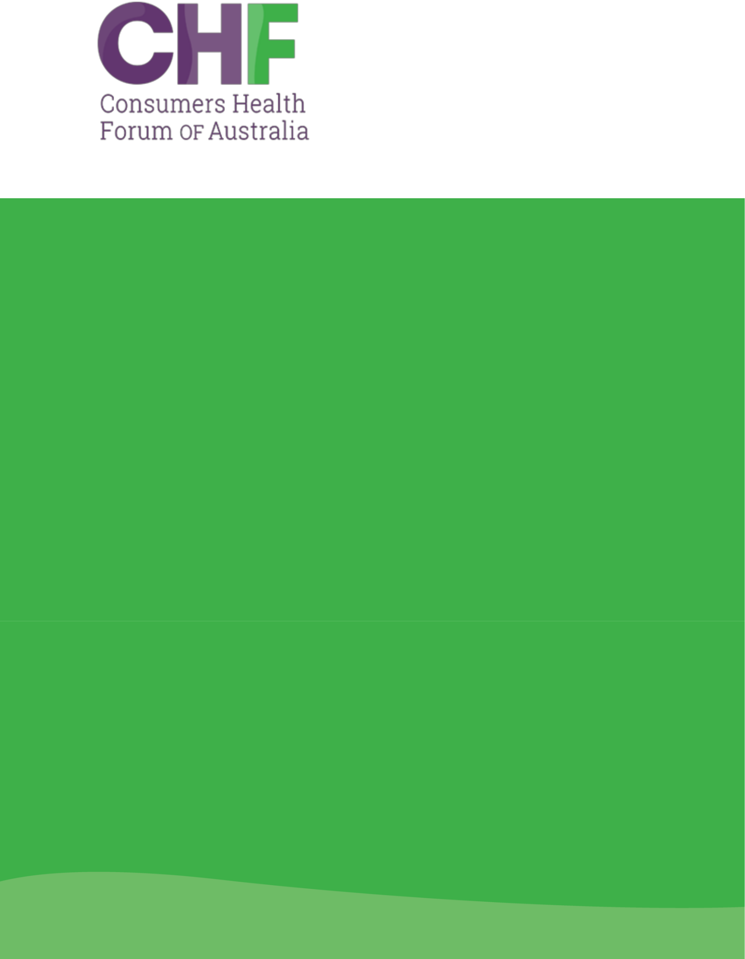

Rural Generalist Medicine

SUBMISSION

December 2023



Consumers Shaping

Health

Consumers Health Forum of Australia (2023)

Rural Generalist Medicine. Canberra, Australia

P: 02 6273 5444

E: info@chf.org.au

twitter.com/CHFofAustralia

facebook.com/CHFofAustralia

Office Address

7B/17 Napier Close,

Deakin ACT 2600

Postal Address

PO Box 73

Deakin West ACT 2600

Consumers Health Forum of Australia is funded

by the Australian Government as the peak

healthcare consumer organisation under the

Health Peak and Advisory Bodies Programme

CONTENTS

Contents


Introduction 4

Consumer consultation 4

Response 4

Consultation questions 6

3

Introduction

Consumers Health Forum (CHF) is the national peak body representing the interests of Australian healthcare consumers and those with an interest in healthcare consumer affairs. CHF works to achieve safe, quality, timely healthcare for all Australians, supported by accessible health information and systems. At the heart of our policy agenda is consumer-centred care.

The Medical Board of Australia is consulting on the application by the Australian College of Rural and Remote Medicine (ACRRM) and the Royal Australian College of General Practitioners (RACGP) to have Rural Generalist Medicine (RGM) recognised as a new field of specialty practice within the specialty of General Practice, under the Health Practitioner Regulation National Law (National Law). We welcome the opportunity to provide a submission on the application by ACRRM and RACGP.

The definition for Rural Generalist was agreed to by ACRRM and RACGP in collaboration with the National Rural Health Commissioner in February 2018:

“A Rural Generalist is a medical practitioner who is trained to meet the specific current and future healthcare needs of Australian rural and remote communities, in a sustainable and cost-effective way, by providing both comprehensive general practice and emergency care and required components of other medical specialty care in hospital and community settings as part of a rural healthcare team.”

If approved and effectively implemented, the proposal will help promote continuity of care in rural and remote communities and increase access to healthcare. It will reduce or remove the need for consumers to travel to major centres and the associated costs. In particular, Aboriginal and Torres Islander Peoples will have access to specialised care on Country.

Consumer consultation

Consumers from CHF’s Rural and Remote Special Interest Group were consulted on the application. The group was established to include the voices of rural and remote consumers in our policy and advocacy work. They help identify where improvements can be made and contribute to the cultural changes needed for sustainable improvements in rural and remote health. The group provided both oral and written feedback which has informed our response.

Response

There is inequity in healthcare provision for rural and remote consumers. They have less access to healthcare services and poorer health outcomes than those in metropolitan areas. Consumers believe that recognising RGM is pivotal to help rectifying shortages and providing safe, high-quality consumer-centred care for remote and rural Australians. Therefore, CHF supports the recognition of RGM as a distinct field of specialty practice within the speciality of General Practice.

- Consumers Health Forum of Australia

Consumers expect the recognition of RGM to attract and retain doctors equipped to deliver high-quality healthcare in rural and remote settings. Consumers support that recognising RGM aims to reduce reliance on locums and promote continuity of care. And that it will likely provide incentives for doctors to forge new career paths and advocate for standardised facilities, staffing, and rural and remote consumer needs.

Rural and remote areas have geographic challenges, lacking local access to healthcare professionals and resources. Recognition of RGM will help ensure communities have access to essential services. Currently, many consumers must travel for care which has negative outcomes for their safety, health, and well-being. Travel also involves personal, social, and financial costs including accommodation and childcare. This is especially burdensome for groups facing social and financial disadvantages. Consumers anticipate that RGM will reduce the need for travel, improving productivity and sustainability in rural healthcare with better use of resources and a reduction in carbon emissions.

We welcome that rural generalists will offer a broad range of services locally including:

- Mental healthcare

- Emergency Care

- Hospital and in-patient care

- Maternity care and birthing services

Particularly, we welcome that rural and remote Aboriginal and Torres Strait Islander communities will increasingly be able to receive care on country, leading to greater continuity of care, culturally safe care, and improved outcomes. However, it must be ensured that Rural Generalists are trained for culturally safe practice.

We recognise that RGM will take a generalist approach, with clinicians practising to their full scope and using advanced skills relevant to local needs. The application emphasises the need for Rural Generalist doctors to be flexible, resourceful, and negotiate with other medical and allied health groups to ensure consumer needs are met. Communication must be a core element of training so clinicians can develop skills to communicate both with their peers and their community, to ensure safe and quality care. It is imperative that safety and quality is not compromised and RGM is well-funded with trainees supported and empowered.

Recognising RGM will formalise the role and establish consistent standards, improving recruitment, retention, and quality of care. Establishing a regulated workforce with standardised training and qualifications will enable consumers to make informed healthcare decisions about their healthcare. It is essential that rural and remote communities are actively engaged to ensure consumers understand the role of rural generalists in their care. Furthermore, given the diversity across rural and remote communities, it is vital that consumers are actively involved in training and ongoing engagement throughout a rural generalist’s career, to help ensure RGM is centred on consumer needs.

Consumers envision rural generalists as pivotal in shaping policy, promoting health education, and advocating for rural and remote populations. Consumers were aware of previous attempts to increase provision of healthcare in rural and remote areas including ‘enhanced skills’ which they do not perceive as successful in encouraging or incentivising clinicians into

5

remote and rural areas in the past. Consumers did recognise successful rural generalist models in Queensland, where Rural Generalists are recognised, and welcome these benefits on a national scale.

Consumers were optimistic that recognising RGM could facilitate health pilots, scaling up positive initiatives and increasing research, ultimately improving healthcare services and access. Consumers want resources to be better centred around the community and support recognition of RGM as they will be uniquely placed to do this.

Consumers were vocal that safety remains a barrier to living outside of cities. Recognising RGM could increase safety and enhance the desirability to live in rural and remote areas as cities become more crowded and overpopulated. Consumers recognise this could increase rural and remote business, recreation, tourist, education, and agriculture opportunities.

Overall, the consumers we consulted support recognising RGM as a distinct field of specialty practice within the speciality of General Practice. CHF echoes this support on the basis that RGM will increase access to safe, high-quality healthcare for remote and rural populations. However, it is vital that RGM is carefully implemented, and trainees are supported to safely utilise the full scope of their skills and trained to work with and listen to consumers. We would like to see more detailed discussion of the long-term sustainability plans for RGM, including evaluation strategies to monitor its effectiveness and adjust as needed, including speaking to local communities, and monitoring how their experience and health outcomes develop.

Consultation questions

Has the claim that regulatory action is necessary to recognise Rural Generalist Medicine as a field of specialty practice been substantiated?

Yes, the application provides a compelling argument that regulatory action is necessary to recognise RGM as a field of specialty practice. CHF supports the proposal on the basis that RGM will increase access to safe, high-quality healthcare for remote and rural populations.

Have the positive consequences of recognition of Rural Generalist Medicine as a field of specialty practice under the National Law been stated? Are there additional positive consequences that should be considered?
The positive consequences were stated in the application. Much of these were substantiated in our limited consumer consultation. Please see the response section for our analysis of the positive consequences.

Have the potentially negative consequences of recognition of Rural Generalist Medicine as a field of specialty practice under the National Law been stated? Are there additional negative consequences that should be considered?
The negative consequences were stated in the application. Our limited consumer consultation has not identified any additional negative consequences. Please see the response section for any analysis of negative consequences. CHF would like to emphasise how important it is that RGM is well-implemented, with trainees supported and engaging with local communities. We

- Consumers Health Forum of Australia

would welcome more detail about how success will be measured to ensure RGM has a positive impact on remote and rural consumers.

Are there specific issues or claims in the application that should be the focus of the AMC assessment of the application?

No, CHF support the recognition of RGM.

In the application for the recognition of Rural Generalist Medicine as a new field of specialty practice are there any impacts for patients and consumers, particularly vulnerable members of the community, that have not been considered or need more detailed consideration?

Based on our limited consumer consultation, we have not identified any issues or particularly vulnerable members of the community that need more detailed consideration in the application. The application provides strong analysis of the impacts on consumers and provides a compelling proposal for RGM.

In the application for the recognition of Rural Generalist Medicine as a new field of specialty practice, are there any impacts for Aboriginal and/or Torres Strait Islander People that have not been considered or need more detailed consideration?
We note that Aboriginal and Torres Strait Islander organisations such as The National Aboriginal Community Controlled Health Organisation (NACCHO) have been consulted. We support continued engagement with Aboriginal and Torres Strait Islander organisations and working closely with rural and remote Aboriginal and Torres Strait Islander communities.

Are there specific stakeholder groups that should be consulted further as the application is assessed and what would they add to understanding of the application? (please see Attachment B for the stakeholder groups for this consultation)

We support continued consultation with consumers.

What are the interactions now between Rural Generalists and other medical and health practitioners including other General Practitioners? How are these likely to change if Rural Generalist Medicine is recognised as a field of specialty practice?
No comment.

Your views on how the recognition of Rural Generalist Medicine will impact on the following:

- disincentives/incentives for General Practitioners to undertake rural practice resulting from additional training requirements
- unnecessary deskilling or restrictions in the scope of practice of other

practitioners who practise in rural environments.

We are content with how this was explored in the application. We recommend that all clinicians and relevant bodies collaborate in the best interest of consumers, enabling access to safe high-quality care for remote and rural communities.

7

Have all economic impacts for governments, businesses and consumers been identified? Should further economic analysis be undertaken during the AMC assessment to assess the claims of minimal costs impact of recognition, and if yes, what should be the focus of the analysis?

No comment.

- Consumers Health Forum of Australia

