*Social Prescribing Roundtable* November 2019

**Stimulus paper**

racgp.org.au chf.org.au

Healthy Profession. Healthy Australia.

#### Social Prescribing Roundtable, November 2019: Stimulus paper

**Disclaimer**

The information set out in this publication is current at the date of first publication and is intended for use as a guide of a general nature only and may or may not be relevant to particular patients or circumstances. The RACGP and CHF and their employees and agents have no liability (including for negligence) to any users of the information contained in this publication.

© The Royal Australian College of General Practitioners and Consumers Health Forum of Australia 2019

This resource is provided under licence by the RACGP and CHF. Full terms are available at [www.racgp.org.au/usage/licence](http://www.racgp.org.au/usage/licence)

*We acknowledge the Traditional Custodians of the lands and seas on which we work and live, and pay our respects to Elders, past, present and future.*

Event hosts and partner



We’d like to thank our sponsors for supporting this event

20808.13

**Social Prescribing Roundtable, November 2019 Stimulus paper** | **i**

# Introduction

This paper is for attendees at the Social Prescribing Roundtable to be held at RACGP House in East Melbourne on Monday 25 November 2019.

The roundtable will be co-hosted by the Consumers Health Forum of Australia (CHF) and The Royal Australian College of General Practitioners (RACGP) in partnership with the National Health and Medical Research Council (NHMRC) Partnership Centre on Health System Sustainability.

The roundtable is supported by funding from the Australian Government Department of Health, the National Mental Health Commission and Capital Health Network.

This stimulus paper covers the basic issues around social prescribing, including:

* defining the concept of social prescribing
* examples of social prescribing happening internationally and locally
* the agenda for primary care reform in Australia and the potential benefits of social prescribing in that context.

While there are several definitions of ‘social prescribing’, to stimulate this discussion we will use the King’s Fund definition as a useful starting point. The King’s Fund defines social prescribing as ‘a means of enabling GPs, nurses and other primary care professionals to refer people to a range of local, non-clinical services.’1 The roundtable will provide a forum to build on and refine this definition so it can be operationalised in the Australian context.

Social prescribing could provide a valuable addition to the existing range of healthcare options. However, to date, the adoption of social prescribing schemes in Australia has been limited. The opportunity for informed and supported individuals to improve their own health and contribute to the more efficient use of healthcare resources has not yet been grasped.

Our model of healthcare needs to adapt as people across Australia experience growing rates of chronic disease, mental health issues and social isolation, which require coordinated multidisciplinary care across a range of providers. In this environment we should consider how we can more effectively influence consumer health and wellbeing by linking with services outside the health system.

This roundtable will explore whether social prescribing can play a role as part of a multidisciplinary approach to keep people well in the community and prevent avoidable hospitalisations. We will also seek to understand how current Australian ad hoc approaches to social prescribing could become an essential and regular component

of healthcare.

The goal for the day is to:

* develop a shared understanding of the scope and key aspects of a proposed model for consideration
* develop a set of recommendations on the merits of social prescribing and how it could be supported in Australia
* identify a network of interested stakeholders and partners to continue this work. The questions discussed will include:

1. Does social prescribing present an opportunity to improve health outcomes and increase consumer participation and engagement?
2. What are the key aspects of the model that will enable social prescribing to be an effective tool to improve health outcomes?
3. Is there an appetite to build systems in Australia to increase social prescribing?
4. If so, how could system changes to promote social prescribing be evaluated to determine their effectiveness and contribute to a growing evidence base?

At the roundtable, independent facilitator, Andrew Hollo, will coordinate a structured discussion by applying his approach of harnessing group insight for positive action.

The roundtable will be held under the Chatham House Rule, where participants are free to share information learned, but not the identity, affiliation or specific remarks of other participants. This encourages an open and honest dialogue for roundtable participants to speak freely on their expertise and experience.

A synthesis of the discussion and consensus-based recommendations will be formulated at the end of the day and a subsequent report will be produced. A draft will be circulated to participants after the roundtable for comment before public release.

We look forward to seeing you there.

|  |  |  |
| --- | --- | --- |
| **Leanne Wells**  Consumers Health Forum of Australia | **Assoc Prof Mark Morgan**  The Royal Australian College of General Practitioners | **Assoc Prof Yvonne Zurynski**  Partnership Centre on Health System Sustainability |

# What is social prescribing?

Several different definitions of ‘social prescribing’ exist, but as yet there is no universally agreed definition.

In the United Kingdom, under the National Health Service (NHS) model, ‘social prescribing enables all local agencies to refer people to a link worker’.2 A link worker is someone who can ‘give people time and focus on what matters to the person as identified through shared decision making or personalised care and support planning. They connect people to community groups and agencies for practical and emotional support’.2 The NHS views social prescribing as a key component of its broader Universal Personalised Care agenda.

In Canada, the Alliance for Healthier Communities is implementing a pilot of social prescribing. Under that model, ‘social prescribing refers to a deliberate and structured way of referring clients from clinical practice to non-clinical supports when appropriate, with the goals of improving their overall health and wellbeing and decreasing the use of the healthcare system for non-clinical needs’.3

Given that estimates suggest that around 20% of patients consult their GP for what are primarily social problems,4 more generally, social prescribing can be described as an opportunity to implement a sustained structural change to how a person moves between professional sectors and their community.5

# What issue are we seeking to address?

As the profile of the health of Australia’s population changes and we continue to see rising rates of chronic disease, mental illness, social isolation and loneliness, we will need to find new ways to support good health outcomes and ensure the sustainability of the health system. At the same time, health expenditure data shows that care has increasingly shifted to expensive inpatient settings.6 The need for a shift to a greater focus on prevention and early intervention in primary care has been long called

for, including investment in fit-for-purpose primary care arrangements that take an integrated approach to care.

We also know that ‘an individual’s ability to recover from their illness and live a contributing life in their community is highly contingent on social determinants, such as access to safe and affordable housing, education, employment and community connectedness’.6 Therefore, new models of integrated care should look beyond health services in order to address the broader contributors to health outcomes. By coupling social care and healthcare we can look upstream in order to meaningfully and durably address the social risks that impact on health.7

Social prescribing is one way to support this approach by linking primary care with local community programs, activities and voluntary services to support patient wellbeing.

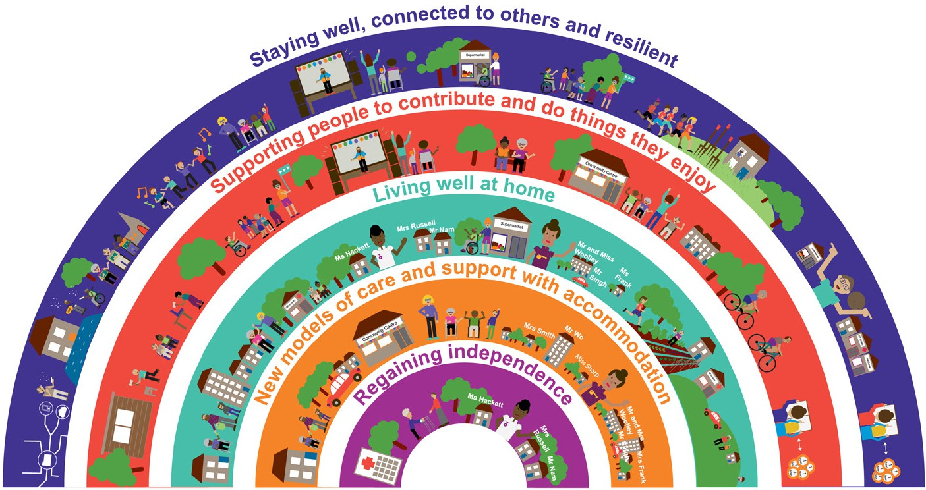

**Figure 1. Innovations in community-centred support**8

# Policy context

In August 2019, the Minister for Health released *Australia’s long term national health plan*,9 which includes a goal to make primary healthcare more patient-focused, more accessible, and better able to provide preventive health and manage chronic conditions. The Australian Government has committed to implement a 10-year plan for primary care and has also commenced the development of a National Preventive Health Strategy.10

We strongly support the Minister’s goal of making the health system better at preventing disease and promoting health, more focused on patients’ multidisciplinary needs, more affordable and more accessible to all. In order to achieve this, we need to consider new and different ways of delivering care and consider all the factors that contribute to health and wellbeing.

# Patient activation in Australians with chronic illness – Survey results

CHF recently published the results of a 2019 [national patient activation survey](https://chf.org.au/publications/patient-activation-australians-chronic-illness-survey-results), which explored the different levels of activation across different healthcare consumers.11 Often, lack of engagement or activation is cited as a barrier to increasing self- management and more shared decision making, which are known to support improved experiences of care and health outcomes.

CHF utilised the Patient Activation Measure (PAM®) tool across a national sample of 1703 adults with two or more chronic illnesses, with consumers being assessed across four levels of activation, as outlined in Figure 2.

|  |  |
| --- | --- |
| **Level** | **Individual engagement in health-supportive behaviours and shared decision making** |
| 1 | Passive, overwhelmed, poor understanding of their role in the care process |
| 2 | Lack knowledge and confidence to manage their health |
| 3 | Appear to be taking action but may still lack confidence and skills to support their behaviours |
| 4 | Have adopted appropriate behaviours but may find them hard to maintain in the face of health stressors |

#### Figure 2. Summary of PAM® tool levels11

Over one-quarter of respondents were classified as Level 4 (having adopted behaviours to support their health) with a further 41% classified as Level 3 (acting but lacking skill and confidence). This research found that many Australians with chronic illnesses have high levels of patient activation and that those with the highest levels of activation had better self-reported outcomes and experiences in the healthcare system.11

The findings suggest that should health policy and practice incorporate measures designed to improve levels of patient activation, the overall health outcomes and experiences of Australians with chronic illness could be improved. Some measures suggested to support consumers to be active participants in their healthcare include shared decision-making practices, tools and resources to support shared decision making, evidence-based self-management services, practice-based health coaches, service coordinators and social prescribing.11

In choosing to focus this discussion on social prescribing, we recognise that social prescribing exists as one component of a broader ‘universal personalised care’ approach. Multiple components are important to improving patient activation, engagement and health outcomes. Evidence suggests that consumers achieve better health outcomes when

they have choice and control over the way their care is planned and delivered, based on ‘what matters’ to them and their individual strengths, needs and preferences. Each of the measures listed above can contribute to this goal. Further research and evidence is needed to better understand the role for each of these tools in the Australian context.

# Value-based healthcare

Value in healthcare is defined as the health outcomes that matter to patients relative to the resources or costs required.12 With almost all governments and healthcare organisations operating in resource-constrained environments, change is best achieved with a focus on both value and outcomes for consumers. This is not to be confused with cost reduction, which cannot solve these problems alone; paying less for ineffective care will not improve outcomes.

The Value Institute for Health and Care in Texas found that the ‘greatest gains in value creation occur when organisations restructure care around patients’ needs, use dedicated, multidisciplinary teams to deliver comprehensive solutions, and measure the results of their care’.13 Social prescribing fits with this model, and recognises that, by broadening the care team out to include service providers in the voluntary and community sectors, there is an opportunity to address both the medical and non-medical challenges the consumer faces in a coordinated way.

In considering what represents value in this context, the definition of care needs to be broad enough to address the social determinants of health, and to recognise that some non-clinical interventions may prove effective in improving health outcomes. And as for any new approach, measuring outcomes will be essential to determining the effectiveness and value of social prescribing.

Equally, social prescribing must represent value to the consumer. Will social prescribing meet consumer expectations, particularly if those expectations are based on traditional models of healthcare? As noted in CHF’s recent report on patient activation, patients achieve better outcomes when they are active participants in their care. This can be achieved by giving consumers choice and control over the way their care is planned and delivered, based on what matters to them.14 In this situation, the consumer is more likely to feel they are getting value out of their care.

# International examples of social prescribing

## United Kingdom

The role of the ‘link worker’ is central to the model of social prescribing being implemented across the United Kingdom through the NHS. Link workers can be known by a variety of names, including wellbeing adviser, community connector, community navigator, community health worker, community health agent and health adviser. Link workers are typically located in primary care through primary care networks as part of

a wider network team and can take referrals from a wide range of local agencies. Link workers co-produce a summary personalised care and support plan based on the consumer’s assets, needs and preferences.14

Under the NHS model, the link worker role does not require a clinical qualification and instead focuses on the ability to provide personalised support and work with the individual, their family and carers to co-produce a personalised support plan. The role involves introducing and connecting people to community groups and working with local partners to support the sustainability of those groups and address gaps as required. Further details are available through the NHS’s *Social prescribing and community-based support summary guide*,2 which includes a draft job description and person specifications for the link worker role. The National Association of Link Workers has also developed a *Code*

*of practice for employers of social prescribing link workers and social prescribing link workers*,15 which sets core standards for high-quality social prescribing practice.

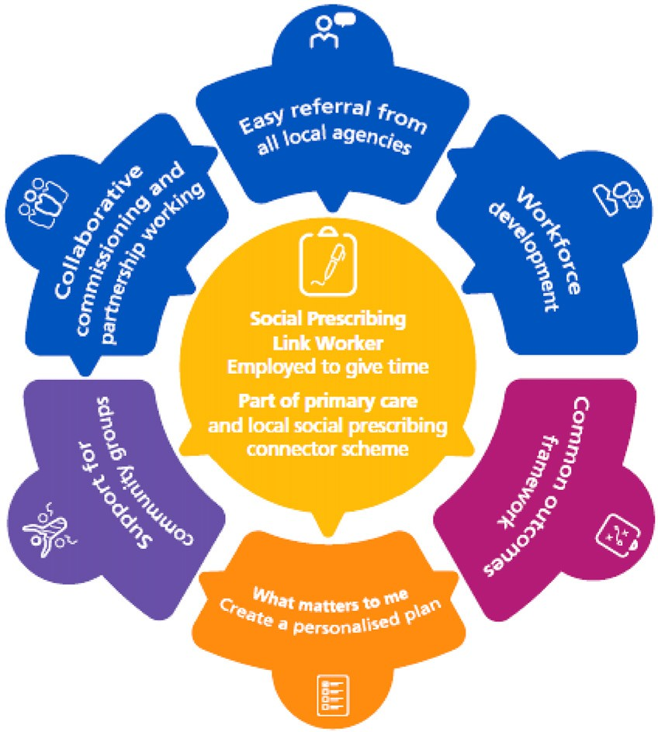

#### Figure 3. Standard model of social prescribing in the NHS2

The NHS suggests that the target cohort for social prescribing includes people:

* with one or more long-term physical health condition
* who need support with their mental health
* who are lonely or isolated
* who have complex social needs that affect their wellbeing.2

In the NHS Long Term Plan, the UK government has committed to building the infrastructure for social prescribing in primary care. The goal is that there will be 1000 new social prescribing link workers in place by 2020–21, with significantly more after that, so that at least 900,000 people will be referred to social prescribing by 2023–24.14

## Canada

The Alliance for Healthier Communities is piloting a social prescribing pilot in Ontario, building on models from the United Kingdom. Doctors and nurse practitioners are enabled to prescribe, for example, dance lessons, cooking classes, volunteer roles, caregiver supports, single parent groups and connections to bereavement networks.

The aim is for clients to be empowered to take control of their own health and co-create solutions.14

Ontario’s chief medical officer has identified loneliness and social isolation as major health threats, noting that ‘people with a weak sense of community belonging are more likely to be in the top five per cent of users of health care services; this five per cent accounts for more than 50 per cent of total health care spending’.16

Under the Ontario model, social prescribing refers to a deliberate and structured way of referring clients from clinical practice to non-clinical supports when appropriate, with the goals of improving their overall health and wellbeing and decreasing the use of the healthcare system for non-clinical needs. The major difference from the UK model is that this pilot is being rolled out in community health centres where interprofessional providers, including clinical and health promotion teams, are already working together, rather than a traditional primary care setting.16

The current pilot is funded through existing resources, with staff taking on implementation alongside their existing responsibilities. This has made it challenging to reach the full scope of social prescribing to this point.3

The Ontario pilot is being trialled in 11 community health centres representing a diverse mix of communities. This model also involves the use of a link worker type role, who acts as the connection between a client, their provider and community supports. The role can be held by people from either clinical or non-clinical backgrounds and involves working with the client in a co-creative way to identify strengths and needs and connect them to appropriate non-medical community resources or supports.3

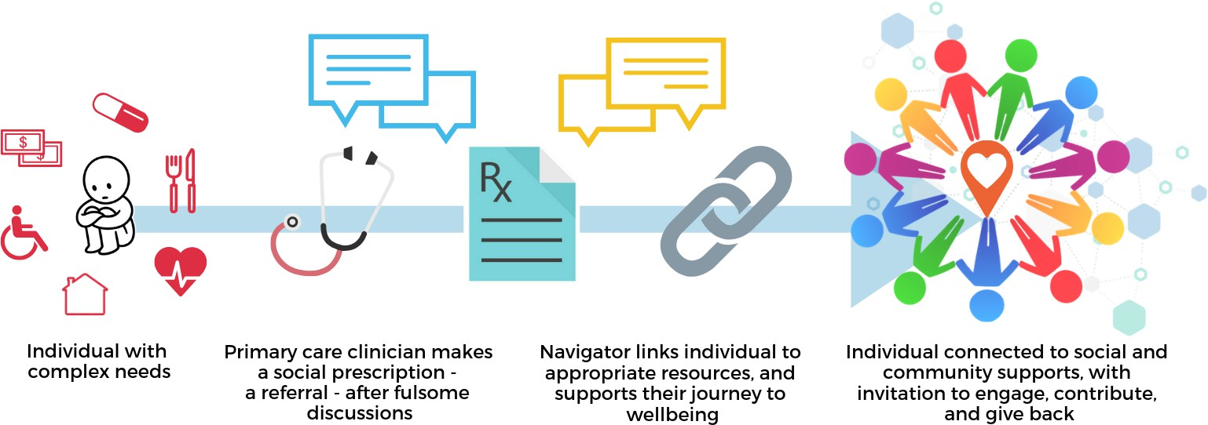

#### Figure 5. Ontario social prescribing pathway3

As of March 2019, 55 providers had made over 600 social prescriptions to 221 clients.

Individuals have been connected with social, learning and physical activities, as well as food, shelter and income supports. Participants have shared the positive impacts of social prescribing through initial focus groups, particularly related to improving their sense of community belonging and mental health and wellbeing.3

## New Zealand

While New Zealand does not have a comprehensive social prescribing program embedded into the health system akin to the United Kingdom, the Green Prescription (GRx) initiative has been in place since 1998. Under this initiative, a health professional provides written advice to a patient or their family to encourage and support them to become more physically active and eat healthier as part of a total health plan.

If the patient wants ongoing support then the script is forwarded to the nearest GRx provider who supports the person to become more active through phone calls, face-to-face meetings and group support programs. In 2014–15, GRxs were issued to more than 47,000 patients.17

The benefits of physical activity and improved nutrition are well known, particularly for those with chronic conditions. A 2015 study looking at the long-term effects of the GRx initiative found that those who had received a GRx were likely to have increased health benefits compared to those who hadn’t participated in the program; this was supported by participants self-reporting positive health changes post-GRx.17 It also found that after at least 24 months of being prescribed and completing a GRx, 23.1% were meeting or exceeding physical activity guidelines, compared with none meeting the guidelines prior to the intervention.17

GRx shares some similarities with the Australian Government’s Lifescripts initiative, which was established in 2009 to provide evidence-based tools to enable general practices to assist patients to modify and/or change their lifestyles. While the resources for the Lifescripts program were withdrawn from circulation in 2013, the information available indicates this initiative adopted a ‘lighter’ approach, where information was given to the consumer and participation was left up to the individual to facilitate. This is known as ‘active signposting’ under the NHS model and works best for people who are confident and skilled enough to find their own way to services after a brief intervention.2

# Individual case study examples

## Brian’s story

Brian* made an urgent, same-day appointment with a nurse practitioner at his local community health centre. During the appointment, he spent most of the session discussing his late wife, who had died just over a year before. The nurse practitioner recognised a need for social prescribing and made a referral.

He was called by a lead consumer representative who had taken on the role of ‘health champion’, working alongside clinical staff to identify needs and co-create solutions. The health champion invited him to join the Learning to Live Again: Life Beyond Grief social support group for people whose partner has died. He attended the group and is now socialising with members of the group through meetings, lunches and other activities.3

## Terry’s story

Terry* has congenital deafness, which he feels stigmatised by, and had previously been socially isolated. He has exhibited difficult behaviours that have escalated over time.

Terry was referred to a social prescribing link worker by his local GP and has been supported by the link worker and local council staff to host weekly card games at his local community centre.

The new social connections have led to calmer and shorter primary care appointments. Moreover, Terry used to be very resistant to participating in group activities, but since organising the card games, he has now become involved with other health support groups. By being invited and supported to lead activities, Terry saw that he can be involved with other people in a trusting, accepting environment, which is having a transformative impact on his life.3

# Program case study examples: Australia

In Australia, many GPs, practice nurses and allied health professionals routinely refer to community organisations. A good example are those patients who are encouraged to attend Parkrun. This is a local government-supported nationwide Saturday morning 5 km run or walk with an emphasis on socialising and exercise. The impact of these ad hoc referrals has not been evaluated.

We are also aware of a small number of more formal social prescribing pilots that are currently underway in Australia. Examples of pilots that have been developed using place-based approaches include those currently taking place in Brimbank, Victoria, and Mt Gravatt, Queensland. Both will be discussed further at the roundtable and some background on the Mt Gravatt pilot is provided in Appendix 1. Additionally, a model of care for social prescribing is being co-designed in the Latrobe Valley, Victoria, by the Latrobe Health Assembly and Larter Consulting, with community members, the local general practice sector and community service stakeholders.The draft model of care

is provided in Appendix 2.

These are just a few of many examples of local communities exploring social prescribing and finding models that work best for them. We will use the roundtable to learn from these cases and identify examples of best practice.

*Examples are based on real cases from the Alliance for Healthier Communities Social Prescribing Pilot in Ontario, Canada. Names have been changed to protect anonymity.

## Further reading

* [Alliance for Healthier Communities. Social prescribing in Ontario – Progress](https://www.allianceon.org/sites/default/files/documents/Rx-Community-Progress-Report-EN-June2019-web.pdf) [report. Ontario: AHC, 2019.](https://www.allianceon.org/sites/default/files/documents/Rx-Community-Progress-Report-EN-June2019-web.pdf)
* [Australian Health Policy Collaboration. The state of self care in Australia.](https://www.vu.edu.au/sites/default/files/the-state-of-self-care-in-australia.pdf) [Melbourne: AHPC, 2018.](https://www.vu.edu.au/sites/default/files/the-state-of-self-care-in-australia.pdf)
* [Consumers Health Forum of Australia. Patient activation in Australians with](https://chf.org.au/publications/patient-activation-australians-chronic-illness-survey-results) [chronic illness – Survey results. Deakin, ACT: CHF, 2019.](https://chf.org.au/publications/patient-activation-australians-chronic-illness-survey-results)
* [Greater London Authority, Healthy London Partnership and the London Social](https://www.london.gov.uk/sites/default/files/social_prescribing_next_steps_document.pdf) [Prescribing Network. Next steps for social prescribing in London. London:](https://www.london.gov.uk/sites/default/files/social_prescribing_next_steps_document.pdf) [Mayor of London, 2019.](https://www.london.gov.uk/sites/default/files/social_prescribing_next_steps_document.pdf)
* [Hendrie D. Are Australia’s GPs ready for social prescribing? newsGP, 26 July 2019.](http://www1.racgp.org.au/newsgp/professional/are-australia-s-gps-ready-for-social-prescribing)
* [The King’s Fund. What is social prescribing? The Kings Fund, 2019.](https://www.kingsfund.org.uk/publications/social-prescribing)
* [Personalised Care Group. Universal personalised care. London: NHS, 2019.](https://www.england.nhs.uk/wp-content/uploads/2019/01/universal-personalised-care.pdf)
* Polley M, Fleming J, Anfilogoff T, et al. [Making sense of social prescribing.](https://docs.wixstatic.com/ugd/14f499_816dc79e160a4e77991599a74236d0d4.pdf) [London: University of Westminster, 2017.](https://docs.wixstatic.com/ugd/14f499_816dc79e160a4e77991599a74236d0d4.pdf)

## Appendix 1 – Case study: Ways to Wellness project

The Mt Gravatt Community Centre Inc, with the support of the local community and a working group, are addressing social isolation and loneliness in Mt Gravatt and surrounding suburbs, through the implementation of the Ways to Wellness Social Prescription project.

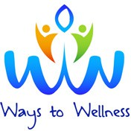

The pilot project is trialling two project models: the Community Link Worker model, funded by the Department of Communities, Disability Services and Seniors, which focuses on community client referrals; and the Holistic Health model, funded by the Department of Social Services, whereby a healthcare link worker, who is co-located at local general practices, receives client referrals through the general practices and other medical and health organisations.

Since its launch in June 2019, the project has supported over 70 participants to connect to social groups, local activities and support services, and to reach their overall health and

wellbeing goals. Participants’ primary presenting issues to date have been mental health issues such as anxiety, depression and schizophrenia, which have contributed to their social isolation.

Before engaging in the project, most participants were receiving medical treatment from a GP, however, few participants were engaging in any social activities and they had few or no social connections. After completing the project’s intake process, 88% of participants had participated in a new activity and/or had joined a social group. The remaining 12% of

participants had primary needs to initially address, such as mental health, disability or linking to aged care services prior to external engagement.

Referral sources have included self-referral, community referrals and organisational referrals.

19% self-referrals

26% community referrals

55% organisational referrals

Over 30 organisations are involved in identifying and referring participants, including local GPs, hospitals, Metro South Hospital and Health Service, Queensland Police, the

Department of Housing, and community organisations. Over 80 local activities and groups have been identified as referral sources, including exercise classes, craft classes, music groups, the Mt Gravatt Men’s Shed, singing groups, seniors’ activities and social groups.

A 1693 Logan Rd, Po Box 806, Mt Gravatt, 4122 P 07 3343 9833 F 07 3420 4366 W mgcci.org.au



Early feedback from participants indicates that the social prescribing approach is delivering positive results.

*‘I feel really supported now in the community and didn’t realise how much support was out there.’*

*‘Both my son and I have joined the Mt Gravatt Men’s Shed. We go once a week together and everyone is so welcoming. It is the highlight of my week.’*

*‘I haven’t played lawn bowls in years (due to depression). The link worker helped me join the local bowls club and I have met some really wonderful people.’*

*‘I know I have lost out on lots of experiences staying home all the time. Thank you for giving me the confidence and support to meet new people and make friends who I can even just have a cup of tea with.’*

The University of Queensland has recently been awarded an Australian Research Council linkage grant in partnership with Mount Gravatt Community Centre Inc and the Mount Gravatt Men’s Shed to research the impact and outcomes of the Ways to Wellness project until September 2022.

A 1693 Logan Rd, Po Box 806, Mt Gravatt, 4122 P 07 3343 9833 F 07 3420 4366 W mgcci.org.au

**CONSULTATION DRAFT**

**Green Script**

**LifeScript**

**Active Script**

**social connectedness**

## Developing a model of "social prescribing" for Latrobe Valley

**DEVELOPED**

**BY THE COMMUNITY, FOR THE COMMUNITY.**

**Different Models of Referral Pathways**

### Strengths-based, empowering, person-centred.

**community referral**

**community prescribing**

Enables people whose health or mental health is affected by non-medical factors such as health literacy, loneliness or social exclusion, housing, financial stress to be referred to a range of community services that can support these issues

**How to build on HELLO campaign?**

English language support

Employment Home

ageing

intergenerational trauma

disabilities and/or brain injury

depression and/or addiction

farmers

employment, financial, housing stress

living with

New to area ex Melbourne/other bereaved

youth

frequent GP attendees

Aboriginal

chronic mental health

suicidal behaviours

socially isolated or lonely

management patients

post-separation

pain

single/young mums reassurance/social/TLC patients

refugees/NESB CALD

SIGNPOSTING e.g. brochures

**1**

* Free / low cost
* Build on strengths
* Creative partnerships
* Transport
* Tear off slip

Every GP has desktop menu of 5-7 community referrals (eg library, neighbourhood house, walking group, community lunch, crisis relief, men’s shed, volunteering, community garden, some sports groups, No Cost Activity Guide

gardens

Option: fund GP to deliver X non-clinical interventions

Referral only

Financial advice

**2**

Hobby

GP, PRACTICE NURSE, CDM NURSE, NURSE PRACTITIONER, ALLIED HEALTH, INTAKE WORKERS

refer to Community Activity / Program

Practical information

Community activity

courses

Consultation

Food vouchers

Latrobe Valley community assets

Embed Social Health Check (SDH screening) into admission/ waiting room questionnaire

* Innovation site
* Collaborative of practices
* Town-based

Physical activity

(organisations, groups, supports) “prescription pad”

Mobility

Befriending services

**3**

Consultation

support

Learning & skills

DEDICATED WORKER / CONCIERGE:

Carer support

multiple chronic diseases long-term unemployed

community connector, care or social navigator, lifestyles coordinator, link worker (clinical or non-clinical?)

Telephone line

Visa

Volunteering

Life Activities

Recreational/ diversional therapy

Arts

Enabling

### Referral sources

Minimise wait list

Simple streamlined referral

support

Clubs

services

* General practice (CDM Nurses)

Enabling/ Coaching

* Other primary care: (allied health, community health)
* District Nurses
* ACAS
* Settlement workers
* MNCH for CALD

**Examples of community priorities:**

* Building confidence • Legal disadvantage
* Elders advocacy • Post-separation support
* Lunch clubs • Neighbourhood disputes
* Coffee companions • Microenterprise coaching
* Walking group • Books
* Footy, cricket • Yoga
* Parent support groups • Community singing
* Churches • Victim assistance

Skills:

e.g. community development, social worker, motivational interviewing, ‘work’ coaching.

Key:

(i) needs assessment (ii) co-producing goals, actions, plus relationship management with

health services and community sector

* has sufficient time
* home visits
* telephone appts
* assertive follow up
* bus

Mix of locations? (general practice, library, neighbourhood house, etc)

Full psychosocial assessment, with quality of life, strengths, goals (maybe psycheck)

* Proactive Policing Unit
* MHAPR
* Pharmacy

model

GPHN

New

**4** OTHER MODELS?

Quantum Social Health Teams model

Worker to use app/digital platform (e.g. Discover Local, AskIzzy, new GPHN platform)

Prescribe service rather than activities e.g. Neighbourhood House, GEST

Volunteers support enabling mechanism (ie accompaniment, welcome pack, buddy system)

* + Self-referral



|

**Social Prescribing Roundtable, November 2019 Stimulus paper 11**

**Appendix 2 – Social prescribing for Latrobe Valley consultation**

* + Hospital discharge planners
  + Ambulance officers/case managers

**Feedback to general practice:**

how will data travel? Worker attends MDT (multidisciplinary team) meetings

* + Community legal
  + Church for CALD
  + Funeral parlours
  + Nurses in primary schools
  + Centrelink
  + Dental

Intake, demand management

# References

1. The King’s Fund. What is social prescribing? London: The Kings Fund, 2019. Available at [www.kingsfund.org.uk/publications/social-prescribing](http://www.kingsfund.org.uk/publications/social-prescribing) [Accessed 1 November 2019].
2. National Health Service England. Social prescribing and community-based support: Summary guide. London: NHS, 2019.
3. Alliance for Healthier Communities. Community – Social prescribing in Ontario: Progress report. Ontario: AHC, 2019.
4. Torjesen I. Social prescribing could help alleviate pressure on GPs. BMJ 2016;352:i1436.
5. Polley MJ, Fleming J, Anfilogoff T, Carpenter A. Making sense of social prescribing. London: University of Westminster, 2017.
6. Global Access Partners. Ensuring the sustainability of the Australian health system. Australia’s Health 2040 Taskforce Report. Sydney: GAP, 2019.
7. No health care without social care. Editorial. Lancet 2019;394(10205):1206.
8. Think Local Act Personal. Innovations in community-centred support. TLAP, 2019. Available at [www.thinklocalactpersonal.org.uk/innovations-in-community-centred-support](http://www.thinklocalactpersonal.org.uk/innovations-in-community-centred-support) [Accessed 1 November 2019].
9. Australian Government Department of Health. Australia’s Long Term National Health Plan. Canberra: DoH, 2019. Available at [www.health.gov.au/resources/publications/australias-long-](http://www.health.gov.au/resources/publications/australias-long-) term-national-health-plan [Accessed 1 November 2019].
10. Australian Government Department of Health. National Preventive Health Strategy. Canberra: DoH, 2019. Available at www1.health.gov.au/internet/main/publishing.nsf/Content/national- preventive-health-strategy [Accessed 1 November 2019].
11. Consumers Health Forum of Australia. Patient activation in Australians with chronic illness

– Survey results. Deakin, ACT: CHF, 2019. Available at https://chf.org.au/publications/patient- activation-australians-chronic-illness-survey-results [Accessed 1 November 2019].

1. Woolcock K. Value based healthcare: Setting the scene for Australia. Issues brief no. 31. Deakin West, ACT: Deeble Institute for Health Policy Research, 2019.
2. Teisberg E, Wallace S, O’Hara S. What is value in healthcare? The Health Advocate, June 2019.
3. National Health Service England. Universal personalised care – Implementing the comprehensive model. London: NHS, 2019.
4. National Association of Link Workers. Code of practice for employers of social prescribing link workers and social prescribing link workers. Birmingham: NALW, 2019. Available at [www.connectlink.org/wp-content/uploads/2019/06/Released_NALW_Code-of-Practice-](http://www.connectlink.org/wp-content/uploads/2019/06/Released_NALW_Code-of-Practice-) for-employers-of-social-prescribing-link-workers-and-social-prescribing-link-workers_12- June-2019.pdf [Accessed 6 November 2019].
5. Williams DC. Connected communities healthier together: 2017 annual report of the Chief Medical Officer of Health of Ontario to the Legislative Assembly of Ontario. Toronto: Ministry of Health and Long-Term Care, 2017.
6. Yule EG. The long-term effectiveness of the New Zealand Green Prescription Primary Care Health Intervention on Christchurch residents. Dissertation. Lincoln University, 2015.

 

Healthy Profession. Healthy Australia.