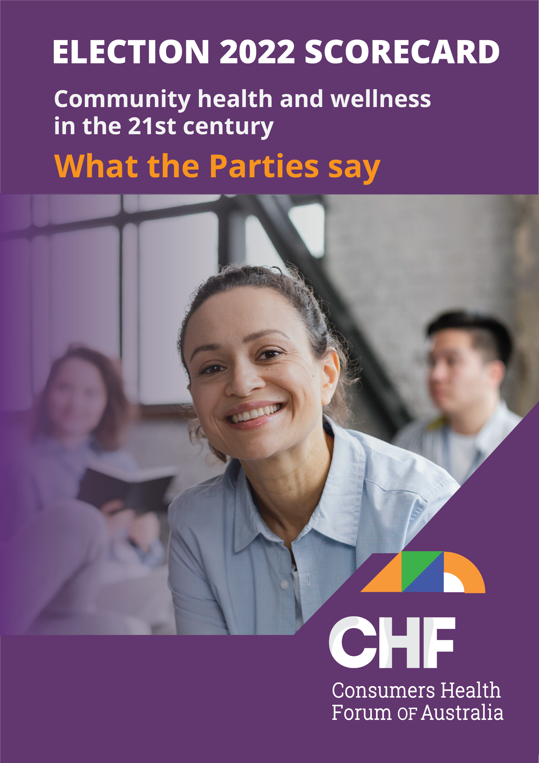

## How CHF rated the parties

CHF identified four key policy areas in its **Election Platform 2022: *Community health and wellness in the 21st century***[launched in February 2022](https://www.chf.org.au/sites/default/files/chf_electionplatform_2022_v4b-digital.pdf). Across these, we called for 13 commitments from Australia’s political parties which would lay the groundwork for a modern sustainable health system that gives equitable access to services and will enable people to get the right care, at the right time and at the right cost.

We invited the Liberal-National Party Coalition (the Coalition), Australian Labor Party (ALP) and the Australian Greens (the Greens) to respond directly to our reform recommendations. We indicated to all parties our intention to publish their responses alongside our appraisal. We received responses from the ALP but not from the Coalition or the Australian Greens.

In our appraisal we rate the parties against the priorities set out in our Election Platform. We also highlight key initiatives from all parties that we believe, while not articulated in our platform, would help achieve the same goals. We have conducted this appraisal using two sources: statements made by the major parties during the election campaign, the parties’ responses to our letter and discussions we have had with them.

Our appraisal applies to the various election pledges made by the major parties as at 16 May 2022.

#### Here’s how CHF rated the parties’ positions:

|  |  |
| --- | --- |
|  | Where a party made an explicit commitment in-line with CHF’s priorities, we scored their position as having **MET** ours. |
|  | Where a party made a statement that supports CHF’s priorities, but without making an explicit commitment to reform, we scored their position as **SUPPORTING** ours. |
|  | Where a party did not make any apparent statement supporting CHF’s priorities, or made a statement in opposition to CHF’s priorities, we scored their position as having **MISSED** ours. |

## Overall assessment

CHF, guided by a consumer led steering committee, developed its priorities for Election 2022 through extensive consultation across its membership and with consumers. The process was informed by recommendations from our ***Making Health Better Together*** [report, which was developed](https://www.chf.org.au/sites/default/files/docs/chf_consumer_commision_report_v4final.pdf) by our Consumer Commissioners in 2020.

We identified four key priorities for reform and called on the incoming government to:

* implement the key policies set out in the 10 Year Primary Health Care Plan
* implement key components and strategies set out in the 10 Year Preventive Health Strategy
* strengthen consumer participation in health policy, governance and delivery
* improve consumer access to health services.

Overall, the debate about health policy in this election has been disappointing, with neither major party devoting much attention to it during the televised leaders’ debates, and the absence of a debate between health spokespeople. This is despite the fact that health is still one of the top issues for people when they are asked about what matters to them. None of the three parties have presented an *overall* overarching vision of what they want to see the health system look like in the future.

Both the Coalition and ALP have supported the *10 Year Primary Health Care Plan* released in March. With wide stakeholder consensus, and after two years of extensive consultation, the Plan provides a forward-looking blueprint for reform of primary health care.

All parties have committed to putting more focus on prevention under the framework of the *National Preventive Health Strategy 2021-2030* - a welcome area of attention. They all have additional initiatives that address various parts of the system. There is, unfortunately, not support across the board to establish a National Centre for Disease Control. We and other health stakeholders consider this an important part of our public health arsenal essential to future pandemic preparedness.

We asked them to deliver on key reforms in both the 10 year plans and to for any additional initiatives to be aligned with those plans, and not distract from them.

It is disappointing that, yet again, neither the ALP nor the Coalition are offering improvements to dental health care access across the community. The Greens have called for dental health to be included in Medicare, which would give the universal access that we have asked for.

There are two key areas that we did not address directly in our Election Platform that have been dominating the health discussion. The first is the pressure on the cost of living from higher inflation and the effect it has on affordability of health services. The second is the effect of workforce shortages and pressures within the health system, particularly in rural and regional Australia.

The Coalition and ALP have announced that they will make prescription medicines cheaper for many Australians by cutting the PBS co-payment. They have also both announced increases to income test limits for the Commonwealth Seniors Health Card, which will give more people access to prescription medicines at concessional levels. CHF notes these measures will not improve access for people on the lowest incomes, including those receiving income support payments, to services or affordable medicines. We are disappointed that only the Australian Greens have made a commitment to increase income support payments, including Jobseeker and related payments, to help move people out of poverty.

COVID has highlighted the critical workforce pressures across the board in the health system. These pressures relate to the number of health professionals, their distribution across the country and the difficulties in recruiting and retaining them. These are not recent problems, but the underlying problems have been exposed since the pipeline for overseas recruitment closed during COVID. All three major parties have made statements on workforce and commitments, but none have committed to do serious work on a national health workforce agenda.

Much of the focus from the ALP and Coalition has been on workforce shortages in rural and regional Australia. This is welcome, as we do need to address the lack of access to healthcare outside the major urban areas. They will take time to come into effect and have an impact, so there needs to be more thought given to how to fill the gaps now while we wait for these pipelines to deliver.

The Coalition has also announced a package of funding for additional mental health services, including expanding Head to Health, headspace, children’s mental health services and aftercare services for people who have tried to take their own lives. It will also fund additional services to support mental health for new parents.

We see a disconnect between what the parties think is important and what consumers have identified as important health reforms. This highlights the need for consumers to be more involved in health policy development and for a more systematic co-design process to give consumers an equal place at the table. This is at the heart of our advocacy for an Australian Consumer Leadership Academy, continued funding for the Youth Health Forum, and a National Youth Commissioner. CHF will make this a priority issue for discussion with an incoming government.

## Primary health care

|  |  |  |  |
| --- | --- | --- | --- |
| **We called for…** | **Coalition** | **ALP** | **Greens** |
| Implement the 10 Year Primary Health Care Plan |  |  |  |
| A National Social Prescribing Program |  |  |  |
| National Collaborative Commissioning across Primary health Networks |  |  |  |

### Our commentary

It is heartening to see that both the ALP and the Coalition have committed to implementing the 10 Year Primary Health Care Plan. It is a Plan which sets out a reform package to ensure the primary healthcare system moves away from a very transactional fee-for-service model to one that treats people holistically. It is also good to see that social prescribing is on the agenda for all parties as a new way to support people to look after themselves and find longer term sustainable ways of maintaining good health.

The Coalition has not provided any further funding pledges to its implementation during the election campaign. The ALP promised $135 m to 50 urgent Care Clinics, $750 million for a Strengthening Medicare Fund, and $250 million for Strengthening Medicare GP Grants. A commitment of funding for team-based care by the Greens augment the plan and both help promote integration and continuity of care.

## Commitment to preventive care

|  |  |  |  |
| --- | --- | --- | --- |
| **We called for…** | **Coalition** | **ALP** | **Greens** |
| Implement the 10 Year Preventive Health Strategy |  |  |  |
| Prevention expenditure to increase to five per cent of total health funding |  |  |  |
| Establish a National Centre for Disease Control |  |  |  |
| A National campaign to raise awareness and address causes of obesity |  |  |  |
| Whole of government approach to address loneliness |  |  |  |

### Our commentary

Prevention is key to making the health system sustainable in the longer term. It has tended to be underdone in policy promises and initiatives in the past. We now have a National Preventive Health Strategy 2021-2030, which was developed through a thorough consultation process and sets out a structured way to improve prevention. It is pleasing to see all parties committed to it and to increasing funding for prevention.

The COVID pandemic highlighted the need for better disease surveillance and more consistent advice on how to address new diseases. This is an issue which needs national leadership, and we are pleased that both the ALP and Greens have committed to establishing a National Centre for Disease Control.

COVID also highlighted the significant problems of loneliness and social isolation, and we are disappointed with the lack of response to our call for a national whole of government approach to addressing this issue. Clearly, we will need to press an incoming government to look at these problems and work together to co-design a program.

## Developing health consumer participation

|  |  |  |  |
| --- | --- | --- | --- |
| **We called for…** | **Coalition** | **ALP** | **Greens** |
| The Establish Australian Health Consumer Leadership Academy |  |  |  |
| Continue funding for Youth Health Forum |  |  |  |
| Appoint a Youth Health Commissioner |  |  |  |

### Our commentary

#### Consumer participation

The Consumer Commission, established in 2020 by CHF, identified the need to better support consumer involvement in all aspects of the health system. The Commission highlighted that, in the pandemic, involvement of consumers in policy and program development and development of the pandemic response was variable. Amidst the pressure for health services to act and adapt expediently to respond to the crisis, and for public health protection measures to be rapidly put in place including vaccination arrangements, consultation with consumers was often overlooked. Jurisdictions that did not adopt this approach strengthened the relationship between consumers and health services and saw the value of collaborating with the people who used the services to get workable solutions.

It is disappointing that we have not seen any commitment from the two major parties to prioritise consumer involvement in discussions about reforms and priorities for health in Australia. We are encouraged that the ALP has indicated interest in discussing the proposed Australian Consumer Leadership Academy. In the 2019 election campaign, the Australian Greens indicated specific support for a Patient Leadership Academy, so we have indicated that they partially meet this priority as it is till part of the policy platform.

#### Youth health

CHF has learnt from the first three years of operating Youth Health Forum that young people have quite a different experience of the health system than others in their communities, and that their needs are simply not being part in many mainstream services. The Youth Health Forum Summit, held in 2021, identified a lack of political and policy representation as a key concern for young people.

The Australian Greens previously indicated a commitment to making sure young people/organisations and bodies representing them are heard and provided with support. This is why we have indicated they address our recommendations on the Youth Health Forum and a Youth Health Commissioner.

The Coalition developed the National Child and Youth Health Action Plan 2020-2030, which included funding for CHF’s Youth Health Forum. It would have been good to see a further commitment to continue this work.

## Improved access to health services

|  |  |  |  |
| --- | --- | --- | --- |
| **We called for…** | **Coalition** | **ALP** | **Greens** |
| Universal dental health funding |  |  |  |
| National scheme to meet travel cost for rural health consumers |  |  |  |

### Our commentary

Both measures called for in the CHF platform would reduce health inequities, so it is very disappointing to see neither addressed by the Coalition or ALP.

There is a significant body of evidence showing the relationship between oral health and overall health status. Currently access is very inequitable. People who can afford dental care get it by either paying directly or using their private health insurance to fund it, while those who cannot afford private dental care, wait long periods for access through a poorly funded public dental system. This is simply not good enough and there is no reason oral and dental health should be treated any differently to other parts of the body.

We welcomed the introduction of the Child Dental benefit Scheme and would welcome a similar scheme for older people, as a step towards a universal scheme.

Both the Coalition and ALP refuse to look at making access to dental care affordable for all, with only the Greens making a commitment to universal dental health funding through Medicare.

People living in regional, rural and remote Australia incur significant costs to travel to get the care they need. this exacerbates the inequity of health access and outcomes for rural healthcare consumers, compared to people living in urban areas. The states and territories provide varying levels of support for such expenses, but rarely meet the cost, so consumers bear the burden. The Commonwealth could take a leadership role and work with the other jurisdictions to establish a national scheme so access to health care is not determined by postcode.