

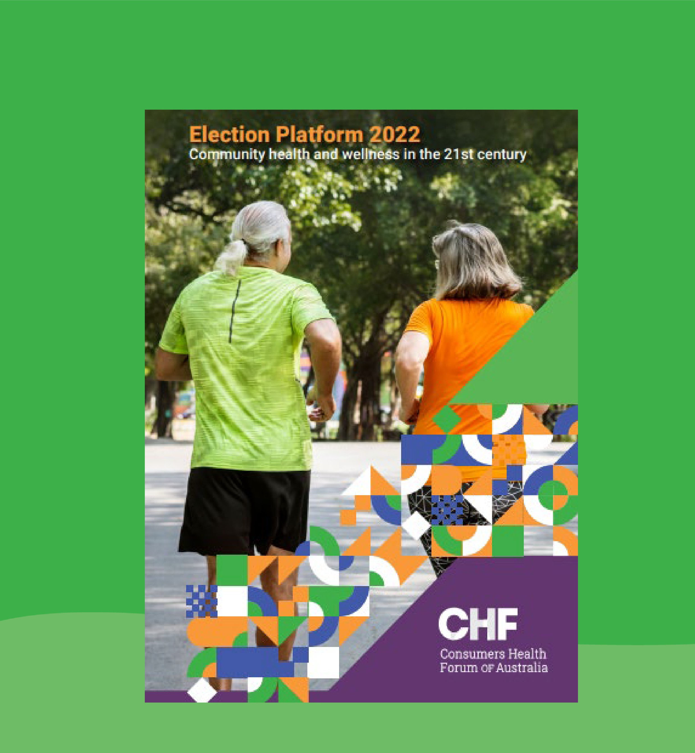

Consumers Health Forum OF Australia

**Information package**

Consumers Health Forum of Australia (2021)

*Information package Election Platform 2022*

**P:** 02 6273 5444

**E:** [info@chf.org.au](mailto:info@chf.org.au)

[twitter.com/CHFofAustralia](http://twitter.com/CHFofAustralia) [facebook.com/CHFofAustralia](http://facebook.com/CHFofAustralia)

**Office Address** 7B/17 Napier Close, Deakin ACT 2600

#### Postal Address

PO Box 73

Deakin West ACT 2600

*Consumers Health Forum of Australia is funded by the Australian Government as the peak healthcare consumer organisation under the Health Peak and Advisory Bodies Program*

[**CO**](https://consumerhealthforum.sharepoint.com/sites/PolicyTeam2/Other/Elections/Election%202022/Election%202022%20information%20package.docx#_Toc96435841)**NTENTS**

**Contents**

What’s in this package? 4

[What should my health care look like? 4](https://consumerhealthforum.sharepoint.com/sites/PolicyTeam2/Other/Elections/Election%202022/Election%202022%20information%20package.docx#_Toc96435841)

What are consumers asking for? 5

What are consumers immediate needs? 5

How can consumers get involved? 6

Get more information 6

Spread the word! 6

Write or call a politician 7

Q&As 9

How were the measures chosen? 9

What about other factors that affect health? . 10 What measures will support young people? 10

How has the pandemic affected consumers’ needs and the measures CHF has included in the Platform? 11

How will CHF persuade political parties and candidates to support the measures in the Platform? 11

Consumers want many more changes than are in this election platform. Why hasn’t CHF included other changes it has called for? 11

What is collaborative commissioning and how would it work? 12

What is social prescribing and how would it work? 12

**3**

# What’s in this package?

* The 4 priorities
* List of Election Platform measures
* How consumers can get involved
* Q&As

“What can be changed so that each patient, carer and community has the health services and care that they need to live the best and longest life that they can?”

### What should my health care look like?

* + I can register with a GP/general practice and build a relationship with my care team – which will include me and my carers/family – empowering me to actively engage in my treatment and care.
  + My GP/practice will be funded to provide me with holistic medical, mental health and allied health care, and dental care, to maintain and/or improve my overall health and wellness.
  + My GP/practice will provide me with continuity of care, including a single point of contact within the general practice and a link worker or navigator to connect me to other systems and supports, including integrated social, community and health systems when I need them.
  + My health care will be integrated and coordinated across primary, secondary and tertiary systems.
  + I can expect to get the same health outcome, regardless of where I live, my income, my level of education, my culture and heritage, my sex, gender or sexual orientation, or my age.
  + I can expect access to new and innovative health technology, including medicines and devices
  + There will be programs to help me improve my health, digital health and health system literacy.
  + Practices will offer services and treatments that are high quality, safe and affordable, and will clearly explain any out of pocket costs.
  + I will be able to access after hours’ services when I need them.
  + I will be able to choose whether to use telehealth, face to face, or other services.

# What are consumers asking for?

`There are four priorities for reform.

* + - Implement the 10 Year Primary Health Care Pan’s key policies.
    - Implement the 10 Year Preventive Health Strategy’s key measures.
    - Strengthen consumer participation in all areas of health policy, delivery, research and governance.
    - Improve consumer access to health services, including availability, choice and cost.

Government plans and strategies have drawn on long term advocacy efforts and consultations and should now serve as the basis for policy decisions by health ministers and governments over the next ten years.

Some areas may need tweaking, some measures need further thought and development and, undoubtedly, new priorities will emerge. It is important that consumers are central to those changes – they must be supported, nurtured and, most importantly, heard.

# What are consumers immediate needs?

Consumers have made it clear that the health system needs to change to offer more accessible, flexible and affordable health care, and that this can be achieved through:

* + - primary health care reforms that deliver national collaborative commissioning across all Primary Health Networks, that incorporate social prescribing
    - delivery on the Government’s promise to allocate 5 per cent of the health Budget on preventive care measures, including by:
      * establishing a centre for disease control
      * delivering a national campaign to raise awareness of and address the causes of obesity
      * offering grants to programs and services that support people experiencing loneliness or social isolation
    - developing health consumer participation and leadership, through
      * an Australian Health Consumer Leadership Academy
      * continuing the Youth Health Forum
      * appointing a Youth Health Commissioner
    - a dental benefits scheme for low income adults to get basic dental care, progressing over time to a universal scheme that treats oral and dental health in the same way as any other health condition
    - a national travel scheme to consistently – and adequately – meet the costs of travel for regional, rural and remote consumers (including carers) to access treatment in urban centres.

# How can consumers get involved?

There are three ways you can support the CHF Election Platform.

* + - Learn more about the Election Platform, what’s in it, and what the measures would achieve for consumers.
    - Spread the word through your networks.
    - Contact politicians and candidates to tell them your views.

## Get more information

CHF has produced supporting materials, which can be found on the [website,](https://chf.org.au/publications/chf-election-platform-2022) including:

* + - a [media release](https://www.chf.org.au/media-releases/health-care-reform-urgently-needed-acting-now-will-bring-about-change-we-need) (22 February 2022)
    - a blog article; “[*Changes in a lifetime we need in our healthcare*](https://www.chf.org.au/blog/changes-lifetime-we-need-our-health-care)” by Leanne Wells, Chief Executive Officer, CHF
    - a detailed case for an [Australian Health Consumer Leadership Academy](https://chf.org.au/publications/establishment-australian-consumer-leadership-academy). These will soon be accompanied by:
    - a series of video endorsements of the Youth Health Forum and Leadership Academy
    - media interviews and editorials
    - political party responses.

These will be available on the CHF website and social media channels when they happen.

There will be a *CHF Talks* webinar in the lead up to the election – please keep an eye out for details in the CHF newsletters and social media channels.

## Spread the word!

To get these key messages across to political leaders and parties, local members and candidates and voters, we need to build momentum across the country, advocating for changes to the health system and health delivery. You can inform your friends, health networks, groups you belong to, and others.

* + - Tell them where they can download this package.
    - Discuss any measures in the package that you are passionate about and encourage others to do the same.
    - Talk about the advocacy you and they can do in your own communities.
    - Like and share media posts about the Election Platform.

## Write or call a politician

Contacting local members and senators, leaders, political parties, and candidates, is really effective. Political offices always record the number of call and emails they receive on an issue, and it affects their own advocacy within their party and in in the community.

Calling or emailing your local member and other candidates is a good start. You will, not doubt receive leaflets and other information with their contact details in the lead up to the election. You can also search for your local member and senators on the Australian Parliament House [website.](https://www.aph.gov.au/Senators_and_Members) Below is a list of other members and senators, who may be interested in consumer views on health.

|  |  |  |
| --- | --- | --- |
| Government, Opposition and Green leaders/spokespeople | | |
| The Hon Scott Morrison MP | Prime Minister | 02 6277 7700  [Scott.Morrison.MP@aph.gov.au](mailto:Scott.Morrison.MP@aph.gov.au) |
| The Hon David Gillespie MP | Minister for Regional Health | 02 6277 7495  [David.Gilespie.MP@aph.gov.au](mailto:David.Gilespie.MP@aph.gov.au) |
| Senator the Hon Linda Reynolds CSC | Minister for Government Services | 08 9477 5411  [Senator.reynolds@aph.gov.au](mailto:Senator.reynolds@aph.gov.au) |
| The Hon Luke Howarth MP | Assistant Minister for Youth and Employment Services | 02 6277 4018  [Luke.Howarth.MP@aph.gov.au](mailto:Luke.Howarth.MP@aph.gov.au) |
| The Hon Anthony Albanese MP | Leader of the Opposition | 02 6277 4022  [A.Albanese.MP@aph.gov.au](mailto:A.Albanese.MP@aph.gov.au) |
| The Hon Mark Butler MP | Shadow Minister for Health and Ageing | 02 6277 4089  [Mark.Buttler.MP@aph.gov.au](mailto:Mark.Buttler.MP@aph.gov.au) |
| The Hon Bill Shorten MP | Shadow Minister for Government Services | 02 6277 4167  [Bill.Shorten.MP@aph.gov.au](mailto:Bill.Shorten.MP@aph.gov.au) |
| The Hon Amanda Rishworth MP | Shadow Minister for Youth | 02 6277 2293  [Amanda.Rishworth.MP@aph.gov.au](mailto:Amanda.Rishworth.MP@aph.gov.au) |
| Mr Adam Bandt | Leader of the Australian Greens | 02 6277 4775  [Adam.Bandt.MP@aph.gov.au](mailto:Adam.Bandt.MP@aph.gov.au) |

|  |  |  |
| --- | --- | --- |
| Minor parties and key independents | | |
| Mr Adam Bandt | Leader of the Australian Greens | 02 6277 4775  [Adam.Bandt.MP@aph.gov.au](mailto:Adam.Bandt.MP@aph.gov.au) |
| Senator Jordon Steele- John | Greens Health Spokesperson | 08 6245 3310  [Senator.steele-john@aph.gov.au](mailto:Senator.steele-john@aph.gov.au) |
| Senator Stirling Griff | Centre Alliance | 08 8272 7575  [Senator.griff@aph.gov.au](mailto:Senator.griff@aph.gov.au) |
| Senator Jacqui Lambie | Jacqui Lambie Network | 03 6431 3112  [Senator.lambie@aph.gov.au](mailto:Senator.lambie@aph.gov.au) |
| Senator Rex Patrick | Independent | 08 8232 1144  [Senator.patrick@aph.gov.au](mailto:Senator.patrick@aph.gov.au) |

# Q&As

### How were the measures chosen?

A consumer led steering group guided the process, which included:

* + - guiding the structure and content of the Platform, including setting the context and the broader health and social issues that need reform
    - selecting priority themes and measures
    - consultations with members and other consumers.

Measures were assessed against principles derived from the Consumer Commission Report.

* + - Equitable access to health and social care, that is affordable, available when needed, delivers the same service and outcomes regardless of a person’s characteristics or where they live, and meets consumers’ needs and preferences.
    - Wellness, with healthcare that holistically addresses all the biological, cultural, environmental and social factors that are integral to consumer outcomes.
    - Person centred care is the foundation for all organisations, in providing safe, high quality healthcare.
    - Choice for consumers and providers to jointly and inclusively select new approaches, including digital services and platforms that are integrated into health care, based on informed consent, capacity and need.
    - Coordination of health and social systems, across sectors and jurisdictions, that enables providers and consumers to collaboratively meet consumer needs.
    - Collaborative leadership, where consumers are partners in, and bring their experience and representation to, all policy development, implementation and evaluation, and at all levels of healthcare organisational governance and leadership.

The Election Platform was considered and approved by the CHF Board and Chief Executive Officer.

**What about other factors that affect health?**

The policies identified in this platform are those in most critical need of attention, and should be dealt with as a priority in the first twelve months following the election. CHF supports broader policy changes, too, as outlined in this Election Platform and detailed in position papers and submissions.

As a small organisation, CHF also collaborates and partners with other peak bodies that maybe be health specific (such as the Royal Australian College of General Practitioners), or peak bodies that either include health within a broader remit (such as the Australian Council of Social Services (ACOSS) and the Federation of Ethnic Communities Council of Australia (FECCA)), or more specific elements of social determinants of health (such as the effect of climate change on health, or specific diseases and conditions).

CHF is a signatory to several campaigns, including:

* + - ACOSS’ Raise the Rate.
    - Climate and Health Alliance’s Health, Regenerative and Just Policy Framework for a National Strategy on Climate Health and Wellbeing for Australia.
    - Uluru Statement from the Heart
    - FECCA’s multicultural Health Collaborative, which is currently being developed.

**What measures will support young people?**

Many of the measures in the Platform will support young people, as well as the broader population. There are two measures that will specifically benefit young people. They are:

* + - continuing investment in the Youth Health Forum, to offer formal support and training for young consumer advocates to prepare for, and step into leadership roles
    - appointing a Youth Health Commissioner to improve engagement between youth voices and government, improve health and wellbeing outcomes, and give young people confidence that their voices are being heard by government.

### How has the pandemic affected consumers’ needs and the measures CHF has included in the Platform?

The COVID-19 pandemic brings many of the big picture issues and policy reforms that CHF has highlighted in previous election platforms (and elsewhere) into sharp focus. Especially relevant is Making Health Better Together, the report from the 2020 Consumer Commission convened by CHF comprising health consumers and experts from around the country.

The report lays the foundation for many of the positions advocated in this platform. These are reforms that will address disadvantage, health inequality, and social determinants of health more broadly, to create a more equitable, accessible and affordable health system that takes a wellness approach in whole of person care – for every person.

### How will CHF persuade political parties and candidates to support the measures in the Platform?

CHF will meet with key decision makers, including politicians and officials, between now and the election. The Platform will be sent to the major political parties, and they will be asked for their positions on each of the measures. When all the responses are received, CHF will give each party a “scorecard”, which will be available on the website and posted on social media.

### Consumers want many more changes than are in this election platform. Why hasn’t CHF included other changes it has called for?

CHF recognises that the newly elected Government will likely face continued economic challenges, with both reduced revenue and continued higher levels of financial support to people, businesses and other organisations, limiting its capacity for major reform.

With that understanding, CHF is calling for some immediate, incremental measures as a starting point that can be built upon to deliver systemic reforms to for a sustainable health system and, in time, a fundamental shift in the way that health care is funded, structured and administered/overseen.

The policies identified in this platform are those in most critical need of attention, and should be dealt with as a priority in the first twelve months following the election. Broader policies supported by CHF, including references to detailed position papers and submissions are outlined in the Election Platform.

For example, CHF is a signatory to ACOSS’ call for withdrawing the “stage 3 tax cuts”, and tax reform to restore a progressive system that would enable the health and social services’ systems to be sustained and improved.

### What is collaborative commissioning and how would it work?

Collaborative commissioning refers to collaboration – or removing siloes – between different health services and systems. For example, funding by the Commonwealth for some services and the states and territories for others can lead to perverse incentives and outcomes for consumers and communities.

Collaborative commissioning is about partnering with communities and consumers to provide flexible funding that offers coordinated and high quality care, that is focused on consumer and community needs and outcomes. For example, it can support general practices to either directly offer, or link to, other health and health related services, particularly for people with comorbidities or chronic conditions.

### What is social prescribing and how would it work?

Social prescription is a key component of whole of person care and, therefore, fundamental to collaborative commissioning.

Links within and beyond health systems are needed to provide a coordinated and continuous patient journey across state-federal, primary-tertiary and public-private divides. An integrated system would recognise environmental contributors to poor health, and link workers/navigators would “prescribe” supports to help alleviate loneliness and social isolation, housing insecurity, poverty, digital access and literacy, and other social issues.