BOARD COMMUNIQUE – January 2022

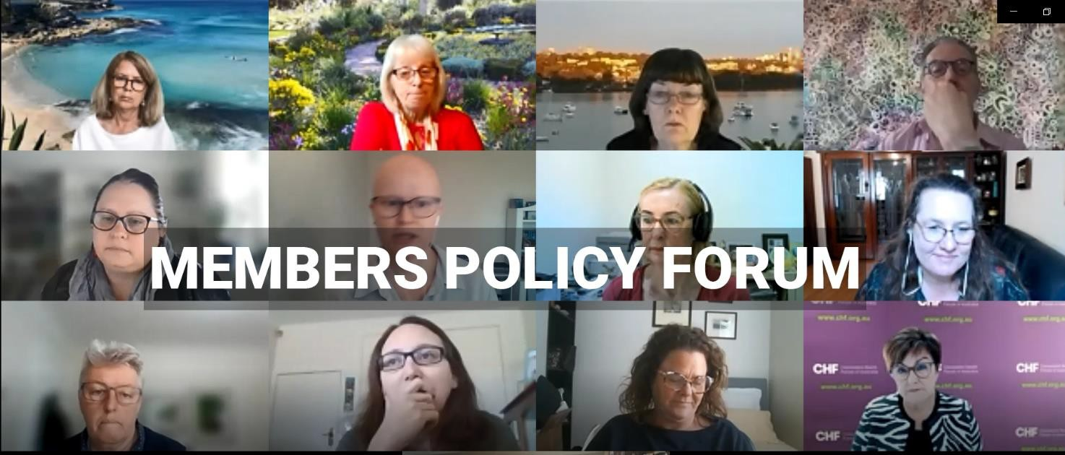

*A screenshot from the virtual Members Policy Forum in November 2021*

A warm welcome to 2022 to all CHF members and consumer advisors. This communique provides an overview of the priorities we will be pursuing this year and a summary of key matters we focused on at the 2021 Members Policy Forum, Board Meeting and AGM in November 2021.

# A third year of COVID

Covid continues to be the major health issue dominating the national conversation. This is likely to remain constant during the first part of the year and in the lead up to the Federal election. As the Omicron wave sweeps through the most populous Eastern States, moving into potentially vulnerable communities further across the country, we are likely to see successive issues of concern. While NSW and Victoria are currently awash with covid cases, Western Australians are coming to terms with the need to wear masks, as officials contemplate reopening the State.

In this fast-moving health crisis, we observe in real-time the results of successful rapid responses to emerging issues and conversely the consequences of missteps or hesitation in policy strategy.

Covid outbreaks put the spotlight on weakness in our health care systems. During the Omicron outbreak, pressure has been placed on Primary Health Care providers to communicate and advise a worried public about how to manage their covid infection. Furloughed staffing issues and overwork has left the workforce in a precariously fragile state. Ongoing consumer involvement can help alleviate some of this pressure.

Designing systems that align with the needs of the people they are meant for, helps to break through barriers of low health literacy, empower self-care and self-management and build health services that efficiently use resources where they are needed. Importantly, early access to services will prevent complications and potentially severe disease outcomes, so it makes good economic sense as well as health care for our community to argue for preventive health measures.

# 2022 priorities

Our focus for the coming year will be on what comes out of the major 10 year plans/strategies – in primary health, preventive health, obesity, and the continuation/aftermath of the pandemic - what we've learnt and what it means for health systems now and in the future.

CHF’s election platform for the Federal election is being developed with a consumer reference group. A substantially drafted version was presented at the Members Policy Forum late last year. The feedback and member’s views have been incorporated into the final draft, which will go to the Board at their next meeting. When the election platform is finalised we will host a webinar to go through the platform with those people who are interested.

The Election Platform is set in the context of the major health crisis caused by the pandemic, and the consequent economic constraints faced by the incoming Government. It asks, “*What can be changed so that each person, carer and community has the health services and care that they need to live the best and longest life that they can*”. It builds on principles based on the work of the 2020 Consumer Commission, for shaping a modern health and wellness system that offers person centred health care.

The election will occur in the charged environment of Australia’s experience and management of COVID where CHF will be seeking commitments to measures that address the weaknesses exposed in our health system, as well as the opportunities for reform that the pandemic highlighted.

We will shortly initiate a survey of consumer experiences of COVID, including the various aspects of public health messaging, impacts on health care access (for those with and without COVID); experience of support and care for those with COVID (across the self care, management in the community and hospital care continuums).

We have received the pleasing news that our Health Peak and Advisory Bodies Programme funding has been approved for the 2022-2025 triennium. This is recognition of our vital role as the national voice for consumers.

Over the coming year, CHF will continue to engage in government priorities and remain part of the winning teams working on consumer and community engagement and health literacy strategies under the National Preventive Health Strategy.

We will be releasing a series of publications from our 2021 Australian Consumer Sentiment Survey.

We will continue our involvement in the National Medicines Policy and supporting the work of NPS MedicineWise as their Consumer Partner, and we will continue to work with the Australian Digital Health Agency on the National Digital Health Strategy

We will be continuing to systematically and regularly gather consumer views, and to host forums on contemporary issues that matter to consumers through Australia’s Health Panel surveys, *CHF Talks* webinars and theme-based roundtables.

We will also be seeking to boost ways in which we can support and build consumer leadership skills through continued advocacy for the *Australian Consumer Leadership Academy*, expansion of *Collaborative Pairs Australia* and *Consumer Link* – our forum for networking and supporting consumer advisors.

# Recognising consumer leaders: Anne McKenzie AM

Pioneering health consumer advocate Anne McKenzie AM has been awarded NHMRC’s Consumer Engagement Award in recognition of an almost 30-year career during which she has helped thousands of Australian clinicians and researchers understand the value of listening to consumers. Anne is a Life Member of CHF and we applaud Anne’s tireless leadership advocating for strengthened consumer and community involvement in research.

# Members’ Policy Forum

CHF closed off 2021 with a well-attended [Members’ Policy Forum.](https://chf.org.au/members-area/members-policy-forum-2021) The program included a presentation and consultation on our Federal Election Platform, currently in development. Members also discussed the concept of a consumer leadership academy, showing great interest and appetite for this innovation which will strengthen the consumer voice in policy matters.

The Forum concluded with a preview presentation of yet to be published data from two consumer telehealth and digital health experience research projects undertaken by Curtin University. Professor Suzanne Robinson and Dr Richard Norman delivered the discussion on the research, giving insight into both the process and the results.

The outcomes gave credibility to some potential assumptions; that consumers prefer face-to-face consultations, however many are price sensitive and prefer not to travel – especially long distances, so these factors will influence their preference. Most consumers are happy to have telehealth consultations, particularly if it’s with a doctor they know, and the reason is not about a new condition.

The study also found that consumers were generally willing to share their de-identified health information from medical health records with universities and research organisations. Another aspect investigated consumer attitudes to alternative methods of care using new technology, noting that people with lower levels of education showed more reluctance.

# Annual General Meeting

We held CHF’s Annual General Meeting in on 22 November 2022, with a pleasing report on a successful but challenging year. The Chair, Mr Tony Lawson commented on highlights and a special resolution was passed to accept minor changes to the Constitution in relation to the membership approval processes.

There were two vacant positions on the Board, with Ms Ros Chataway returning and Ms Allison Willis elected as a new member. Mr Mark Diamond retired, and we thank Mark for his extensive contribution on the Governance Committee and to the work of the Board as a whole.

Allison Wills is a long-standing consumer advocate involved in the South Australian health consumer network, Health CAN SA, and formerly Health Consumers Alliance SA.

The AGM also saw some very positive financial results with CHF returning a surplus for the last financial year. This continues to reinforce the long-term stability of the organisation. We are increasing the diversity of funding sources which gives additional protection from unexpected shocks.

# Office holders

Mr Tony Lawson and Ms Jo Watson were unanimously elected as Chair and Deputy Chair.

# Summit 2023

After the successful *Shifting Gears Summit* in 2021, we will be hosting similar summits focused on consumer leadership as a bi-annual event.

# Partnerships

The Board endorsed a Statement of Collaborative Intent with the Health Consumer Advisory Network of South Australia (Health CAN SA). CHF and Medicines Australia have joined forces to update the 2015 *Working Together Guide* which aids ethical partnerships between patient organisations and pharmaceutical companies.

# Next meeting of the Board

24 February 2022

|  |  |
| --- | --- |
| A person smiling for the camera  Description generated with very high confidence | cid:image010.png@01D1E731.C3D03130 |
| Tony Lawson Chair | Leanne Wells  Chief Executive Officer |