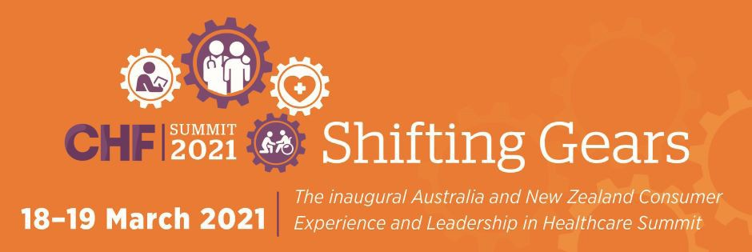
Jennifer Doggett and Cate Carrigan reported on the Consumers Health Forum of Australia’s Virtual Summit 2021: Shifting Gears, for the Croakey Conference News Service.
Nicole MacKee contributed to live-tweeting of the event.

Croakey Health Media is a non-profit public interest journalism organisation based in Australia.
https://www.croakey.org

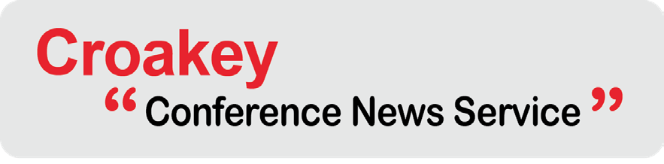

© 2021 Croakey Health Media

Contents
Shifting Gears: success stories and way-points on the road to
consumer-centred healthcare 3
Using social media to engage consumers in health service design
and quality improvement 11
Navigating the road to consumer leadership in health: Shifting Gears
day two 15
CroakeyVOICES examines Shifting Gears to drive consumer leadership
and experience in healthcare 34
Shifting Gears Summit: a user’s manual in ten parts 36
Health consumers of today, partners of tomorrow 57
CroakeyVOICES joins consumers Shifting Gears on the road to
improved quality in healthcare 60
Health Voices 62

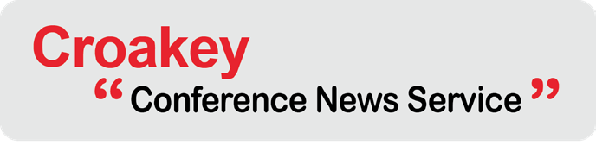

Contents

#ShiftingGearsSummit

 https://bit.ly/38pXIEt
You can track Croakey’s coverage of the summit here.


Shifting Gears: success stories and way-points on the road to consumer-centred healthcare

Image: Unsplash

What would our health systems look like if consumers were in the driving seat – if consumer experiences and leadership were enabled to seamlessly transform health and social care to better serve their needs?
In Australia we do have successful models that have arisen from genuine consumer co-design, such as the Aboriginal Community Controlled Health Services.
Aotearoa/New Zealand has integrated consumer and community representation into key health funding and service delivery organisations, such as District Health Boards. But in other areas both countries have a long way to go.
A summit hosted by the Consumer’s Health Forum of Australia (17-19 March) starts off by asking speakers and participants why such reform is needed, and goes on to showcase success, and provide inspiration for future efforts.

Jennifer Doggett writes:
You can track Croakey’s coverage of the summit here.
After a year in which health systems have shifted gears like never before, the first Australian and New Zealand conference on consumer leadership and experience in healthcare provides an opportunity to harness the momentum for change and drive future consumer-centred health system reform.
The Shifting Gears summit on 18-19 March, hosted by the Consumers Health Forum of Australia (CHF), will bring leading consumer advocates together with organisations and health professionals, breaking new ground on consumer-centred care.
The two day virtual event will provide an opportunity to learn from innovative projects, share experiences and plan for the future.
Speakers at the Summit come from Australia, New Zealand and overseas and include representatives of the public, not-for-profit and private sectors.
This event is targeted at consumers and consumer organisations, health professionals, health service providers, those who commission and fund health services, and policymakers.

A critical time
The Summit comes at a critical time for the Australian and New Zealand health systems.
While both countries have successfully responded to the initial phase of COVID-19, there are ongoing challenges in managing the pandemic, including the delivery of the vaccine program.
Apart from COVID-19, Australia is facing some major health system challenges, including responding to the findings of the Royal Commission into Aged Care Quality and Safety and the Royal Commission into Victoria’s Mental Health System, as well as implementing the upcoming National Preventive Health Strategy.
Across the Tasman, New Zealand is also undertaking significant health system reforms, including establishing an independent Mental Health and Wellbeing Commission, responding to the recommendations of the Health and Disability System Review and implementing a new Māori Health Action Plan.
Consumer leadership and involvement will be crucial to these processes and the Shifting Gears Summit provides a timely opportunity to learn from successful examples of consumer engagement, including projects using co-design models.

Keynotes and plenary sessions
Following a musical Acknowledgement of Country from Indigenous youth vocalists, the Kari Singers, the Summit starts by posing the question Why it is Time to Reimagine Health and Social Care? to four keynote speakers.
Joining from Canada will be Vincent Dumez, Co-Director and Patient Partner, Centre of Excellence on Partnering with Patients and the Public, University of Montreal. Dumez left his job as a consulting firm executive to use his 30 years of experience with multiple chronic diseases to develop the ‘patient partner’ concept at Université de Montréal and advocate for consumer health interests in Canada. He’s now co-leading the Centre of Excellence on Partnership with the patients and public.

New Zealand’s Dr Ashley Bloomfield, Director General of Health, will provide the Aotearoa New Zealand perspective, followed by a joint presentation from Susan Pearce and Craig Cooper, from the NSW Health Elevating the Human Experience project.
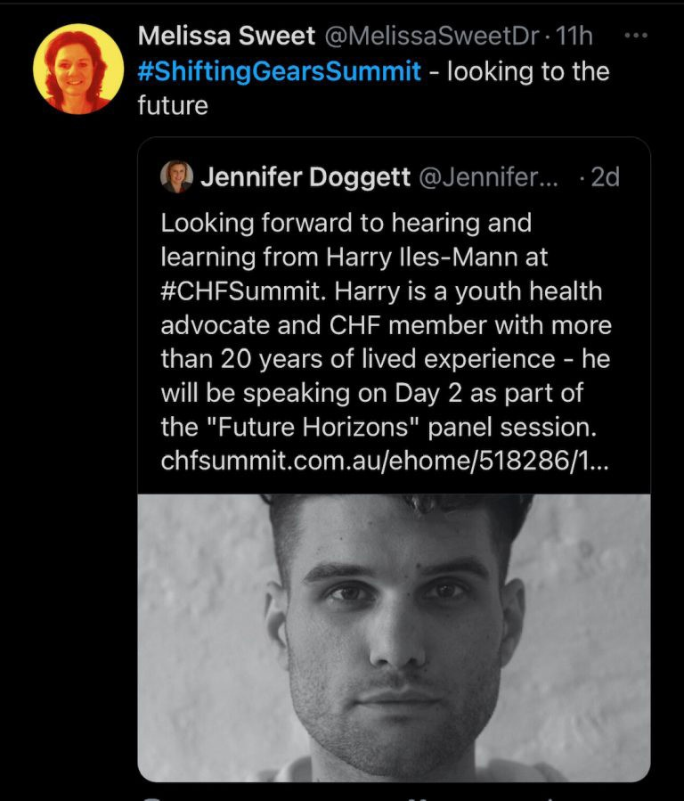

Day two kicks off with a panel session on Global Trends in Safety and Quality, featuring Dr Lynne Maher (Ko Awatea, Counties Manukau Health’s centre for health system innovation and improvement), Jeffrey Braithwaite (Australian Institute of Health Innovation) Jennifer Zelmer (Canadian Foundation for Health Improvement), Professor Anne Duggan (Australian Commission on Safety and Quality in Health Care and Dr Christine Walsh (NZ Health Quality and Safety Commission).
Maher will also be part of Future Horizons, the Summit’s final plenary session, facilitated by Suzanne Robinson (Curtin University). She will be joined by a diverse panel of speakers including Kate Mulligan (Alliance for Healthier
Communities, Ontario, Canada), youth advocate Harry Iles-Mann and representatives from CSIRO Health and Biosecurity and the Digital Health CRC.

Summit streams
The plenaries and breakout sessions at the Summit are grouped into four general themes:
- Consumers as researchers
- Consumer-based healthcare
- Consumer leadership
- Consumer enablement.
In addition to these four themes, there is a concurrent stream focussed on COVID -19, and a final stream specifically targeted at New Zealand participants. Some of the highlights for each stream are outlined below.

Consumers as researchers
Jump into one of six streams

Research is an often neglected area for consumer engagement but the ‘consumers as researchers’ stream highlights a number of successful collaborative and co-designed projects.
You can track Croakey’s coverage of the summit here.
These include a project based at the QEII Hospital in Brisbane where a PhD student, two academics and three consumers have been working together to enrich research experiences, processes and outcomes. The presentation on this project will outline how consumer partnerships in research need to start early and include carefully considered strategies for meaningful collaboration.

CHF’s partnership with the Digital Health CRC and leading Australian Universities in engaging consumers in research will be described by Suzanne Robinson (Digital Health CRC). Her presentation covers how to take a consumer driven approach, with engagement throughout the research cycle, for example by taking researchers out of the university environment to engage with the lived experience of consumers and consumer organisations.
You can track Croakey’s coverage of the summit here.
The importance of collaboration and co-design with Aboriginal and Torres Strait Islander consumers and researchers in the development of methodology will be highlighted in a presentation from Lilian Daly from the Bureau of Health Information, using the example of of the ongoing NSW Aboriginal Patient Experience Survey.
A joint presentation from Yvonne Zurynski and Jeffrey Braithwaite (both from the Australian Institute of Health Innovation, Macquarie University) will focus on consumers’ role in sustainable healthcare systems and why their engagement is so critical to health systems research.

Consumer-based healthcare
Social media, organisational strategy and human-centred design thinking are all covered in the consumer-based healthcare stream.
The stream kicks off with a panel session on how to gear an organisation’s strategy, culture and practices around consumer-centred care, involving representatives from Safer Care Victoria, Western NSW Primary Health Network, the NSW Agency for Clinical Innovation, ACSQHC and the Canadian Foundation for Health Care Improvement.
Victoria Smyth (Western NSW PHN) will discuss how her organisation worked with consumer co- design agency, Kairos Now, to update their Consumer and Community Engagement Framework. She will outline the importance of co-designing guiding documents with consumers and community, to develop language that speaks to the end users and supports better engagement, service design and outcomes.
The impacts of involving young consumers in service design will be discussed by Kerryn Pennell, from Orygen National Centre for Excellence in Youth Mental Health.
Jennie Parham from Consumers Health Forum will give an overview of the Collaborative Pairs project in Australia, in which consumers and providers are paired to develop new ways of working together. Helen Dickinson will discuss the evaluation of the pilot program.
Examples of consumer collaboration on specific projects will be provided by Rawa Osman, (pharmacist and design lead from NPS MedicineWise) and Clare Mullen (Health Consumers’ Council WA).

Consumer leadership
Impressive consumer leaders and advocates from Australia, New Zealand and the rest of the world will present as part of this stream.
These include Jane Cockburn, Co-Chair, Chris O’Brien Lifehouse Partnership Advisory Council and facilitator of Collaborative Pairs Australia who will give a keynote address.
The implementation of a peer run and peer delivered mental health warmline service in NSW will be described by Irene Gallagher (Being Mental Health Consumers). Ray Newland (Western Health) will discuss his lived experience and journey as a consumer advisor.

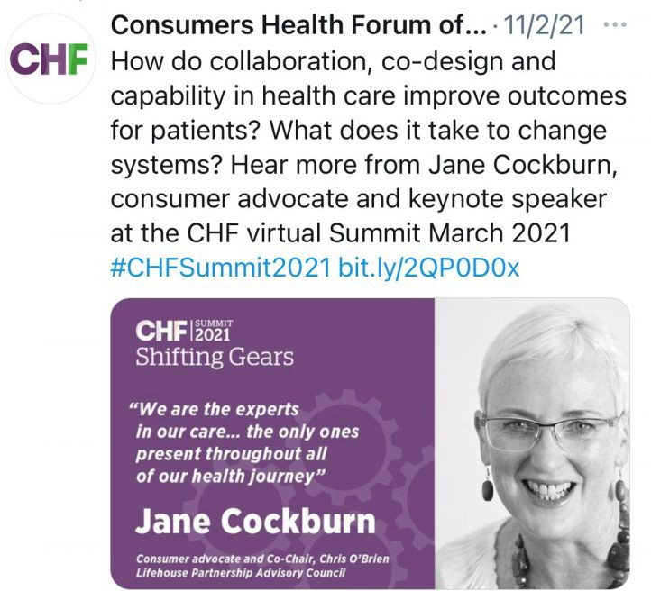
Strategies to include the ‘hidden voices’ of frail, homebound and bedridden consumers in health research will be discussed by Penelope McMillan (ME/ CFS SA). Her presentation is based on a consumer-initiated and consumer-led collaboration with Flinders University’s researchers sparked by the report, Just Invisible, by disability advocate Ricky Buchanan.
You can track Croakey’s coverage of the summit here.
The ANZDATA Registry is a clinical quality registry that collects and produces statistics relating to the outcomes of treatment of those with end stage renal failure. Shyamsundar Muthuramalingam (ANZDATA-South Australian Health and Medical Research Institute) will describe consumer involvement in this registry, including the
coproduction of consumer-specific reports.
This stream will also include a workshop Beyond a Tick in the Box: Consumer Leadership in 2021
with representatives from Cancer Voices NSW and Health Consumers NSW.

Consumer enablement
Clinicians breaking new ground in partnering with consumers to deliver better healthcare will feature in this stream, including a presentation from Dr Lyndal Trevena, Professor of Primary Health Care at the University of Sydney, whose interests include access to shared decision- making for patients with lower levels of literacy and from diverse cultural backgrounds.
The Australian Digital Health Agency will facilitate an engagement session where participants can share their views on the future directions of digital health for Australia. This session will also feature a digital storyteller and live scribe to visually capture the views of participants.
The presentation from Reema Harrison (UNSW) will shed light on why people from culturally and linguistically diverse backgrounds continue to be excluded from consumer engagement and what can be done to address this. Her presentation is based on research undertaken with consumers from four linguistically and ethnically diverse communities.

COVID-19 stream
The COVID-19 stream includes a well-stacked panel discussion on consumer and community engagement in the current COVID-19 vaccination strategy.
Participants include social scientist Holly Seale, CEO of the Federation of Ethnic Community Councils of Australia Mohammad AlKhafaji, Professor of Global Health and Equity Richard Osborne, Breast Cancer Network Australia Consumer Health Representative Dr Susannah Morris, and GP and epidemiologist Dr Nicole Allard.
Emily Phillips will bring insights from the National Community Controlled Health Organisation to the panel. Australia’s Aboriginal community controlled health sector has been widely acclaimed for its effective response to the threat of COVID-19, due in no small part to its “on the ground” engagement with community, and is now ready to tackle the challenge of vaccination.

The role of state health consumer organisations in the COVID response will be discussed in a session including representatives of four state-based consumer peaks: Melissa Fox (Queensland), Michael Morris (NSW), Danny Vadasz (Vic) and Bruce Levett (Tasmania).
You can track Croakey’s coverage of the summit here.
Rob Anderson from Musculoskeletal Australia will discuss the role of consumers in the largest Australian survey of people with, or caring for someone with, musculoskeletal conditions.

NZ stream
Co-design is a major focus of the New Zealand stream with a number of presentations on successful co-design projects supported by NZ Health Quality & Safety Commission.
These include the co-design of:
- a new quality and safety marker for consumer engagement
- a procurement process to support district health boards in selecting a provider for a peer support service, and
- cancer services for Pacific women with endometrial cancer.
Another co-designed project which will be showcased at the Summit is an initiative to improve care for transgender people, from the New Zealand Canterbury District Health Board. This project resulted in key surgical services being made available for the first time in the public system.
The development of Consumer Councils in New Zealand is the subject of a joint presentation by Rosalie Glynn (Consumer Council, Counties Manukau DHB), Jo Rankine, (patient experience lead, Counties Manukau DHB) and Russ Aiton (Chair, West Coast DHB).
There are also sessions specifically focussing on health issues affecting Maori/Pacific New Zealanders, including a session on restraint/seclusion in the mental health system with a Maori/ Pacific focus.

Big ideas forum
A highlight of the Summit will be the Big Ideas Forum, facilitated by the ABC’s Ellen Fanning.
This Forum will showcase a series of one minute videos from consumers presenting their ambitious, transformational and achievable ideas to improve the health system.

Cocktail hour
Just because it’s virtual does not mean the Summit will lack a cocktail hour. From 6-7pm on Day 1 participants can join CHF CEO Leanne Wells in conversation with leading collaborative pairs practitioners Mark Doughty, from the Kings Fund UK, and Louisa Walsh from La Trobe University.

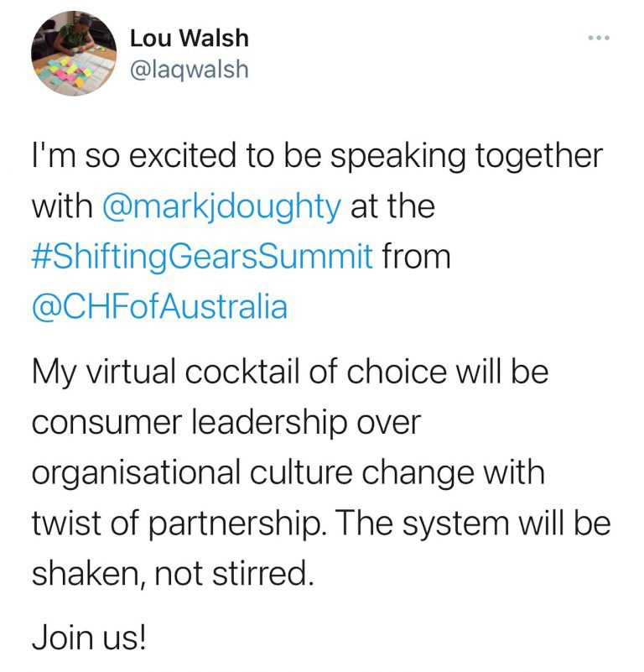
You can track Croakey’s coverage of the summit here.

Masterclasses
Two pre-conference masterclasses (additional registration required) will give participants the opportunity to explore two key current health consumer issues: health literacy and co-design.
The half day Health Literacy Masterclass will be facilitated by Professor Kirsten McCaffery, Director of the Sydney Health Literacy Lab and cover strategies to improve health literacy, digital health literacy and lessons learned from COVID about health literacy.

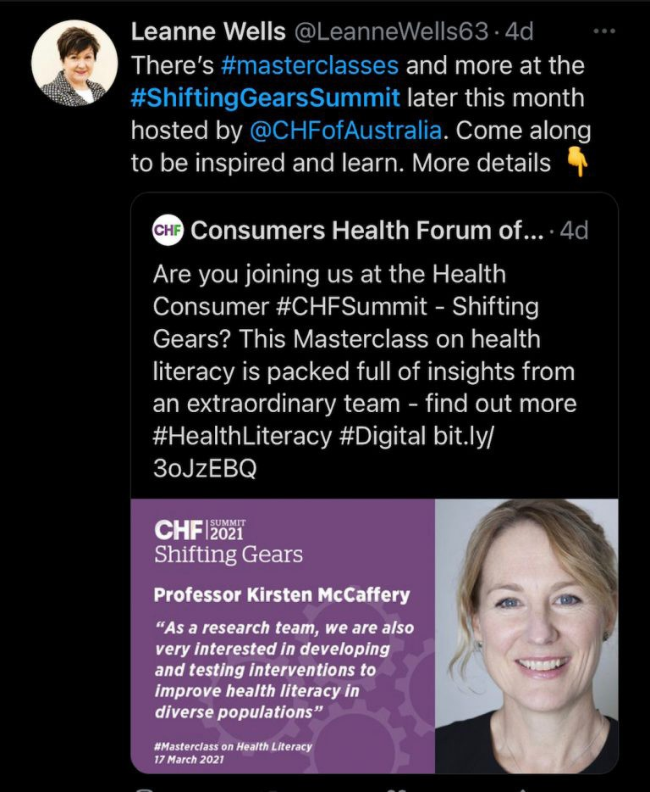
You can track Croakey’s coverage of the summit here.
The Experienced Based Co-Design (EBCD) Masterclass is a dedicated half-day session led by Lynne Maher, Innovation and Improvement Clinical Director from the Ko Awatea Health System Innovation and Improvement in New Zealand.
This masterclass will provide an overview of EBCD methodology and showcase, through case studies, how consumers, families and staff have used experience based co-design to improve health and care services.

More information
See here for more information about the Summit.
Principal Sponsors of the Summit are: the Australian Department of Health, Australian Digital Health Agency, NSW Health, Australian Commission for Safety and Quality in Health Care.

 https://bit.ly/38RFdZQ
You can track Croakey’s coverage of the summit here.


Using social media to engage consumers in health service design and quality improvement

Friday’s agenda includes a presentation from PhD candidate Louisa Walsh, whose research centres around how hospitals use of social media to engage consumers in improving their services, and how this could be done safely, more often and better.
In the post below, and along with her supervisors Drs Nerida Hyett and Sophie Hill, Walsh discusses some of her findings so far, and issues an invitation to health services that might wish to participate in the next part of the project.

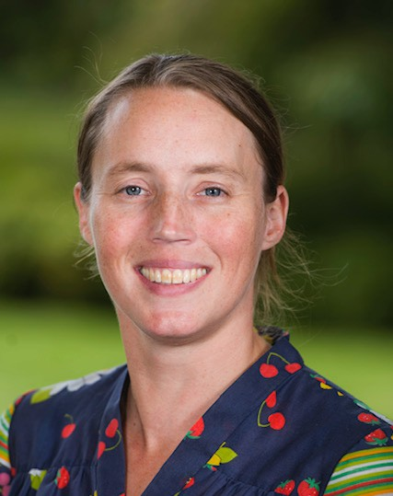
Louisa Walsh, Nerida Hyett and Sophie Hill write:
Social media has defined and shaped the internet for more than 15 years. Social media sites are among the most used websites in the world, and nearly 80 percent of Australians have at least one social media account.
In health services, using social media has been identified as a potential way to create more equal relationships between health professionals and consumers, increase participation in service design activities, and improve health service data collection.
Despite these potential benefits, it is likely that social media is
underutilised as a communication tool in health. Louisa Walsh

Importantly, the two-way communication potential of social media, which is essential for these relationship building and participation benefits, is likely not being fulfilled. Our research aims to help hospitals, health professionals and consumers better understand how social media can be used as a tool to involve consumers in designing and improving health services. The project has three phases:
You can track Croakey’s coverage of the summit here.
- a review of the international literature;
- an interview study with Australian health consumers and public hospital health professionals; and
- a consultation on an evidence-based guide for health professionals and consumers wanting to use social media as part of their suite of consumer engagement activities.
The first two studies have been completed, and the first paper from the review of the international literature has just been published. The final study is about to commence.

How is social media used as a consumer engagement tool?
Through our research we have categorised the different ways social media can be used to engage people in service design and Quality Improvement (QI) activities: descriptions, examples and suitable platforms for each method can be found in the review.
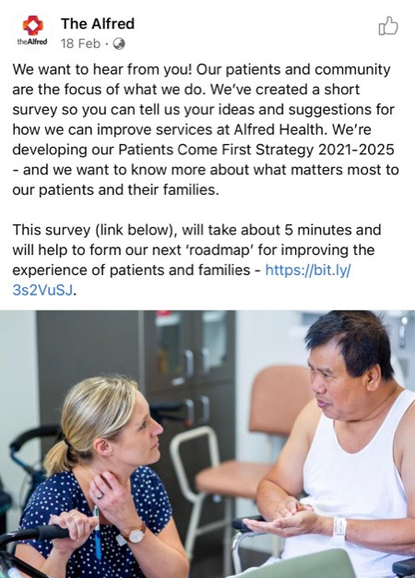
Broadly speaking, social media can be used as either an information gathering tool, or as a space for collaboration where consumers and health professionals can work together on service design and QI projects.
QI survey
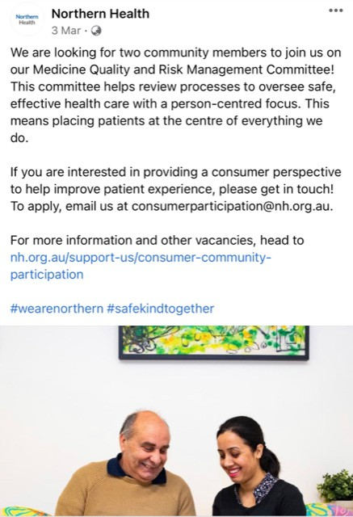
A call for consumer voices

A hospital asking their Facebook followers to comment on the new design of their outpatient area, or a consumer sending a direct message to a hospital’s Twitter account with feedback about recent hospital stay, are two different examples of gathering information through social media that can be used for design or improvement projects.
You can track Croakey’s coverage of the summit here.
Virtual spaces can also be used for online co-design and collaboration, for example the online project management platform Slack could be used as a space for a hospital QI project working group which includes health professionals and consumers.

Benefits and risks of social media as a consumer engagement tool
There are benefits and risks of using social media for consumer engagement.
Social media can help overcome barriers associated with face-to-face engagement, such as time, costs and physically attending the hospital. Social media can also increase the number of people reached through engagement activities, and may improve the diversity of people engaged.
For consumers, using social media to initiate engagement with hospitals, or to more easily collectivise and advocate for change, is of particular benefit.
Finally, open communication on social media can increase organisational transparency, which can improve consumer trust and service reputation.
However, social media use is not without risk. Consumers and providers in our research were concerned about being harmed by other users through bullying, harassment, trolling, and privacy or professional behaviour breaches.
Organisational leaders were concerned about losing control over communications, particularly feedback mechanisms, which might lead to reputational harm.
Our research also identified that engaging consumers through social media might lead to poorer information, because in-depth discussion may be more difficult to achieve compared to face-to- face discussions.
It is important to note that the data informing these risks and benefits were collected before the onset of the COVID-19 pandemic. Recent important developments in social media, such as the rise in disinformation and corresponding strategies to combat it, and the Facebook news ban which temporarily shuttered the sites of many health-related organisations, might change perceptions of risks and harms.

How can hospitals implement social media as a consumer engagement tool?
Our research explored the barriers and enablers for social media for consumer engagement, and we are in the process of co-producing a guide for using social media as part of health service design and QI activities.
Firstly, organisations need to be set up for using social media. Hospitals play a large role in helping consumers and providers use social media for consumer engagement.
Good governance in the form of clear policies, processes and plans is vital, as is adequate training and resourcing. Social media interactions also need to be made safe through good monitoring and moderation practices, ground rules, and clear and accessible policies around privacy and data use.

Once an organisation is ‘social media ready’, social media-based consumer engagement plans need to be developed within each design or improvement project.
You can track Croakey’s coverage of the summit here.
Project planners (which should include consumers) need to consider which method of social media use fits with the needs of the project and the target engagement group. Additional training and support may also be needed.
These additional considerations sit alongside all the usual planning that takes place when engaging with consumers in service design and QI activities.
Finally, we have found that sharing learning around social media-based consumer engagement gives other people and organisations confidence to try these methods.
If you are already doing social media-based consumer engagement, please find ways to share your experiences so others can learn from your knowledge and expertise – including via social media!

What’s next?
The next stage of the project is a consultation on the guide we are developing. If you are interested in being contacted when the consultation starts, or want to receive any of the publications from my project direct to your inbox, please get in touch!
*Louisa Walsh is a PhD candidate and Research Officer at the Centre for Health Communication and Participation, La Trobe University. On Twitter, @laqwalsh; Dr Nerida Hyett is a lecturer in Occupational Therapy at La Trobe Rural Health School, La Trobe University; Dr Sophie Hill is Director of of the Centre for Health Communication and Participation, La Trobe University
The authors would like to thank the advisory committee members who have contributed to this project – Jayne Howley, Nicole Juniper, Chi Li, Belinda MacLeod-Smith and Sophie Rodier.


 https://bit.ly/3c3H3Jd
You can track Croakey’s coverage of the summit here.

Navigating the road to consumer leadership in health: Shifting Gears day two

If one measure of a good conference is the questions it raises, the conversations it engenders and the relationships it fosters, the Consumers Health Forum of Australia Shifting Gears Summit was a raging success.
That this was achieved via a virtual event makes it all the more remarkable, but consumer leaders and advocates are passionate. They owned the Summit with their presentations, panel participation and reporting; their tweets and conference chat commentary.
In the day two instalment of her coverage, below, Jennifer Doggett captures some of these key presentations and ensuing discussions.
Do track down the #ShiftingGearsSummit hashtag on Twitter check out this Twitter list of participants if you’d like to explore further.

Jennifer Doggett writes:
You can track Croakey’s coverage of the summit here.
Day two of the Consumers Health Forum’s Shifting Gears Summit was all about the shifts happening all over the health system – in quality and safety, research, policies and programs and consumer engagement.
Presenters outlined both the successes and challenges they have experienced while trying to shift cultures and practices. Participants asked insightful questions, questioned assumptions and contributed their experiences via the chat and Twitter thread.
Some highlights from these presentations and discussions are outlined below.

Shifting quality and safety
Facilitator, Dr Lynne Maher, Director for Innovation at Ko Awatea, set the scene for a panel discussion on quality and safety. She outlined multiple levers for improvement, including medicines and device regulation, workforce credentialing and accreditation, and mandatory health service standards.
She also highlighted the need for a culture of innovation and continuous improvement.
Professor Jeffrey Braithwaite, from the Australian Institute of Health Innovation, reminded participants that we have seen improvements in healthcare quality and safety over the past 30 years. However, he also noted that 40 percent of care provided currently is either unnecessary or harmful, and this has proved hard to change.
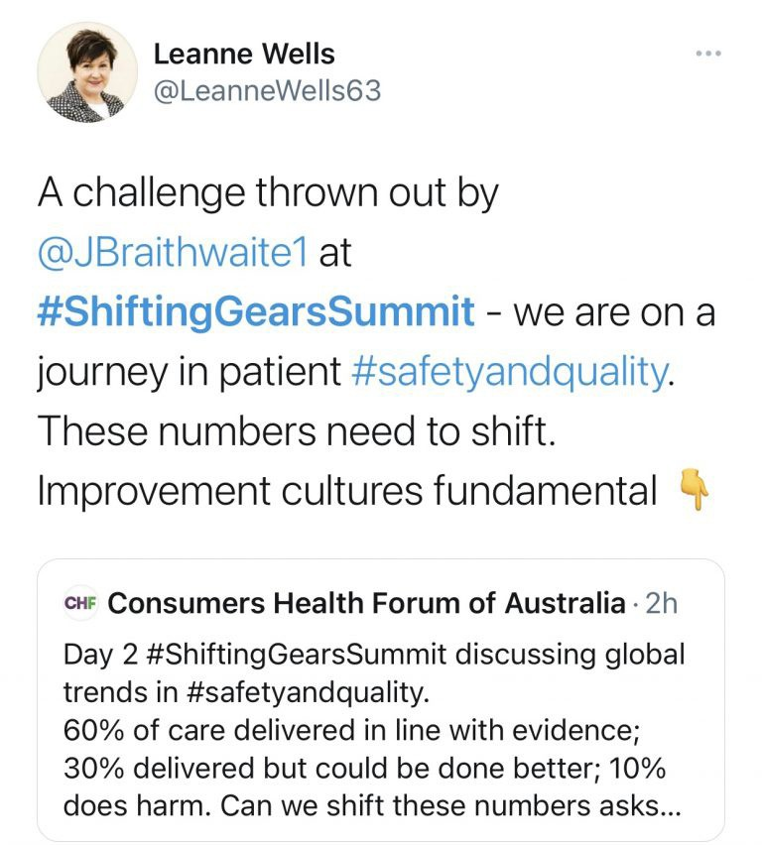
He stressed the need for a collaborative approach to improving quality and safety:
“ No one of us is as smart as all of us. Healthcare is a team game – we’re smarter when we pool our brains.”

His suggestion that consumers should visit their doctors to discuss their health instead of their illness drew some contrasting responses from participants.
You can track Croakey’s coverage of the summit here.
Sherrilyn Ballard welcomed the focus on wellness saying that this model has a lot to offer within a culturally safe and diversity lens.
However, Louisa Walsh said she had “a bit of a visceral reaction” to Braithwaite’s statement, arguing that instead of medicalising ‘wellness’, we should create environments which make wellness the default, and support communities and individuals to manage their own wellness.
Clare Mullen was also not convinced that doctors should be central to a wellness model. She commented that the role of community, neighbourhoods and peers should be emphasised rather than health professionals.
Braithwaite highlighted the emerging field of genomics as one in which consumer engagement is critical, particularly in relation to the use of personal data.
Maryanne Richardson agreed that a key question needing to be answered in this area is “Who owns the health information and what will it be used for”.
More information on the role of consumers in genomics was provided via the poster presentation from Janney Wale from the Melbourne Genomics Community Advisory Group (CAG).
The poster outlined how the CAG works to address the complex issues around communication, privacy, informed consent, ethics, patient experience, standards/policies, data storage and re-use of data.
This includes initiating a “Register of CAG activities” to record and demonstrate the value of the partnership in enabling use of genomics within public hospital practice in Victoria and beyond.
Another panellist, Jennifer Zelmer, President and CEO at Healthcare Excellence Canada, described how COVID-19 shone a spotlight on vulnerabilities in our health systems, as well as revealing some common strengths and resilience.
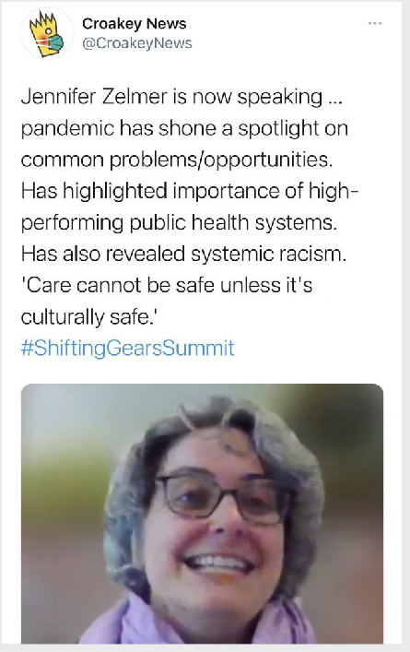
“ We have seen an explosion of virtual care globally. Changes happened in a month that would have taken ten years previously. There have been some fabulous results but also some cases where this was rushed and needs to be improved.”
Zelmer identified that having high performing primary healthcare and public health sectors rendered health systems better able to respond effectively to the pandemic, while challenges such as systemic racism and poor health system integration hindered the response.
Weaving together different forms of knowledge – traditional, individual, community and clinical – she said, would help address these challenges.
Professor Anne Duggan, Clinical Director of the Australian Commission for Safety and Quality in Health Care, argued that the future of healthcare depends on wise consumers challenging health professionals’ assumptions about whether interventions are necessary.

In response, Dr Christine Walsh of the NZ Quality and Safety Commission said that we are all wise consumers and need to be supported to be so. She described consumers, families, communities and whanau as “the biggest untapped resource in the health system”.
You can track Croakey’s coverage of the summit here.
Jacqui Pierce also welcomed the focus on consumer experience of care,
“ We need to put quality of life at the forefront because too often the quantity of life is the focus of treatment.”
Duggan highlighted the important role played by clinical care standards and projects such as the Australian Atlas of Healthcare Variation which reveal gaps and over-servicing in care across the country.
Her suggestion that consumers should ask care providers “Walk me through how this will alter my quality and quantity of my life” was welcomed by participants, including Jacqueline Forst who said she would love to see this on the standard consent forms.

Shifting research
Kicking of the research stream for the day, Yvonne Zurynski from the NHMRC Partnership Centre for Health System Sustainability (PCHSS), explored how consumers can influence the health system to move from volume-based care to value-based care.
She described the PCHSS’s partnership with the CHF as “very important” and outlined some key findings from a joint research project on consumer experience of healthcare.
This project found that navigating the health system was very problematic for consumers with chronic and complex conditions with 50 percent of respondents reporting that they found it hard to find the best health provider for them.
Zurynski outlined ways in which consumers can influence health systems change, including through questioning the assumptions of researchers, healthcare providers and health service managers.
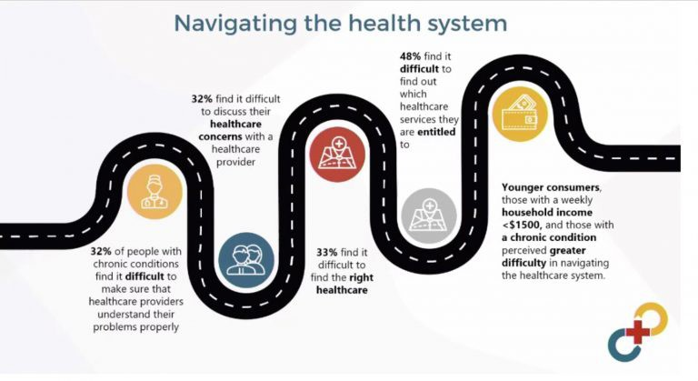
In responding to the suggestion that consumers should be empowered to ask questions Susan Sims noted that this is just one part of the equation. The other part is getting health professionals’ to recognise that patients and carers are the experts in their own lives.

Co-presenters of this session also highlighted the importance of engaging with specific groups of consumers in research, including consumers with rare diseases (who often know more than clinicians about their condition) and young diverse consumers who are often overlooked.
You can track Croakey’s coverage of the summit here.
Ruth Cox described how internationally, partnering with consumers in healthcare research is being increasingly accepted as a philosophical necessity as well as having positive outcomes for research and those involved.
Her poster presentation outlined how the QEII hospital in Brisbane is applying best practice principles to successfully partner in a series of studies.
Another poster presentation, from Monash University’s Darshini Ayton, looked at consumer and community involvement in healthcare research and identified the following enablers and barriers:
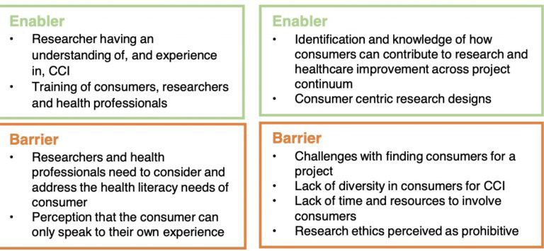

Shifting gears in New Zealand
Two projects from New Zealand provided very different but equally successful examples of consumer co-design.
Ester Vallero and Jennifer Shields from the Trans Health Working Group in Canterbury described their work to reduce the inequity of access and substandard health outcomes for transgender people, and the confusion around gender-affirming health services.
They identified a number of positive outcomes of the project, including:
- Increased availability of surgical services for trans people in public health services
- New Community and Hospital HealthPathways,
- District Health Boards (DHBs) showing willingness to improve their delivery of gender- affirming services
- A network of GPs supportive of transgender people
- A Canterbury DHB hospital champion for transgender health has been identified
- Formal connection to the Ministry of Health team working on access to gender- affirming care
- Comprehensive community information for HealthInfo on gender identity and gender-affirming care.

Ester Vallero identified the team approach as one key factor for the project’s success:
You can track Croakey’s coverage of the summit here.
“ It was important to be a team with lots of allies in the community and in the health system. In our experience meaningful consumer engagement is not a job for one person.”
A procurement panel to select a new Alcohol and Other Drugs (AOD) Peer Support Service by Taranaki District Health Board was another example provided.
The need for this new service arose from a marae-based co-design hui in December 2019 at which people with lived experience were invited to speak and health professionals/service providers were invited to listen.
After working with people with experience of addiction to develop the service model, Taranaki DHB decided to adjust their usual procurement processes to engage consumers. This involved moving away from the usual paper based process and using a kanohi ki te kanohi approach with a consumer led panel.
The project was described as a “huge learning process for the DHB” which ultimately encouraged them to be more flexible and consumer-focussed.
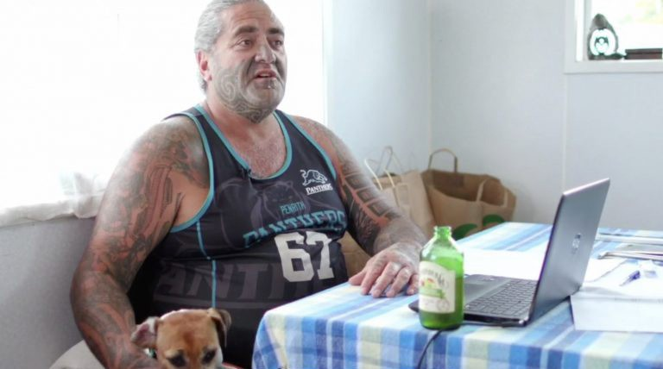
Dallas Hikaka, a member of the consumer-led panel

The evaluation of the program found that consumers reported feeling safe, both personally and culturally throughout the process and feeling that their expertise was valued.
Public health portfolio manager, Channa Perry reported that Taranaki DHB intends to embed this approach into future procurement processes at the organisation.

Shifting gears in Australia
Numerous Australian examples of consumer engagement and co-design were presented in the plenaries, break-out streams and poster session.
One practical example of evidence-based co-design (EBCD) was provided by Tara Dimopoulos- Bick, Russell Winwood and Helen Kulas who outlined their involvement in “Bursting the Bubble”, a quality improvement project to address the controlled delivery of oxygen in acute care for people living with chronic obstructive Pulmonary Disease.

The key steps involved in this project were:
You can track Croakey’s coverage of the summit here.
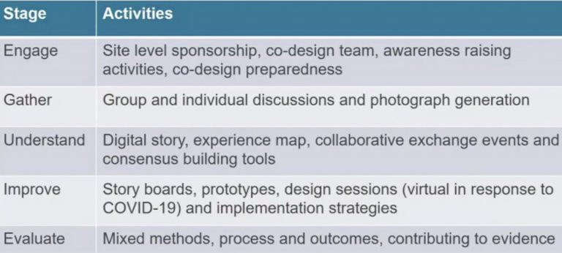
Tara Dimopoulos-Bick described how the project used photo generation to create a digital story to help everyone understand each other’s experience, a key component of the co-design process.
“ We asked people to take at least two photographs that represented their experiences. The photographs were collated and used illustratively alongside the experience map to share experiences at a collaborative exchange event, to foster empathy and generate a sense of needing to mobilise together to achieve change.”
Helen Kulas described how both the consumers and the clinicians loved the photo exercise, stating that it enabled them to speak to each other very powerfully during the collaborative exchange events. She said the experience of mapping and digital story generation helped move participants from “I” to “we”.
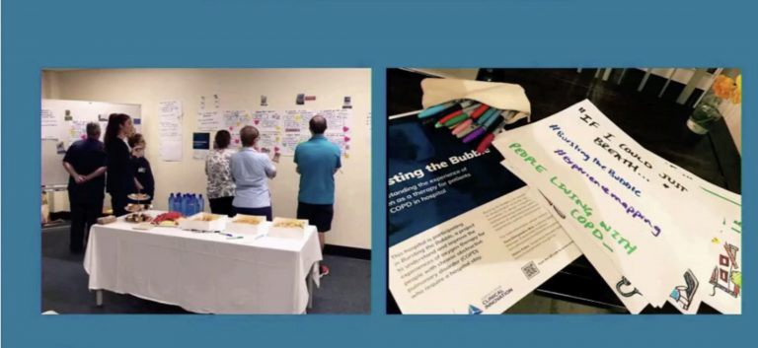
Kulas also warned there can be risks of “getting on the co-design bandwagon” if organisations do not have a commitment to working through all stages and supporting all participants throughout the process.
“ Co-design can be incredibly rewarding but it is also incredibly exhausting – empathy can be emotionally exhausting. We need to look after each other to get to the end goal.”

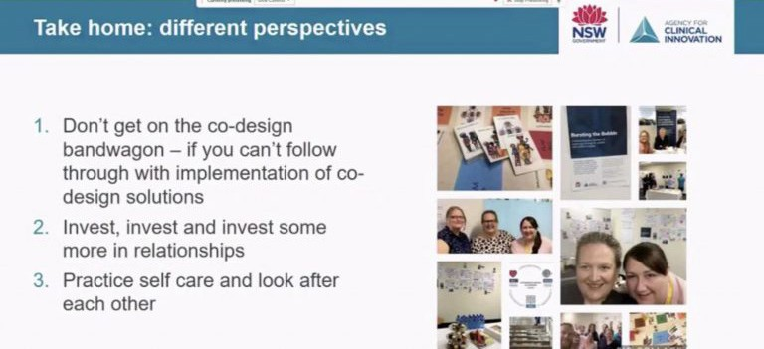
You can track Croakey’s coverage of the summit here.
The presentation ended with a sneak peak at a board game developed by the project to help teach co-design processes.
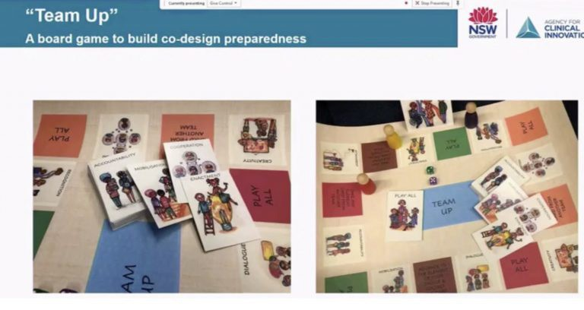
Louisa Walsh presented her research on the use of social media as a tool for consumer engagement (previewed here at Croakey). She outlined the risks and benefits of social media for consumer engagement, including the following.
- Risks: consumers causing harm, organisations losing control, engagement might not be as rich.
- Barriers: consumer and provider fears, lack of consumer skills and resources, lack of organisational processes and support, social media landscape.
She also described a guide she was developing based on this research for services to share their learnings about social media engagement in order to make it more accessible to others.

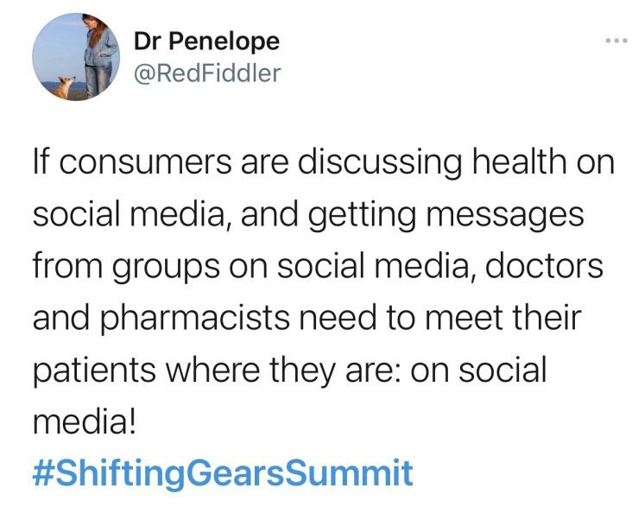
You can track Croakey’s coverage of the summit here.
Peter King from the Southern Adelaide Local Health Network (SALHN) described the “genuine partnership” SALHN has developed between consumers, community and health professionals to achieve excellence in person and family centred care.
He celebrated the success SALHN has in its COVID-19 response by focussing on teamwork, togetherness and trust and using diverse strategies to expand its consumer engagement and partner with vulnerable communities.
Said King,
“ We’re better than we used to be but not as good as we will be.”
Clare Mullen described how consumer stories, voices, needs, and interests were included in the development and implementation of the WA Healthy Weight Action Plan, a collaboration between Health Consumers’ Council WA, the Department of Health, and the WA Primary Health Alliance.
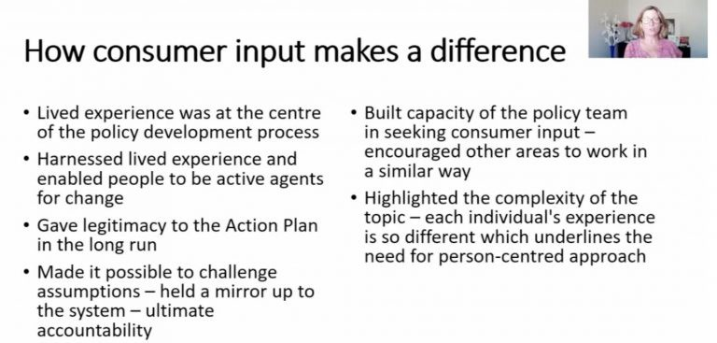

One key component of this project was asking GPs about the barriers they experienced in providing better care to larger patients. This revealed how much mental health can be a barrier for people with larger bodies becoming healthier and resulted in a focus on mental health in the plan.
You can track Croakey’s coverage of the summit here.
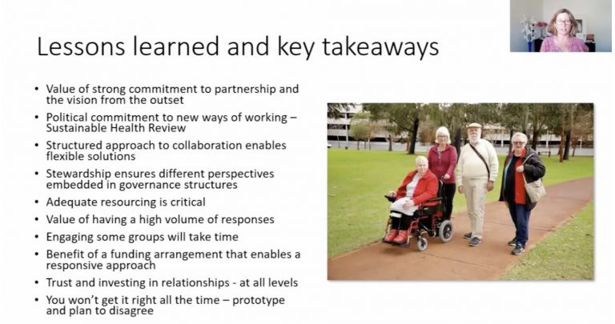
Consumer engagement was a theme in many of the poster presentations, including one by Deborah Howe and Linda Soars which outlined the development of web resource to support the elimination of the use of seclusion and restraint in NSW acute mental health units and emergency departments.
Another example of co-design was provided in the poster presentation by Melissa Mao on the “Social Brain Toolkit”, a suite of evidence-based online interventions, co-designed with people with acquired brain injury and their communication partners, which targets communication skills post-injury.
The poster describes how the tool-kit was developed using the “Non-adoption, Abandonment, Scale-Up, Spread, and Sustainability” theoretical framework of eHealth implementation to facilitate co-design.
A poster by Karen Gainey presented the findings of a study examining academic journals’ and health organisations’ instructions for writing lay summaries. The study found that 124 of the 526 websites searched published or mentioned lay summaries and 108 of these provided sets of writing instructions.
The most common elements of these instructions referred to structure, content and length, and Gainey identified scope for increased consumer input into lay summaries to improve their accessibility to their intended audience.
Participants also contributed their views on consumer engagement through the interactive chat function.
Mahinaarangi Bartlett reminded participants that all voices are important, regardless of race, education and financial status.
Ruth Cox commented that in some ways the pandemic made consumer engagement more accessible as many meetings and conversations moved online which reduced travel and burden for many. She said that they had never had such great attendance and conversation at the QEII Consumer Advisory Council.

Melissa Cadzow related the different experiences she had with consumer engagement during the COVI-19 pandemic.
You can track Croakey’s coverage of the summit here.
“ Some health services used technology to make it accessible – running with virtual meetings etc. However, others shut down consumer involvement work for nine months.”

Shifting the future of healthcare
The final panel session focussed on shifting the future of healthcare and featured an inspiring keynote from Dr Kate Mulligan, Dalla Lana School of Public Health, University of Toronto about the Ontario social prescribing program.
Mulligan provided an overview of the program developed by her organisation to improve health outcomes for marginalised and socially isolated people and to foster appropriate health systems utilisation, by creating a clinical pathway between mainstream health systems and community and voluntary supports.
Her slides told the story, showing a correlation in Toronto communities between poor COVID outcomes and social determinants such as insecure housing, food insecurity, racial segregation, poor transport infrastructure and a lack of access to digital technologies.
Her team worked via Ontario’s established community health services to address factors such as social isolation and meet basic material needs, taking a complex adaptive approach, rooted in local specificity and feedback.
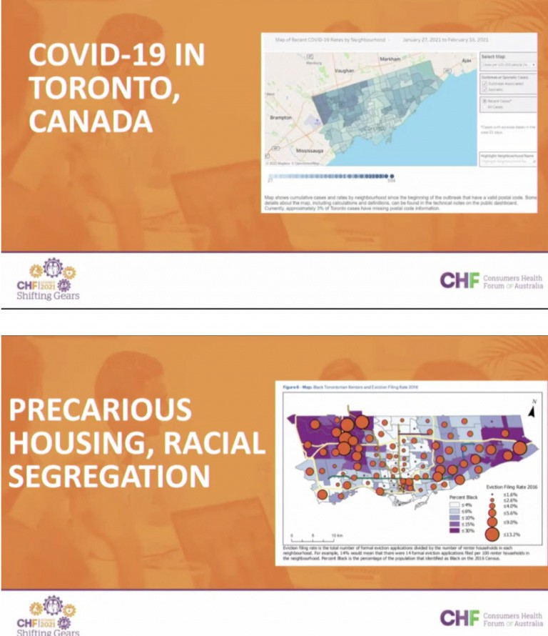

Clare Mullen was impressed with the project’s outcome of an almost 50 percent decrease in loneliness among the community targeted. She also made the point that in Australia’s fee-for- service funding system a decrease in doctors’ visits may not be an incentive for providers.
You can track Croakey’s coverage of the summit here.
Participants in this session engaged with Mulligan’s suggestion that the healthcare system needs to make “cognitive shift” from “what’s the matter with you?” to “what matters to you?”
Jane Synnot commented that it was “so great to hear people are being met where they are, that they can get help without feeling at risk”.
Candice Fuller said she loved the “walking alongside” concept!
Sian Slade from the Australian Medical Students Association said that AMSA have just started a social prescribing champions scheme – based on the UK approach – with medical students learning about social prescribing.
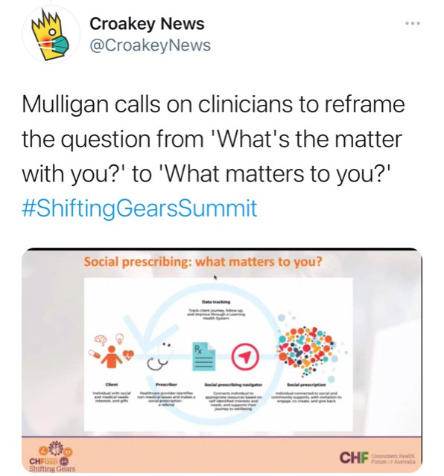
The final panel discussion was facilitated by Dr Lynne Maher who described COVID-19 as “in some ways a gift” in exposing the fault lines in our health system and driving rapid change.
She challenged panel members to reimagine the future of healthcare, eliciting a variety of responses.
Harry Illes-Mann said the most important thing is to look at the parts of our system which work well – embedding these and also looking at supplementing where they fall short. “When we work together we can get a lot done,” he said.
Tim Shaw highlighted the power of digital technology to transform health, saying that he believed that consumers have not yet benefitted from digital transformation, which so far has just swapped face to face care for online.

He described the next phase in the process as digital co-design to create new models of care to deliver what works for consumers, not just what works for the health system.
You can track Croakey’s coverage of the summit here.
Rob Grenfell from CSIRO stressed that equity has to be first and foremost in future transformations of healthcare. “If we don’t make equity important we will not bring everyone with us,” he said.
He made the case that we should measure health system performance by how well it serves the most difficult to reach populations.
The panel session also included a vigorous discussion on co-design. Harry Illes-Mann argued that co-design was not the only method for consumer partnerships in healthcare and that it could exclude some consumers.
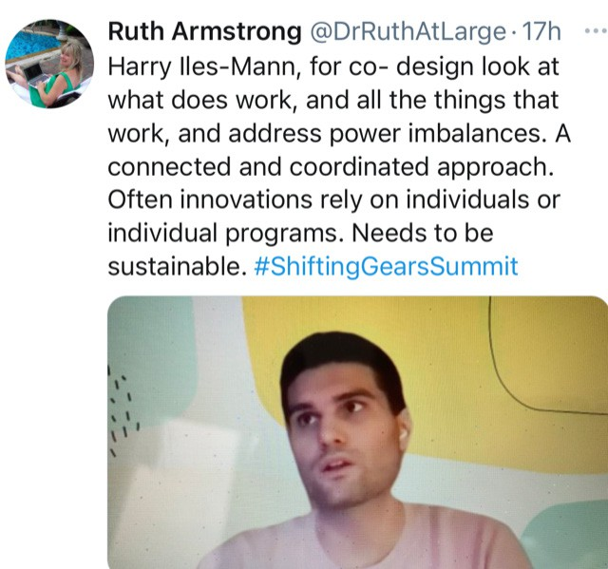
Lynne Maher responded by highlighting co-design is contextual and can work with marginalised groups to provide a better understanding of how care would work for them.
The importance of co-design in aged care was stressed by Janette Donovan who said that this approach was very important for future of aged care and to increase older people’s participation in their care and their communities. “I am currently looking at very poor design for a new residential aged care facility that may contribute to social isolation and loneliness in one of our most vulnerable groups of people,” she added.
Reflections and key takeaway messages from the Summit were provided by the four consumer rapporteurs.
Roxxanne MacDonald highlighted the role of consumers as the drivers of transformation and the potential for digital technologies to bridge gaps.

Professor Judi Walker embraced the notion of a “wise consumer” as described by Anne Duggan, who by asking difficult questions can help combine scientific and patient expertise.
You can track Croakey’s coverage of the summit here.
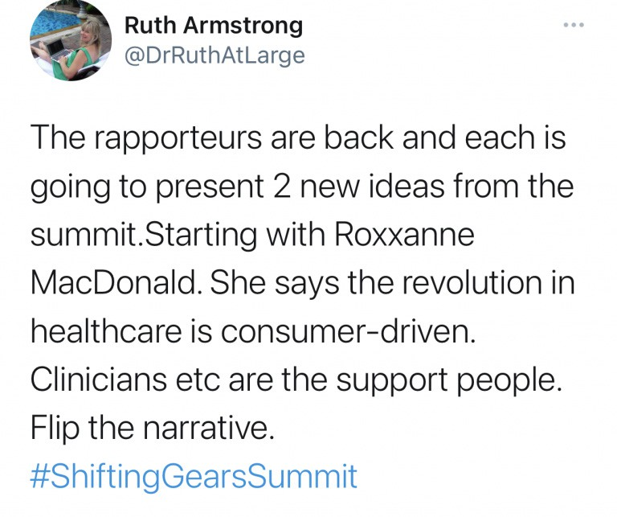
She also made a special mention of the Taranaki DHB consumer-led procurement project which she said tackled the tricky imbalance between management and consumers and transformed a bureaucratic process into something consumer-friendly which delivered real outcomes.
Renza Scibilia expressed some frustration at the lack of progress in including consumers as equal decision makers in health. She identified a “fear of equalisation – that consumers will take over” as one reason for this and suggested that behavioural research can help ensure consumer voices can be heard and make a difference.
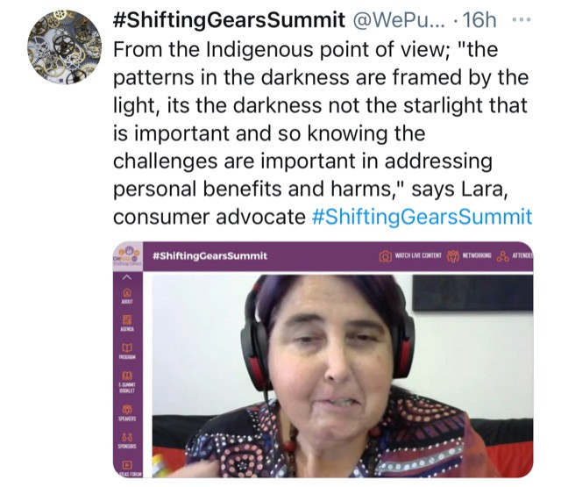
Lara Pullin said that COVID-19 has demonstrated how issues that consumers have been working on for years are suddenly able to be addressed.
She urged participants to consider non- standard ways of engaging consumers, and to consider issues such as reimbursement for engagement as there is a divide between those who don’t need it and those who will be unable to participate without it.
Noting the absence of Indigenous voices in many sessions of the Summit, Pullin left participants with the beautiful image of her Dark Emu Dreaming – a black emu defined by the stars around it, saying “the patterns in the darkness are framed by the light.”
The Summit concluded with CHF Chair Tony Lawson thanking the 800 delegates, 50 speakers, consumer rapporteurs, NZ partners, sponsors and organisers who made the event possible.

Shifting the narrative on Twitter
You can track Croakey’s coverage of the summit here.
A few highlight Tweets on Croakey’s selection
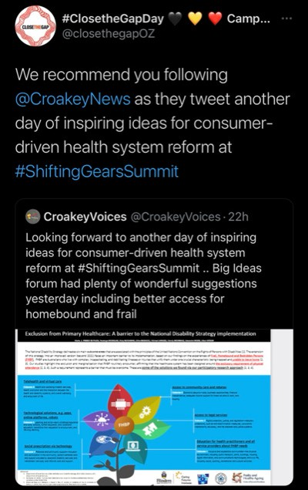
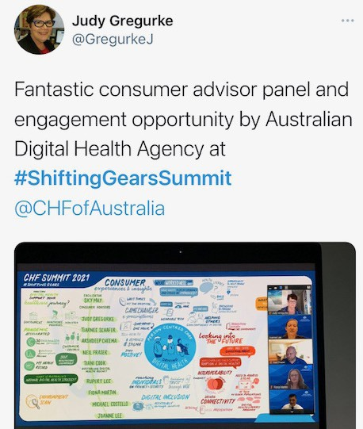

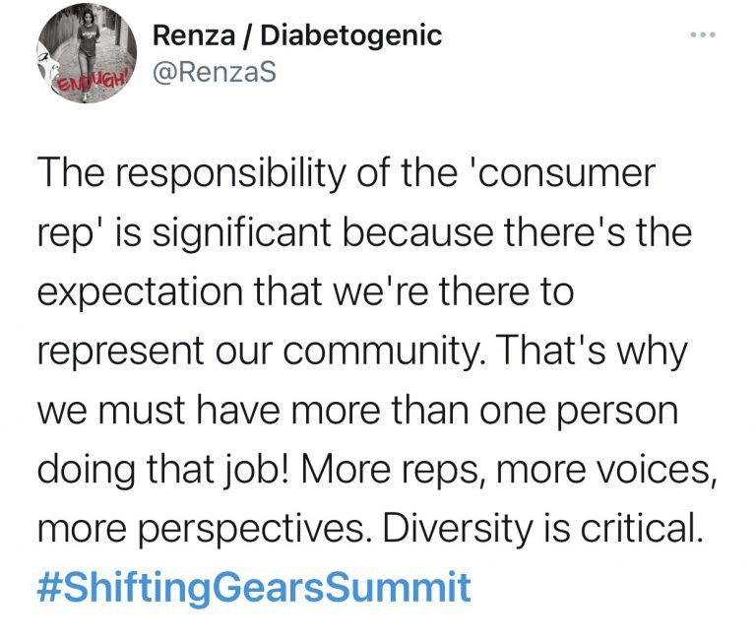
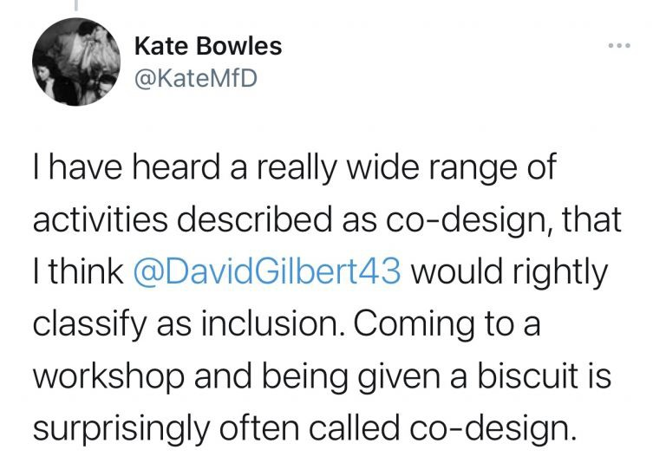
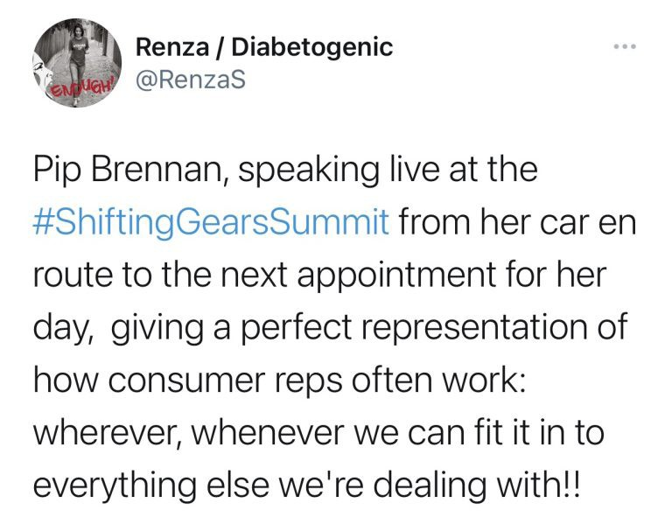
You can track Croakey’s coverage of the summit here.

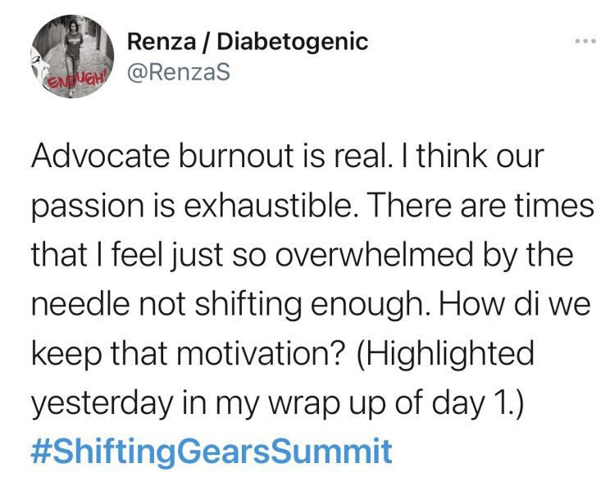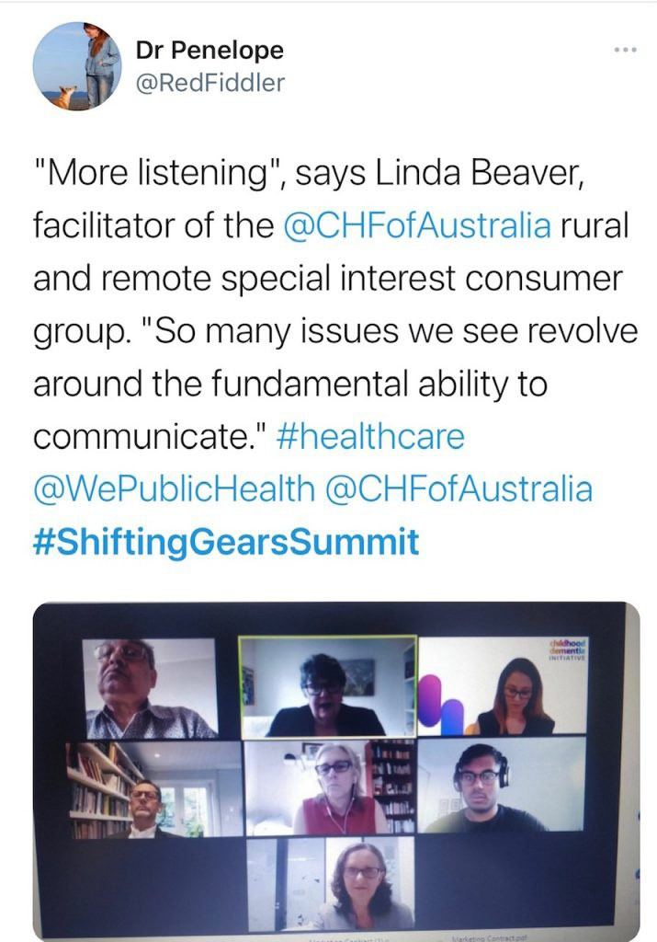
You can track Croakey’s coverage of the summit here.

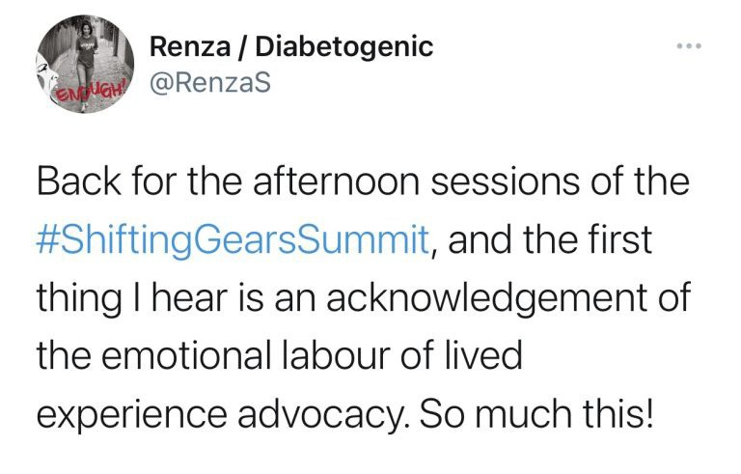
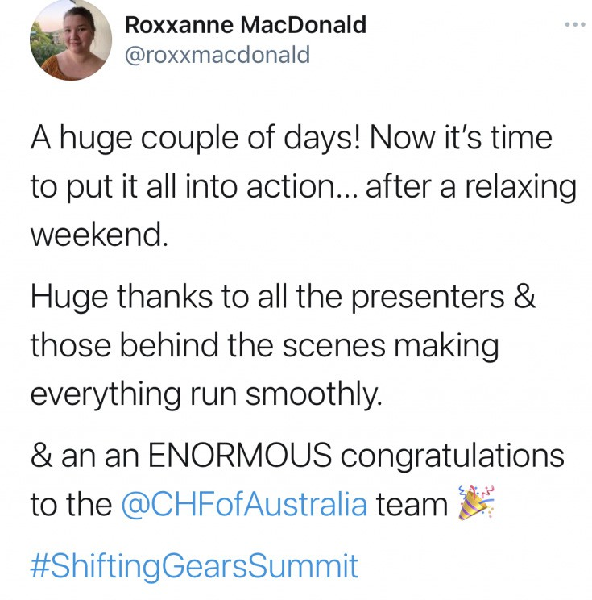
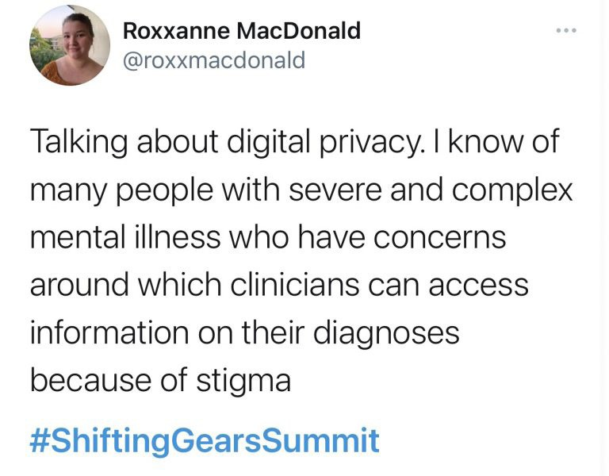
You can track Croakey’s coverage of the summit here.

Analytics
You can track Croakey’s coverage of the summit here.
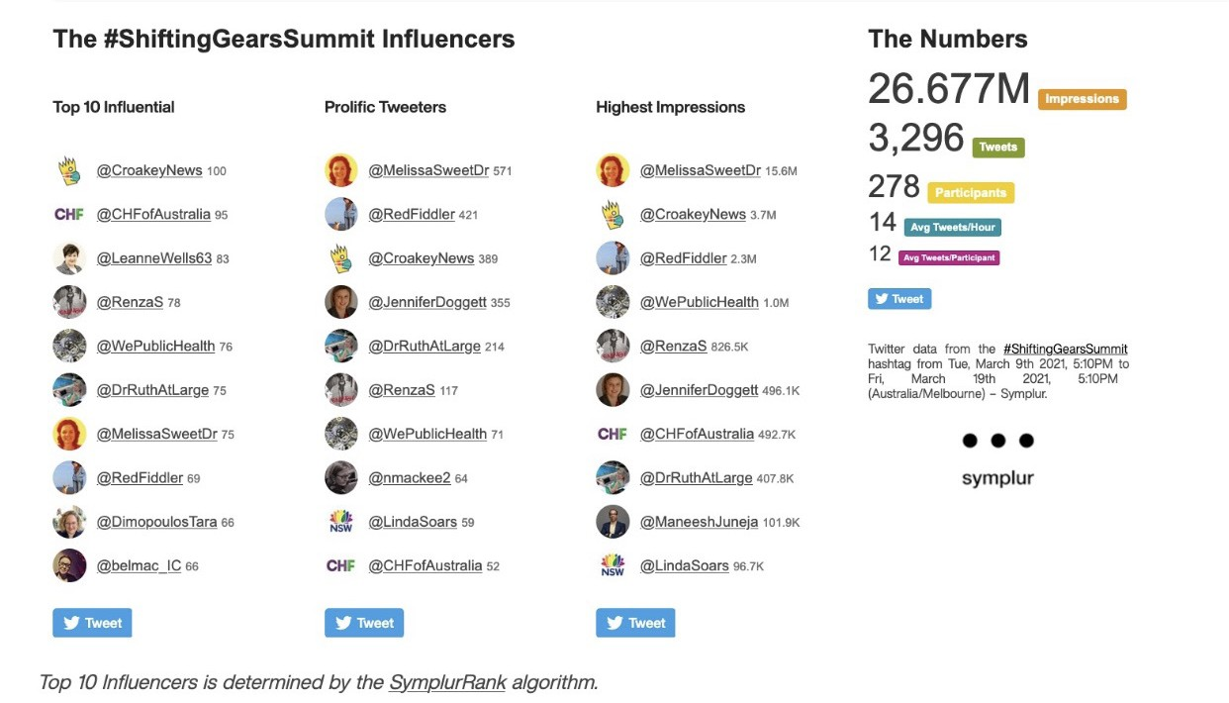
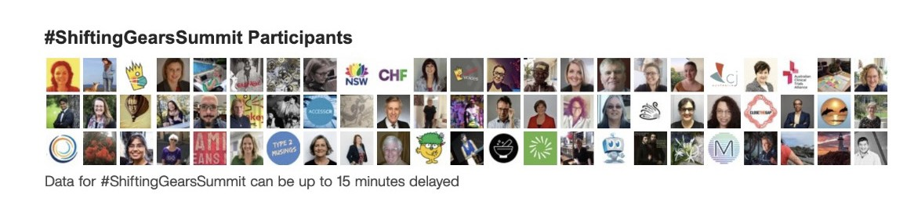
According to Symplur analytics, 278 Twitter accounts had participated in the #ShiftingGearsSummit discussion by end March 19, sending 3296 tweets, and creating 26.7 million Twitter impressions.

A reminder to delegates that sessions from the Summit will be available on demand for 12 months.

 https://bit.ly/3uufgYy
You can track Croakey’s coverage of the summit here.

CroakeyVOICES examines Shifting Gears to drive consumer leadership and experience in healthcare
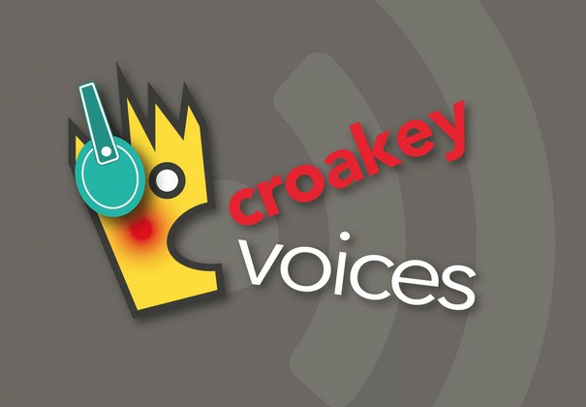
The Consumers Health Forum’s Shifting Gears Summit saw over 800 delegates taking part in an energised discussion about the importance of consumer participation in transforming and improving health services.
Consumers spoke up about the need for greater engagement at all levels of health service: from planning to delivery, research and management.
They want a healthcare system where patient input isn’t just box-ticking a questionnaire but full partnership, with consumers engaged in every aspect of health delivery and with the conversation moving from what can medical science do to what do you want, why and will it make your life better?
The international virtual gathering, with representatives from Australia, New Zealand, the United Kingdom and Canada, sparked spirited debate on moving consumers to the very heart of health service planning, with co-design and the power of digital technology highlighted as two critical tools to empowering consumers.

CroakeyVoices spoke to a range of delegates about the opportunities and challenges ahead:
You can track Croakey’s coverage of the summit here.
- Vincent Dumez: Codirector of the Centre of Excellence on Partnership with Patients and the Public at University of Montreal
- Kellie O’Callaghan: Consumer advocate. Past chair of a regional health service and involved in a range of state and local health-focused boards and committees
- Craig Cooper: Consumer advocate and member of the NSW Health Clinical Excellence Commission Consumer Council
- Rosemary Ainley: Editor of CreakyJoints Australia and co-leader of the Young Women’s Arthritis Support Group
- Kelly Foran: Founder Friendly Faces Helping Hands Foundation and consumer advocate
- Roxxanne McDonald: Consumer Health Forum Board Director and YHF Young leader.

Play episode
Twitter: @croakeyvoices

 https://bit.ly/2OcUNbo
You can track Croakey’s coverage of the summit here.

Shifting Gears Summit: a user’s manual in ten parts

Image, Unsplash

Hopefully you caught some of Croakey’s coverage of the Consumers Health Forum of Australia Shifting Gears Summit, particularly Jennifer Doggett’s action packed reports from days one and two.
It was a multilayered online event, with much of each day running in six different “streams”, several panels, a robust rolling “chat”, poster presentations, breakout sessions and of course Twitter commentary.
In the post below, Jennifer Doggett spotlights 100 insights, moments and facts that will make you feel like you were there, as well as prompting reflection and further reading.
And please don’t miss the first of our two Croakey Voices podcasts, in which Cate Carrigan takes the opportunity to go a little deeper with several of the presenters and delegates.

Jennifer Doggett writes:
You can track Croakey’s coverage of the summit here.
If you’re looking to catch up with what happened at the recent #ShiftingGearsSummit, here are some highlights, hidden gems and tips for further reading, in the Shifting Gears Summit 10 top 10s.

10 Summit locations
Warragul, Australia

Montreal, Canada

Bass Coast, Australia


Canterbury, New Zealand
You can track Croakey’s coverage of the summit here.

Toronto, Canada

Ararat, Australia

Copenhagen, Denmark


Glenn Innes, Australia
You can track Croakey’s coverage of the summit here.

Taranaki, New Zealand

Devon, UK


10 Memorable Summit Quotes
You can track Croakey’s coverage of the summit here.

“ It’s now or never.”
Vincent Dumez, Keynote speaker and co-director of the Centre of Excellence on Partnership with Patients and the Public at University of Montreal

“ The health system needs to be shaken not stirred.”
Louisa Walsh, Presenter, PhD candidate and consumer advocate

“ We have lived all, we hear all, we see all and we can influence all.”
Kellie O’Callaghan, speaker and consumer advocate

“ Kindness is a meta value – you can’t be kind to others if you’re not being kind to yourself.”
Ashley Bloomfield, speaker and New Zealand Director-General of Health

“ Not including consumers in healthcare is like throwing someone a birthday party and not inviting them.”
Anne MacKenzie, Presenter and Community Engagement Manager, Telethon Kids Institute

“ Care cannot be safe unless it is culturally safe.”
Jennifer Zelmer, Plenary presenter; President and CEO at Healthcare Excellence Canada

“ Community trust will be the oil of the future.”
Kate Mulligan, Keynote speaker and Director of Policy and Communications at the Alliance for Healthier Communities, Ontario

“ Equity should be in the DNA of our health system.”
Jeffrey Braithwaite, Speaker and Director, Australian Institute of Health Innovation

“ We may all be from the same cookie machine but we are all different cookies.”
You can track Croakey’s coverage of the summit here.
Mary Lynne Cochrane, Presenter and consumer advocate

“ Consumer engagement grows at the speed of trust.”
Peter King, Presenter and consumer representative

10 Key Summit tweets
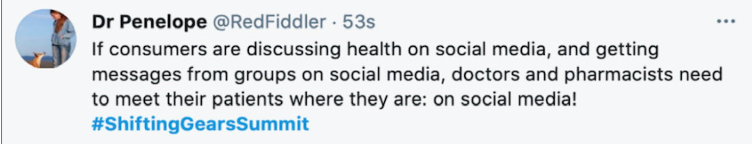
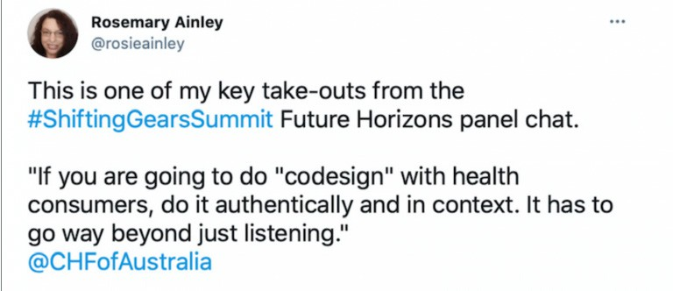
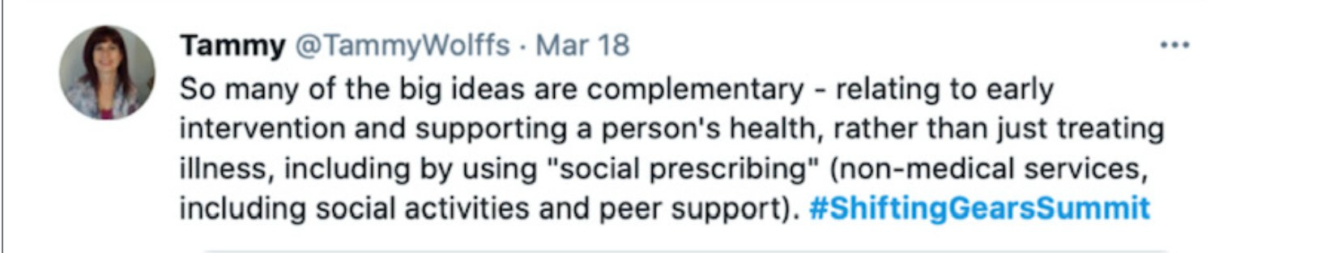
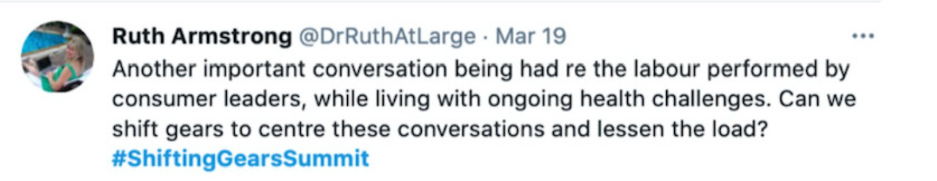
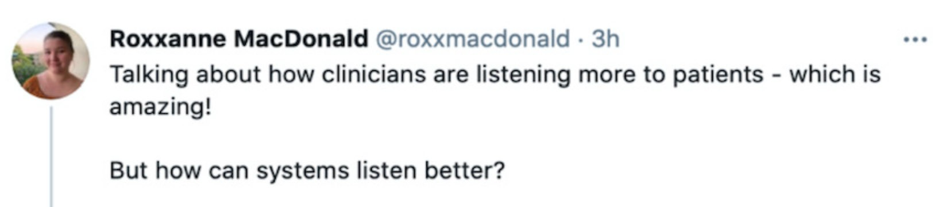

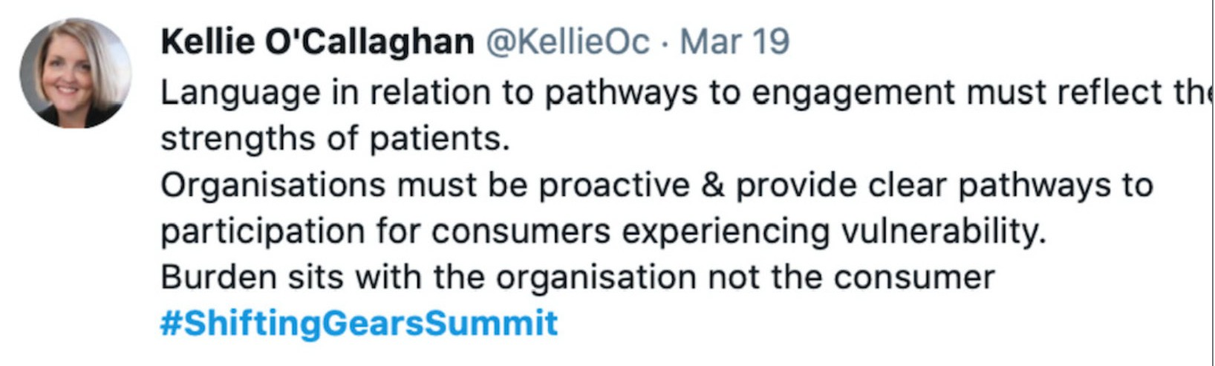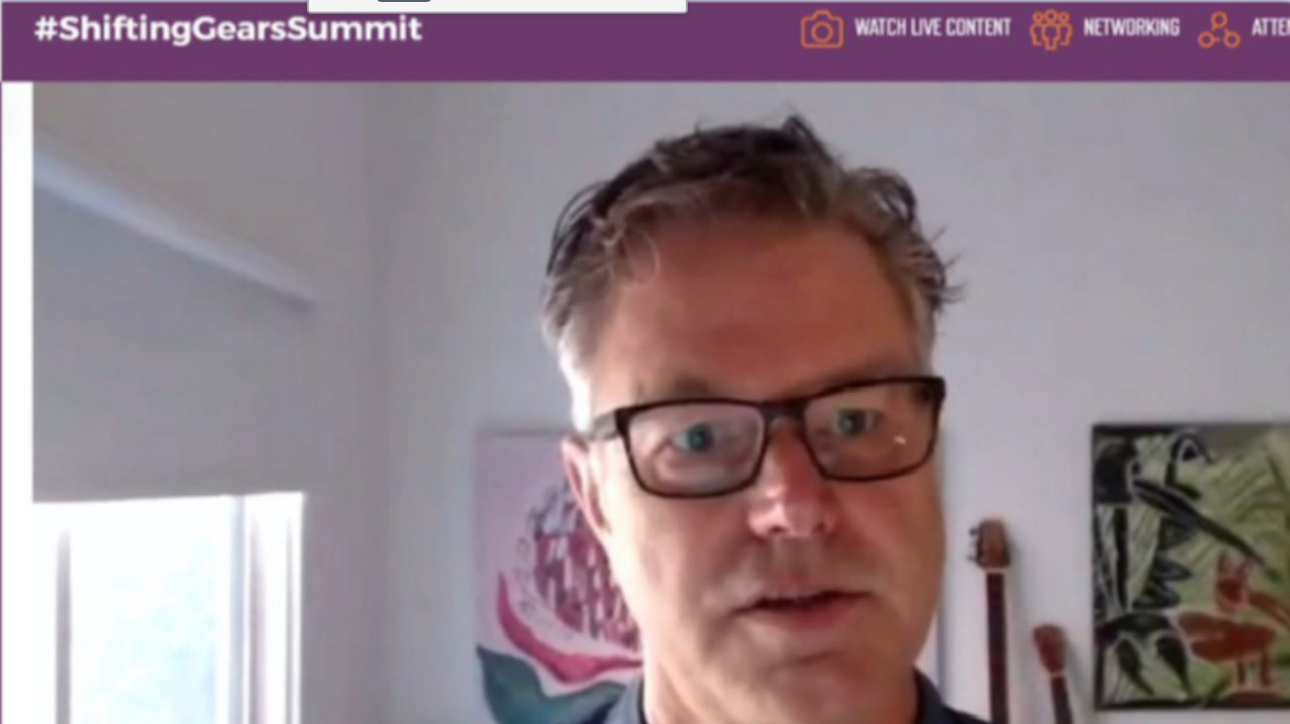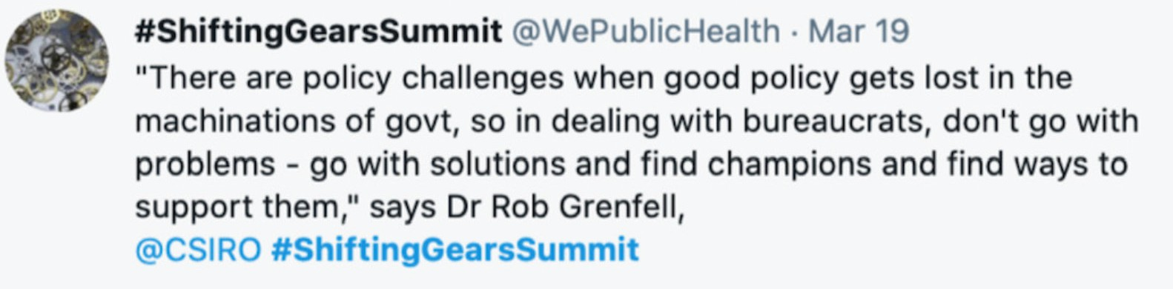
You can track Croakey’s coverage of the summit here.

10 Summit Tweeters to follow
Renza / Diabetogenic, @RenzaS Roxxanne MacDonald, @roxxmacdonald Dr Penelope, @RedFiddler
Kellie O’Callaghan, @KellieOc
Tara Dimopoulos-Bick, @DimopoulosTara
Priyanka Rai, @priyankarai113 Ruth Armstrong, @DrRuthAtLarge Lou Walsh, @laqwalsh
Tammy Wolffs, @TammyWolffs
Brett Scholz, @brett_scholz

10 pithy comments from the online delegates’ chat
You can track Croakey’s coverage of the summit here.
“ Patient voice, patient choice.”

Gary Sutcliffe
“ The patient will see you now’ takes on a broader meeting.”

Jo Root
“ There are two ways of talking to people. One identifies their deficiencies and the other looks for their strengths, resilience and experiences. It’s important to use the latter method.”

Christine Walker
“ The whole family is impacted when someone is ill; has an accident – no matter what the outcome. Being in a rural or isolated area is so challenging.”

Jane Synnot
“ One of our consumer reps said to use the word “input” rather than “feedback” when asking them.”

Lidia Najbar
“ Navigation through systems is important but systems must always be reflective about their processes and systems. Consumers advocate out of necessity and that itself creates inequity – not all consumers can advocate. Systems, policies and processes need to be strong enough to respond to consumer needs without them having to advocate.”

Nicole Mills
“ Dismantling medical hegemony is taking time. I think we are very fortunate to have the Tiriti here in NZ ( although much work to implement the Tiriti still) which is about
partnership and this lets the concept of cross sectorial rights to partnership to increase in the health space.”

Frank Bristol
“ Consumer leaders can be champions for health professionals – and health professionals can be champions for consumer leaders. We need buddy systems.”

Melissa Cadzow
“ Sometimes it seems that we ask for information from our community before we are ready to do something with it. We then get all this valuable feedback, and don’t have anywhere to go with it.”

Christine Chandler
“ Huge thanks to CHF to host Big ideas, it shows what the grassroots consumers are capable of and how the policymakers are so wary of them.”
Shyamsundar Muthuramalingam

10 pieces of wisdom from presenters
You can track Croakey’s coverage of the summit here.
“ Consumers are the only people with a full view of the health system.”

Vincent Dumez
“ We’re all in this together.”

Craig Cooper
“ ‘Mark Doughty’ the person and ‘Mark Doughty’ the patient are very different people to the health system.”

Mark Doughty
“ We need clinically literate managers and managerially literate clinicians.”

Leanne Wells
“ Evidence is important but it doesn’t always leave much room for the patient’s voice.”

Jeffrey Braithwaite
“ The response that consumers get from health professionals and services when they first give feedback or tell their story determines how confident consumers feel about engaging in the future.”

Louisa Walsh
“ I often have discussions with people in position of power about the difference between power and influence. The health system in my experience is keen to allow space for consumers to influence, but not so keen to allow to share decision making power, particularly around priorities and resourcing.”

Ester Vallero
“ The key challenge is building capacity amongst leaders to really cede power. And that’s not easy to do in a system that likes project scopes and clear deliverables.”

Clare Mullen
“ We need to move beyond EBM in our teaching and include SDM – shared decision- making – with patients.”

Yvonne Zurynski
“ Indigenous communities across Canada are at much higher risk and face barriers to health access, including historic and present day racism. That said, they have self-
organised tremendously well to ensure protection from Covid. A key challenge is serving urban Indigenous populations equitably.”
Kate Mulligan

10 important statistics mentioned at the Summit
You can track Croakey’s coverage of the summit here.
Aboriginal and Torres Strait Islander communities in Australia have experienced no deaths from COVID-19 and have only had 150 cases.

Emily Phillips
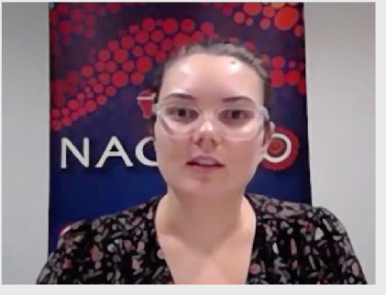

Around 60 percent of healthcare is in line with evidence, around 30 percent is wasted and 10 percent comes with some adverse outcome or near miss.”

Jeffrey Braithwaite

Māori are twice as likely to die of cancer than non-Māori.”

Dr Chris Walsh

Almost 50 percent of Australians surveyed reported that fundamental changes are needed to make our health system work better.”

Yvonne Zurynski
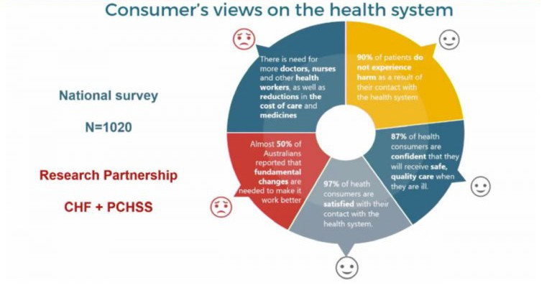

Avoidable patient harms are one of top ten causes of deaths – the most common of these are due to medication errors, unsafe surgical care and hospital-based infections.”

Dr Chris Walsh

2.5 million Australians don’t have access to the Internet.”
You can track Croakey’s coverage of the summit here.

Stanislav Minyaev

Musculoskeletal conditions affect over seven million Australians (more than any other national health priority area) and are the leading cause of disability worldwide.”

Rob Anderson

50 percent of aged care workers in Melbourne were born overseas.

Nicole Allard

A social prescribing program in Toronto resulted in a 49 percent decrease in loneliness in the target population.”

Kate Mulligan

89 percent of health occurs through our genetics, behaviour, environment and social circumstances.”
Tina Janamian
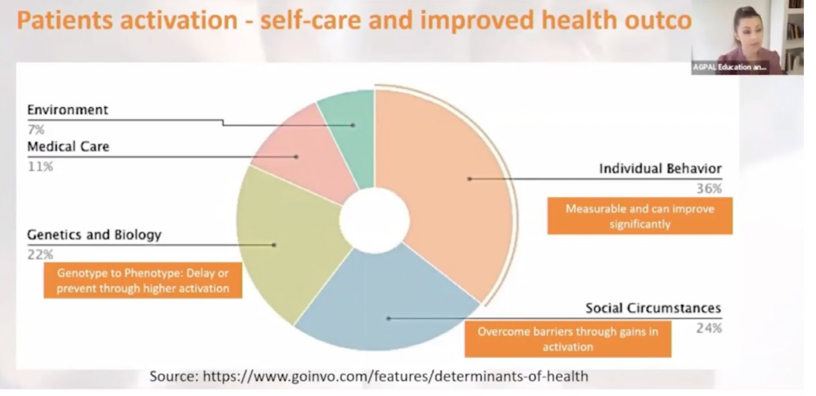

10 resources mentioned in presentations/chat
You can track Croakey’s coverage of the summit here.
Collaborative practice and patient partnership in health and social services, Centre of Excellence on Partnership with Patients and the Public

The ‘Real People, Real Data’ project, Consumers Health Forum of Australia

Health Care Opinion: patient stories
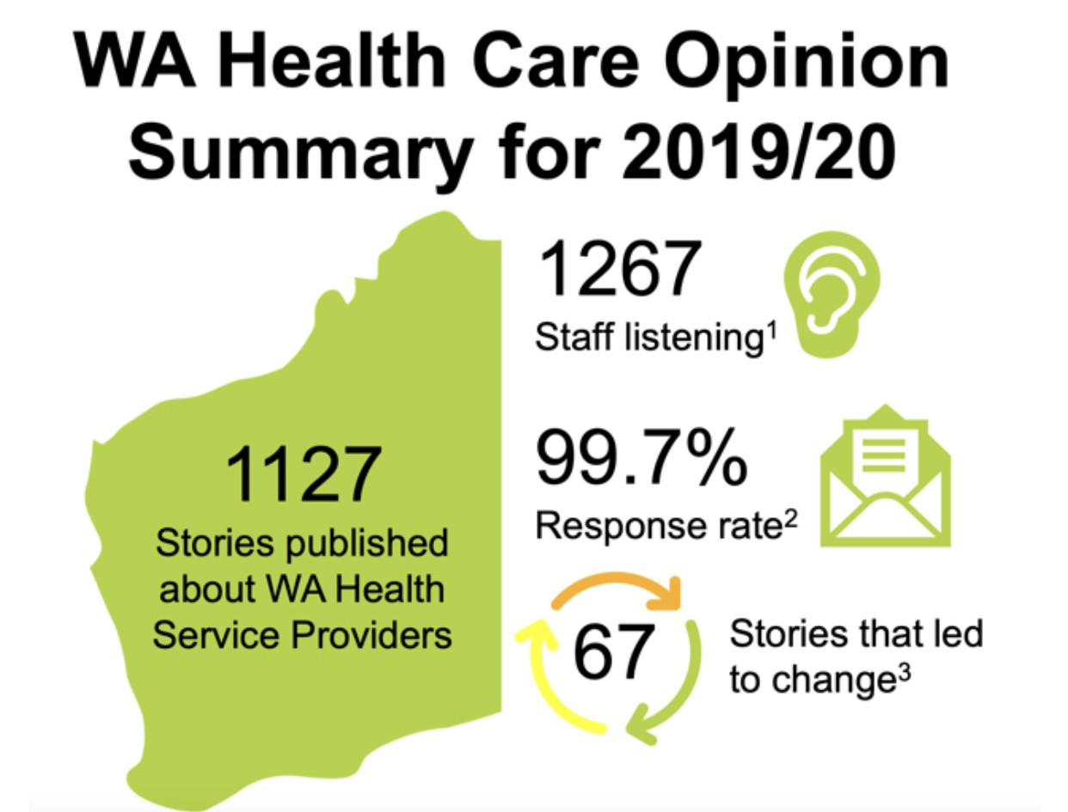

Loneliness Thought Leadership Roundtable report, Consumers Health Forum of Australia

The Indigenous Genomics Health Literacy Project Queensland Genomics Advisory Group

The “Join Us” national disease-agnostic research register, The George Institute


The consumer engagement quality and safety marker (New Zealand)
You can track Croakey’s coverage of the summit here.

Working Together: A Partnership between NPS MedicineWise and the Consumers Health Forum of Australia

Consumer and Community Engagement Framework – Western NSW PHN
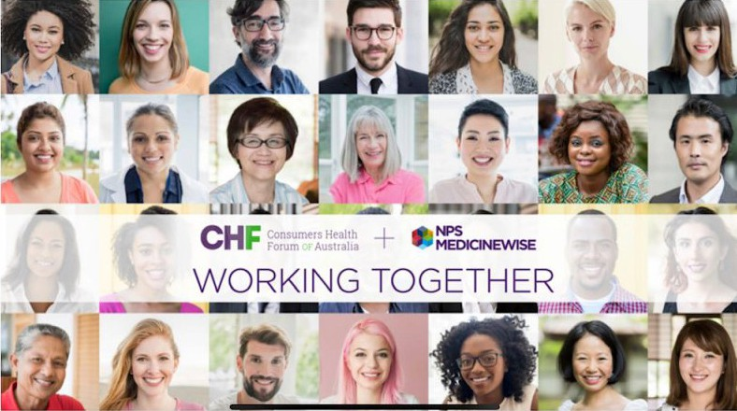

Building collaborative leadership: A qualitative evaluation of the Australian Collaborative Pairs trial, Helen Dickinson Alison Brown Suzanne Robinson Jenny Parham Leanne Wells

10 highlights from the poster session
You can track Croakey’s coverage of the summit here.

The Partnership Advisory Council
The Empowerment Ladder was developed by the Partnership Advisory Council at the Chris O’Brien Lifehouse Hospital in NSW. It demonstrates how collaborative consumer leadership and executive trusting relationships can drive better outcomes and experiences for, and with, patients.
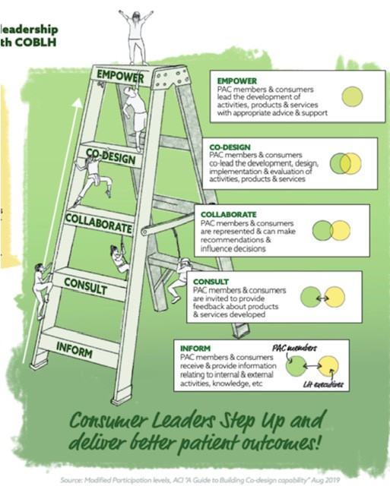

QEII Hospital
Ruth Cox, Director of Occupational Therapy at the QEII Hospital in Brisbane, identified the following challenges in applying best practice principles to successfully partner with consumers in a series of studies.
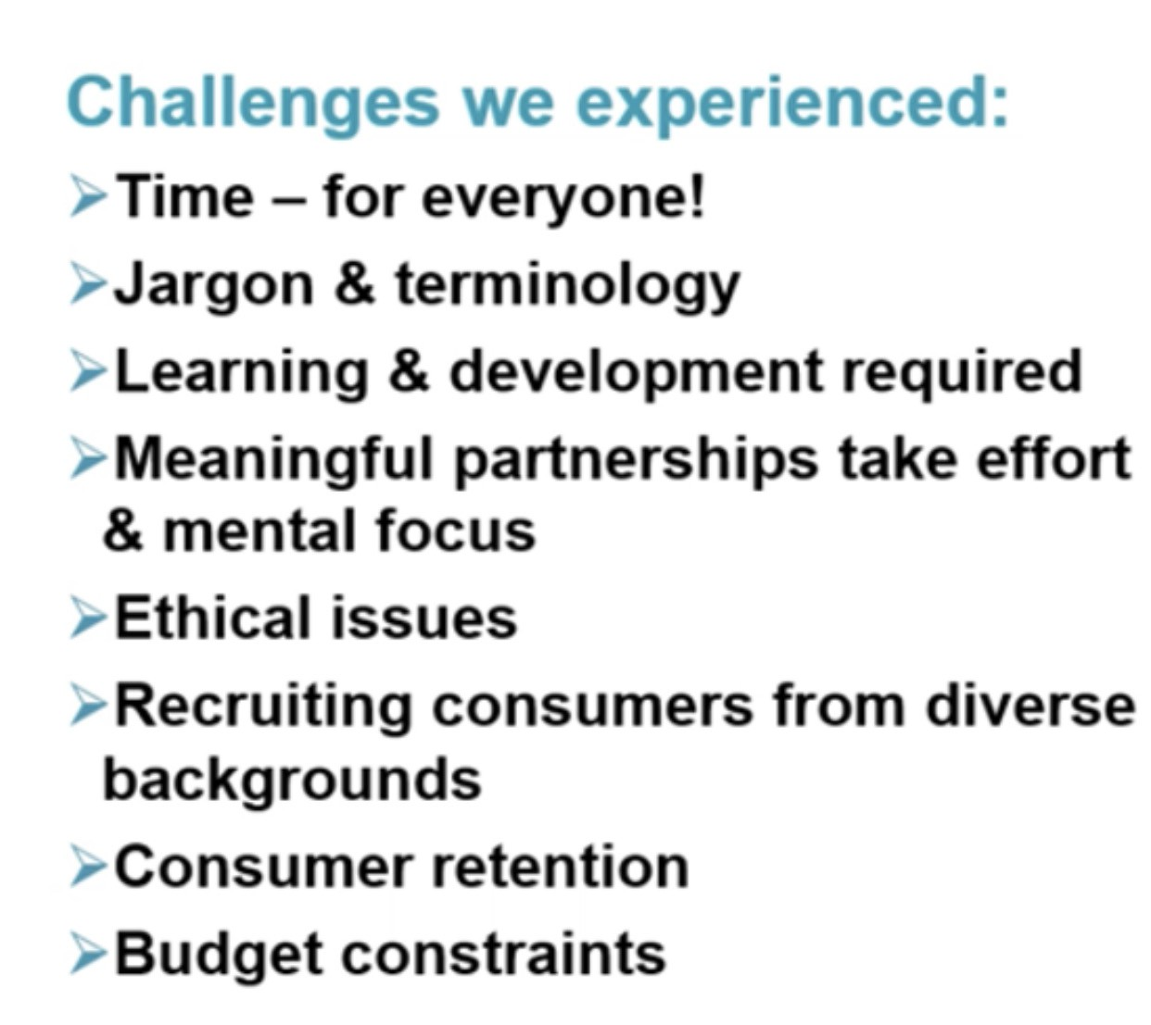

Australian Health Research Alliance
You can track Croakey’s coverage of the summit here.
The Australian Health Research Alliance (AHRA) poster outlined the process for co-designing an online hub to foster consumer and community involvement in health and medical research and healthcare.
Health professionals, researchers and consumers participated in the co-design process – a key part of this process consisted of a series of workshops where participants expressed their priorities for the hub.
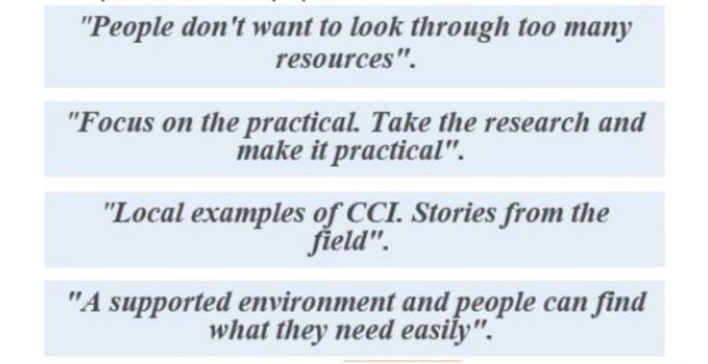

Sydney Health Partners
Angela Todd, Research Director, Sydney Health Partners, described a small project that was undertaken in partnership with consumer networks within three large health services in NSW. The project set out to develop a resource for consumers, promoting the value of being involved in health research.
Consumers were involved at all stages of the development of this brochure, including the sharing of personal stories about their involvement in health research.
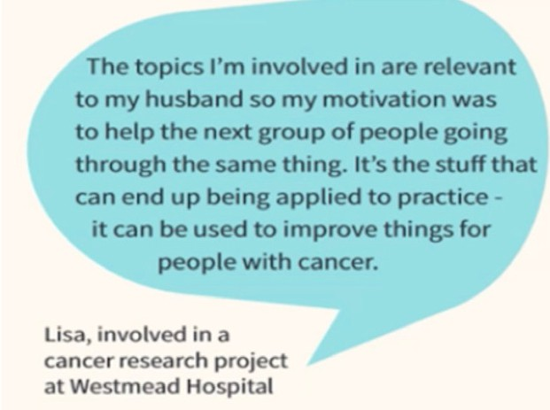

Personalised technologies
You can track Croakey’s coverage of the summit here.
Huong Ly Tong is a digital health scientist with a background in public health. She presented the findings of a co-design project exploring consumers views on personalisation of innovative
technologies such as AI, mobile apps and fitness trackers to promote healthy behaviour change. This project found that there is no ‘one size fits all’ approach to this emerging area of healthcare. Genomics research collaboration
Three case studies of collaboration between researchers and consumers in the field of clinical genomics were presented by Stephanie Best from the Murdoch Children’s Research Institute.
She outlined how to move the traditional, paternalistic conversation about patient engagement to a collaborative sharing of expertise, and highlighted the importance of approaching collaboration with realistic expectations.
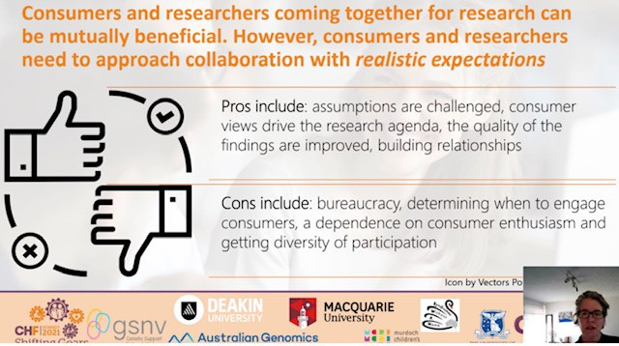

The Victorian Comprehensive Cancer Centre
Dr Joanne Britto, Consumer Engagement Manager at the Victorian Comprehensive Cancer Centre, identified five levels of engagement (below) as part of her presentation on the development of a consumer and communication engagement action plan.
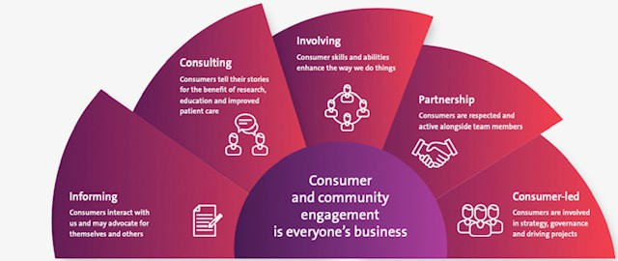

Breathlessness collaboration
You can track Croakey’s coverage of the summit here.
A collaborative project supported by the University of South Australia, Central Adelaide Local Health Network and Health Translation SA aimed to communicate advances in understanding persistent breathlessness, and evidence-based effective strategies to manage it to consumers.
Kylie Johnston from UniSA presented the eight key messages across two themes, developed in conjunction with consumers to reflect their values and priorities.
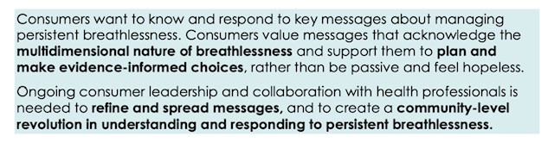

Sacred Heart Mission
Rebecca Edwards and Trevor Skerry from the Sacred Heart Mission in Victoria reflected on how their organisation had to change in response to COVID-19 in order to continue to provide care for its diverse clients, many of whom were experiencing significant hardships due to the pandemic.
A trauma-informed practice lens and a social determinants view of policy decision making were identified as key strategies to support this process.
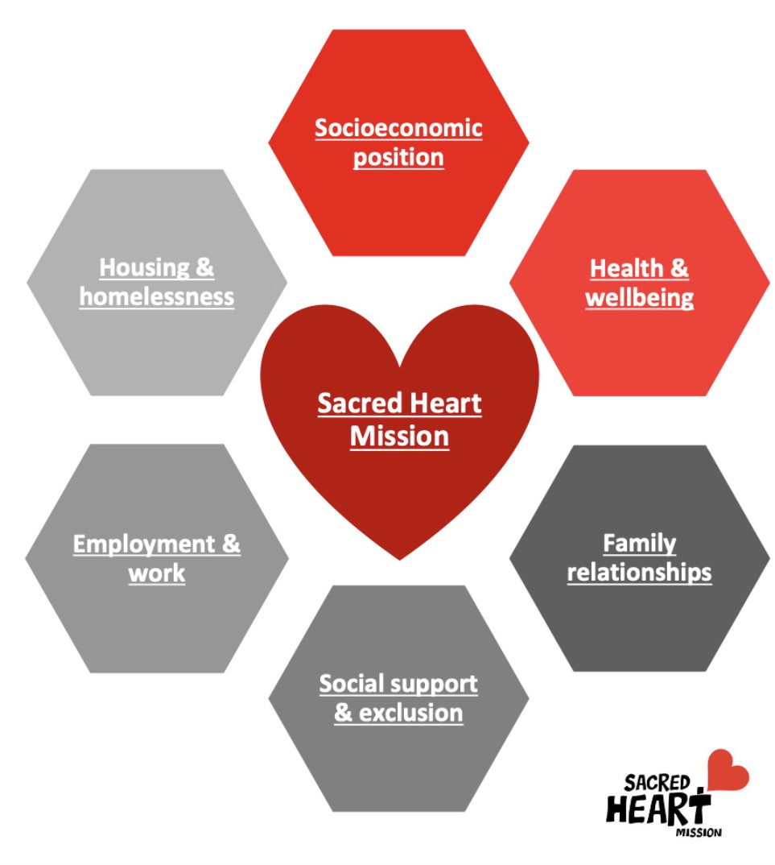

Exclusion from primary healthcare
You can track Croakey’s coverage of the summit here.
Dr Maria Alejandra Pinero de Plaza, an NHMRC Postdoctoral Research Fellow with the CRE in Frailty and Healthy Aging, presented her research findings on the exclusion from primary healthcare of people who are frail and homebound.
In her presentation she identified six areas for action, based on the National Disability Strategy:
(1) Inclusive and accessible communities, (2) statutory protections, (3) Economic security, (4) Personal and community support, (5) Learning and skills (6) Health and wellbeing.


10 suggestions for post-Summit reading
You can track Croakey’s coverage of the summit here.
The Patient Will See You Now: The Future of Medicine Is in Your Hands Paperback, Eric Topol MD
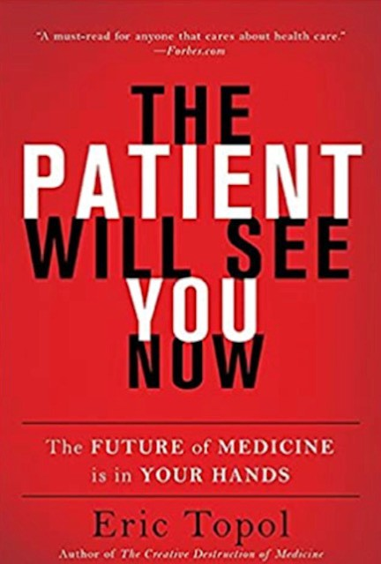
The Patient Revolution, David Gilbert
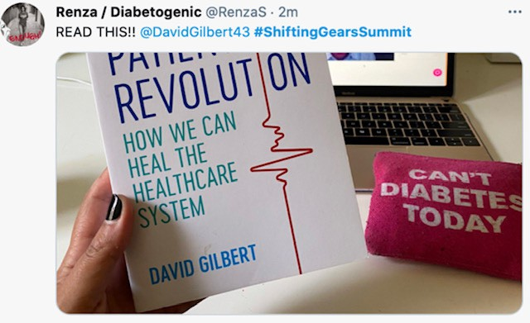
Health Consumers NSW and Older Women’s Network older people’s experience of ageism in the health system
The Health and Disability System Review, Ministry of Health, New Zealand
Consumer enablement: a clinician’s guide, NSW Health
Social prescribing: The next step for equitable healthcare, Kate Mulligan and Kavita Mehta
Issues Brief no 34: Can value-based health care support health equity?, The Deeble Institute

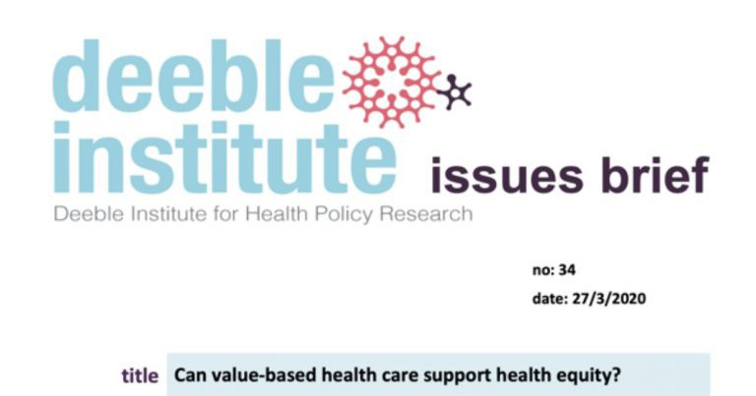
You can track Croakey’s coverage of the summit here.
Facing the Ethical Challenges: Consumer Involvement in COVID-19 Pandemic Research, N Straiton, A McKenzie, J Bowden, A Nichol, R Murphy, T Snelling, J Zalcberg, J Clements, J Stubbs, A Economides, D Kent, J Ansell, T Symons

The Digital Doctor: Hope, Hype, and Harm at the Dawn of Medicine’s Computer Age, Robert Wachter
From Risk to Resilience: an equity approach to Covid-19, Chief Health Officer of Canada
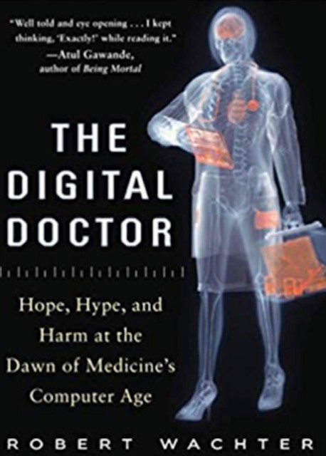

Analytics
You can track Croakey’s coverage of the summit here.
According to Symplur analytics, 349 Twitter accounts had participated in the #ShiftingGearsSummit discussion by end March 31 2021, sending 3719 tweets, and creating
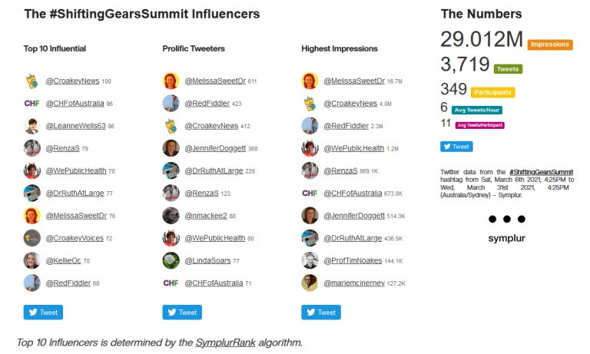
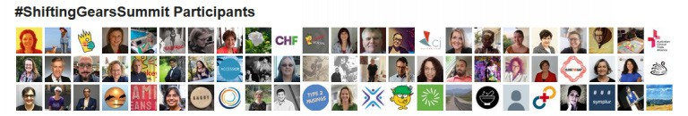
29.01 million Twitter impressions.

 https://bit.ly/2OE2Myf
You can track Croakey’s coverage of the summit here.


Health consumers of today, partners of tomorrow

The Shifting Gears Summit hosted by the Consumers Health Forum of Australia (CHF) highlighted the changing role of consumers in healthcare, moving from a tokenistic “charity and volunteer” model to one of co-design and co-creation.
The Trans-Tasman conference involved leading consumer advocates from Australia and New Zealand, as well as keynote speakers from Canada and the UK. It showcased the many and varied ways in which consumers are working at all levels of the health system to drive changes which support the delivery of consumer-centred care.
Below CHF CEO, Leanne Wells, draws on CHF’s work in areas such as the Collaborative Pairs Australia program, and the presentations and discussions at the Summit, to explore strategies for strengthening the role of consumers to ensure they continue to shape the health system of the future.

Leanne Wells writes:
COVID-19 has shown that more than ever, our health depends on us and how we respond to messages like pandemic precautions and getting vaccinated.
The COVID era has accentuated the trend towards more assertive health consumers. Rising use of ‘Dr Google’ and digital health generally has fueled a more questioning attitude from consumers about their health and treatment options.
Australasia’s first health consumers conference involving over 820 delegates from Australia and around the world recently displayed the growing momentum of consumer influence in healthcare.

The Consumers Health Forum conference was titled Shifting Gears and consumer leaders and delegates attending the virtual conference have stepped up a gear. With consumer
You can track Croakey’s coverage of the summit here.
representatives and advocates now so much an active part of the health system, it is time for their place to receive more formal support, recognition and pay.

A health consumers academy
A health consumers’ academy to support research, education and training would provide the intellectual and organisational leadership entity for more strategic development of health
consumer leaders, advocates and their organisations as an integral part of the health system.
This should include the establishment of a bespoke mentoring program for consumer advocates. Consumer leaders would benefit from mentors in the same way leaders in the business and clinical worlds do.
Their insights and advice must be recognised with appropriate remuneration. Leadership and education in collaborative practice and better ways to work together and share power are already underway through leading-edge programs such as CHF’s Collaborative Pairs Australia.

Beyond the volunteer model
We are moving from the traditional volunteer and charity-based tradition of consumer advocates. The demand for consumer advocates and their insights in an era of chronic diseases such as diabetes and mental illness where effective therapies can depend very heavily on non-medical services as much as clinical interventions, is placing heavier and more complex demands on a relatively small pool of competent people.
And as we heard at the conference, patient groups and organisations like CHF are reporting that demand for consumer advisors is outstripping supply.
The lay consumer’s experience and perspective can play a pivotal role in areas like tailoring hospital and primary care to an individual patient’s needs, advising hospitals on consumer-friendly services and ensuring patients can be partners in care – rather than the subjects of care – by getting the best information on treatment options.

Strategic and irreplaceable
The place of the consumer representative or advocate in health organisations is now widely accepted. The pity has been that too often it seems the “consumer” may be seen as more of public relations gesture or compliance exercise than a genuine attempt to have them serve as a strategic and irreplaceable functionary who may attend board and committee meetings but be excluded from crunch decisions. This practice is changing but is far removed from the ethos of the business world where the consumer is sovereign.
It is worth remembering that the consumer is often the only individual in the care setting to have complete experience and knowledge about all aspects of their care. The best healthcare professionals and organisations learn from listening to the lived experience of consumer advocates in improving health policy and practice.
The qualitative evidence available from lived experience and consumer insights is equally valid to quantitative data in research.

Consumer-centred care
You can track Croakey’s coverage of the summit here.
A central driver in the changing attitudes to effective healthcare has been the move away from provider-centric care practices to more individually focused consumer-centred, personalised care.
The advantages of consumer-centred care in both health and economic terms have been highlighted in landmark reports by both the Productivity Commission in its Shifting the Dial Report and the CSIRO in its Future of Health report.
In 2018 CHF released a White Paper called Shifting Gears: Consumers Transforming Health which set out the transformational policy shifts needed to make the health system more person- centred, and described varied roles consumers can play in shaping better policy, programs, research and services.
The central messages of the conference sought to re-imagine health towards a future where the focus is on consumers as partners in health and social care. As contemporary practice and
research around the world is showing, where the consumer or patient is engaged in the decisions about their care, outcomes improve, and experience is better.
The consumer of tomorrow will be recognised as a full “actor” of care, own their medical information, understand the value of evidence-based medicine, be better decision makers and be fully engaged as transformational partners.

Strengthening Aboriginal and Torres Strait Islander voices
There was strong recognition of the need for health systems to embrace the community- controlled ethos of Aboriginal and Torres Strait Islander healthcare, and a call for strengthening Indigenous voices in consumer advocacy. The success of Aboriginal community-controlled health centres in countering COVID offers insights of benefit to the rest of Australia.
That experience demonstrates that health and social care organisations need to be ‘engagement capable’, that is actively creating environments where consumer-centred services can flourish.
Culture, strategy and practices all need to work to deliver consumer-centred programs and services.
We are at risk of a growing shadow of inequity as a consequence of widening wealth disparities. The development of ever more varied and expensive treatments and the advent of digital health has increased the risk of the well-off having care not available to others who are often the ‘unheard yet most vulnerable’.
Health consumer advocates play a vital role in pressing for quality healthcare to be available to all and for reforms to the system not only to make the most of medical advances but to promote wellness through preventive health measures.

 https://bit.ly/2OZ7RRV
You can track Croakey’s coverage of the summit here.

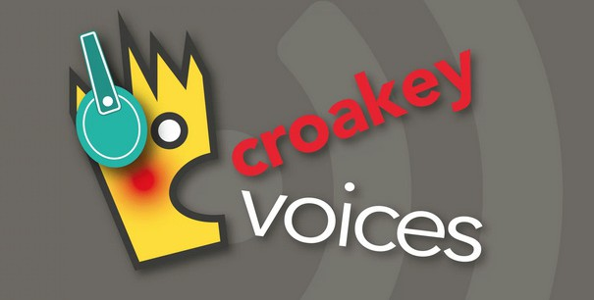
CroakeyVOICES joins consumers Shifting Gears on the road to improved quality in healthcare

Powerful voices for change at the Consumer Health Forum’s Shifting Gears Summit called for full partnership with clinicians in designing healthcare into the future – laying the ground for a healthcare system more responsive to patient needs.
In CroakeyVoices’ second dive into the recent summit, we hear about the importance of consumers questioning treatment options and asking for alternatives, examine a UK model of patient/clinician partnership and catch up with how health consumer advocacy is driving change in New Zealand.
The Consumer Health Forum’s first Australasian Summit, with contributions from around Australia, New Zealand, the UK and Canada, focused on how health consumers, with their deeper knowledge of their own conditions, should play a vital role in improving the healthcare system.
In this podcast, Cate Carrigan explores the themes of health quality and care with a number of keynote speakers and delegates:
- Professor Anne Duggan: Clinical Director at the Australian Commission on Safety and Quality in Health Care and Conjoint Professor, School of Medicine and Public Health, University of Newcastle.
- David Gilbert: Director of In Health Associates, the first Patient Director in the NHS at the Sussex MSK Partnership (Central), and author of “The Patient Revolution – how we can heal the healthcare system”. https://www.inhealthassociates.co.uk/publication/the-patient- revolution/

- Rosalie Glynn: Chair of the Counties Manukau DHB Consumer Council and consumer representative on the Quality Safety Marker group and the Patient and Whaanau Centred Care Board (PWCC).
You can track Croakey’s coverage of the summit here.
- Louisa Wright: Louisa Walsh is a PHD candidate at the centre for Health Communication and Participation at La Trobe University.

Listen to the first Shifting Gears Summit podcast here. Contact CroakeyVoices via:
Email: cate.carrigan1@gmail.com Twitter: @croakeyvoices

Croakey Conference News Service
- Reporting by Jennifer Dogett and Cate Carrigan
- Live tweeting by Nicole MacKee
- Editing by Dr Ruth Armstrong
- Layout and design by Mitchell Ward

Health Voices

JOURNAL OF THE CONSUMERS HEALTH FORUM OF AUSTRALIA
Click here to see articles by conference contributors.


62

