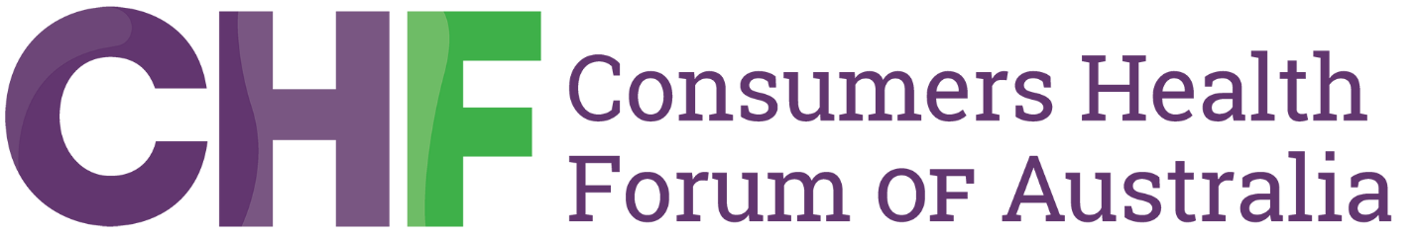

CHF welcomes Australian Government investment to make seeing a doctor more affordable and accessible

Sunday 23 February 2025
The Consumers Health Forum of Australia (CHF) welcomes the Australian Government's $8.5 billion investment to deliver an additional 18 million bulk-billed GP visits each year for Australians.
Helping Australians better afford their GP visit has been a policy CHF has long advocated for. It’s heartening to see the Government respond emphatically to this call.
CHF is also pleased to see support for today’s announcement from across the parliament. Making healthcare more accessible and affordable is above politics.
“What we have been consistently hearing from consumers for some time now is that they struggle to find providers that will bulk bill them, and they simply cannot afford to see a doctor,” said CHF CEO Dr Elizabeth Deveny.
“This investment, if taken up by GPs, will significantly reduce out-of-pocket costs when consumers see a GP.”
A consumer in regional NSW told us, “My doctor used to bulk bill but 12 months ago introduced a $30 copayment. He said it was because his costs had gone up and he couldn't afford to do it anymore. I looked around and couldn't find a doctor to bulk bill. I think the payment needs to go up to make it possible for them to bulk bill.”
“Consumers in rural and remote Australia often struggle with limited healthcare access — doubling the bulk billing Medicare rate for standard consultations is an important way to tackle this,”
“While this funding support makes it easier for some Australians to see their GP, the rising cost of living means consumers are still forced to prioritise some medicines over others or pay the electricity bill.” said CHF CEO Dr Elizabeth Deveny.
During this parliamentary term we have seen how investment into Medicare helps lift bulk billing rates. Our hope is that areas that have lower rates of bulk billing are prioritised and we soon see a lift in the rates in those areas.
Dr Deveny noted that there are other ways that healthcare can be made more affordable especially through the PBS Safety Net, which many consumers are unaware of.
The PBS Safety Net is a system designed to reduce the cost of prescription medicines once a set spending threshold is reached within a calendar year. To qualify, individuals or families often need to track their medicine costs or gather records from multiple pharmacies, which can be a barrier to accessing these savings.
“The PBS Safety Net is a wonderful system which provides ensures people can afford their medicines when they need them over a 12 month period. The paper based administration of the system isn’t great.
“We can’t understand why in 2025, the system can’t be automated like so many other government services. Automating the PBS Safety Net would mean consumers could track their own spend and see when they qualify. Interestingly the Medicare Safety Net is automated, we wouldn’t accept a paper based Medicare Safety Net system, so why do we accept it for the PBS?” said Dr Deveny.
Media contact
Public Affairs Manager – CHF
Benjamin Graham
0461 545 392
b.graham@chf.org.au

