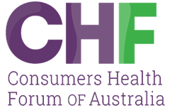

SUBMISSION TO THE THERAPEUTIC GOODS ADMINISTRATION

Reviewing the safety and regulatory oversight of unapproved medicinal cannabis products

October 2025

Consumers Health Forum of Australia (2025)
Canberra, Australia
Reviewing the safety and regulatory oversight
of unapproved medicinal cannabis products
E: ceo@chf.org.au
twitter.com/CHFofAustralia
facebook.com/CHFofAustralia
Office Address
Level 5, 15 Moore St
Canberra ACT 2601
Postal Address
PO Box 308
Collins Street West VIC 8007

Consumers Health Forum of Australia
is funded by the Australian Government as the
peak health care consumer organisation under
the Health Peak and Advisory Bodies Program

Contents

Introduction 4

Responses to consultation questions 4
Quality and Safety Requirements for medicinal cannabis products 5
Emerging safety concerns for medicinal cannabis products 6
How do we address the current issues with medicinal cannabis products? 8

Key recommendations 11

Conclusion 11

References 13
Table 1. 14

References for Table 1 15

Introduction
Consumers Health Forum (CHF) is the national peak body representing the interests of Australian healthcare consumers and those with an interest in healthcare consumer affairs. CHF works to achieve safe, quality, and timely healthcare for all Australians, supported by accessible health information and systems. At the heart of CHF’s policy agenda is patient-centred care, and therefore, we appreciate the opportunity to provide a submission to the Therapeutic Goods Administration (TGA) for their review of the safety and regulatory oversight of unapproved medicinal cannabis products (the Review).

In 2021, CHF provided input to Health Products Regulation Group regarding the TGA consultation on “potential reforms to medicinal cannabis manufacturing, labelling and packaging requirements”. At that time of the consultation, CHF expressed support for the introduction of Good Manufacturing Practices (GMP) requirements and consistent labelling standards for both unapproved and approved medicinal cannabis products. Since CHF’s previous input, CHF presently supports a review of the current regulatory reforms on unapproved medicinal cannabis products in Australia. Ensuring that medicines are safe, high-quality, affordable and accessible is essential for consumers. The CHF is committed to making sure that health regulations are shaped by these priorities, placing consumer needs at the centre of policy and decision-making.

Given the short timeframe of the consultation period for the Review and lack of specific resourcing for consumer consultation, we were unable to do an in-depth consultation with the wider community on this important regulatory reform. We strongly recommend that future consultations are afforded sufficient time and funding to prioritise consumer engagement. Engaging directly and meaningfully with consumers of unapproved medicinal cannabis can, not only contribute valuable insights into improving the quality and safety of these products but also act as a vehicle through which we can build consumers’ trust in the healthcare system.

Responses to consultation questions
The CHF has identified and chosen to respond to five of the 22 questions in the consultation, as these were the most relevant to consumers’ healthcare and experiences of accessing and using medicinal cannabis. Our responses to the consultation questions were informed by consumer feedback via general community and medicinal cannabis user surveys and relevant research literature. CHF had two questions included in a Pureprofile Omnibus survey of 1,001 Australian adults, nationally representative of age, state and gender. CHF conducted its own survey of consumers who had gained a prescription for medicinal cannabis (either for themselves or a dependent) for multiple sclerosis, epilepsy, chronic non-cancer pain, chemotherapy-induced nausea and vomiting or palliative care needs. This was advertised across CHF’s consumer networks, and we received 27 responses.

Quality and Safety Requirements for medicinal cannabis products
1. Do you believe the current quality and safety requirements for medicinal cannabis products are sufficient?
Results from the survey conducted by CHF with current medicinal cannabis users or their carers suggests quality and safety requirements are not sufficient. Despite this being a group of consumers using the medicine, one in four (25.9%) indicated the requirements were not sufficient and one in seven (14.8%) were not sure.
In the Pureprofile Omnibus survey, which included users and non-users of medicinal cannabis, three in five respondents (61.2%) were unaware that unapproved medicinal cannabis products are not subject to quality checks by the Therapeutic Goods Administration (TGA), and a further 16.1% were unsure. This finding demonstrates a lack of awareness and raises serious concerns about informed decision-making among consumers, as most medicinal cannabis products are “unapproved” medicines, supplied under special access schemes (SAS) or authorised prescriber (AP) pathways, and not listed on the Australian Register of Therapeutic Goods (ARTG). That is, consumers are largely unaware that much of this medicine category has bypassed the rigorous pre-market evaluation required for registered medicines.
In the follow-up question, two in five (38.7%) respondents indicated that knowing most medicinal cannabis does not undergo full TGA quality checks made them less confident in its safety, and a further 18.8% were unsure. The results highlight consumers' concerns about whether these products meet appropriate safety and quality standards. Collectively, the general community survey findings indicate that many Australians are under the impression that all therapeutic goods are thoroughly assessed and approved by the TGA to ensure they meet established safety standards.

2. Would you recommend changes to the current quality requirements for medicinal cannabis products?
In the CHF survey with medicinal cannabis users, one in three (33.3%) recommended changes to the current quality requirements for medicinal cannabis products including:
- Mandatory testing of all cannabis products for safety and dosage accuracy, ideally regulated by the TGA
- Clearer labelling and updated packaging standards to ensure transparency
- Technical reviews of cannabis strains/types to match them with medical conditions, improving clinical relevance and patient outcomes
- Encouragement of local production (especially outdoor-grown production) to lower prices and improve freshness
- Reduce the number of manufacturers but require each to produce a diverse range of strains to meet varied patient needs
- Government criteria for approval should include producing multiple types of medicinal cannabis to ensure broad therapeutic coverage
- Dry herb vaporisers should be more accessible (not limited to pharmacies), as current restrictions are seen as counterproductive
- Prioritisation of patient care over profit, with more affordable options for consultations and prescriptions by reputable health providers.
From these results it is clear consumers would like to see some changes to the current quality requirements for medicinal cannabis products. A longer-term reform would be to move to mandatory ARTG registration for the higher risk cannabis products to strengthen regulatory oversight and ensure that these products consistently meet standards for safety, efficacy, and quality as other registered medicines. This would align it with other prescription medications and would help eliminate misleading claims and substandard formulations. It would require more robust clinical evidence and manufacturing compliance. This would also improve transparency for consumers and product quality. Registration would also mean enhanced monitoring and collection of data about adverse events, both of which are necessary to ensure safe use. Even without registration there needs to be work put into better reporting and analysis of adverse events.
The short-term existing processes could be enhanced. While full TGA checks may not always apply, the Therapeutic Goods Order No. 93, Standard for Medicinal Cannabis (TGO 93) [2] sets minimum quality standards for medicinal cannabis products. However, compliance with TGO 93 is self-declared by sponsors or importers, and not always independently verified. This could be amended with provisions for stronger oversight of the quality requirements for medicinal cannabis products which would minimise contamination risks and ensure consistent dosing, while also increasing public confidence through transparent labelling and verified ingredients.
We recommend greater transparency in quality assurance as it would help ensure medicinal cannabis products consistently meet safety, efficacy, and manufacturing standards, while empowering consumers to make informed choices. Clearly communicating how these products are tested, produced, and verified increases trust in the regulatory system, prevents misinformation, and promotes accountability among manufacturers. It also supports better clinical outcomes through consistent product quality and aligns medicinal cannabis with the same expectations applied to other therapeutic options.

Emerging safety concerns for medicinal cannabis products
5. In general, what are the safety risks you have identified or are concerned about with unapproved medicinal cannabis products? If possible, please provide data or other forms of evidence to support those views.
In a survey conducted by CHF with medicinal cannabis users, approximately one in three (29.6%) medicinal cannabis users reported experiencing side effects. However, most reporting side effects indicated the symptoms were generally mild, and individuals were able to seek guidance from their doctor or prescriber. However, consumers noted that clinicians often seemed to lack knowledge on medicinal cannabis especially on its clinical effects, its benefits and possible adverse effects [3]. The lack of knowledge from trusted health providers limits the quality of information and guidance available to consumers on how to effectively manage their treatment. A consumer stated that this can lead consumers to resort to ‘cowboy clinics’ for help.
The results from CHF survey with medicinal cannabis users showed that information about medicinal cannabis was being sought from a variety of sources including internet search (51.9%), healthcare professionals (40.7%), friends or family (40.7%) and online forums or support groups (33.3%). However, one in five (18.5%) consumers felt important details were missing from the information they received before you started medicinal cannabis. A further one in five (18.5%) were unsure if details were missing. Having reputable information available to health professionals about the safety and efficacy of medicinal cannabis was a common sentiment among the responses to a follow-up question regarding what information was missing.
This limited information raises concern, as it reduces people’s ability to give fully informed consent and/or to use the product with confidence and safety. [4]. Without sufficient information, consumers may be less prepared to recognise, manage or be able to gain timely support from health professionals, which can impact both the effectiveness of the treatment and the consumers’ overall safety. Furthermore, it is imperative to place greater emphasis on healthcare provider, consumer and career education, as much of the current available information is led by medicinal cannabis organisations [5]. As a result of the limited availability of reliable information and the inability to have in-depth discussions with their individual healthcare professional, many consumers are turning to online forums such as Reddit to seek guidance and share experiences. We recommend that the TGA enhance public awareness by providing information on their website or by endorsing authoritative sources, such as HealthDirect or Alcohol and Drug Foundation,
Persistent stigma and discrimination around medicinal cannabis continue to affect prescribing and access. To ensure consumers can receive care that is equitable, evidence-based, and free from prejudice, health professionals need not only accurate clinical knowledge but also a balanced and respectful understanding of medicinal cannabis use.
This requires more than training alone: it calls for cultural change within the profession, supported by clear guidance, accountability mechanisms, and leadership that normalises medicinal cannabis as a legitimate therapeutic option.
A model for this could be the CPD course offered by the Pharmaceutical Society of Australia to pharmacists. By introducing a standardised medicinal cannabis education program for practitioners, we ensure that healthcare providers stay current in this rapidly evolving field while aiding stigma reduction which in turn enables safe, informed and equitable access.

How do we address the current issues with medicinal cannabis products?
4. What information would you like to see on medicinal cannabis product labels to help better understand what is in them and to ensure their safe use?
In a survey conducted by CHF with medicinal cannabis users, nearly one in three (29.6%) would like to see changes made to the labelling of their medicinal cannabis product to improve their understanding of the product and how to use it safely. Among those wanting changes the most common changes suggested were clearer dosage instructions, more information on ingredients, clearer warnings on information about side effects, legal approval for medical use and intended use or therapeutic indication.
Although TGO 93 outlines baseline quality standards for medicinal cannabis products, including specifications for labelling, packaging, ingredients, and contaminant thresholds, adherence to these requirements is typically self-declared by sponsors or importers and is not consistently subject to independent verification.
The two currently approved medicinal cannabis products on ARTG are Epidyolex (a CBD-only product) for severe epilepsy and Sativex (nabiximols, containing THC and CBD) for multiple sclerosis-related spasticity (Figure 1) are required to have the same information as other prescription medications on the labels. While, Figure 2 shows unapproved medicinal cannabis products with bright colours and logos, unlike approved products, are not required to carry standardised health warnings.
Given that unapproved products make up the majority of medicinal cannabis available in Australia, the lack of consistent labelling and the use of packaging that resembles retail or lifestyle products raises safety concerns. Many products are brightly coloured or designed in ways that could appeal to children, increasing the risk of accidental ingestion.
In addition, the commercial, consumer-style presentation of these products contrasts with the standard clinical packaging used for most prescription medicines, which may inadvertently signal that medicinal cannabis is less regulated or less dangerous than other therapeutic products. Clear, standardised labelling and packaging requirements are needed to support safe use and public confidence

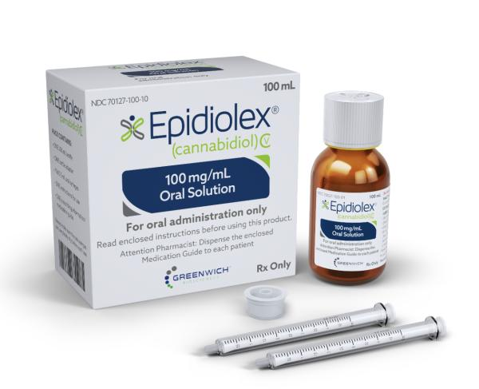
EPIDYOLEX
SATIVEX

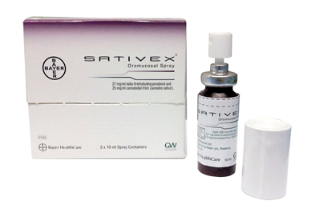
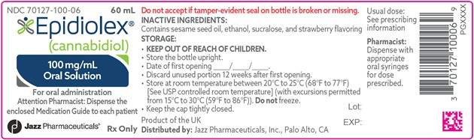

Source: https://www.drugs.com/pro/epidiolex-oral-solution.html & https://www.mims.co.uk/first-cannabis-based-prescription-medicine-launched/neurology/article/1019294
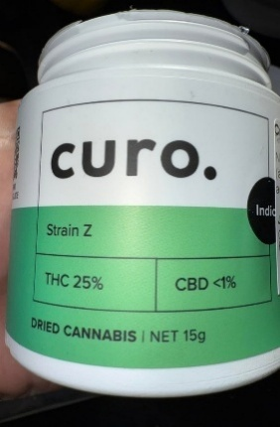
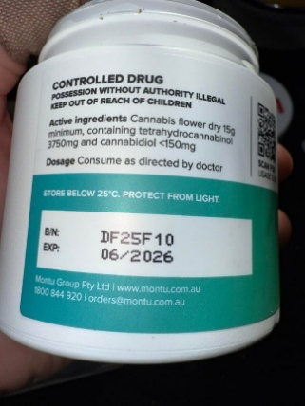
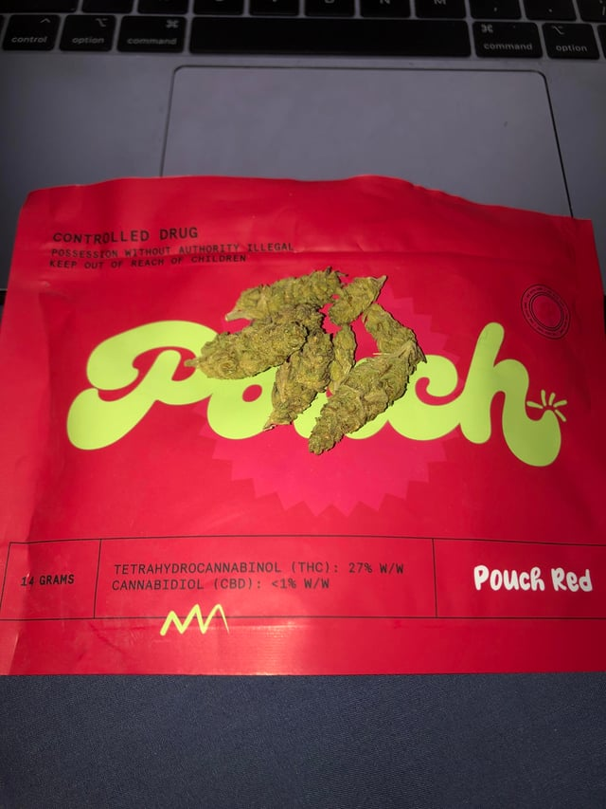
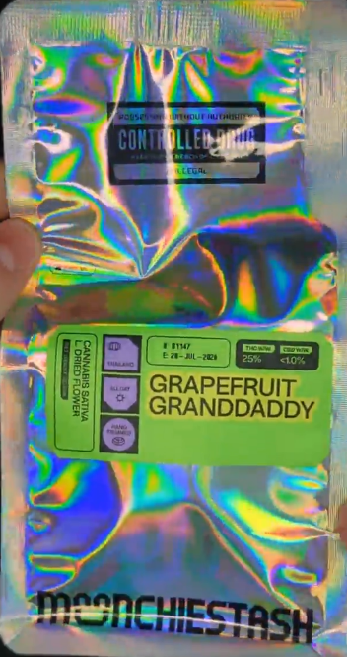
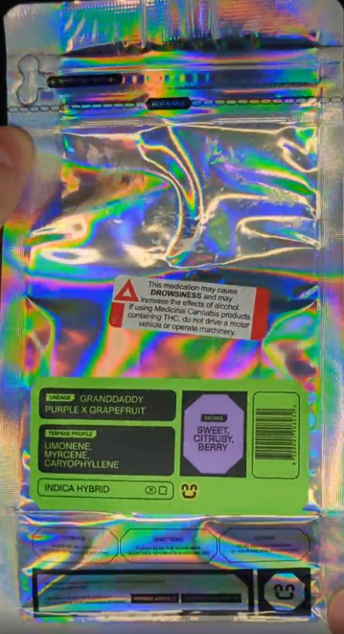
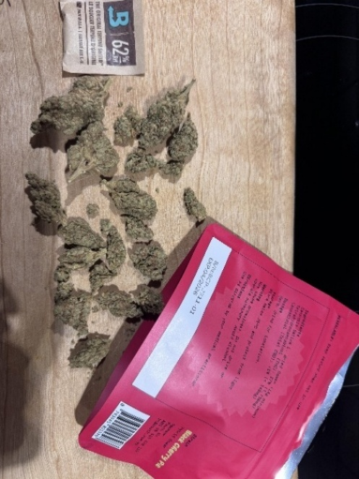
Figure 1. Two currently approved medicinal cannabis products on ARTG
Source: https://www.reddit.com/r/MedicalCannabisOz/
Figure 2. Examples of unapproved medicinal cannabis products in Australia
Countries with medicinal cannabis regulations similar to Australia such as the United Kingdom and Germany typically share the following characteristics: strict federal oversight, prescription-only access, limited product registration, special access schemes or pilot programs, and controlled cultivation and importation (Table 1). Regulations vary across these countries, with differences in required content, packaging standards, and compliance enforcement.
Table 1 illustrates that health warnings are mandatory in all 11 countries with regulatory frameworks comparable to Australia. However, Australia currently lacks a requirement for standardised health warnings on medicinal cannabis products, underscoring a notable inconsistency in patient safety standards that is seen in countries with similar legislation to Australia.
To support safe and informed use, we recommend that medicinal cannabis product labels include standardised comprehensive information such as intended use, health warnings, contraindications, method of administration, testing and certification details, legal and age restrictions, and specific cautions related to driving and operating machinery. These elements are essential for ensuring patient safety, public awareness, and regulatory compliance.
However, we do recognise that product labels have limited area. Considering this, we recommend a Consumer Medicine Information (CMI) leaflet be available with all packaging even if all the details are on the product label. The CMI should be written in plain language and designed with consumers. It should highlight key health warnings and potential side effects and provide clear instructions on what to do in an emergency. To ensure all consumers receive this vital information, we propose that dispensaries be mandated to provide a CMI with every medicinal cannabis product. This model is already placed in the United Kingdom and could be adopted in Australia.

22. Would you like to see any changes made to the labelling of your medicinal cannabis product to improve your understanding of the product and how to use it safely?
As previously stated in question 4, CHF recommend that medicinal cannabis product labels and/or a Consumer Medicine Information (CMI) leaflet include the following:
- comprehensive information such as intended use
- health warnings
- side effects
- how to seek help
- contraindications
- method of administration
- testing and certification details
- legal and age restrictions
- specific cautions related to driving and operating machinery.

Key recommendations
Based on consumer feedback and identified gaps in the current system, we propose the following recommendations:
1. Enhance regulatory oversight and product quality
- Strengthen quality controls for medicinal cannabis to reduce contamination risks, ensure consistent dosing, and build public trust through transparent labelling.
- Move in the longer-term to mandatory ARTG registration of certain cannabis products to align with standards for safety, efficacy, and quality, helping prevent misleading claims and poor formulations.
- Increase transparency in quality assurance by clearly communicating how products are tested and manufactured to support informed consumer choices, improve trust, and ensure consistent clinical outcomes.
2. Improve health professional knowledge
- Awareness campaign aimed at health professional to improve their knowledge and to help effect a cultural shift in attitude towards normalizing the prescription of medicinal cannabis as a legitimate therapeutic option.
3. Improve consumer information and support
- Provide consumers with accessible, reliable and plain-language resources on safe and effective use of medicinal cannabis.
- Consumer medicines information leaflets that show intended use, health warnings, contraindications, administration method, certification, legal restrictions, and driving-related cautions to promote safe and informed use.
- Enhance public awareness through TGA website or endorse authoritative sources.

4. Standardise labelling requirements
- Introduce mandatory labelling that mirrors that for other prescription medicines.

Conclusion
It seems clear that the current special access scheme was not designed for the current volume of prescriptions. Current regulatory gaps in medicinal cannabis oversight may compromise patient safety and public trust. The lack of standardised labelling, inconsistent quality controls, and limited product registration create risks around contamination, dosing, and misinformation. Aligning medicinal cannabis with broader therapeutic standards is essential. Requiring registration and transparent quality assurance would bring cannabis products in line with other regulated medicines, improving safety, efficacy, and accountability.

As with all medications clear and consistent labelling is critical for informed use. Comprehensive product information, including health warnings, contraindications, and usage guidance, supports safer consumption and better clinical outcomes. Improved transparency fosters public confidence and regulatory integrity. Open communication about testing, manufacturing, and certification helps consumers make informed choices and strengthens trust in the system.

References

- Graham M, Chiu V, Stjepanović D, Hall W. A provisional evaluation of Australia's medical cannabis program. Int J Drug Policy. 2023 Dec; 122:104210. doi: 10.1016/j.drugpo.2023.104210. Epub 2023 Oct 7. PMID: 37813082.
- Therapeutic Goods Administration. Therapeutic Goods Order No. 93 – Standard for Medicinal Cannabis [Internet]. Canberra: Australian Government.
- Rønne ST, Rosenbæk F, Pedersen LB, Waldorff FB, Nielsen JB, Riisgaard H, Søndergaard J. Physicians' experiences, attitudes, and beliefs towards medical cannabis: a systematic literature review. BMC Fam Pract. 2021 Oct 21;22(1):212. doi: 10.1186/s12875-021-01559-w. PMID: 34674661; PMCID: PMC8532330.
- Bekker CL, Mohsenian Naghani S, Natsch S, Wartenberg NS, van den Bemt BJF. Information needs and patient perceptions of the quality of medication information available in hospitals: a mixed method study. Int J Clin Pharm. 2020 Dec;42(6):1396-1404. doi: 10.1007/s11096-020-01125-x. Epub 2020 Aug 28. PMID: 32857256; PMCID: PMC7603457.
- Mills L, Arnold JC, Suraev A, Abelev VS, Zhou C, Arkell RT, McGregor SI, Lintzeris N. Medical cannabis use in Australia seven years after legalisation: findings from the online Cannabis as Medicine Survey 2022–2023 (CAMS-22). Harm Reduction Journal. 2024 May; 21:104. doi:10.1186/s12954-024-0099
- Hallinan CM, Gunn JM, Bonomo YA. Implementation of medicinal cannabis in Australia: innovation or upheaval? Perspectives from physicians as key informants, a qualitative analysis. BMJ open. 2021 Oct; 11(10): e054044. Doi: 10.1136/bmjopen-2021-054044

Table 1. Regulations for medicinal cannabis in 12 countries
Region | Legal Status | Access Requirements | Prescribing Rules | Packaging & Labelling | Health Warning Requirements
Australia [1] | Legal under federal and state regulations | SAS, Authorised Prescriber Scheme, Clinical Trials | Doctors must be approved under SAS or Authorised Prescriber | TGO 93: child-resistant, ingredient labels, batch info | Not standardised; caution for Schedule 8 drugs
United States [2] | Illegal federally; legal in many states | Varies by state; physician recommendation required | Physician recommendation: qualifying conditions vary | State-specific; often includes child-resistant packaging | Required in most states; varies by jurisdiction
Canada [3] | Fully legal for medical and recreational use | Healthcare provider authorisation; licensed sellers or home grow | Any healthcare provider can authorise | Standardised packaging, bilingual labels, THC/CBD content | Mandatory under Cannabis Act; standardised warnings
United Kingdom [4] | Legal for medical use since 2018 | Limited NHS access; private clinics more common | Only specialist doctors on GMC register | Complies with Human Medicines Regulations 2012 | Included in patient information leaflet
Germany [5] | Legal under Medicinal cannabis Act (MedCanG) | Doctor's prescription; pharmacy access | No narcotic prescription needed; physician prescribed | Pharmaceutical labelling norms; dosage and safety info | Required; not standardised but must meet norms
Israel [6] | Legal for medical use since 1990s | License through certified physicians; pharmacy dispensing | Certified physicians issue licenses | THC/CBD content, usage instructions, side effects | Required by Ministry of Health; THC >25% restricted
Thailand [7] | Legal for medical use only | Licensed dispensaries with certified practitioners | Prescription valid for 30 days; certified practitioners only | GACP guidelines; no advertising; traceable products | Required; prescription-only use; no advertising
Brazil [8] | Legal under strict regulation | Medical prescription; GMP-compliant products | Prescription required; THC >0.2% needs stricter protocols | ANVISA RDC 327/2019; THC/CBD content, usage instructions | Required; warnings on side effects and contraindications
New Zealand [9] | Legal for medical use | Prescription-only | Licensed medical practitioners | Ministry of Health guidelines | Health warnings required
Ireland [10] | Legal under pilot program | Specialist-led access | Specialist doctors | Strict product controls | Warnings included in patient info
Denmark [11] | Legal under pilot program | Prescription-only | Licensed physicians | Pharmacy standards | Warnings included in packaging
France [12] | Legal under pilot program | Specialist prescribing | Specialist doctors | Strict product regulation | Warnings included in pilot program
South Korea [13] | Legal for specific conditions | Government-controlled import | Certified doctors | Strict import packaging | Health warnings required

References for Table 1
1. Therapeutic Goods Administration. Medicinal Cannabis Hub [Internet]. Canberra: Australian Government Department of Health and Aged Care; [cited 2024 May 1]. Available from: https://www.tga.gov.au/products/unapproved-therapeutic-goods/medicinal-cannabis-hub
2. National Conference of State Legislatures. State Medical Cannabis Laws [Internet]. Washington, DC: NCSL; [cited 2024 May 1]. Available from: https://www.ncsl.org/health/state-medical-cannabis-laws
3. Health Canada. Regulations under the Cannabis Act [Internet]. Ottawa: Government of Canada; [cited 2024 May 1]. Available from: https://www.canada.ca/en/health-canada/services/drugs-medication/cannabis/laws-regulations/regulations-support-cannabis-act.html
4. UK Government. Medicinal Cannabis Information and Resources [Internet]. London: GOV.UK; [cited 2024 May 1]. Available from: https://www.gov.uk/government/collections/medicinal-cannabis-information-and-resources
5. CMS Law. Legal Roadmap to Cannabis – Germany [Internet]. Berlin: CMS Legal Services; [cited 2024 May 1]. Available from: https://cms.law/en/int/expert-guides/cms-expert-guide-to-a-legal-roadmap-to-cannabis/germany
6. Ministry of Health. Medical Cannabis Unit [Internet]. Jerusalem: Government of Israel; [cited 2024 May 1]. Available from: https://www.gov.il/en/departments/topics/medical-cannabis/govil-landing-page
7. Belaws. Thailand Cannabis Regulations 2025 [Internet]. Bangkok: Belaws; [cited 2024 May 1]. Available from: https://belaws.com/thailand/thailand-cannabis-regulations-2025/
8. ANVISA. RDC 327/2019 – Regulation of Cannabis Products [Internet]. Brasília: Agência Nacional de Vigilância Sanitária; [cited 2024 May 1]. Available from: https://brisa.com.br/rdc-327-2019-manufacturing-importation-and-commercialization-of-cannabis-products/
9. Ministry of Health NZ. Medicinal Cannabis Scheme [Internet]. Wellington: Government of New Zealand; [cited 2024 May 1]. Available from: https://www.health.govt.nz/regulation-legislation/medicinal-cannabis
10. Health Products Regulatory Authority. Medical Cannabis Access Programme [Internet]. Dublin: HPRA; [cited 2024 May 1]. Available from: https://www.hpra.ie/regulation/controlled-drugs/medical-cannabis-access-programme
11. Danish Medicines Agency. Medicinal Cannabis Pilot Programme [Internet]. Copenhagen: Danish Medicines Agency; [cited 2024 May 1]. Available from: https://laegemiddelstyrelsen.dk/en/special/medicinal-cannabis/
12. Agence nationale de sécurité du médicament et des produits de santé. Cannabis for Medical Use – Pilot Program [Internet]. Saint-Denis: ANSM; [cited 2024 May 1]. Available from: https://ansm.sante.fr/

