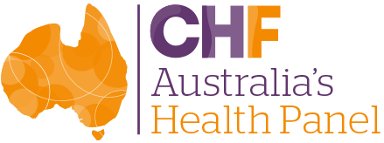

Understanding how Australian health consumers navigate their oral health and dental care

REPORT

March 2026

Consumers Health Forum of Australia (2026).
Understanding how Australian health consumers navigate their oral health and dental care. Canberra, Australia

P: 02 6176 0000
E: info@chf.org.au
twitter.com/CHFofAustralia
facebook.com/CHFofAustralia
Office Address
Level 5, 15 Moore St
Canberra ACT 2601
Postal Address
PO Box 308
Collins Street West VIC 8007

Consumers Health Forum of Australia is funded by the Australian Government as the peak healthcare consumer organisation under the Health Peak and Advisory Bodies Program

SUMMARY 4
BACKGROUND 6
FINDINGS 7
RECOMMENDATIONS 21
References 23
APPENDICES 24
Appendix A Supplementary Tables 24
Appendix B. Methods 30
Respondent classifications 31
Limitations 32
Appendix C. Survey 33

SUMMARY
Australians want dental care to be affordable, timely and part of everyday healthcare. In this AHP survey on access to public dentist services, 910 consumers describe a system where cost exposure and public capacity determine whether and when care happens. The care itself is strongly valued once people are able to be seen. The findings point to practical levers: reduce out‑of‑pocket exposure; buy down wait times; fund prevention at scale; and bring services closer to where people live and receive primary care.
Key insights
Cost and financial strain are shaping behaviour. Only 20.0% reported no strain from their last dental payment; 37.4% experienced some strain, 28.6% had to change spending or dip into savings, and 12.5% faced serious strain affecting essentials. Open comments describe cutting back on essentials (19.9%), unexpected gaps despite PHI (18.4%), using savings/super (14.2%), high one‑off procedure costs (12.9%), and delaying/avoiding care (9.7%). Strain is higher among respondents who arrange care for others, and among those reporting chronic illness, disability, mental health experience, or living in smaller rural and remote areas.
Long waits and pathway confusion block entry. A sizeable share of respondents report they have never been eligible (33.7%) or unsure of their eligibility (28.6%) and as such have never actually used public services. While others report current or past eligibility for public dental services, fewer still use them due to long public wait times. Delays in treatment rise from 58.5% in metro areas to 76.1% in smaller rural/remote communities; by age, 70.0% for 65-74 vs 38.9% for 85+. Quality is not an issue once people are seen.
Public appetite for reform is emphatic. 93.7% support increased Federal funding; respondents prioritise publicly funded emergency (96.3%), preventive (94.2%) and restorative (92.9%) care (not cosmetic). They back a team‑based model - dentists (94.4%), hygienists/therapists (76.0%), dental specialists (65.1%) and are open to selected primary‑care roles (GPs, nurses, pharmacists, speech pathologists) for prevention and navigation funding. These preferences align with CHF’s pre‑Budget advocacy and national reform conversations.
Recommendations
To improve affordability and access to oral healthcare for Australians, we recommend:
- Increasing Federal funding for public dental services. Expand funding for preventive, emergency and restorative care, reflecting strong consumer support and clear evidence of financial hardship caused by current out‑of‑pocket costs.
- Reducing long wait times through public-private partnerships. Use voucher programs and purchase additional private clinic capacity to relieve pressure on public dental waiting lists, particularly in regional and high‑need areas.
- Funding preventive dental care as a core service. Provide free or subsidised routine prevention (check‑ups and cleaning) to reduce long‑term treatment needs, costs, and avoidable deterioration in oral health.
- Improving access for rural, older and priority populations. Expand mobile clinics, aged‑care outreach, and regional workforce capacity to address persistent geographic and age‑related access gaps.
- Integrating oral health into primary care. Support GPs, nurses, pharmacists and allied health professionals to deliver basic preventive advice, triage and referral, helping consumers navigate dental care earlier and more effectively.
- Strengthening cost transparency and insurance value. Improve clarity of gap fees, review private health insurance rebates, and address unexpected out‑of‑pocket costs experienced even by insured consumers.

Next steps
To progress reform, coordinated national action is required. Key priorities for the next 12 months include:
- Commit new Federal investment in public dental services, including targeted funding for seniors, low‑income groups and people with complex needs.
- Implement short‑term wait‑list relief measures, including vouchers and contracted private capacity, while longer‑term reforms are developed.
- Pilot funded preventive dental care for priority populations to demonstrate impact on access and downstream costs.
- Expand outreach models (mobile and aged‑care services) in regional and remote communities.
- Begin integrating oral health into primary care, with funded prevention, triage and referral pathways.
- Develop a national roadmap setting out responsibilities, timelines and evaluation measures, informed by consumer, provider and government collaboration.

BACKGROUND
Oral health is integral to overall health and participation in work, study and community life. The World Health Organization (WHO) notes that oral diseases affect approximately 3.7 billion people, are largely preventable (1), and that prevention/treatment are often excluded from universal health coverage (UHC) benefits, such as Medicare in Australia. This exclusion contributes to high out‑of‑pocket spending and avoidable disease burden.
In Australia, the financing mix for dental care is dominated by non‑government spending. In 2022-23, total dental expenditure was $12.5 billion, and 61% of spending was by the non‑government sector (individuals, insurers and others). Government spending (Commonwealth and states/territories) has fluctuated over the decade, while per‑capita non‑government expenditure has trended upward, underscoring persistent household exposure to dental costs (2).
Affordability barriers are visible in national monitoring and media reporting of official data. The Australian Institute of Health and Welfare (AIHW) reports that only around half of Australians aged 15+ see a dental professional in a given year, while cost is a commonly cited reason for delaying or avoiding care. Findings from CHF’s 2025 National Consumer Sentiment Survey aligns with AIHW’s report – three in ten (29.3%) missed out on dental care they needed in the past year with cost as the main reason (67.0%). Avoidance and delay contribute to worsening conditions and potentially preventable hospitalisations (PPHs): in 2022-23, more than 87,000 hospitalisations for dental conditions were potentially preventable (2).
The distribution of need is not even. Older Australians, including people living in residential aged care, experience high and often unmet oral health needs. Recent Australian research reports substantial oral health problems among aged‑care residents and calls for improved access and a Senior Dental Benefits Scheme, noting links between poor oral health and adverse outcomes (for example, pneumonia and cardiovascular disease) (3). These findings reinforce the case for targeted outreach models (for example, mobile services and on‑site care) for priority groups.
Policy discussion has increasingly focused on expanded public funding and integration. The discussion includes option for a Medicare‑style universal primary dental scheme, Commonwealth leadership on funding, workforce expansion, and mixed public-private delivery with no out‑of‑pocket costs for covered services (4). Evidence reviews support integrating oral health with primary care. For example, risk assessment, brief prevention, triage and referral in general practice), which can improve access to prevention where dental workforce and capacity are constrained (5).

FINDINGS
Against the backdrop discussed in the background, this report presents consumer insights from an online survey conducted between 13 February to 1 March 2026 to capture consumers’ experiences of arranging care for others, affordability pressures, and preferences for how dental services should be funded, delivered, and expanded (see Appendix B for details on our study methodology).

Demographics
A total of 910 consumers completed the survey. The sample was older and more female‑dominant than the general Australian population, which reflects the composition of some participating networks and the voluntary nature of Australia’s Health Panel. Most respondents were aged 65 years and over, with the largest age groups being those aged 75-84 years (40.7%) and 65-74 years (31.4%), and women comprised 69.5% of the sample. Whilst these demographic skews should be considered when interpreting population-level generalisability; however, they do provide strong insight into groups that are disproportionately affected by dental affordability and access barriers.
The survey achieved broad geographical representation, with respondents drawn from all states and territories in proportions broadly consistent with national population distribution. A majority of respondents (62.9%) lived in metropolitan areas, with 35.1% living in regional or rural communities, a distribution that closely mirrors the national metro-regional split.
As with previous Australia’s Health Panel surveys, the intention is not to represent the population statistically, but to provide a policy-relevant snapshot of consumer experience. The demographic pattern in this sample is valuable: older Australians, people managing chronic conditions and those in regional areas are among the groups most affected by dental cost pressures, public dental wait times, and gaps in access.
Cost and financial strain are shaping dental behaviour
For most respondents, dental care is a budget stressor, not a routine expense. Only 20.0% reported no strain from the last out‑of‑pocket payment (Figure 1). The remainder described some strain (37.4%), spending/savings changes (28.6%), or serious strain affecting essentials (12.5%). The burden is uneven: arrangers of care, people reporting mental health experience, chronic illness, disability, pre and peri retirement aged and those living in smaller rural and remote areas were more likely to report higher levels of strain.

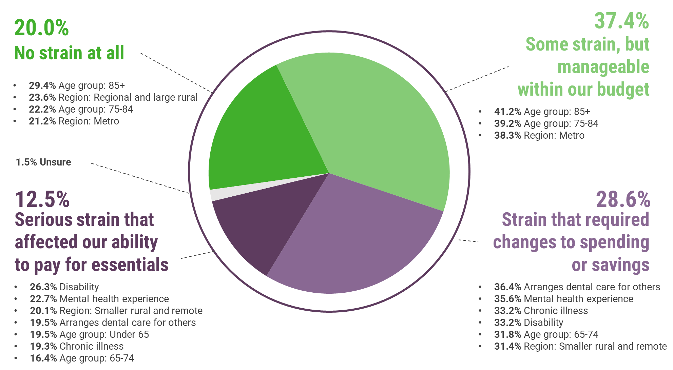
Figure 1. Financial strain from out-of-pocket dental expenses more serious impacts more common among groups with existing health issues

Open responses specified what “strain” looks like in practice and were coded into themes (Figure 2). Responses are most commonly cutting back on essentials and discretionary items (19.9%), encountering unexpected gaps despite private insurance (18.4%), and drawing on savings or super (14.2%). Many cited the shock of high one‑off procedures such as crowns or implants (12.9%), while others delayed or avoided care (9.7%), opted for cheaper or minimal treatment (6.7%), or relied on credit/payment plans (5.2%). More details are provided in Appendix A Table S1. The picture provided by respondents is of a system where price exposure shapes attendance patterns, treatment choices and, ultimately, oral health trajectories.
Figure 2. Top 10 themes highlight the impact of out-of-pocked dental expenses

Public dental eligibility and the gap between eligibility and use
Public dental care is designed as a safety‑net, yet a notable eligibility and use gap emerges. A sizeable share of respondents report they have never been eligible (33.7%) or unsure of their eligibility (28.6%) and as such have never actually used public services (Figure 3). The next highest tranches are currently eligible, 24.1% had accessed services; 6.2% were eligible but had not used them. There are also groups who report past eligibility with access (6.0%) no access (1.4%) recorded. This matters: the many households are exposed to price risk of dental and oral health services (e.g. only around 55% have extras cover) (6) are those who should benefit most from the safety‑net of public dental services - yet capacity and eligibility clarity limit real‑world uptake.

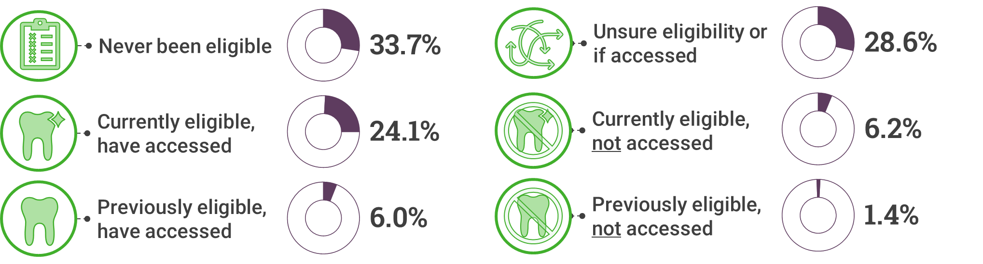
Figure 3. Eligibility for and use of public dental care among survey respondents

Long waits and navigation barriers block entry
The system’s principal friction points are waiting time and entry clarity. Among eligible respondents, 60.6% had delayed or cancelled treatment due to long public wait times (Figure 4). This experience was widespread across those eligible for public system treatment, but not evenly distributed. Delays were more pronounced outside metropolitan areas, rising from 58.5% in metropolitan areas to 76.1% in smaller rural and remote communities. Delays were consistently high among groups reporting disability (70.8%), mental health experience (74.6%), or chronic illness (69.8%) indicated that long waits had caused them to postpone or cancel treatment. Taken together, these patterns reinforce that waiting times are disproportionately affecting people with higher health needs and those living outside major cities, driving delayed care even when public eligibility exists.
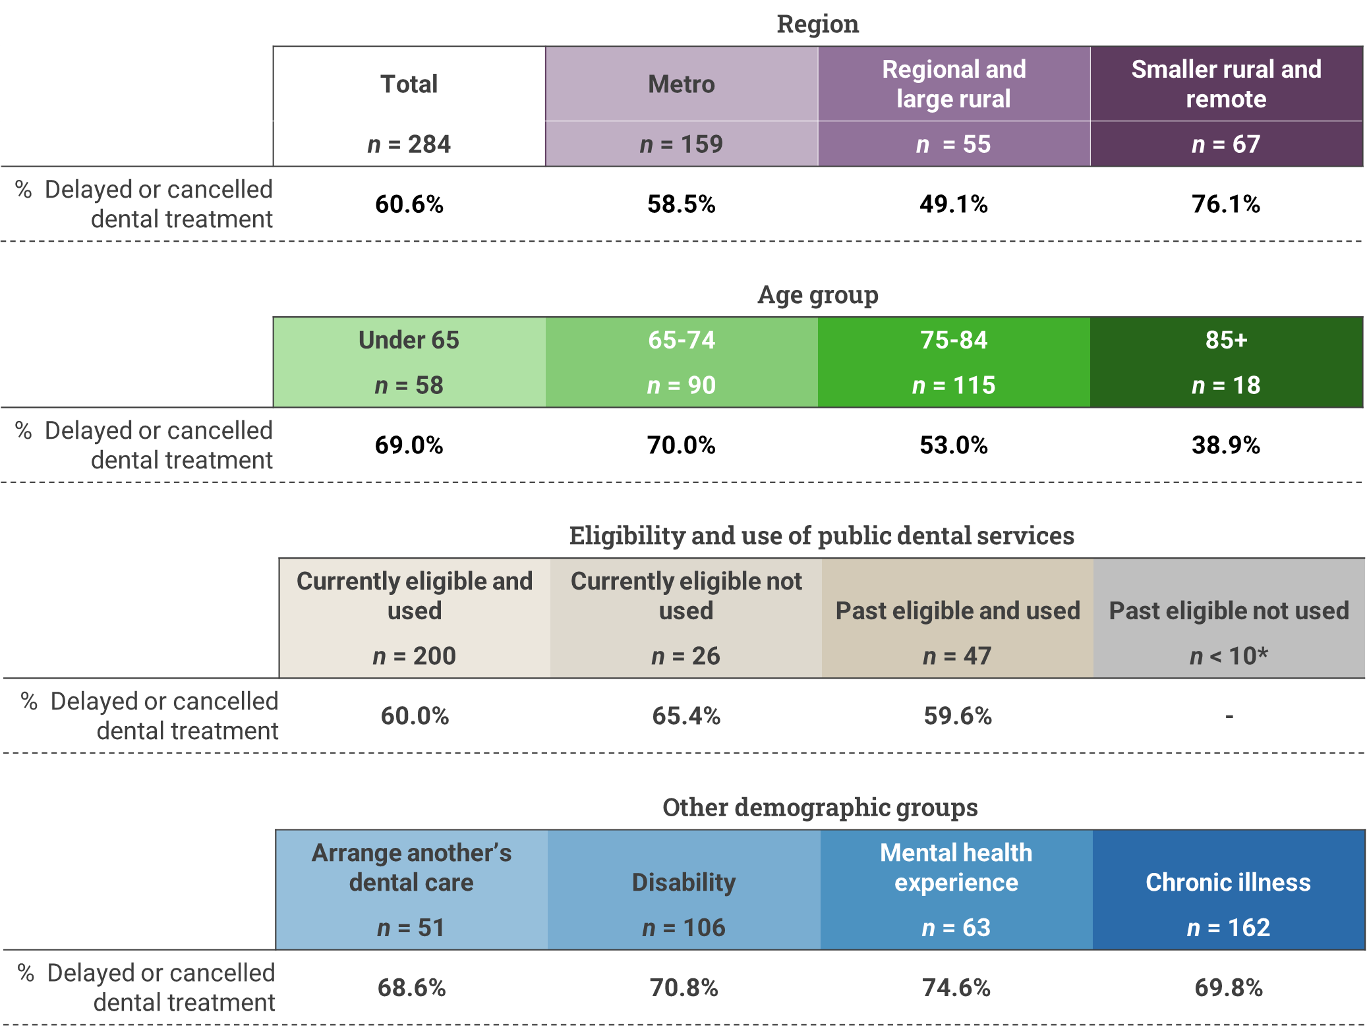
Figure 4. Respondents who delayed or cancelled dental treatment due to long public dental wait times

For those who were eligible but had not accessed public services, the leading reasons (Figure 5) were:
- Wait times are too long (56.5%)
- Preference for private care (30.4%) - often a common response to delays or uncertainty of public system
- Don’t know where or how to access services (20.3%)
- Negative past experiences with the public system (11.6%)
- Too far to travel / not accessible (10.1%)
Distance barriers reinforce inequity for regional and remote respondents. The finding is consistent with the solutions (see Appendix A Table S2), where people call for mobile clinics, transport support, and co-location with primary care to bring services within reach.
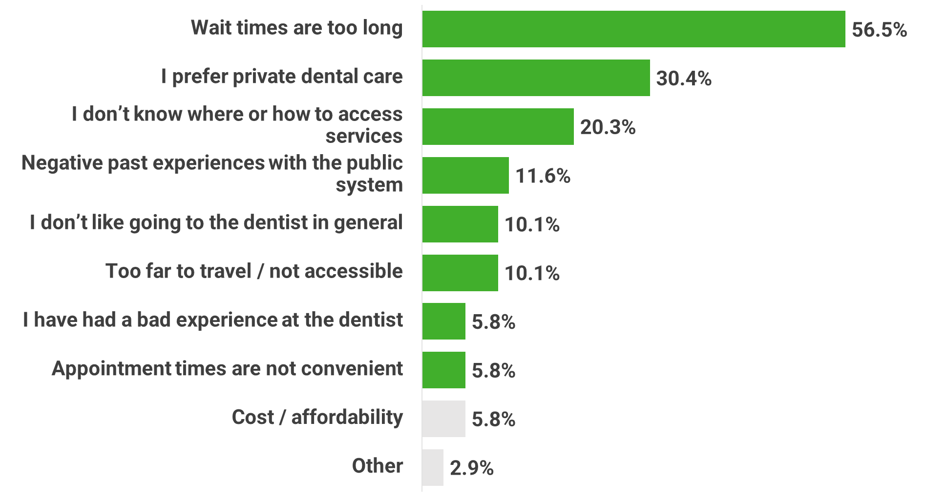
Figure 5. Main barriers to accessing public dental services
Note: Cost and affordability was not a response option but were recoded from respondents’ “Other’ responses

Quality is not the problem once people are seen
Among those who accessed public dental care, most reported positive experiences (Figure 6), with 57.4% rating the quality of care as Excellent or Very good, compared with 20.7% rating it Fair or Poor. These overall results indicate that, once consumers are able to access public dental services, perceptions of clinical care are generally favourable.

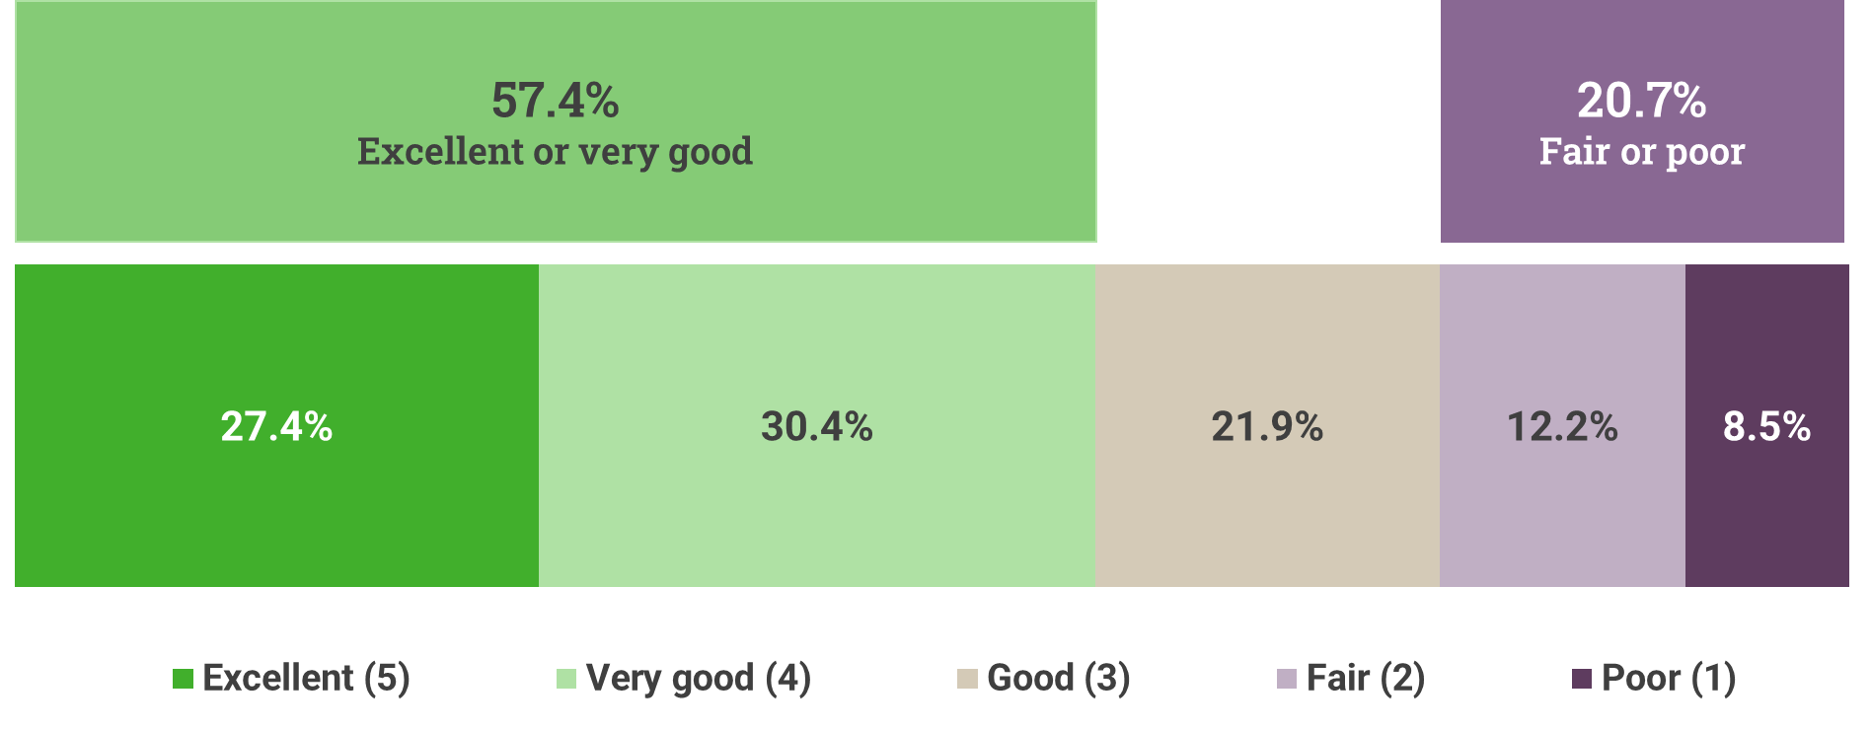
Figure 6. Most respondents who accessed public dental services gave positive ratings about the quality of care received.

While ratings varied across subgroups (Figure 7), the overall pattern remained consistent. Positive ratings (Excellent/Very good) were reported by 58.0% of metropolitan respondents, rising to 64.8% in regional and large rural areas, but falling to 48.4% in smaller rural and remote communities, where a higher proportion also rated care as Fair or Poor (29.0%). Age‑based differences were also evident: Excellent/Very good ratings were highest among respondents aged 85 years and over (88.2%), compared with 49.0% among those aged under 65, while Fair/Poor ratings were more common among younger age groups and those living outside major cities.

Differences were also apparent by eligibility and life circumstances. Respondents who were currently eligible and had accessed public dental care reported higher satisfaction (58.6% Excellent/Very good) than those who were previously eligible (52.7% Excellent/Very good), suggesting that continuity of eligibility and engagement with the system may shape experience. Positive ratings were broadly similar among those who arranged dental care for others and those who did not, and remained above 50% among respondents reporting disability, mental health experience, or chronic illness, although Fair/Poor ratings were consistently higher in these groups than in the overall sample.
Taken together, these findings reinforce a key distinction in the consumer experience: clinical quality is not the primary weakness of the public dental system.
Figure 7. Subgroup patterns vary, but the overall message is the clinical experience is of good quality once it is accessible

Who arranges care, who misses out, and how care is funded
Most respondents arrange dental or oral care for themselves only (82.6%), a likely function of the older age of respondents to this survey. Among the 17.4% who arrange care for both themselves and others, caregiving responsibilities were concentrated around older adults, rather than children (Figure 8). Nearly one in ten respondents (9.5%) reported arranging care for an adult aged 60 years or over, compared with much smaller proportions arranging care for children (1.6%) or adolescents (1.3%), or for adults under 60 (2.4%). A further 2.1% arranged care for people across more than one age group, indicating compounding care responsibilities within some households.
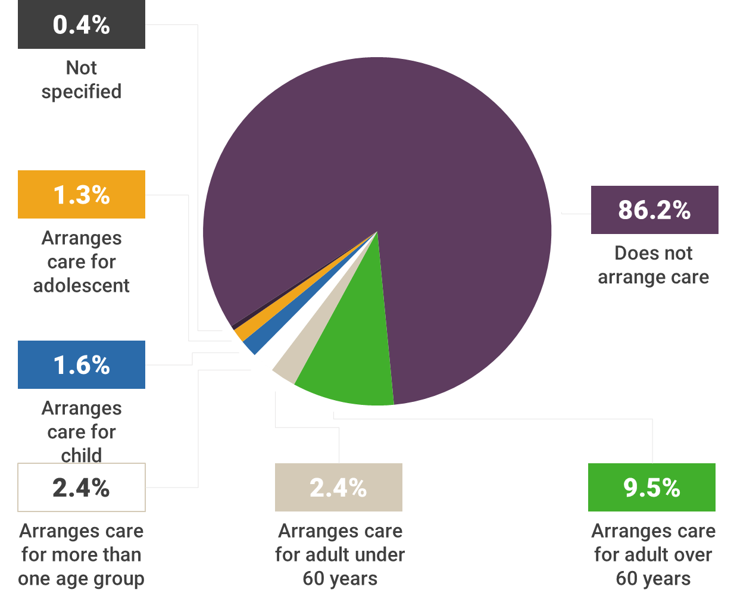
Figure 8. Respondents who arrange dental or oral care for another person

Among respondents who arrange only their own dental care, around one quarter (24.7%) had seen a dental professional in the past two months, while 42.7% were last seen in the previous year and 26.2% had not accessed care for more than a year. For those arranging care, dental visits for themselves were similar with fewer than one in four care providers (22.9%) having seen a dental professional in the past two months, while 43.8% were last seen in the previous year and 24.2% had not been seen for more than a year (Figure 9). Similar delays were evident across all dependents’ age groups, including among older adults: only 19.4% of adults aged 60 years or over had a visit in the past two months, while 28.0% had last been seen more than a year ago. Even among children and adolescents, around one quarter had not accessed care for over a year, suggesting that current Child Benefit Schemes alone does not guarantee timely preventive care.
Figure 9. Most recent dental visit among people for whom respondents arranged care for themselves only or another, by age group where care arranged for another

How care was funded further explains these patterns in delayed care (Figure 10). Respondents who arrange only their own care most commonly relied on private health insurance (42.2%) or out‑of‑pocket payment (36.2%), with 17.7% using state or territory public dental services. Among those who arrange care for themselves and others, reliance on private pathways was even stronger, with 43.5% funded through private health insurance and 41.6% paid out‑of‑pocket, while only 13.0% used public dental services and 0.6% used Commonwealth schemes. For older dependents (aged 60 years and over), fewer than one in five (18.3%) used public dental services, while more than two thirds relied on private health insurance or direct payment.
Regardless of whether people are arranging their own dental care only, or their own and another’s care, respondents are relying primarily on private funding. However, these findings point to a distinct carer burden within the dental system where costs can be cumulative. This combination helps explain why carers were more likely elsewhere in the survey to report financial strain, delayed care, and support for expanded public funding and outreach models.
Figure 10. How the most recent dental visit among those arranging care for themselves and others was funded

What consumers want: clear public support for investment and expanded models of care
There is overwhelming support for government action. 93.7% support increased Federal funding (Figure 11). When asked about funding for specific public dental and oral care services, approval was strongest for a Senior Dental Benefit Scheme (93.4%) and Low Income Dental Scheme (92.1%).
Figure 11. Strong support for expanded federal dental funding across demographic and eligibility groups
In addition, respondents prioritise coverage for preventive (94.2%), emergency (96.3%), and restorative (92.9%) care, with substantially lower support for cosmetic procedures (19.6%) (Figure 12).
Figure 12. Consumer support for government-funded dental and oral care services
On who should deliver publicly funded preventive care, respondents support a team‑based model led by dentists (94.4%), with strong roles for dental hygienists/oral health therapists (76.0%), dental specialists (65.1%) and other comments mentioned dental prosthetists (e.g. for dentures) (Figure 13). Many are open to primary‑care roles for GPs, nurses, pharmacists and speech pathologists, particularly for preventive advice, triage and navigation.
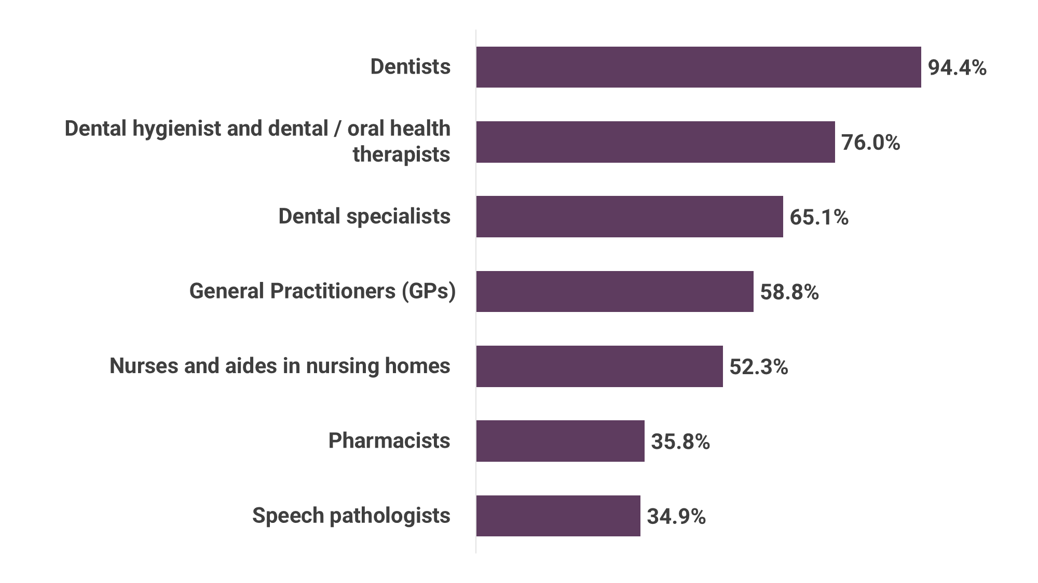
Figure 13. Consumer views on which providers should deliver government‑funded preventive dental services

Cost and access barriers drive demand for universal dental coverage
Open‑text solutions are strikingly aligned with these preferences (Figure 14). The most common proposals were increased public funding and shorter waits (20.9%), adding dental to Medicare / universal coverage (18.2%), improved rural/remote access incl. mobile clinics (8.8%), and free or subsidised preventive care (7.6%), followed by calls for higher PHI rebates/reduced gaps (9.2%), support for major restorative work (5.6%), and after‑hours/emergency access (4.3%). Together, the results describe a consumer‑endorsed roadmap: buy down waiting times, reduce price exposure, deliver prevention at scale, and bring services closer to where people live and receive primary care.
Figure 14. Suggested improvements for getting dental or oral care when needed centre on a need for more public funding

RECOMMENDATIONS
Findings from this survey reveal that high out-of-pocket costs, long public dental wait times, under‑use of public services despite eligibility, and limited support for older Australians, people with disability, and rural/remote residents can shape care seeking behaviour. Consumers supported greater federal investment in dental care and want more affordable, timely, and preventive services. Addressing these challenges requires coordinated national action focused on affordability, access, prevention, and better integration of oral health into mainstream health care. The following recommendations are proposed:
1) Increase federal funding for public dental services
- Why: Consumers overwhelmingly support increased Federal investment and a package that prioritises preventive, emergency and restorative care. 93.7% support increased funding; support for clinical coverage (not cosmetic) remains high across subgroups.
- Action (0-12 months): Commit to staged funding growth focused on prevention and urgent care, with capped or no‑gap settings for priority cohorts, such as for a Senior Dental Benefits Scheme.
2) Cut public wait times by purchasing additional capacity
- Why: 60.6% of eligible consumers delay or cancel due to long waits; the impact is most acute outside major cities (up to 76.1%).
- Action (0-12 months): Deploy voucher programs and session purchase from accredited private clinics to address local backlogs while maintaining fee caps and outcomes reporting.
3) Fund preventive dental care as a core service, not a discretionary add‑on
- Why: Respondents strongly support publicly funded preventive care; open‑text solutions emphasise free/subsidised check‑ups. Prevention reduces downstream costs and avoidable hospitalisations.
- Action (0-12 months): Provide no‑gap preventive packages (risk‑based check‑up/clean/fluoride) for priority groups including older people, people with disability or chronic illness, and rural/remote residents as priority.

4) Target outreach to older Australians, carers and regional/remote communities
- Why: Carers mainly support older dependants, visits are infrequent, and funding tilts private; delays peak in smaller rural/remote areas.
- Action (0-12 months): Fund mobile/onsite clinics for residential aged care and regional towns; include transport assistance and home‑visit capacity where appropriate.
5) Integrate oral health into primary care to improve navigation and early intervention
- Why: One in five eligible non‑users report not knowing how/where to access public care; respondents are open to selected primary‑care roles in prevention and navigation.
- Action (0-12 months): Commission primary‑care‑based prevention and triage (brief risk assessment, advice, warm referral, recall prompts) with item‑based funding and closed‑loop referral to public dental clinics.
6) Lower out‑of‑pocket exposure and improve price transparency
- Why: Consumers report unexpected PHI gaps (18.4%) and strain from large one‑off procedures (12.9%); clear fee information reduces bill‑shock and enables informed choice.
- Action (0-12 months): Introduce standardised fee displays and gap‑estimate tools for common services; review PHI extras settings for essential dental value.

References
1. World Health Organization. Oral health [Internet]. Report No. Available from: https://www.who.int/news-room/fact-sheets/detail/oral-health
2. Australian Institute of Health and Welfare. Oral health and dental care in Australia [Internet]. Canberra: AIHW; 2025. Report No. Available from: https://www.aihw.gov.au/reports/dental-oral-health/oral-health-and-dental-care-in-australia
3. Caughey GE, Air T, Rahja M, Inacio MC. The oral health care needs of people living in residential aged care, Australia, 2016-20: a retrospective cross-sectional study. Med J Aust. 2025 Apr 7;222(6):318–20. doi:10.5694/mja2.52625 PubMed PMID: 40089915; PubMed Central PMCID: PMC11972596.
4. Duckett S, Cowgill M, Swerissen H. Filling the gap: a universal dental care scheme for Australia. Grattan Institute; 2019.
5. Christian B, George A, Veginadu P, Villarosa A, Makino Y, Kim WJ, et al. Strategies to integrate oral health into primary care: a systematic review. BMJ Open. 2023;13(7). doi:10.1136/bmjopen-2022-070622
6. Blades M. CHOICE [Internet]. [cited 2026 Mar 13]. Australian health insurance statistics at a glance. Available from: https://www.choice.com.au/money/insurance/health/articles/private-health-insurance-statistics-in-australia

APPENDICES

Appendix A Supplementary Tables
S1. Themes describing the financial impacts of dental costs (Q12)
Theme  n=669 | Definition | Example quote
Cutting back on essentials/discretionary spend (19.9%) | Stated reductions in day-to-day or discretionary spending to afford dental bills (e.g., food, groceries, outings, fuel, utilities). | ‘Significant dent so we cut back on food and recreation and returned to normal financial status after six months’
Insurance gap large / poor value of private health extras  (18.4%) | Out-of-pocket gaps despite holding private health insurance or concerns about extras value/premiums. | ‘I broke a tooth which required dental surgery to remove it. Even though I have good private hospital coverage I was not covered for this. It cost $2000.’
Pension/low income/benefits making dental unaffordable  (16.6%) | Difficulty paying due to being on a pension, disability support or low/fixed income. | ‘I sold my house just over 12 months ago and moved into a "retirement village". Worst move ever. I wasn't aware that my pension would be cut in half. I am paying monthly fees to village, health insurance, plus other essential bills so that doesn't leave much to spend on food. When I have been to the dentist there is always a hefty out of pocket expense and small gap payment.’
Used savings / dipped into superannuation / emergency fund  (14.2%) | Using savings, super or emergency funds to cover dental costs. | ‘We withdraw from savings, delay plans to fix issues around the house.’
High unexpected one-off cost causing strain  (12.9%) | Large one-off procedures (crowns, implants, root canal, surgery) created significant financial pressure. | ‘$4000 worth of dental work was required for elderly Mum. This meant Mum & Dad (both on pensions) could not afford a holiday, to eat out, to purchase other items required to keep them safely functioning in their own home.’
Delayed or avoided dental care  (9.7%) | Delaying or skipping appointments/treatment, extending intervals between visits to manage costs. | ‘I had to delay the procedure & then spend carefully for some months hoping that there would not be any kind of emergency with things like cars, the house pets etc’
Chose cheaper or minimal treatment (extraction over crown/RC; shop around, overseas) (6.7%) | Opting for lower-cost care (e.g., extractions) or shopping around, deferring high-cost options like crowns or root canal. | ‘I needed extensive care implant s and oral surgery.  It was more cost effective to fly to Thailand and put everything on my credit card.  I now owe thousands of dollars.  Still much less than using an Australian dentist.’
Used credit/loans/payment plans; family, debt collectors (5.2%) | Reliance on credit cards, loans, payment plans or experiences with debt collection. | ‘I put it on my credit card and paid it off as I could.’
Bills paid late / juggling bills  (4.0%) | Paying other bills late, juggling expenses, or falling behind on rent/mortgage due to dental costs. | ‘Couldn't pay bills and limited food shopping.’
Impact on other healthcare  (3.6%) | Reducing or delaying other (human or even pet) healthcare spending to afford dental bills. | ‘The very nice professional dentist stated I have to get dentures which I caused me bleeding gums and not able to eat . Returned to him and I was to have Implants which I was to pay between $10,000 / $15,000. My specialist bowel doctor has connected my inability to eat (no teeth) with my bowel disease.’
Public dental long waits / access issues  (3.3%) | Experiences with public dental access constraints: long queues, vouchers, or location barriers. | ‘My wife got taken off the waiting list by receptionist. When she needed urgent dental help. No help was given. So she had to go private @ $350 cost. As we couldn’t the high cost of $1000. Tooth was pulled. Complains letter is on its way. To central highland rural health.’
No impact  (3.1%) | Dental costs had minimal or no reported financial impact. | ‘I was lucky I could afford it, so no impact at all.’
Sold assets / cancelled plans  (1.9%) | Selling assets or cancelling plans (e.g., holidays) to pay for care. | ‘I had to take out a private loan from a family member, just to receive basic dental care. I required emergency dental care. Had I not asked my family member, I would probably have to sell some belongings of reasonable value.’
Mental/emotional stress  (1.8%) | Reported stress, anxiety or worry due to the financial pressure of dental bills. | ‘The fees are just too much - they said I had eight cracked and broken teeth from lifelong grinding during sleep due to stress (born disabled with high level challenges and low employment).’
Relied on charity/food pantry/social services  (0.7%) | Using charitable food or social services because money was diverted to dental bills. | ‘After paying my rent, I only have $290 a fortnight to live on, so I had to depend on charity to feed me for a few fortnights so I could pay the dentist for my tooth.’

S2. Themes describing proposed solutions to improve dental care accessibility and affordability (Q16)
Theme  n=774 | Definition | Example quote
Increased public funding and shorter wait times  (20.9%) | More government investment in public dental so people are seen faster (shorter waitlists, more chairs/clinicians). | ‘Have enough funding available for the dental dept … to be able to assess and care for emergencies, provide basic care for those that can't afford a private dentist.’
Dental included in Medicare / universal coverage  (18.2%) | Add dental/oral health to Medicare (bulk-billed or universal rebate), so essential dental care is treated like other medical care. | ‘Having access to dental care in the same way that Medicare works.’
Higher PHI rebates / smaller gaps / better value  (9.2%) | Lift private health rebates and/or reduce gaps and premiums so out-of-pocket costs are lower. | ‘Making dental services more affordable and making the PHI organisations be more generous in the range of services they cover and the annual rebate level…’
Rural/remote access & outreach (incl. mobile clinics; homeless) (8.8%) | Expand services outside cities, more regional clinics, mobile vans, Royal Flying Doctor Service,  and reduce travel burden. | ‘More access to dental care for people with intellectual disability — outreach in group homes… innovative approaches like twilight sedation…’
Free or subsidised preventive care (annual check/clean; basics)  (7.6%) | Cover or subsidise routine prevention such as annual check‑ups, cleans, fluoride and/or sealants to avoid costly treatment. | ‘A healthy mouth is absolutely crucial to overall health. For many people once neglected teeth are fixed (at huge cost in the private system running into many thousands of dollars) then regular preventative treatment is minimal cost for maximum benefit.’
Coverage for major restorative work (crowns/ implants/ dentures/ root canal)  (5.6%) | Provide public or PHI support for clinically-necessary major restorative work, not just extractions. | ‘Implants for older Australians. Preventative care for all Australians. Major services for Indigenous Australians.’
After-hours and emergency access  (4.3%) | Ensure timely urgent and after-hours access to keep people out of Emergency Departments. | ‘Walk-in service.’
Expand workforce and clinics (3.9%) | Train and attract more oral-health staff and open additional chairs/clinics to meet demand. | ‘There is a need to train dentists and dental hygienists in mainstream services to provide preventive care…’
Aged care and disability access (mobile services, sedation, staff training)  (3.7%) | Regular on-site care for residents and people with disability (mobile teams, suitable sedation, staff training). | ‘Better access to dental self-care info… including people with cognitive disability, and automatic placement on follow-up waitlists.’
School and child dental programs  (3.7%) | Strengthen school dental programs, ensure kids get regular preventive care and support for necessary orthodontics. | ‘Children should all be eligible for free dental care provided by any dentist, possibly in the same way as Medicare at a doctor’s.’
Oral health education and awareness  (3.7%) | Fund education campaigns and tailored resources to lift oral-health literacy and preventive behaviours. | ‘Better access to proactive information about dental self-care… provided in diverse formats for different groups.’
Quality, safety and anti-overservicing regulation  (3.0%) | Tighten standards, oversight and accountability to improve quality and curb overservicing. | ‘When it is considered ‘too hard’, oral health gets neglected and the person ends up needing intervention rather than preventive care.’
Integration with primary care  (2.5%) | Connect dentistry with GPs/pharmacies/urgent-care centres and enable referral pathways (e.g., care plans). | ‘Being able to have allied health or nurses in GP services do the same triage adults get in public dental… would help.’
Transport support / proximity  (2.2%) | Provide travel subsidies, bring services closer to people, or deliver home visits where appropriate. | ‘Being able to find services closer to home.’
Publicly funded vouchers usable at private dentists  (1.7%) | Provide vouchers so people can use nearby private dentists when public clinics are full. | ‘I would expand the ‘voucher’ service so people could use private dentists… with a small co-payment but cap the fees so they don’t abuse government-funded programs.’
Regulated, transparent fees / price caps  (0.8%) | Introduce price transparency, standard schedules, or caps to curb high and variable fees. | ‘Access to publicly-subsidised private dentists - free for pensioners and low-income people and Medicare-regulated fees otherwise.’
Payment flexibility: instalments/loans/ no-interest  0.3% | Offer safe instalment plans or low/no-interest loans to spread unavoidable costs. | ‘Some part-payment or instalment options would be handy for unexpected emergency treatment — there is not always spare cash available.’

Appendix B. Methods
Australia’s Health Panel is a growing group of health consumers who regularly complete surveys on health issues. The project is run by the Consumers Health Forum of Australia (CHF), and surveys from 2025 onwards are delivered through LimeSurvey, an open-source online survey platform for survey creation, distribution and analysis.
We conducted an online survey from 13 February 2026 to 1 March 2026 to explore consumers’ experiences of arranging care for others, affordability pressures, and preferences for how dental services should be funded, delivered, and expanded (please see full survey attached as Appendix B).
CHF invited Australia’s Health Panel as well members of the National Oral Health Alliance (NOHA) to distribute the survey to their organisation’s consumer networks. Participating NOHA organisations are outlined in the list below. In total, 910 respondents completed the survey after receiving an invite, which included respondents from:
- AHP (n = 205)
- Council of the Ageing (COTA) Australia (n = 675)
- National Rural Health Alliance (n = 15)
- Oral Health Association of Australia (OHAA) (n = 1)
- Friends of Really Excellent Dentistry (FRED) (n = 1)
Because multiple invitation platforms were used, some participants could complete the survey more than once. Duplicate surveys were identified and removed using a combination of demographic information (i.e., age, gender and postcode) and IP address.
Text responses from participants who selected the ‘Other’ option were recoded into one or more existing response categories when appropriate. We anticipate that this may have occurred when participants misunderstood the question or misread the available response options.
We summarised the data using the means, frequencies and percentages and only surveys completed up to Q16 were included in our final analysis. We categorised location of residence at the States or Territory level based on the postcodes or area of residence provided by respondents.
To analyse the qualitative data, we applied coding frames using keyword patterns allowing a response to match multiple themes.
Our tables and figures report findings for 910 respondents, unless stated otherwise. We removed “Not applicable”, “No answer” or “Prefer not to say” answer options, and therefore, total n (subsample size) throughout this report may vary.

Respondent classifications
- Region of residence: Respondents were grouped into three categories, metropolitan areas, regional and large rural towns, and medium and small rural or remote areas, based on the postcode of their home address. Postcodes were mapped to the Modified Monash Model (MMM), which classifies areas according to remoteness and population size. The three categories used in this report correspond to:
  - More et
- Age groups: Respondents were grouped into the following age bands for reporting:
  - Under 65
  - 65-74
  - 75-84
  - 85 or over
These age categories reflect the demographic patterns that are most relevant to people’s dental care needs, access issues, and eligibility in public dental settings.
- Eligibility for and use of public dental services: Two survey questions asked respondents about:
  - Whether they are currently eligible for public dental services (Q1), and
  - Whether they have ever accessed public dental or oral health services (Q2).
Responses from these two questions were combined to create the following mutually exclusive groups:
  - No - never eligible: Respondents who reported they have never been eligible for public dental services (Q1 = “No - I am not eligible”).
- Unsure currently eligible/previously eligible or can’t recall access: Respondents who were unsure about eligibility (Q1 = “Unsure” or “Prefer not to say”) or could not recall whether they had accessed services (Q2 = “Unsure/can’t recall”).
  - Currently eligible and accessed: Respondents who reported they are currently eligible (Q1 = “Yes - I am eligible”) and have previously accessed public dental services (Q2 = “Yes - I have accessed”).
  - Currently eligible, not accessed: Respondents who reported they are currently eligible (Q1 = “Yes - I am eligible”) but have never used public dental services (Q2 = “No - I have not accessed”).
- No - past eligible and accessed: Respondents who indicated they were eligible in the past (Q1 = “No - I am not currently eligible”) and have accessed public dental services at some point (Q2 = “Yes - I have accessed”).
- Past eligible, not accessed: Respondents who indicated they were eligible in the past (Q1 = “No - I am not currently eligible”) but never used public dental services (Q2 = “No - I have not accessed”).
- Arranging care for others: Respondents were asked whether they arrange dental or oral healthcare on behalf of another person they care for (such as a child, partner, or older family member). For reporting purposes, respondents who answered “Yes” were grouped into a single category.
- Disability: Respondents were asked if they identify as a person with a disability. For analysis, those who answered “Yes” were grouped into the Disability category.
- Mental health experience: Respondents were asked whether they identify as someone with mental health experience. Those who responded “Yes” were grouped into the Mental health experience category.
- Chronic illness: Respondents were asked whether they live with a chronic illness or long‑term health condition. Those who selected “Yes” were grouped into the Chronic illness category.

Limitations
This survey is based on n = 910 responses, which may limit the generalisability of findings to the broader population. The sample size reduces statistical power and may not fully capture demographic diversity. Non-response and incomplete answers could introduce bias, and as the data are self-reported, they may be subject to recall or social desirability bias. Finally, the cross-sectional design provides a snapshot in time and cannot establish causality.

Appendix C. Survey
Public dental and oral health funding
We’re conducting a short survey (about 10 minutes) about experiences accessing public dental and oral health services.
Your views will help inform advocacy for better dental & oral care funding and integration with the wider healthcare system.
Your responses are anonymous and will only be used for research and advocacy purposes. There are no right or wrong answers - please answer honestly based on your own experience.
For the purposes of this survey, ‘dental and oral care’ refers to health care delivered by any oral health practitioners such as dentists, dental specialists, orthodontists, dental therapists, dental hygienists, oral health therapists, and dental prosthetists.
There are 25 questions in this survey.

Section 1: Experience with dental and oral care services
Public dental or oral care refers to dental services subsidised by State and Territory public dental services. Private dental care are dental services paid for using private health insurance or directly by the consumer.
Q01. Have you ever been eligible to receive public dental or oral health services?
Please choose only one of the following:
- Yes - I am currently eligible
- Yes - I have been eligible in the past, but not now
- No - I have never been eligible
- I am unsure if I am currently eligible or was previously eligible
- Can't recall

Q02. Have you ever accessed public dental or oral health services?
Only answer this question if the following conditions are met:
- Answer was less than or equal to 'Yes - I have been eligible in the past, but not now' at question ' [Q01]' (Have you ever been eligible to receive public dental or oral health services? )
Please choose only one of the following:
- Yes
- No
- Unsure
- Don't know

Q03a. How would you rate the quality of care you personally received through public dental services?
Mouseover: Public dental or oral care refers to dental services paid mainly by State and Territory public dental services, and not by funded through self-funding or Private Health Insurance.
Only answer this question if the following conditions are met:
- Answer was 'Yes' at question ' [Q02]' (Have you ever accessed public dental or oral health services? )
Please choose only one of the following:
- Excellent
- Very good
- Good
- Fair
- Poor
- Don't know

Q3b. If you are eligible but have NOT accessed public dental or oral health services, what are the main reasons? *
Only answer this question if the following conditions are met:
- Answer was 'No' at question ' [Q02]' (Have you ever accessed public dental or oral health services? )
Please choose all that apply:
- I have not needed dental care
- Wait times are too long
- Appointment times are not convenient
- Too far to travel / not accessible
- I don’t know where or how to access services
- I prefer private dental care
- I have had a bad experience at the dentist
- I don’t like going to the dentist in general
- Negative past experiences with the public system
- Other:

Q04. Have you ever had to delay or cancel dental treatment for yourself because of long wait times in the public system?
Only answer this question if the following conditions are met:
- Answer was less than or equal to 'Yes - I have been eligible in the past, but not now' at question ' [Q01]' (Have you ever been eligible to receive public dental or oral health services? )
Please choose only one of the following:
- Yes
- No
- Not applicable

Q05. Approximately, how long ago did you last access a dental or oral care service?
Please choose only one of the following:
- Less than 2 months (i.e., this year)
- Last year (i.e., 2025)
- More than a year ago (i.e., 2024 or earlier)
- I’ve never been
- Don't know / can't recall

Q06. How was your most recent dental or oral care paid for?
Please choose only one of the following:
- State or Territory public dental service (free or low cost)
- Private dental service (self-funded, out-of-pocket)
- Private health insurance (no gap, variable gap, or fixed gap)
- Australian Government scheme (e.g., Child Dental Benefits Schedule, Veterans Dental schedules)
- Can't recall
- Other

Q07. Do you arrange dental or oral care on behalf of someone you provide care for (child or adult)?
Please choose only one of the following:
- Yes
- No
- Prefer not to say

Q08. Please specify who you have arranged dental or oral care for
Only answer this question if the following conditions are met:
- Answer was 'Yes' at question ' [Q07]' (Do you arrange dental or oral care on behalf of someone you provide care for (child or adult)? )
Please choose all that apply:
- Child (aged 0-12 years)
- Adolescent (aged 13-17 years)
- Adult (aged 18-59 years)
- Adult (aged 60 years or over)
- None of these

Q09. Approximately, how long ago was their last dental or oral care appointment?
If you care for more than one person within the age group, indicate the most recent appointment.
- Only answer this question for the items you selected in question Q08 ('Please specify who you have arranged dental or oral care for')
Please choose the appropriate response for each item:
 | Less than 2 months (i.e. this year) | Last year (i.e. 2025) | More than a year ago (i.e. 2024 or earlier) | They’ve never been | Don't know / can't recall
{Q08_1.question}
{Q08_2.question}
{Q08_3.question}
{Q08_4.question}

Q09. How was their most recent dental or oral care paid for?
- Only answer this question for the items you selected in question Q08 ('Please specify who you have arranged dental or oral care for')
Please choose the appropriate response for each item:

 | State or Territory public dental service (free or low cost) | Private dental service (self-funded, out-of-pocket) | Private health insurance (no gap, variable gap, or fixed gap) | Australian Government scheme (e.g., Child Dental Benefits Schedule, Veterans Dental schedules) | Other | Can't recall
{Q08_1.question}
{Q08_2.question}
{Q08_3.question}
{Q08_4.question}

Q11. Thinking about the last time you paid out-of-pocket for dental or oral care, how much financial strain did it place on your household?
Please choose only one of the following:
- No strain at all
- Some strain, but manageable within our budget
- Strain that required changes to spending or savings
- Serious strain that affected our ability to pay for essentials
- Don't know

Q12. Can you briefly describe how paying out-of-pocket for dental or oral care financially impacted your household?
Only answer this question if the following conditions are met:
- Answer was 'Some strain, but manageable within our budget' or 'Strain that required changes to spending or savings' or 'Serious strain that affected our ability to pay for essentials' at question ' [Q11]' (Thinking about the last time you paid out-of-pocket for dental or oral care, how much financial strain did it place on your household? )
Please write your answer here:

Section 2: Integration of oral health into health policy
Q13a. Would you support or oppose an increase to Federal Government funding for public dental and oral care?
Please choose only one of the following:
- Strongly support
- Support
- Neutral
- Oppose
- Strongly oppose
- Don't know

Q13b. Which of the following public dental and oral care services would you support to receive Federal Government funding? *
Please choose the appropriate response for each item:
 | Support | Oppose | Uncertain
Senior Dental Benefits Scheme (aged 65+ years)
First Nations Dental Scheme
Low Income Dental scheme
A general increase to funding to expand existing public dental services

Q14. If funding for dental and oral care were increased by the Federal Government, which types of care should be covered?
Please choose all that apply:
- Preventive care (e.g. check-ups, cleaning)
- Emergency care (e.g. pain relief, teeth extractions)
- Restorative care (e.g. fillings, crowns, dentures)
- Cosmetic care (e.g. teeth whitening, veneers)
- All dental services
- Other:

Q15a. If funding for dental and oral health was increased by the Federal Government; which dental and oral health providers should be eligible to provide preventative services using government funding?
Mouseover: Preventative dental and oral care involves regular check-ups, professional cleanings, and good home hygiene advice and monitoring (e.g. effective cleaning techniques and dietary choices) to prevent dental problems before they start.
Please choose all that apply:
- Dentists
- Dental hygienist and dental / oral health therapists
- Dental specialists (e.g. orthodontist, periodontist, oral and maxillofacial surgeon)
- Don't know
- Other:

Q15b. If funding for dental and oral health was increased by the Federal Government, which other health providers should be eligible to provide preventative services using government funding?
Mouseover: For example good home hygiene advice, dietary recommendation, and general monitoring to prevent dental problems before they start.
Please choose all that apply:
- General Practitioners (GPs)
- Nurses and aides in nursing homes
- Speech pathologists
- Pharmacists
- Don't know
- Other:

Q16. What changes would help you and the people you care for get dental or oral care when needed?
Please write your answer here:

Section 3: Demographics
In this part of the survey, we ask a few questions about you—such as your age, gender, postcode and other general characteristics.
These questions help us understand who is participating in the panel and allow us to analyse the results of this and future surveys in meaningful ways.
Your responses will be kept confidential and used only for research purposes. You can skip any question you're not comfortable answering. Thank you for helping us ensure our research reflects a diverse range of perspectives.
D1. What is your age?
Please choose only one of the following:
- Under 18
- 18-24
- 25-34
- 35-44
- 45-54
- 55-64
- 65-74
- 75-84
- 85 or over
D2. How do you describe your gender?
Note: Gender refers to current gender, which may be different to sex recorded at birth and may be different to what is indicated on legal documents
Please choose only one of the following:
- Man or male
- Woman or female
- Non-binary
- I use a different term (please specify)
D3a Where do you live?
 | Please enter a four digit number | I don't know
Postcode

D3b. Where do you live?
Only answer this question if the following conditions are met:
- I don’t know is selected at D3a
Please choose only one of the following:
- Sydney
- Rest of New South Wales
- Melbourne
- Rest of Victoria
- Brisbane
- Rest of Queensland
- Adelaide
- Rest of South Australia
- Perth
- Rest of Western Australia
- Tasmania
- Northern Territory
- Australian Capital Territory
- Outside Australia

D4. Do you identify as any of the following?
Please choose all that apply:
- Aboriginal and/or Torres Strait Islander
- Person with a disability
- Person with a chronic condition
- Person with a mental health experience
- Culturally and linguistically diverse (CALD)
- LGBTQIA+ person
- None of the above

Thank you for your response.
We'll share the findings with you next month.

State/Territory: New South Wales (32.0%), Victoria (23.2%), Queensland (13.2%), South Australia (10.1%), Western Australia (9.9%), Australian Capital Territory (4.3%), Tasmania (3.3%), and the Northern Territory (2.0%). Disability: One in five respondents (20.9%) identified as a person with disability. Mental health experience: 14.5% reported lived experience of a mental health condition. Chronic illness: 44.4% reported living with a chronic condition. Cultural identity: 1.8% identified as Aboriginal and/or Torres Strait Islander; 4.7% identified as culturally and linguistically diverse (CALD); 3.6% identified as LGBTQIA+. Gender diversity: Small proportions of respondents identified as non‑binary (0.5%), or another identity (0.5%).
For clarity, “complete” surveys are defined as those finished up to and including Q16
Australian Government Department of Health and Aged Care, “Modified Monash Model (MMM).”

