

“We are not robots. Human activity is precious”: consumer experiences and expectations of AI use in healthcare settings

REPORT

July 2026

Consumers Health Forum of Australia (2026).
“We are not robots. Human activity is precious”: consumer experiences and expectations of AI use in healthcare settings. Canberra, Australia

P: 02 6176 0000
E: info@chf.org.au
twitter.com/CHFofAustralia
facebook.com/CHFofAustralia
Office Address
Level 5, 15 Moore St
Canberra ACT 2601
Postal Address
PO Box 308
Collins Street West VIC 8007

Consumers Health Forum of Australia is funded by the Australian Government as the peak healthcare consumer organisation under the Health Peak and Advisory Bodies Program

SUMMARY 4
BACKGROUND 6
FINDINGS 7
Demographics 7
AI is already present in healthcare, but consumers do not always know when or how 7
Consumers see benefits when AI solves real healthcare problems 10
Consumers accept AI as support, not as the decision-maker 12
Trust depends on safeguards people can see and use 14
Data control and accountability are central to social licence 16
AI could widen inequities unless governance is built around diverse consumers 19
References 20
APPENDICES 21
Appendix A. Supplementary table 21
Appendix B. Methods 24
Appendix C. Survey 26
Appendix D. Supplementary figures 37

SUMMARY
Consumers are already encountering Artificial Intelligence (AI) in healthcare, but trust is not yet established. Half of consumers reported that AI had been used in their care, yet many others were unsure whether AI had been used at all. Consumers generally support AI when it helps address practical problems in healthcare, such as reducing waiting times, improving communication, and giving clinicians more time with consumers. However, support depends on transparency, clinician oversight, strong data governance, and clear accountability.
Key findings
- AI is already part of care, but not always visible. Half of consumers reported AI use in their care, while many others were unsure whether AI had been used.
- Consumers support AI when it solves real healthcare problem. The strongest perceived benefits related to waiting times, clinician time, communication and reduced administration.
- Consumers accept AI as a support tool, not a decision-maker. AI was more acceptable for notes and analysis, and far less acceptable for deciding treatment or access.
- Trust depends on visible safeguards. Consumers want explanation, clinician review, testing, opt-out rights, and the ability to review or correct AI-generated information.
- Data control is central to social licence. Most consumers wanted explicit permission before their health data is used for AI, and support for technology company control was very low.
- Trust is unevenly distributed. Consumers with disability were more likely to distrust AI and to say it is moving too fast, while Culturally and Linguistically Diverse (CALD) consumers were more likely to be uncertain.
Recommendations
AI should be implemented in ways that are transparent, clinically supervised and aligned with consumer expectations, with strong governance, clear accountability and protections that enable trust.
- Make AI visible and consent-based: consumers should be told before AI is used (e.g., before the consultation) to help better understand its purpose and be able to ask questions or opt out.
- Keep clinicians responsible: AI should support care, with clinician review and clear human accountability for decisions and errors.
- Set boundaries for high-risk use: documentation and support uses should be distinguished from diagnosis, treatment, and access decisions, which require stronger safeguards.
- Strengthen data governance: require explicit consent, clear limits on secondary use, strong privacy protection, and transparent data control arrangements.
- Test, monitor and report for safety and equity: require independent validation, performance monitoring across population groups, review rights, and correction mechanisms.

BACKGROUND
Artificial intelligence (AI) in healthcare encompasses simple rule-based systems and statistical models to more advanced machine learning and generative AI. It is increasingly embedded across healthcare systems in areas such as clinical decision support, diagnostics, administration and population health management. In Australia, AI has been positioned as a facilitator of more efficient, accessible and personalised care [1-3]. However, its use has raised important questions about safety, equity, transparency and accountability [2-4].
Recent policy work in Australia emphasise that AI systems must be safe, effective and aligned with the interests of consumers. This includes establishing appropriate governance, clinical oversight and ongoing evaluation, particularly where AI influences healthcare decisions and/or outcomes [2-4]. There has also been focus on ensuring that AI systems are trustworthy, explainable and responsive to the needs of diverse populations [4,5].
AI systems that are trained on incomplete or unrepresentative data may produce less accurate or less fair results for some groups, including people from culturally and linguistically diverse (CALD) backgrounds, people with disability, and those living in regional or remote areas [2,4]. These risks need to be addressed but will require careful consideration of what types of data are used, who is represented, and how disparities in performance are identified and managed [2,4]. Consumers and health providers need clarity about whether AI is assisting or making decisions, who is responsible when errors occur, and how its role is communicated in and across care settings [4,5]. There is a need to ensure that AI is used to address clearly defined problems and deliver tangible benefits [2,4], alongside protecting consumers’ privacy and safeguarding how personal data are collected, used and shared [2,4].
Consistent with these issues, previous Australia’s Health Panel findings showed that consumers are cautiously supportive of AI use in healthcare, particularly where it can improve efficiency, access or quality of care [1]. However, this support depends on safeguards, transparency and ensuring that clinicians remain central to decision-making in healthcare.
Aim
This report presents consumer insights from an online survey conducted between 15 June and 29 June 2026. The survey explored how consumers encounter AI in healthcare, what benefits and risks they see, and what conditions they require for AI to be acceptable and trustworthy.

FINDINGS
A total of 250 consumers completed the survey. As with previous Australia’s Health Panel surveys, the sample is not intended to be nationally representative. It provides a policy-relevant snapshot of engaged health consumers, many of whom are regular users of the health system (see Appendix B for details on our study methodology).

Demographics
The sample included consumers aged under 65 years (52.8%) and 65 years and over (47.2%). Most consumers identified as women or female (81.0%) and lived in metropolitan areas (74.0%). Priority populations were well represented, including people with chronic conditions (55.8%), people living with disability (27.7%), people with mental health experience (25.1%), people from CALD backgrounds (9.1%), LGBTQIA+ people (7.4%), and Aboriginal and/or Torres Strait Islander people (0.9%). Consumers were geographically diverse, with representation from most states and territories.

AI is already present in healthcare, but consumers do not always know when or how
AI is no longer hypothetical for consumers. Half of consumers reported that AI had been used in their care (Figure 1): 38.0% said they had been told AI was used and understood what it was doing, while 12.4% said they had been told AI was used but did not really understand it. Some either suspected AI may have been used or were not sure. This is the central issue: AI may already be present in care, but consumers are just not aware of it.
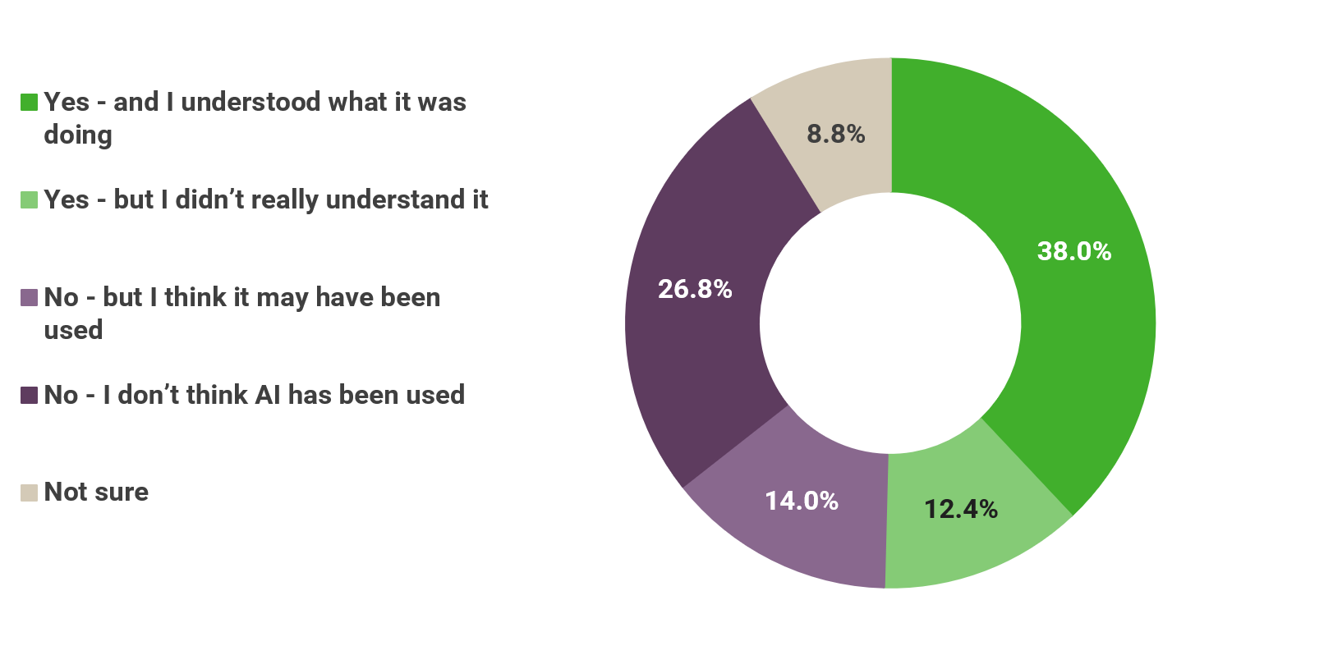
Figure 1: AI use is already known to some consumers, but many remain unsure whether it has been used in their care.
This matters because transparency is the starting point for every other safeguard. Consumers do not have the option to consent, ask questions, check outputs, or request an alternative if they do not know AI is being used. The issue is not only whether AI is safe, but whether consumers can recognise whether and when AI has a role in their own care.
Among those who had experienced AI in healthcare (Figure 2), its use was concentrated in consultations and documentation but not limited to them. AI was most often reported in GP or specialist consultations and note-writing or summaries were the dominant role. At the same time, consumers also described AI being used in self-directed health information seeking, apps, diagnostic settings, and in some cases, advice or care pathways.

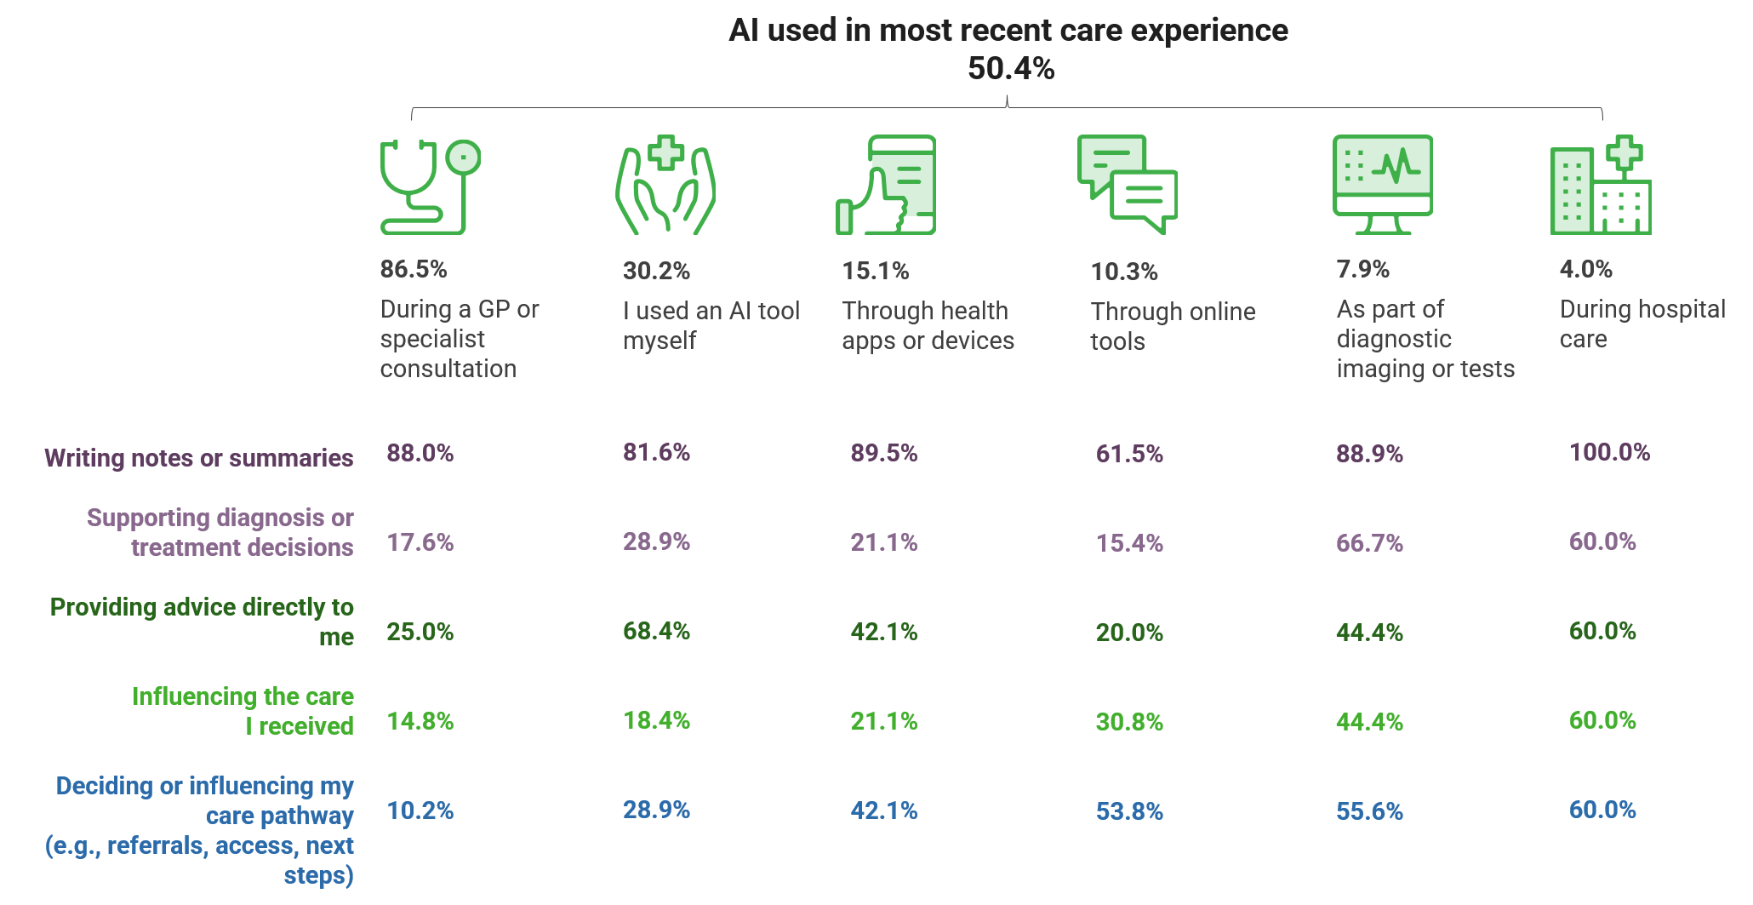
Figure 2: AI is most encountered in consultations and documentation, but consumers also report use in advice, care pathways and self-directed health information seeking.
The pattern suggests AI in healthcare is currently most visible as a documentation and support tool. However, boundaries are already shifting. Once AI contributes to advice, records, referrals or next steps, it becomes part of the care relationship rather than a back-office tool.
AI is already part of healthcare, but consumer awareness is uneven. The first challenge is making AI visible enough for consumers to understand, question and consent to its use.
Key Takeaway

Consumers see benefits when AI solves real healthcare problems
“AI should be used for admin purposes, write ups, documents and extra time spend on paperwork so the clinicians can spend more time with consumers and carers.”
Respondent aged 45-54 years, Female
Consumers did not describe AI benefits in abstract or technical terms. Instead, they identified opportunities for AI to address existing pressure points in the health system: earlier detection, more time with clinicians, better coordination, fewer repeated forms shorter waiting times, and better communication (Figure 3).
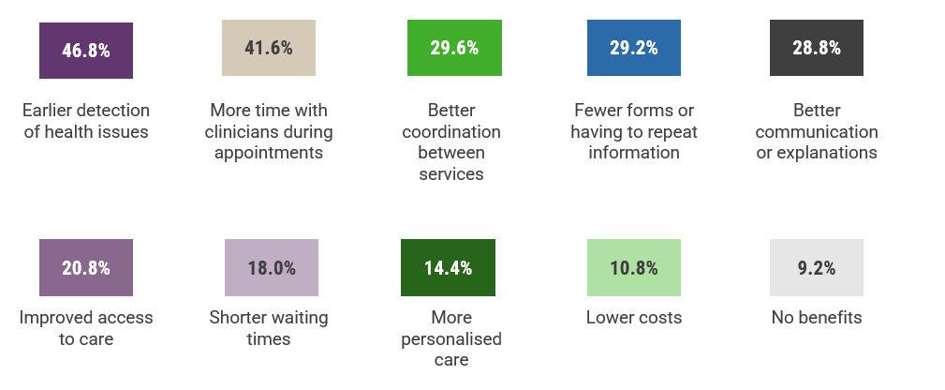
Figure 3: Consumers want AI to reduce pressure points in the health system, especially waiting, repetition, poor communication and limited clinician time.

Consumers want healthcare benefits, not technology for its own sake. AI needs to improve access, communication and care experience, not simply increase automation.
Key Takeaway
This is an important distinction. Consumers do not appear to evaluate AI according to technical sophistication or organisational efficiency. Instead, they judge AI by whether it delivers tangible improvements to their experience of care. Support was strongest where AI was seen as creating more clinician time, improving communication, reducing repetition and shortening waiting times. AI is seen as useful when it creates more space for care and meaningful provider-consumer interaction. Consumers were less interested in automation for its own sake and more interested in whether AI made healthcare easier to access, navigate and understand.

Consumers accept AI as support, not as the decision-maker
“Clinicians must retain responsibility for clinical decisions, in consultation with the patient. AI is appropriate to streamline processes and administration but it should not make clinical decisions or replace the clinician’s insight and personal connections with the patient.”
Respondent aged 55-64 years, Female
While consumers recognised several potential benefits of AI, their support depended heavily on how AI was used. Consumers drew a clear distinction between AI as a support tool and AI as a decision-maker. Consumers were more open to AI being used for documentation or analysis, but much less accepting of AI deciding treatment or access (Figure 4). This shows that consumers are not making a simple yes-or-no judgement about AI. They are judging the task, the risk, and the consequence of getting it wrong.
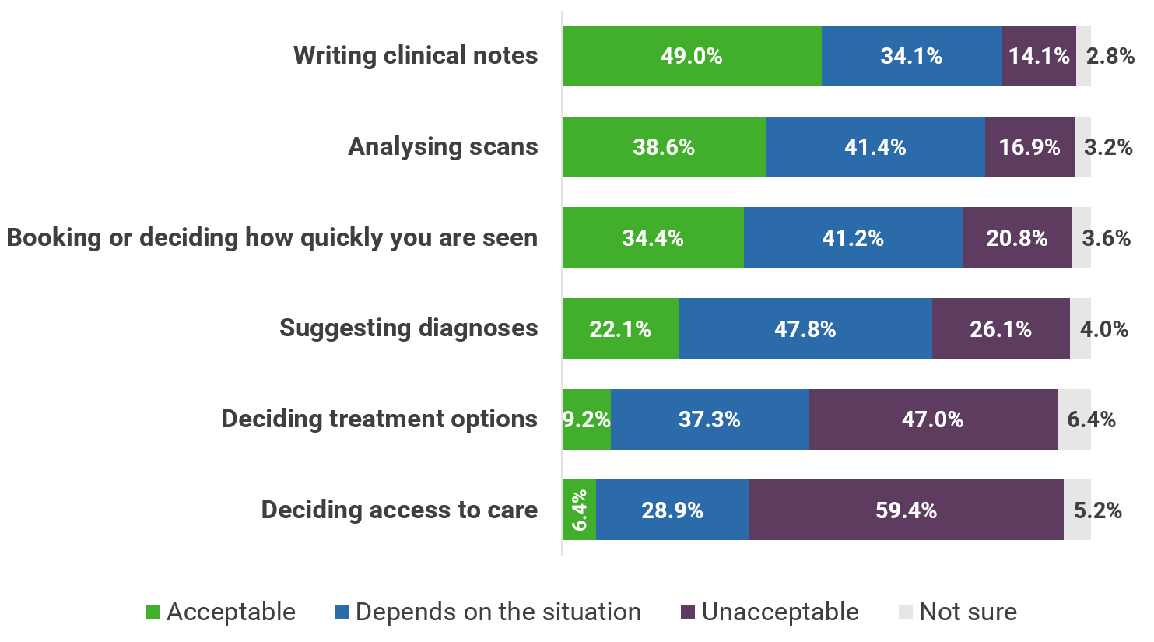
Figure 4: Consumers distinguish between assistive uses of AI and decision-making uses of AI.

Consumers are 0 AI outright. They are drawing a boundary: AI may support care, but it should not decide diagnosis, treatment or access without human judgement and accountability.
Key Takeaway
One possible explanation is that some forms of AI are more visible and easier for consumers to understand in practice. For example, a consumer may see a clinician using an AI scribe during a consultation and recognise that it supports documentation. In contrast, AI used for scan interpretation, triage, prioritisation, or treatment decisions may be less visible, more difficult to understand or question, and more directly involved in decisions affecting their care. This may help explain why acceptability declines as AI moves closer to clinical judgement and decisions about access to care or treatment.

Trust depends on safeguards people can see and use
“The most important thing is transparent, accountable use of AI that I can clearly understand and trust. I need to know how an AI tool works, why it is being used in their care, what its limits are, and who is responsible for decisions made with its support.”
Respondent aged 65-74 years, Male
Because consumers are more comfortable with AI supporting care than making decisions, trust becomes critical when AI takes on a greater role. While some consumers trust AI use in healthcare, many remain uncertain and others are sceptical (Figure 5).
This suggests that consumers have not reached an established view about AI. Rather than outright rejecting it, many appear to be weighing its potential benefits against concerns about safety, transparency, accountability and data use. Consumers who neither trust nor distrust AI in healthcare are likely watching how AI is introduced. If AI is introduced without explanation, review, correction rights or consent, uncertainty can easily become distrust. If it is introduced carefully, with visible safeguards, there is still room to build confidence.
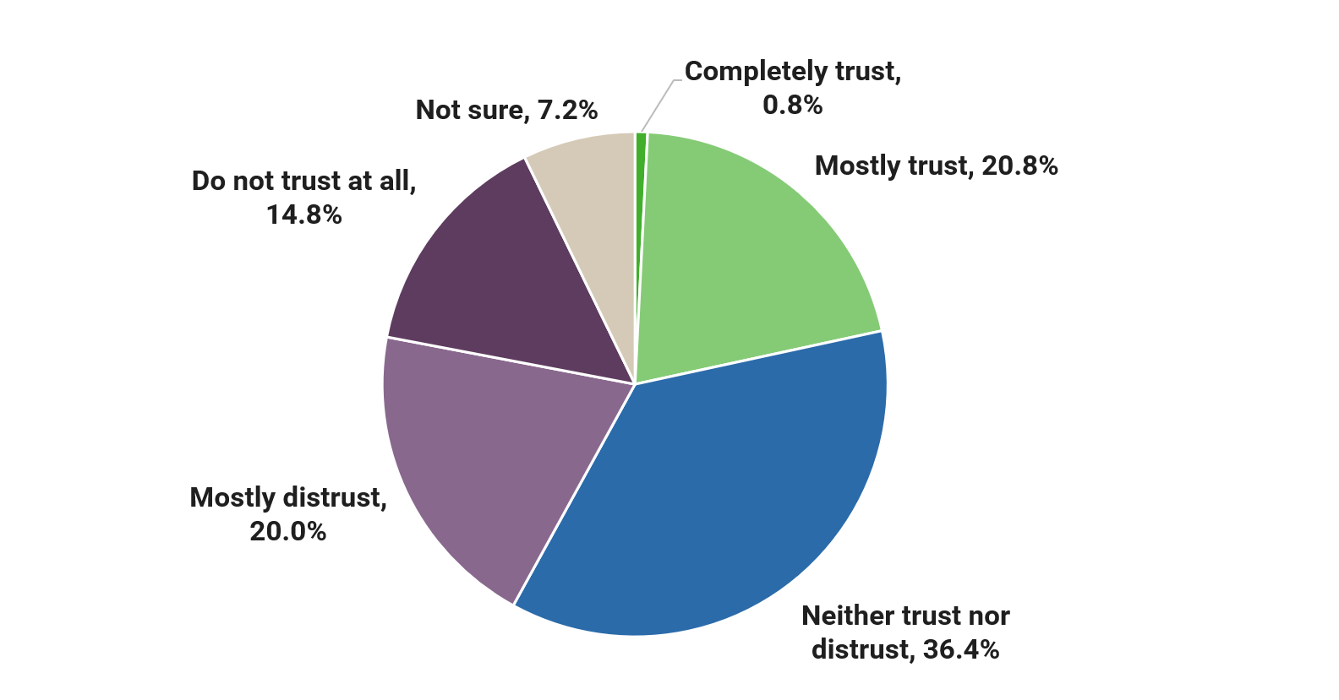
Figure 5: Trust in AI is not yet established, with more consumers distrusting than trusting and many remaining undecided.

Among consumers who had experienced AI in healthcare, confidence depended less on AI itself and more on the safeguards surrounding its use. Consumers were more confident when AI was explained by a clinician, reviewed by a clinician, open to scrutiny, and could be questioned or challenged (Figure S1, Appendix D). Where confidence was lower, consumers described uncertainty about accuracy, data use, consent and review rights (Figure S2, Appendix D). These findings suggest that trust is built through transparency, oversight and accountability rather than the technology alone. Consumers are not simply asking whether AI works; they want to know how it works, who checks it, and what happens when something goes wrong.
Subgroup patterns suggest that trust is shaped by lived experience of the health system. Consumers with disability were more likely to distrust AI (47.1%) and more likely to say AI is moving too fast (52.9%). CALD consumers were more likely to sit in the uncertain middle (54.2%). While these findings should be interpreted cautiously due to small subgroup sizes, they should not be understood simply as lower trust in technology. Instead, they may reflect caution among consumers who have previously experienced barriers, poor communication, exclusion, or other forms of system failure in healthcare. For these groups, trust may depend on stronger evidence that AI will improve rather than reproduce existing inequities.

Data control and accountability are central to social licence
“Clear regulations, independent testing and review, clear explanations for patients, strong data protection, clinician oversight, overriding principle of equity.”
Respondent aged 55-64 years, Female
Trust was not only shaped by how AI is used in care, but also by how health data are governed. For consumers, AI in healthcare is also a data issue. Consumers most often preferred shared control of health data used to develop AI, followed by control by the individual patient (Figure 6). Very few supported technology or health device companies controlling health data. This indicates that social licence for AI depends on who controls data and whose interests the system appears to serve.
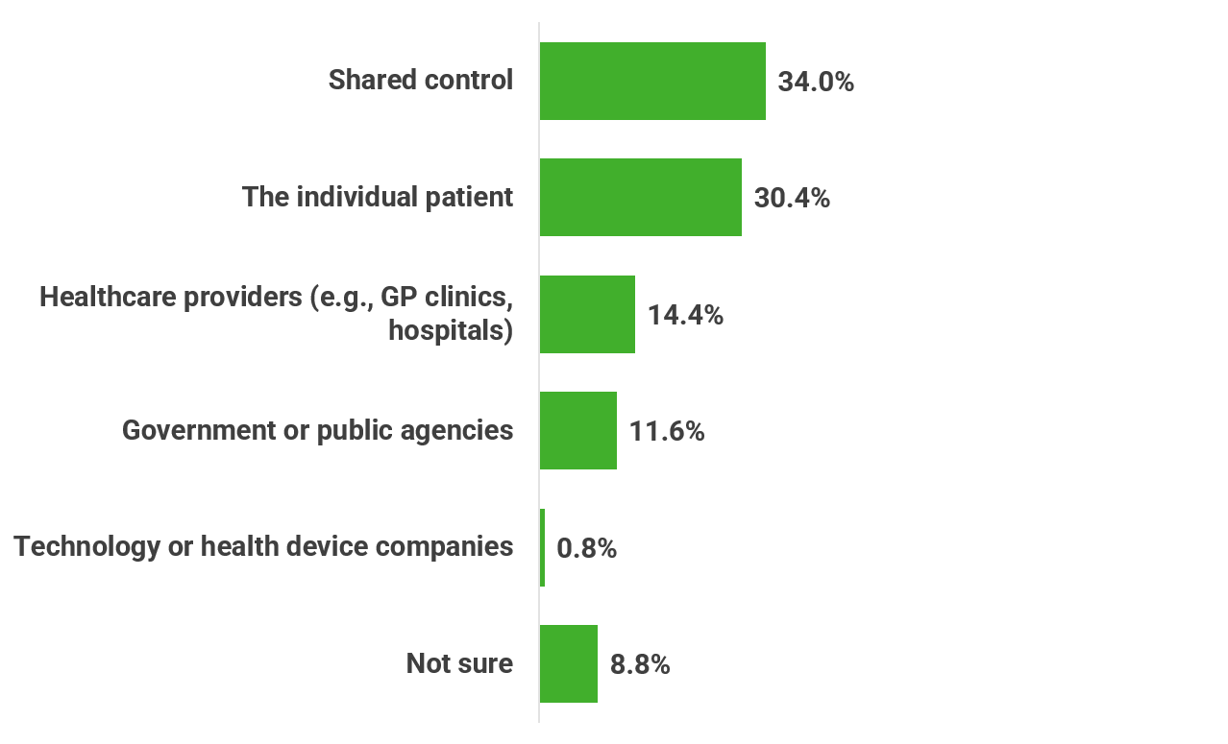
Figure 6: Consumers want control over health data used for AI, with strong preference for explicit permission and very low support for technology company control.
Consent expectations were strong. Around two-thirds of consumers said their data should only be used for AI with explicit permission (67.2%). Consumers in medium and small rural or remote areas were even more likely to favour explicit permission (70.8%). A separate pattern was seen among consumers with living with disability, who were somewhat more likely to say their data should not be used for AI at all (16.2%). These findings suggest that consent is central to consumer acceptance of AI data use, but safeguards alone may not address the concerns of those who fundamentally oppose the use of their health data for AI.
Data concerns were broader than cybersecurity. Consumers were concerned about their data being used in ways they had not agreed to, being sold or used for profit, and being accessed by unknown parties (Figure 7). Many were concerned about who would be responsible for care decisions and whether AI would work fairly for people with different backgrounds, conditions or needs. These concerns suggest that consumers do not view data governance as a privacy issue alone, they see it as closely connected to questions of control, accountability and fairness. Consumers are not only asking whether data can be kept secure; they are asking who controls it, whose interests are being served, and whether they will have any say in how their information is used.

Figure 7: Consumers’ data concerns centre on responsibility, consent, access, fairness and misuse.

Consumers want to know who controls their data, who benefits from it, and who is answerable when AI contributes to mistakes. Shared responsibility must not become unclear responsibility.
Key Takeaway
Accountability was also a key concern. When asked who should be responsible if AI contributes to a mistake in their care, most consumers favoured shared responsibility between clinicians, healthcare organisations and AI developers (55.0%) (Figure S4, Appendix D). This suggests consumers recognise that AI is introduced and used within healthcare systems, but still expect clear accountability when things go wrong.

AI could widen inequities unless governance is built around diverse consumers
As one consumer put it:
“Use of [AI] model which are not going to exacerbate structural inequities which mean some groups have less access, poorer treatment and worse health outcomes. Equity must be at the heart.”
Respondent aged 35-44 years, Female
Concerns about data use and accountability extended beyond privacy to questions of fairness. Consumers raised concerns about whether AI would work safely and fairly for people with different backgrounds, conditions, and needs. (Figure S3, Appendix D). Open-text responses connected this risk to existing inequities in healthcare including women not being believed, rare or complex conditions being overlooked, older people being expected to navigate digital systems, and marginalised groups being underrepresented in the data used to develop AI for healthcare. This is why equity in healthcare cannot be treated as a later implementation issue. If AI is built on incomplete data, poorly tested across population groups, or introduced without accessible communication, it may reproduce the same patterns that consumers already experience in healthcare. AI cannot be considered effective if it works well on average but leaves some consumers consistently less well served.
Consumers see governance as more than regulation The leading themes in what would build trust were transparency and communication (32.1%), human oversight and control (30.4%), consent and patient choice (23.3%), accuracy and safety (23.3%), testing and validation (22.5%), and governance and accountability (19.2%) (Appendix A). Together, these themes point to the same expectation: AI must be designed and implemented with consumers, not simply applied to them.
Across the findings, consumers are not asking whether AI should exist in healthcare. They are asking what role it should play, who controls it, who checks it, who benefits from it, and who is responsible when it fails. That makes AI governance a consumer issue, a safety issue and an equity issue, not simply a technical issue.
Equity in AI cannot be assumed from average performance. AI systems need to be tested, monitored and governed for diverse consumers, especially those already exposed to health system barriers.
Key Takeaway

References
- Australia’s Health Panel. What Australia’s Health Panel said about Artificial Intelligence in Healthcare. July 2024.
- Australian Government. Safe and responsible artificial intelligence in health care: legislation and regulation review [Internet]. Canberra: Australian Government; 2024.
- Department of Industry, Science and Resources. Australian Government response: Senate Select Committee on Adopting Artificial Intelligence (AI) report . Canberra: Australian Government; 2024.
- Australian Government. Safe and Responsible Artificial Intelligence in Health Care – Legislation and Regulation Review. Canberra: Australian Government; 2024.
- Australian Commission on Safety and Quality in Health Care. Pragmatic artificial intelligence (AI) guidance for clinicians [Internet]. Sydney: ACSQHC; 2024.

APPENDICES

Appendix A. Supplementary table
Themes in responses to the question: “What is the most important safeguard or change that must happen for you to trust AI in healthcare?”
Theme  N=240 | n, % | Theme description | Example quote
Transparency and communication | 77, 32.1% | Clear, upfront explanation of when, how and why AI is used, including what happens to patient data. | “Transparency about its use, its purpose, and what my data is going to be used for.”
Human oversight and control | 73, 30.4% | Strong expectation that clinicians remain responsible, review outputs, and can override AI decisions. | “Clinician oversight… a human must always be able to override it.”
Accuracy and safety | 56, 23.3% | Concerns about correctness, reliability, and avoiding harmful errors in clinical care. | “It must be accurate and regulated.”
Consent and patient choice | 56, 23.3% | Patients want explicit permission, the ability to opt out, and control over whether AI is used in their care. | “Consent to use and the ability to still have control… especially if it is incorrect.”
Testing, validation and evidence | 54, 22.5% | AI must be rigorously tested, evidence-based, and independently validated before use. | “Independent verification/testing when it comes to AI being used to influence decisions.”
Governance, regulation and accountability | 46, 19.2% | Need for clear rules, legal frameworks, and accountability for errors or harm. | “Legislation and regulation… with clear accountability and consequences.”
Privacy and data protection | 35, 14.6% | Strong expectations around data security, confidentiality, and limits on data sharing or reuse. | “Strong safeguards to protect privacy… not to be sold or passed on.”
Role boundaries (AI as a support tool) | 27, 11.3% | AI should assist clinicians, not replace human judgement or decision-making. | “AI should be a tool… not the source of decision making.”
Equity and bias | 27, 11.3% | Concerns about fairness, bias, and whether AI works safely across different populations. | “AI must be free of the biases built into the medical system.”
Education and awareness | 25, 10.4% | Need for better understanding among patients and clinicians about how AI works. | More education around how it works and safeguards in place.
Review and correction rights | 21, 12.9% | Patients want access to AI outputs and the ability to check and correct errors. | “I would like to read and review what AI has generated.”
Distrust or rejection of AI | 16, 6.7% | Some consumers express fundamental distrust or outright opposition to AI in healthcare. | “There is nothing that will assist me to trust AI.”

Appendix B. Methods
Australia’s Health Panel is a growing group of health consumers who regularly complete surveys on health issues. The project is run by the Consumers Health Forum of Australia (CHF), and surveys from 2025 onwards are delivered through LimeSurvey, an open-source online survey platform for survey creation, distribution and analysis.
We conducted an online survey from 15th June 2026 to 29th June 2026 to explore consumers’ views and experiences regarding AI in healthcare (Appendix C).
In total, 250 consumers completed the survey after receiving an invite. Duplicate surveys were identified and removed using a combination of demographic information (i.e., age, gender and postcode) and IP address.
Text responses from participants who selected the ‘Other’ option were recoded into one or more existing response categories. This may have occurred when consumers misunderstood the question and/or misread the available response options.
We summarised the data using the means, frequencies and percentages and only surveys completed were included in our final analysis. We categorised location of residence at the States or Territory level based on the postcodes or area of residence provided.
To analyse the qualitative data, we applied coding frames using keyword patterns allowing a response to match multiple themes.
Our tables and figures report findings for 250 consumers, unless stated otherwise. We removed “Not applicable”, “No answer” or “Prefer not to say” answer options, and therefore, total n (subsample size) throughout this report may vary.
Response classifications
- Q4: Response options of “Somewhat confident” and “Very confident” were combined into a “Confident”, while “Somewhat uncertain” and “Very uncertain” were combined into “Unconfident”. Responses of “Neither confident nor unconfident” were retained.
- Q14: Response options of “Mostly trust” and “Completely trust” were combined into “Trust”, while “A bit better” and “Do not trust at all” were combined into “Do not trust”. Responses of “Neither trust nor distrust” were retained.

Demographic classifications
- Region of residence: Consumers were grouped into three categories, metropolitan areas, regional and large rural towns, and medium and small rural or remote areas, based on the postcode of their home address. Postcodes were mapped to the Modified Monash Model (MMM), which classifies areas according to remoteness and population size. The three categories used in this report correspond to:
  - Metropolitan areas: MMM 1
  - Regional and large rural towns: MMM 2-3
  - Medium and small rural and remote areas: MMM 4-7
- Age groups: consumers were grouped into the following age bands for reporting:
  - Under 55
  - 55-64
  - 65-74
  - 75 or over
- Other classifications: For LGBTQIA+, CALD, ATSI, disability, mental health experience, and chronic illness, consumers who answered “Yes” were classified as belonging to that group. Those who answered “No” were classified as not belonging to the group, and “Don’t know” or missing responses were recorded as “Unknown”.

Limitations
This survey is based on 250 responses and is not intended to be nationally representative. A substantial proportion of respondents reported disability, chronic illness, or mental health experience, meaning the findings may be most relevant to groups with higher levels of healthcare use. Some subgroup analyses involved relatively small sample sizes and should be interpreted cautiously, particularly for CALD consumers and consumers in smaller rural or remote areas. These findings are intended to identify indicative patterns rather than provide population estimates or definitive comparisons. As participants were recruited through Australia's Health Panel, the sample may over-represent consumers who are more engaged with the healthcare system. Findings are based on self-reported data, may be subject to bias, and cannot establish causality.

Appendix C. Survey
AI in Healthcare Survey
This survey is being conducted by the Consumers Health Forum of Australia (CHF) as part of Australia’s Health Panel.
We are interested in your views and experiences of artificial intelligence (AI) in healthcare.
AI can include tools used by health professionals (e.g. to help write clinical notes, analyse scans, or support diagnosis), as well as tools used directly by health consumers (such as chatbots like ChatGPT or symptom checkers).
There are no right or wrong answers. Your responses will be combined with others and used to inform advocacy and policy work.
The survey will take around 10 minutes to complete.

Section 1: Healthcare Experience
We’d like to understand whether and how you’ve encountered AI in your own healthcare experiences.
Artificial intelligence (AI) refers to computer systems that can perform tasks that usually require human intelligence. For example, analysing scans, helping write clinical notes, suggesting diagnoses, or providing health advice (such as chatbots).
In some cases, AI may be used in healthcare without being clearly identified to patients.

Q1. Thinking about your recent healthcare experiences, have you ever noticed or been told that AI was used in your care?
(Choose one of the following answers)
- Yes - and I understood what it was doing
- Yes - but I didn’t really understand it
- No - but I think it may have been used
- No - I don’t think AI has been used
- Not sure

Survey routing
- Group A Yes (both)
- Group B No but think maybe, No, Not sure

Section 2: Lived Experience (Group A only)
The next questions ask about your experience with AI in healthcare and how it affected you.

Q2a. Where was AI used during your recent healthcare experience?
(Please select all that apply)
- During a GP or specialist consultation
- During hospital care (including Emergency)
- As part of diagnostic imaging or tests
- Through online tools (e.g. symptom checker, chatbot)
- Through health apps or devices
- I used an AI tool myself (e.g. ChatGPT, Gemini, Copilot, Claude) for a health question
- Other (please specify)
- Not sure

Q3. What role did AI play during your recent healthcare experience?
(Please select all that apply)
- Writing notes or summaries
- Supporting diagnosis or treatment decisions
- Providing advice directly to me
- Influencing the care I received
- Deciding or influencing my care pathway (e.g. referrals, access, next steps)
96. Other (please specify)
98. Not sure

Q4. Thinking about that experience, how confident or uncertain are you that your health concern was handled appropriately?
(Choose one of the following answers)
- Very confident
- Somewhat confident
- Neither confident nor unconfident
- Somewhat uncertain
- Very uncertain
98. Not sure

Q5. What most influenced how confident or uncertain you felt about how your health concern was handled?
(Please select between one to three options that matter most to you)
- A clinician explained it clearly
- A clinician checked or confirmed it
- I could see or review what the AI produced or suggested
- I could ask questions or challenge it
- I didn’t know it was being used at the time
- I wasn’t sure how accurate it was
- I wasn’t sure how my data was being used
- It felt efficient/helpful
- It felt impersonal
- I could correct or challenge what the AI produced if it was wrong
96. Other (please specify)
98. Not sure

Section 2: Expectations (Group B only)
Even if you haven’t experienced AI in your care, we’d like to understand what would matter to you if it was used.

Q2b. If AI were used in your care, what would matter most to you?
(Please select between one to three options that matter most to you)
- A clinician explains how AI is used clearly
- A clinician checks the results from AI systems
- I can see or review the output from systems using AI
- I can ask questions or challenge the use of AI
- I can choose not to use systems that use AI
- The systems using AI are accurate and reliable
- My data and privacy are protected within systems using AI
- My data from my care isn’t reused for another purpose
- A clinician remains responsible for care decisions
96. Other (please specify)
98. Not sure

Section 3: Acceptable vs Unacceptable Use (Groups A & B from here on)
People have different views on where AI should or shouldn’t be used in healthcare and we’re interested in your opinion.

Q6a. What benefits would you most want to see from the use of AI in healthcare?
(Please select between one to three options that matter most to you)
- Shorter waiting times for care
- More time with clinicians during appointments
- Better communication or explanations
- Fewer forms or having to repeat information
- Earlier detection of health issues
- Better coordination between services
- Lower costs
- Improved access to care (e.g. regional, remote, after hours)
- More personalised care
- I do not see benefits from AI in healthcare
96. Other (please specify)
98. Not sure

Q6b. For each of the following, do you think the use of AI in healthcare is acceptable?
(Please choose the appropriate response for each item)
 | Acceptable | Depends on situation | Unacceptable | Not sure
- Writing clinical notes | ○ 1 | ○ 2 | ○ 3 | ○ 98
- Booking or deciding how quickly you are seen | ○ 1 | ○ 2 | ○ 3 | ○ 98
- Analysing scans | ○ 1 | ○ 2 | ○ 3 | ○ 98
- Suggesting diagnoses | ○ 1 | ○ 2 | ○ 3 | ○ 98
- Deciding treatment options | ○ 1 | ○ 2 | ○ 3 | ○ 98
- Deciding access to care | ○ 1 | ○ 2 | ○ 3 | ○ 98
Q7. Which of the following conditions would make the use of AI acceptable to you?
(Please select between one to three options that matter most to you)
- A clinician reviews the output
- I am clearly told before AI is used in my care
- I can see or check the output or summary
- I can ask questions or challenge it
- It has been independently tested and approved
- I can choose not to use AI without this affecting the quality, cost or timeliness of my care
- It is proven to improve health outcomes
- I know who is responsible for care decisions
- I can correct errors in AI‑generated notes, summaries or records
- AI works safely and fairly for all groups (including different backgrounds, conditions and communities)
- Not applicable - AI use is never acceptable in healthcare
96. Other (please specify)
98. Not sure

Section 4: Data Use and Control
AI in healthcare often relies on health data. These questions explore your views on how that data should be used and controlled.

Q8. Who should control health data used to develop AI?
(Choose one of the following answers)
- The individual patient
- Government or public agencies
- Healthcare providers (e.g. GP clinics, hospitals)
- Technology or health device companies
- Shared control
96. Other (please specify)
98. Not sure

Q9. Which statement best reflects your view on the use of your health data for AI?
(Choose one of the following answers)
- My data should only be used with my explicit permission
- My data can be used without explicit permission if there are strong safeguards
- My data should not be used for AI
98. Not sure

Q10. What concerns you most about your data being used in AI?
(Please select between one to three options that matter most to you)
- Data being sold or used for profit
- Lack of clear consent
- Not knowing who has access
- Data being used in ways I didn’t agree to
- Risk of breaches
- AI may not work safely or fairly for people with different backgrounds, conditions or needs
- Not knowing who is responsible for care decisions
- No concerns
96. Other (please specify)
98. Not sure

Section 5: Trust and Accountability
The next questions are about what would build your trust in AI, and who should be responsible if something goes wrong.
Q11. If AI contributes to a mistake in your care, who should be responsible?
(Choose one of the following answers)
- The clinician
- The healthcare organisation
- The AI developer
- Government/regulators
- Shared responsibility (e.g. between clinician, organisation and AI developer)
96. Other (please specify)
98. Not sure
Q12. Which of the following safeguards would increase your trust in AI in healthcare?
(Please select between one to three options that matter most to you)
- Independent testing and approval
- Being clearly told before AI is used
- A clinician reviews outputs after AI was used
- Being able to see or check the output after AI was used
- Strong data protections
- Ability to opt out without affecting care quality, cost or access
- Clear explanation of risks
- I can review and correct AI‑generated information about me
96. Other (please specify)
98. Not sure
Section 6: Future Direction
Finally, we’d like your views on how AI in healthcare is developing in Australia and what needs to happen next.
Q13. Overall, AI in healthcare in Australia is:
(Choose one of the following answers)
- Moving too fast
- About right
- Moving too slowly
- Not sure
Q14. Overall, how much do you trust the use of AI in healthcare?
(Choose one of the following answers)
- Completely trust
- Mostly trust
- Neither trust nor distrust
- Mostly distrust
- Do not trust at all
98. Not sure
Q15. What is the most important safeguard or change that must happen for you to trust AI in healthcare?
(Open text)

Demographics
In this part of the survey, we ask a few questions about you—such as your age, gender, postcode and other general characteristics. These questions help us understand who is participating in the panel and allow us to analyse the results of this and future surveys in meaningful ways.
Your responses will be kept confidential and used only for research purposes. You can skip any question you're not comfortable answering.
Thank you for helping us ensure our research reflects a diverse range of perspectives.

D1. What is your age?
Please choose only one of the following:
- Under 18
- 18-24
- 25-34
- 35-44
- 45-54
- 55-64
- 65-74
- 75-84
- 85 or over

D2. How do you describe your gender?
Note: Gender refers to current gender, which may be different to sex recorded at birth and may be different to what is indicated on legal documents
Please choose only one of the following:
- Man or male
- Woman or female
- Non-binary
- I use a different term (please specify)

D3a. Where do you live?
 | Please enter a four digit number | I don't know
Postcode

D3b. Where do you live?
Only answer this question if the following conditions are met:
- I don’t know is selected at D3a
Please choose only one of the following:
- Sydney
- Rest of New South Wales
- Melbourne
- Rest of Victoria
- Brisbane
- Rest of Queensland
- Adelaide
- Rest of South Australia
- Perth
- Rest of Western Australia
- Tasmania
- Northern Territory
- Australian Capital Territory
- Outside Australia

D4. Do you identify as any of the following?
Please choose all that apply:
- Aboriginal and/or Torres Strait Islander
- Person with a disability
- Person with a chronic condition
- Person with a mental health experience
- Culturally and linguistically diverse (CALD)
- LGBTQIA+ person
- None of the above
Thank you for your feedback. It will shape our advocacy on this issue.
We’ll share a short summary of what we hear with everyone who responds.
Thank you for completing this survey.

Appendix D. Supplementary figures
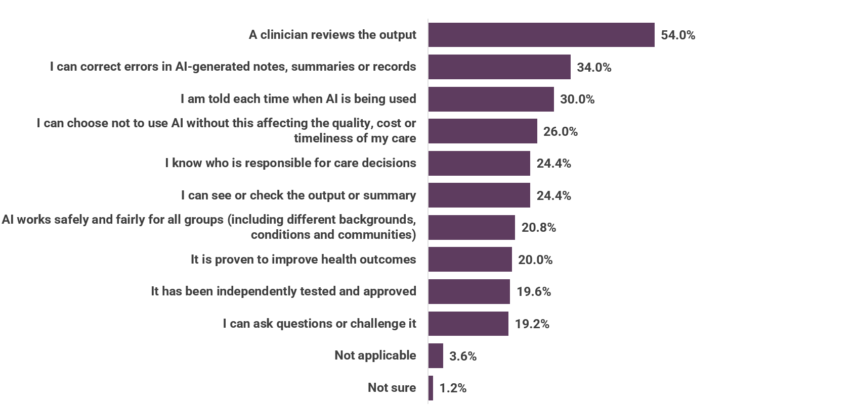
Supplementary Figure S1 AI becomes acceptable when it is proven effective, testable, correctable and fair, with transparency and choice also playing important roles

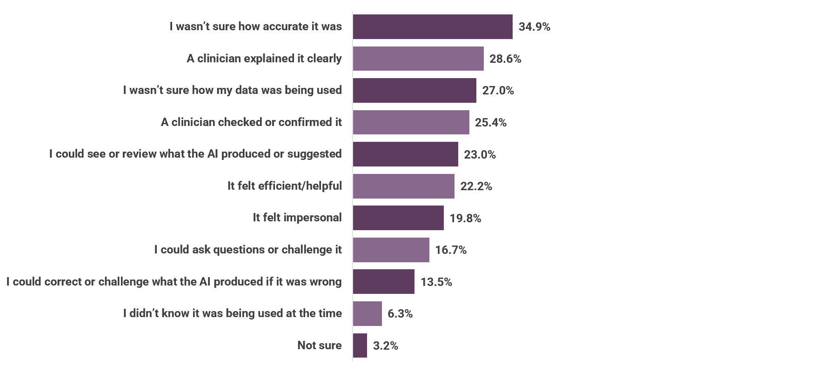
Supplementary Figure S2. Confidence in AI-assisted care depends on explanation, clinician checking, reviewability and clarity about data use.

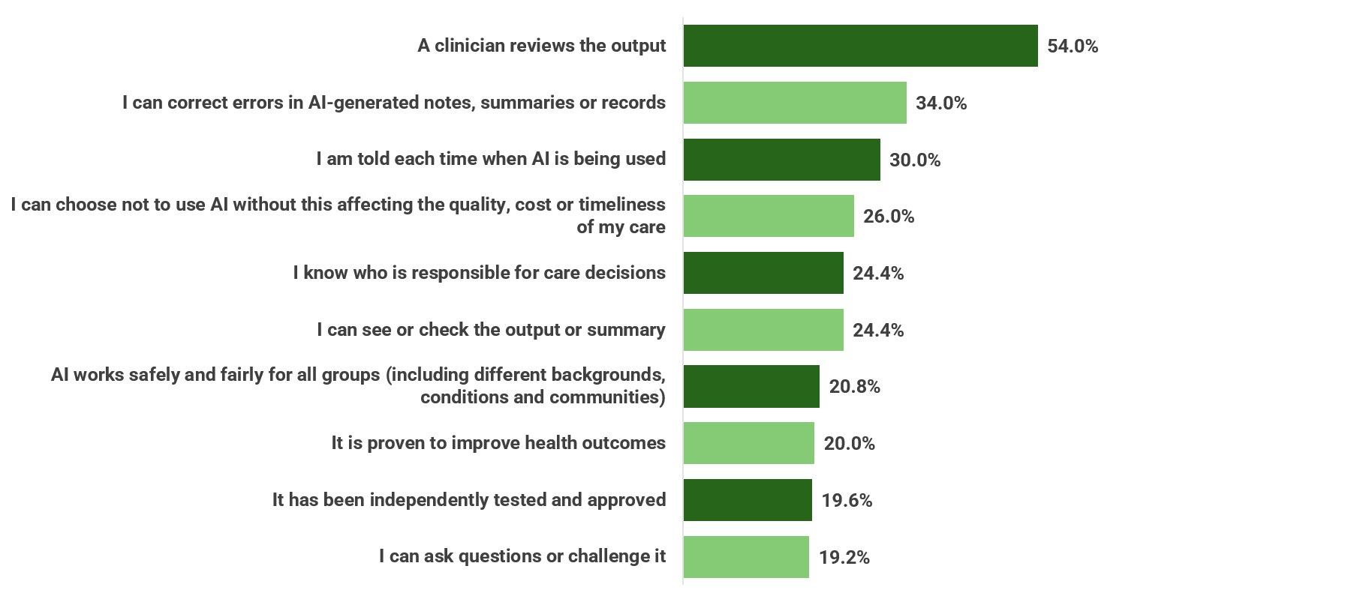
Supplementary Figure S3 Consumers prioritise clinician oversight, review rights and opt-out options as the most important safeguards to build trust in AI in healthcare.

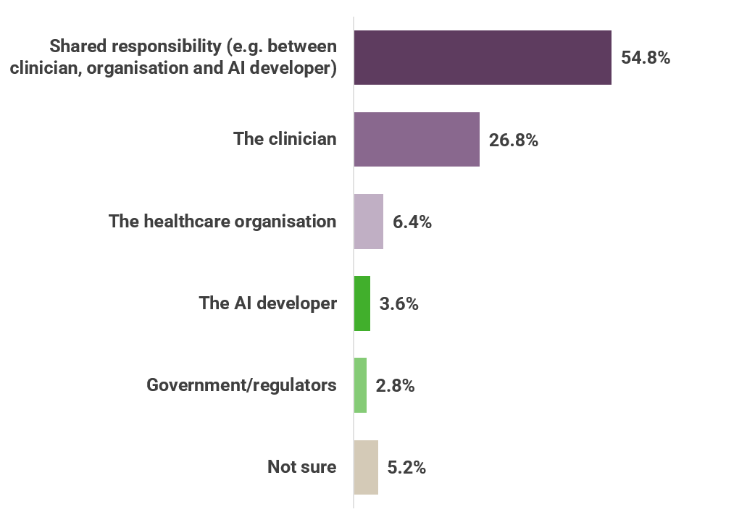
Supplementary Figure S4: Consumers expect responsibility for AI errors to be shared, but trust depends on clear review and correction safeguards.

Consumers were from Victoria (33.8%), New South Wales (19.5%), Queensland (16.9%), South Australia (10.0%), Western Australia (10.0%), the Australian Capital Territory (5.2%), and Tasmania (3.5%). Location data was missing for 1.3% of consumers.
For clarity, “complete” surveys are defined as those finished up to and including Q14
Australian Government Department of Health and Aged Care, “Modified Monash Model (MMM).”

