

23 October 2018

Electricity Price Review
Secretariat
Ministry of Business, Innovation and Employment
15 Stout Street
PO Box 1473
Wellington 6140

Email to: energymarkets@mbie.govt.nz

SUBMISSION on
Electricity Price Review: First Report for Discussion

1. Introduction

1.1 Thank you for the opportunity to make a submission on the Electricity Price Review First Report. This submission is from Consumer NZ, New Zealand’s leading consumer organisation. It has an acknowledged and respected reputation for independence and fairness as a provider of impartial and comprehensive consumer information and advice.

Contact: Aneleise Gawn
Consumer NZ
Private Bag 6996
Wellington 6141
Phone: 04 384 7963
Email: aneleise@consumer.org.nz

2. Overview

2.1 Our submission on the report focuses on key questions relating to affordability, the major issue facing consumers in the electricity sector. To inform the Electricity Price Review’s work, we have provided additional data from our research relevant to this issue.

2.2 In section four of our submission, we outline our recommendations to address affordability concerns. These recommendations include proposed interventions in the electricity sector to improve consumer protection and price transparency.

2.3 In section five, we identify areas where we consider further research is required to inform decision-making. The final section of our submission provides additional information requested by the review secretariat regarding Powerswitch.

3. Comments on part three: Consumers and prices

3.1 Consumer interests
Question: What are your views on this assessment of consumers’ priorities?

We agree with the priorities identified in the report. Electricity is an essential service and consumers should be able to access it at an affordable price. In addition, consumers have the right to expect the supply of electricity to be of acceptable quality.

Environmental considerations are also becoming increasingly important to consumers. Our 2017 consumer issues survey found 55 percent of consumers took environmental factors into account some or all of the time when they were making purchasing decisions.

Of relevance to the electricity sector, the same survey found 70 percent were concerned about climate change, up from 61 percent in 2016. When choosing an electricity retailer, one in three consumers said they took into account retailers’ efforts to reduce their carbon emissions.

  - Consumer representation
Question: What are your views on whether consumers have an effective voice in the electricity sector?

In our view, consumers are not adequately represented in the electricity sector. We therefore support the recommendation of the International Energy Agency that consumer participation and representation need to be strengthened.

As the report notes, decision-making processes are often inaccessible to individual consumers. The significant resources required to take part also means organisations representing consumer interests, such as Consumer NZ, cannot always fully participate.

We consider participation funding needs to be available not only to ensure consumer interests are adequately represented, but also that consumers receive the information they need to make informed decisions. We recommend funding from the Electricity Authority levy should be available to support these goals.

Consumer NZ receives some funding from the Electricity Authority to help run the Powerswitch site. However, this funding does not extend to providing advice or other services to electricity consumers. Government funding to support our participation in regulatory or other decision-making processes is minimal.

Our recommendations for participation funding are discussed further in section four.

  - Consumer trust
Question: What are your views on whether consumers trust the electricity sector to look after their interests?

In our 2018 energy satisfaction survey, just 26 percent of consumers agreed energy retailers had customers’ best interests at heart. Only 30 percent agreed companies charged customers fairly.

Our survey found consumers generally felt more positive about their own retailer. However, the figures above show consumers’ trust in the electricity industry as a whole is not high.

Low trust levels are likely to be among the factors influencing the extent to which consumers consider switching is worthwhile. Just 13 percent of consumers in our survey considered it was very likely they would switch in the next 12 months.

  - Prices
Question: What are your views on this assessment of the makeup of recent price changes?

Both retail and distribution charges have contributed to the significant increase in power prices that consumers have experienced over the past decades. Despite flat demand in the past few years, there has been no reduction in domestic prices.

In the absence of legislative requirements for regular price monitoring, or a requirement to ensure consumers have access to affordable power, there has been insufficient scrutiny of price increases and whether they’re justified.

Consumers lack the bargaining power of industrial and commercial users, which have not experienced the same marked price increases. Large users are able to negotiate the terms of supply and the price they pay. However, individual consumers hold little sway over prices in this sector.

Consumers’ ability to easily “shop around” is also hampered by the array of plans available. As the report notes, some consumers are able to more easily navigate the system than others. Those who are not, or who do not have a choice of retailer, are disadvantaged.

  - Affordability
Question: What are your views on this assessment of the size of the affordability problem?

Affordability is a major issue. Rising power prices have had a significant impact on many consumers, particularly low-income households.

In our 2018 survey, 15 percent of consumers had cut back on heating because of the cost of power. In the past year, 18 percent had run into financial difficulties paying their bill. Fourteen percent had overdue fees added to their account because they couldn’t pay on time.

Of major concern, customers of prepay provider Globug were significantly more likely to be struggling. More than a third (38 percent) had cut back on heating because of the cost.

Just over half had experienced financial difficulty paying for power in the past year with one in two borrowing from friends or family to meet costs. Sixty-four percent had a household income of less than $50,000.

The difficulty of keeping their homes warm was compounded by the fact many lived in uninsulated houses that lacked efficient heating. Fifty percent said their home was difficult to heat during winter.

Our research shows the impact of rising prices has been more pronounced on low-income households that are renting. Not only do these households face rising power bills, but the quality of rental accommodation means these properties are harder to heat.

Insulation requirements for rental accommodation will help improve the quality of rental housing. However, these improvements will be of limited benefit unless tenants are able to pay for the power required to heat their homes to a reasonable temperature.

Low-income households are also less able to take advantage of technology that can reduce power use or invest in more energy efficient appliances. In addition, they are less likely to be able to reduce their reliance on the grid by installing solar generation.

Given retailers have no obligation to supply, consumers who experience financial difficulties paying for power can face disconnection. Last year, 25,317 households had their power disconnected because of unpaid bills, up from 19,106 in 2015.

The only option for these consumers may be to go on a prepay meter. Despite paying for power in advance and receiving a more restrictive service, customers on prepay are charged comparatively high rates and encounter other fees, including fees to top up their meter.

The figure below shows Auckland prices of prepay provider Globug are near the top of the market, based on average annual consumption for a medium sized household of 7576kWh. It is the third most expensive provider.
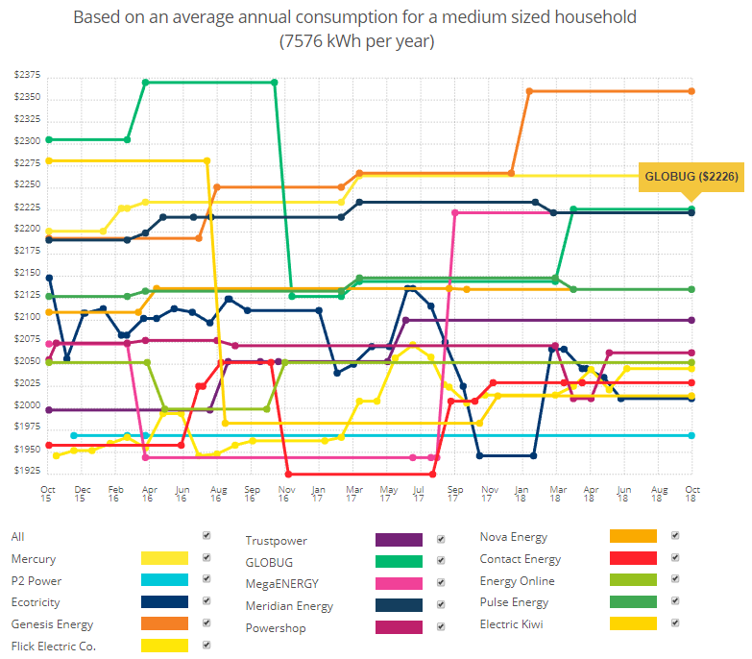

Figure 1: Prices in Auckland. Sourced from powerswitch.org.nz, 23 October 2018.

Globug prices in Wellington and Christchurch are also at or near the top of the market as the figures below show.

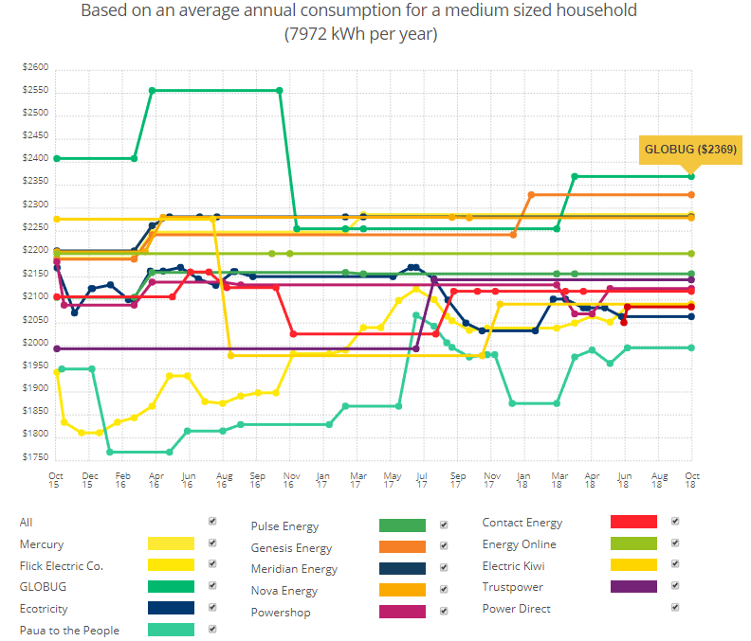

Figure 2: Prices in Wellington. Sourced from powerswitch.org.nz, 23 October 2018.

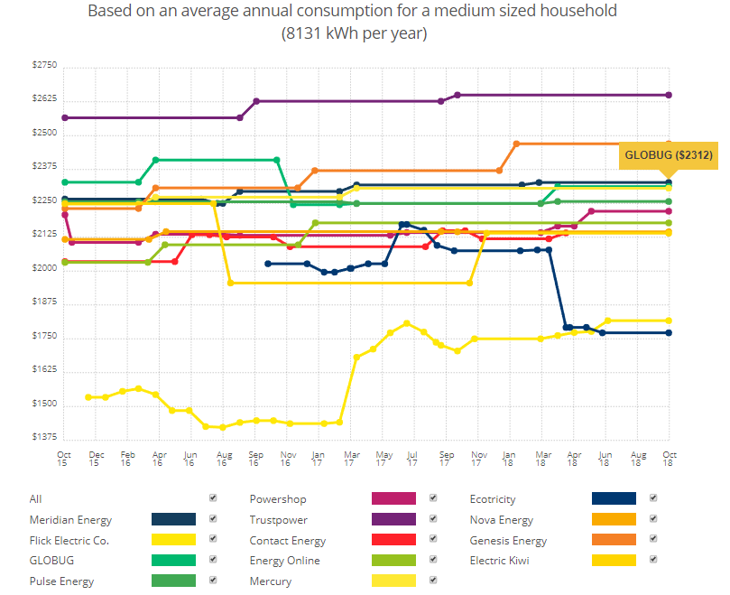

Figure 3: Prices in Christchurch. Sourced from powerswitch.org.nz, 23 October 2018.

The cost of prepay electricity is important. Research here and overseas suggests households on prepay plans are more likely to experience energy poverty and be unable to afford adequate home heating.

In other countries where prepay use has grown, regulators have signalled the need to improve consumer protections to ensure prepay customers can switch easily, are treated fairly and don’t face disproportionate costs.

In Northern Ireland,the regulator has introduced a code of practice on services for prepay customers. It’s also adopted a goal of ensuring vulnerable consumers have the same access to utility services as other consumers.

In New Zealand, there are no specific protections for prepay customers and limited monitoring of services. The Electricity Authority does not routinely collect information on the type of contracts each retailer has with its customers.

Interventions have been limited to voluntary guidelines for assisting vulnerable consumers. The guidelines recommend retailers offer prepay meters to consumers who may be having difficulty paying bills. However, they don’t contain any service standards for prepay customers.

4. Addressing problems
Without government intervention in the electricity sector, affordability will be a growing problem. Our key recommendations for improving outcomes for consumers are set out below.

4.1 Improving consumer protection

- Recognise electricity as an essential service: Reforms of the electricity sector have failed to recognise electricity is an essential service that consumers should be able to access at an affordable price. Legislation governing the sector should include fairness and affordability objectives.

- Fund consumer participation: Participation funding needs to be available to ensure:
  - consumer interests are adequately represented in decision-making processes, and
  - consumers receive the advice and support needed to help make informed choices.

We recommend funding from the Electricity Authority levy be provided to support these goals. This is similar to the approach recommended by the Australian Competition and Consumer Commission to fund consumer participation in the Australian market.

As the provider of Powerswitch, Consumer NZ is well-placed to provide additional advice and support services for domestic electricity consumers. These services could include a helpline, chatline, as well as targeted advice for vulnerable consumers.

- Introduce mandatory consumer protection standards: Mandatory standards are required to provide protection for vulnerable consumers. At a minimum, these standards (which could be introduced by regulation) need to:
- regulate debt charges applied by retailers
- ensure vulnerable consumers are not disconnected
- ensure prepay customers are treated fairly and do not face disproportionate charges; prepay rates should be capped below post-pay rates, recognising prepay customers receive a more restrictive electricity service.

- Remove late payment fees: So-called prompt payment discounts effectively act as a late payment fee, penalising consumers who are unable to pay by the specified date.

The review’s analysis of retail billing data shows the significant impact these fees have on low-decile households. We consider the fees are discriminatory and should be removed.

- Remove fees for manual payments: Low-income households are also more likely to be affected by fees charged for paying bills over-the-counter or by post (rather than electronically). We consider these fees are unfair and should be removed.

  - Improving price transparency

- Require regular price reviews: The analysis of retail billing data estimates retailers earn $40 million in additional revenue as a result of consumers being on the wrong plan. We consider retailers should be required to advise their customers at least annually if they are on the most cost-effective plan for their electricity usage. Retailers’ compliance with this requirement should be subject to regular audit by the Commerce Commission. Penalties for non-compliance should apply.

- Require retailers to publish all available prices: To improve transparency and drive efficient pricing, we believe retailers should be required to publish all available prices and offers. In addition, retailers should not be able to offer a price or discount to a customer unless that price/discount is publicly available to all consumers.

We consider these requirements would avoid the need to regulate in regard to “win backs”. Much of the debate around “win backs” stems from the fact retailers may offer special deals to retain customers. However, these offers aren’t published or available to other consumers.

On their own, win back protections have limited success as they only affect the proportion of the market that switches. Most consumers don’t switch.

- Require regular price monitoring: Regular price monitoring should be undertaken to provide consumers with data to compare what they’re paying against the market average. Similar price monitoring is being proposed in Australia. We also recommend regular league tables be published comparing retailers. This role could be undertaken by Consumer NZ, as part of our Powerswitch role, or by the Commerce Commission.

- Fund an independent price comparison site: A single, independent energy comparison site, such as Powerswitch, is the best option to ensure consumers have access to reliable price information. We consider funding should be provided via the Electricity Authority levy and be sufficient to support website maintenance, development and publicity.

To ensure the site is sustainable, it must be fully funded (via the levy) rather than from switching fees paid by retailers. Switching fees are not a sustainable revenue source. Consumers who use the site to compare prices may decide not to switch (therefore no fees are paid). Retailers may also choose not to pay switching fees.

Funding to promote Powerswitch could come from levy money the Electricity Authority uses to promote the “What’s my number?” website. We consider the existence of two websites, “What’s my number?” and Powerswitch, is confusing for consumers and duplicates efforts.

Funding also needs to be sufficient to support Powerswitch training for budget services and services such as Citizens Advice Bureaux. As noted under 4.1(b), we recommend the Powerswitch site is supported by additional consumer services such as a helpline, chatline and targeted advice for vulnerable consumers.

- Areas for further research

5.1 Low-fixed charge tariffs
The review’s analysis of retail billing data shows consumers in lower deciles have higher uptake of low-fixed charge plans. However, it also reports about 40 percent of consumers in the lowest decile are on standard plans and paying more for power.

We agree electricity usage, by itself, is not a good predictor of deprivation: low-income households that have high use do not benefit from the existing low-fixed charge tariffs. We consider changes are needed to ensure these households are not disadvantaged.

However, simply removing the tariffs may result in price rises for many low-income consumers. We consider more research is required to identify the best options to address problems with the tariffs and ensure their original intent can be achieved.

5.2 Additional disclosure requirements for retailers and lines companies
Assessment of whether retailers’ and lines companies’ charges are fair and reasonable has been hampered by the lack of comparable data. We consider further research is needed to determine whether companies should be subject to disclosure requirements that would facilitate this type of analysis.

5.3 Review of lines companies
As the report notes, New Zealand has a high number of lines companies for its size. Our 2013 analysis of lines companies’ profits per customer showed wide variation (see figure 4). Commerce Commission data also indicate a link between company size and operating cost per customer.

We believe a review of lines companies is needed to assess whether existing arrangements are resulting in inefficient or unfair outcomes for consumers. The review also needs to consider whether lines companies’ planning is adequate to cope with changing technology and consumer needs.

Figure 4: Comparison of line companies’ regulated profits. Source: Consumer NZ.
6. Other issues
The review secretariat has requested additional information relating to Powerswitch, the use of consumption data and facilitating switching through the site.

6.1 Access to electricity consumption data
- Powerswitch calculates savings based on 12 months’ estimated or actual consumption. Use of actual consumption data provides a better indication of savings than estimated data.

As at September 2018:
  - 64 percent of consumers had their consumption estimated
  - 36 percent entered actual consumption data.

In comparison, in October 2016:
  - 88 percent of consumers had their consumption estimated
  - 12 percent entered actual consumption data.

- While there has been an increase in consumers using actual consumption data, better information may be available to consumers when half-hourly data can be uploaded.

- With access to half-hourly consumption data, Powerswitch could improve price comparisons and help consumers make better decisions about:
  - investments in energy products or devices
  - when and how they use energy.

- Some retailers are providing this data to customers via websites and apps. However, the information is difficult for third-parties to access on behalf of consumers and is not available for Powerswitch use.

- In 2016, we recommended the Electricity Authority revise the framework for giving consumers and their agents better access to consumption data. Specifically, we proposed standardised requirements for:
- authorisation of an agent to act on behalf of a consumer. There are currently no standard authorisation criteria and retailers have differing requirements.
- requesting and returning data (including half-hourly) electronically in real-time. Retailers have up to five days to provide consumption data and not all retailers are required to provide half-hourly data for customers on smart meters.

To date, no progress has been made on these issues.

6.2 Facilitating switching
- Powerswitch currently facilitates switching in one of two ways. Consumers either complete a form or are directed to the retailer’s website to start the switch.

- When a form is completed, it’s sent directly to the retailer to complete the switch. Where consumers are directed to the retailer’s website, they have to initiate the switch themselves on the website.

- According to the Electricity Authority, the process to enable Powerswitch to complete a switch on behalf of a consumer is likely to be complex.

- If a retailer provided an agreed portal into its system to initiate a switch, remote initiation could work. However, if Consumer NZ was using its own software to initiate and complete a switch, this would create problems in the current registry system.

- The Authority considers there will be difficulties with automated delivery of and responses to notifications, and acknowledgements. Each retailer has a unique participant identifier and the registry has only one inbox and outbox per participant identifier.

- Retailer systems usually automatically connect to the inbox to provide information to the registry, and to the outbox to receive information. If Consumer NZ was accessing the registry, we would receive information on switches and maintenance files in which we had no interest.

- Similarly, the retailer would receive acknowledgements and notifications for ICPs for which it had no record. The Authority believes this could create significant difficulties with the management of information and automated setup of accounts in retailers’ systems.

- Switching through the site would also be hampered as retailers are able to reject customers for a variety of reasons, including poor credit history, or require a bond before accepting a new customer. These issues would prevent automatic switching.

- At present, evidence does not suggest existing switch options on Powerswitch create a barrier to changing retailer. Our survey research shows the most common reason why consumers considering switching do not go ahead is because they can’t find a price that’s attractive enough to make them switch.

- Consumer NZ could look further into this and other ways to improve Powerswitch for consumers if further funding was available. We would be happy to cost a scoping project to achieve this.

See section 7A of the Consumer Guarantees Act.

