**FAST diagram**

ligne courte

To help you develop a functional analysis diagram, Appvizer gives you a **FAST diagram template** as well as a reminder of the steps to build it on the second page.

It’s up to you to complete it with information about your project!

More info: <https://www.appvizer.co.uk/magazine/operations/project-management/fast-diagram>

# Blank FAST diagram template

## Template to print

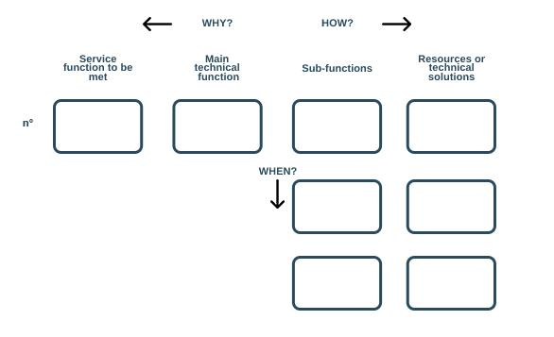

## Table template to complete with Word

|  |  |  |  |
| --- | --- | --- | --- |
|  | ← Why | How → |  |
| N°1 Service function | N*1 Main technical function | N°1 Sub-function | Resources or technical solutions |
| N°2 Sub-function | Resources or technical solutions |
| N°3 Sub-function | Resources or technical solutions |
| N°4 Sub-function | Resources or technical solutions |
| N*2 Main technical function | Sub-function | Resources or technical solutions |
| N°2 Service function | Main technical function | Sub-function | Resources or technical solutions |

# A reminder of the steps to build a FAST diagram

1. Do a functional analysis first
2. List **all the functions of a product**, for example, for a washing machine: wash clothes, rinse clothes, spin clothes,
3. Detail these functions, **prioritize** them and value them (high or low importance),
4. Identify the **main functions** (removing stains), the **secondary functions** (softening the laundry) and the **constrained functions** (not damaging the laundry),
5. For each function identified:
6. You should ask yourself "How is this function accomplished?" and write the answer to the right, in the form of an **active verb** and a noun designating something measurable,
7. And then, you should wonder "Why develop this function?" and write the answer on the left,
8. For each logic problem in the scenario, identify **missing or redundant functions** or adjust the **order of functions**.
9. Identify those that occur simultaneously or depend on each other, by asking "**when** this function is performed, does another **function trigger**? Or does it depend on the triggering of another function?" and write the answer below.

|  |
| --- |
| Comments   * Use this template according to your needs, there is no such thing as a typical FAST diagram * For more customization, use an adapted software |