Fractions & Decimals RESOURCES

chocolate cake recording sheet
Predict which table you think each of the ten guests will sit. Use the diagram below to record your prediction.
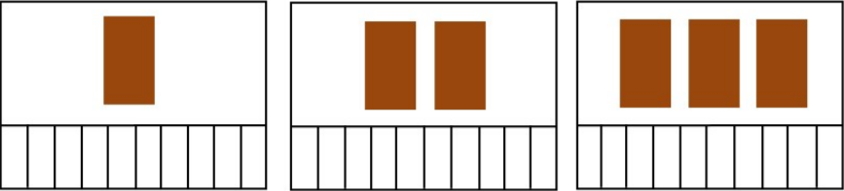
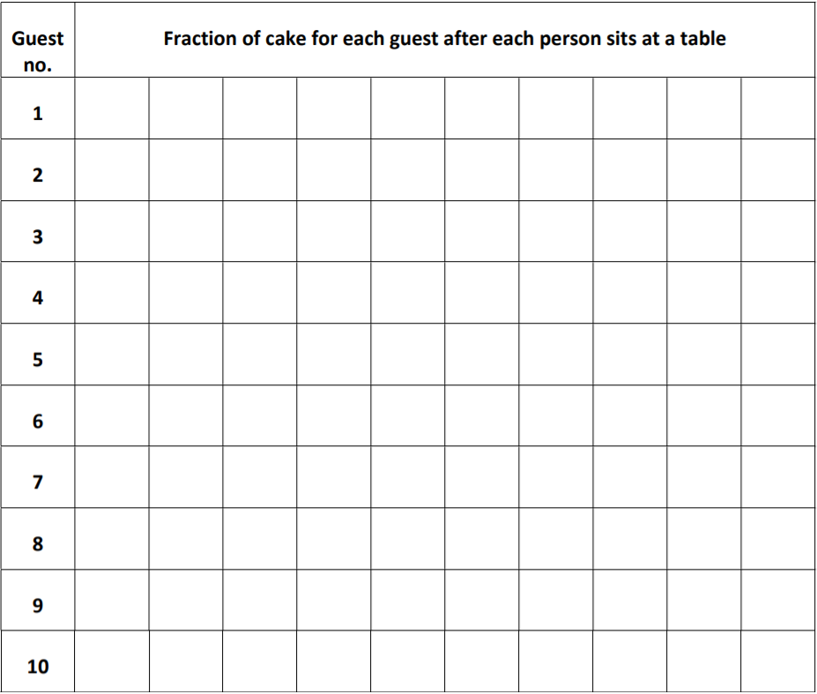
Use the table below to record how much cake each person will get as each guest takes a seat at a table. This fraction will change when an additional person sits at a particular table. (There will be ten records for guest 1 but only one record for guest 10)

