The Art of Angles

af Klint Artwork
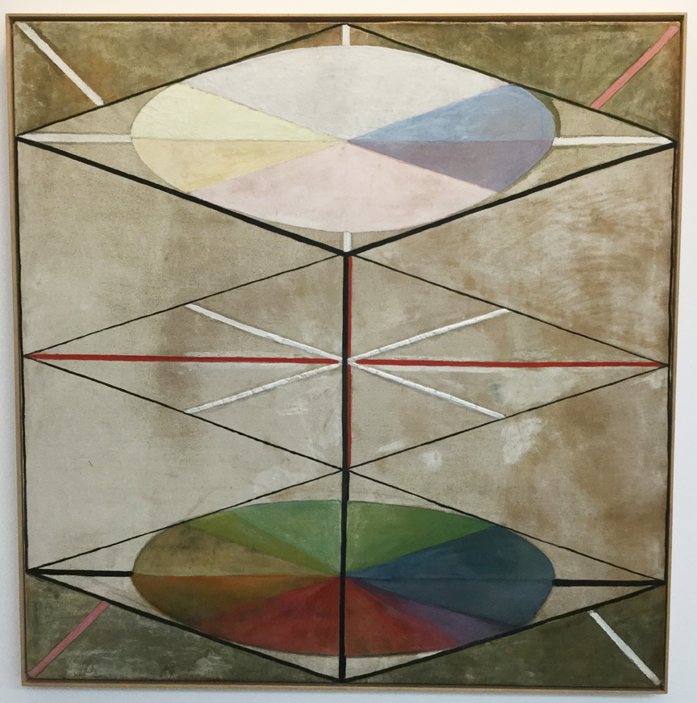
Hilma af Klint, 1914-1915, The Swan No 23
https://www.twocoatsofpaint.com/2016/07/hilma-af-klint-sustenance-possibility.html

© Department of Education and Training CC BY 4.0, excluding third party content.

