The Art of Angles

Kandinsky Artworks
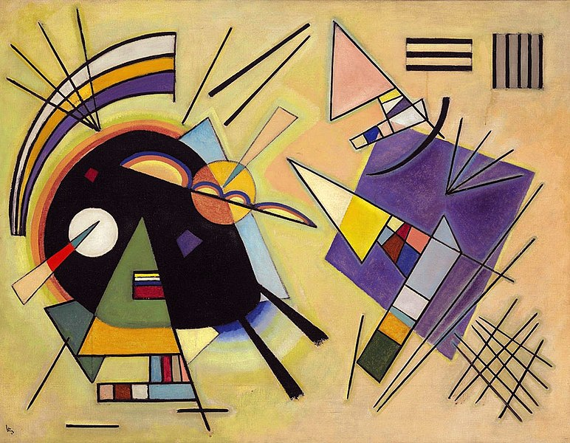
Wassily Kandinsky, 1923, Black and Violet
https://commons.wikimedia.org/wiki/File:Wassily_Kandinsky_Black_and_Violet.jpg
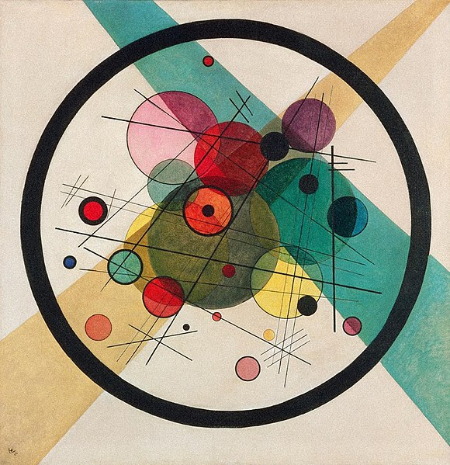
Wassily Kandinsky, 1923, Circles in a circle
https://commons.wikimedia.org/wiki/File:Wassily_Kandinsky_Circles_in_a_Circle.jpg
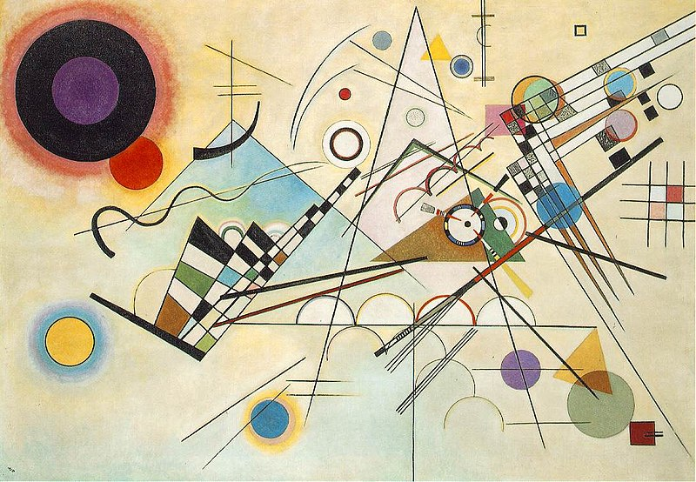
Wassily Kandinsky, 1923, Composition 8
https://commons.wikimedia.org/wiki/File:Vassily_Kandinsky,_1923_-_Composition_8,_huile_sur_toile,_140_cm_x_201_cm,_Musée_Guggenheim,_New_York.jpg

© Department of Education and Training CC BY 4.0, excluding third party content.

