The Art of Angles

Lake Condah Cloak

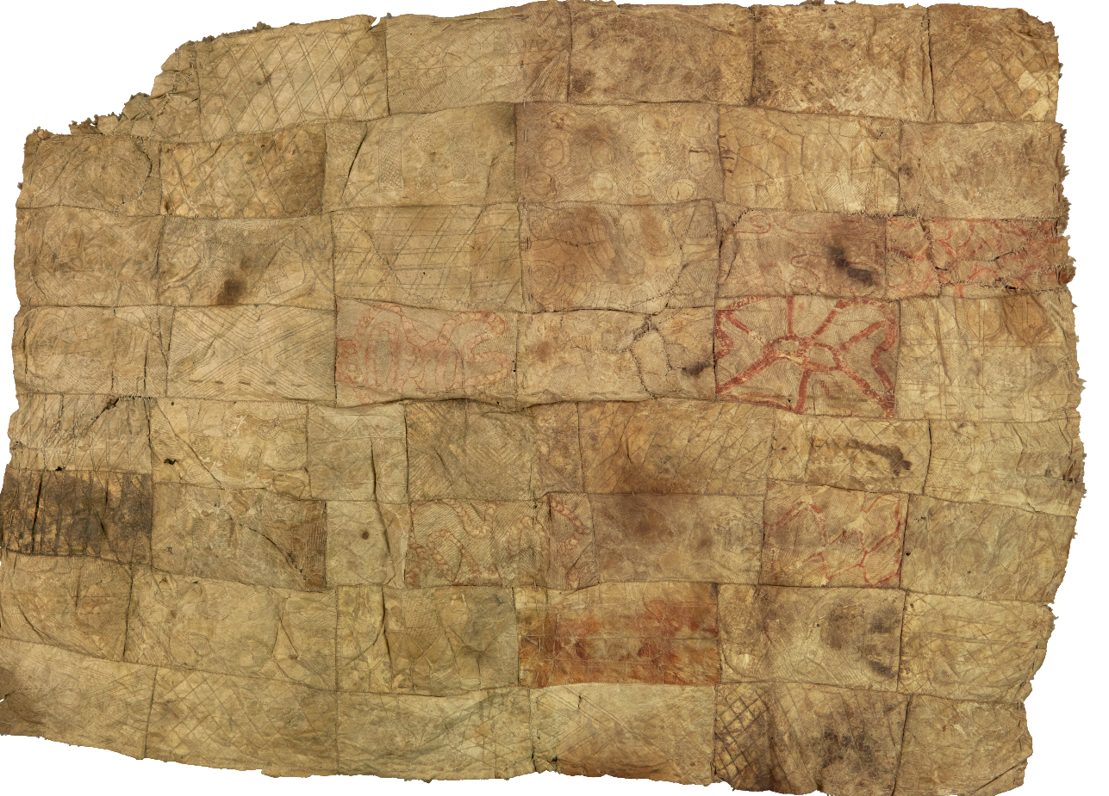
Lake Condah Cloak, collected in 1872, Gunditjmara people

© Department of Education and Training CC BY 4.0, excluding third party content.

