The Art of Angles

Mondrian Artworks
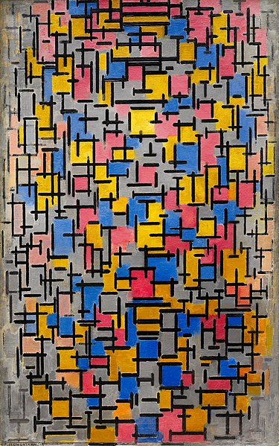
Piet Mondrian, 1916, Composition
https://commons.wikimedia.org/wiki/File:Composition,_Piet_Mondrian,_1916.jpg

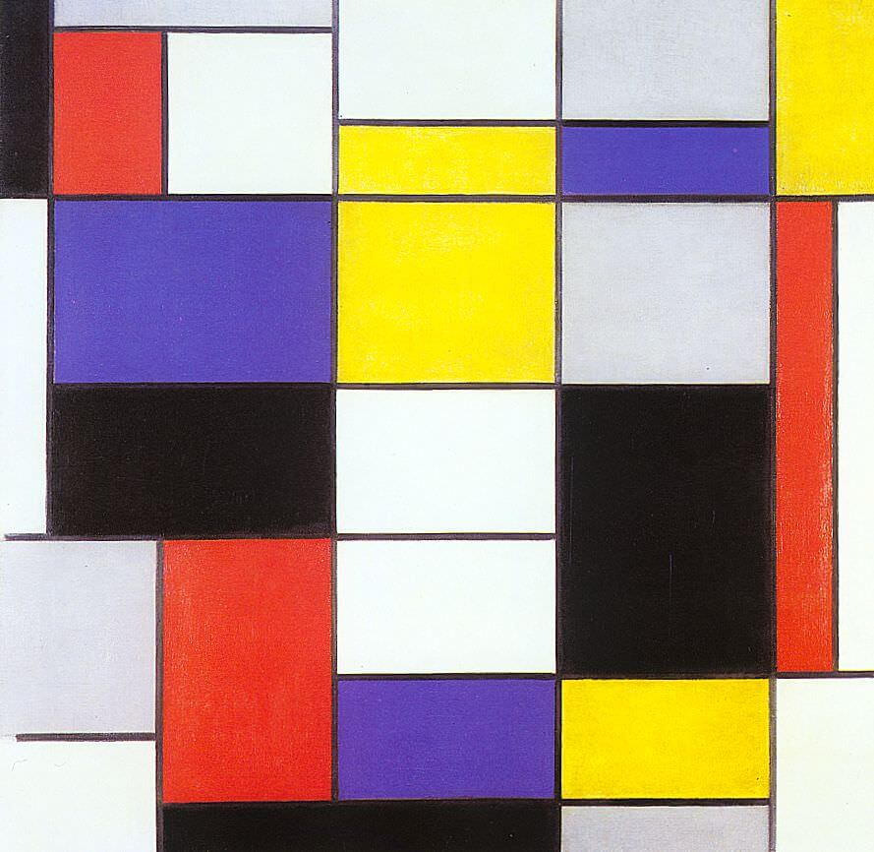
Piet Mondrian, 1923, Composition A
https://www.wikiart.org/en/piet-mondrian/composition-a-1923

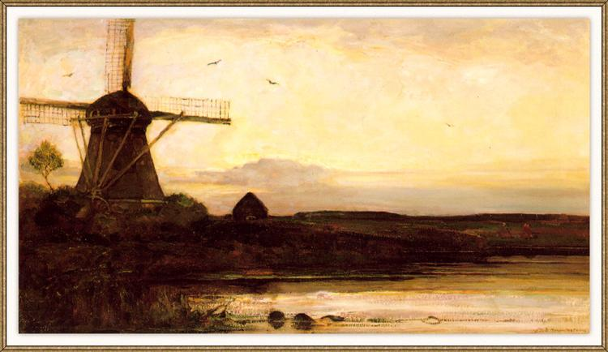

Piet Mondrian, 1905, Mill in the evening
Mill in the evening, 1905 - Piet Mondrian - WikiArt.org

© Department of Education and Training CC BY 4.0, excluding third party material.

