The Art of Angles

Monuments

Monuments
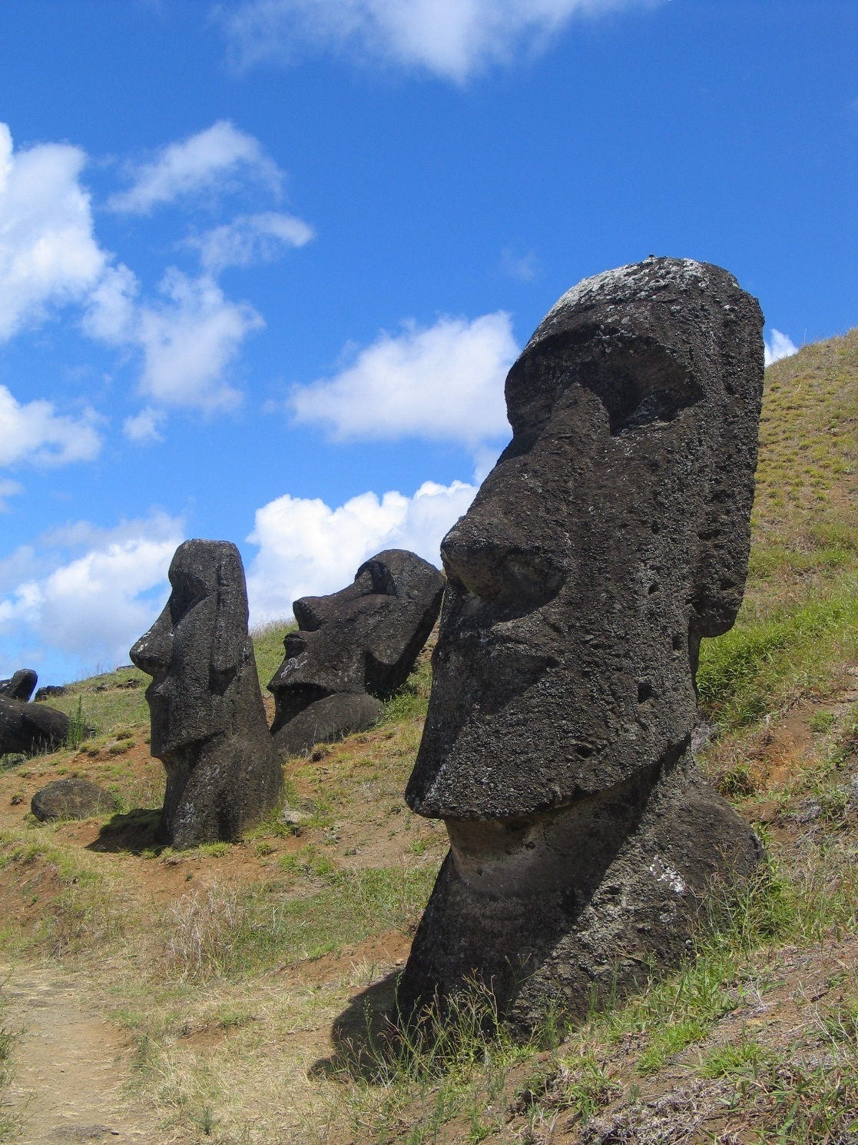
Moai at Rano Raraku, Easter Island
https://en.wikipedia.org/wiki/Easter_Island#/media/File:Moai_Rano_raraku.jpg
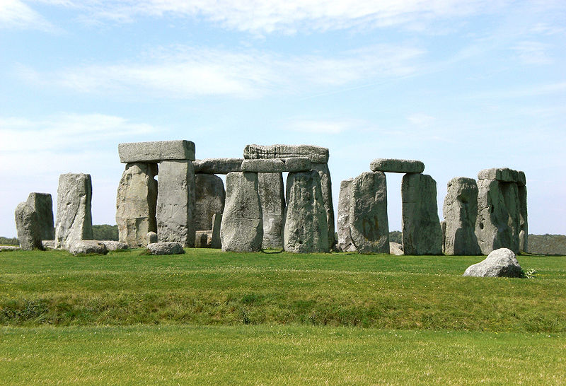
Stonehenge
Image by AlMare CC BY-SA 3.0
https://commons.wikimedia.org/wiki/File:Stonehenge,_Salisbury_retouched.jpg

© Department of Education and Training CC BY 4.0

