The Art of Angles

Uccello Artwork
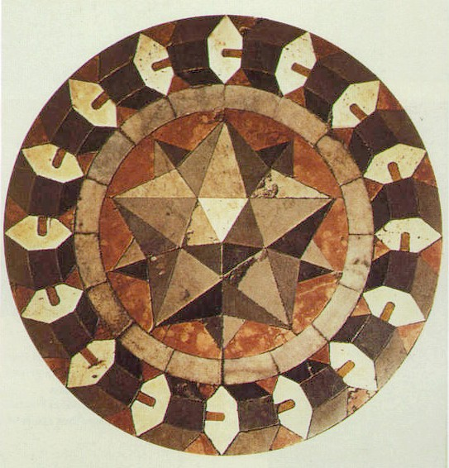
Paolo Uccello, Marble floor mosaic Basilica of St Mark Venice
https://commons.wikimedia.org/wiki/File:Marble_floor_mosaic_Basilica_of_St_Mark_Vencice.jpg

© Department of Education and Training CC BY 4.0

