POETRY AND THE POSSIBILITY OF LANGUAGE
RHYME AND RHYTHM PATTERNS

Excerpt from,
Can you find an example of alliteration in this excerpt?
Underline the rhyming words.
What do you notice about the rhyme pattern?
Read the stanzas aloud. What do you notice about the sound and syllable pattern?

Weary Will, by A.B. Paterson
The strongest creature for his size
But least equipped for combat
That dwells beneath Australian skies
Is Weary Will the Wombat.

He digs his homestead underground,
He’s neither shrewd not clever;
For kangaroos can leap and bound
But wombats dig forever.
Full transcript available at
poetrylibrary.edu.au/poets/paterson-a-b-banjo/poems/weary-will-0023003
Edward Lear, There was a Young Lady of Clare, from, ‘The Book of Nonsense’, (1887)
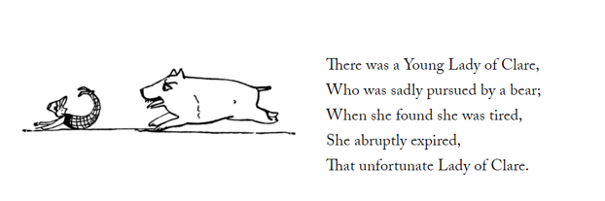

Underline the rhyme pattern in Edward Lear’s nonsense rhyme. The Book of Nonsense can be viewed at https://en.wikisource.org/wiki/The_Book_of_Nonsense

© Department of Education and Training CC BY 4.0

