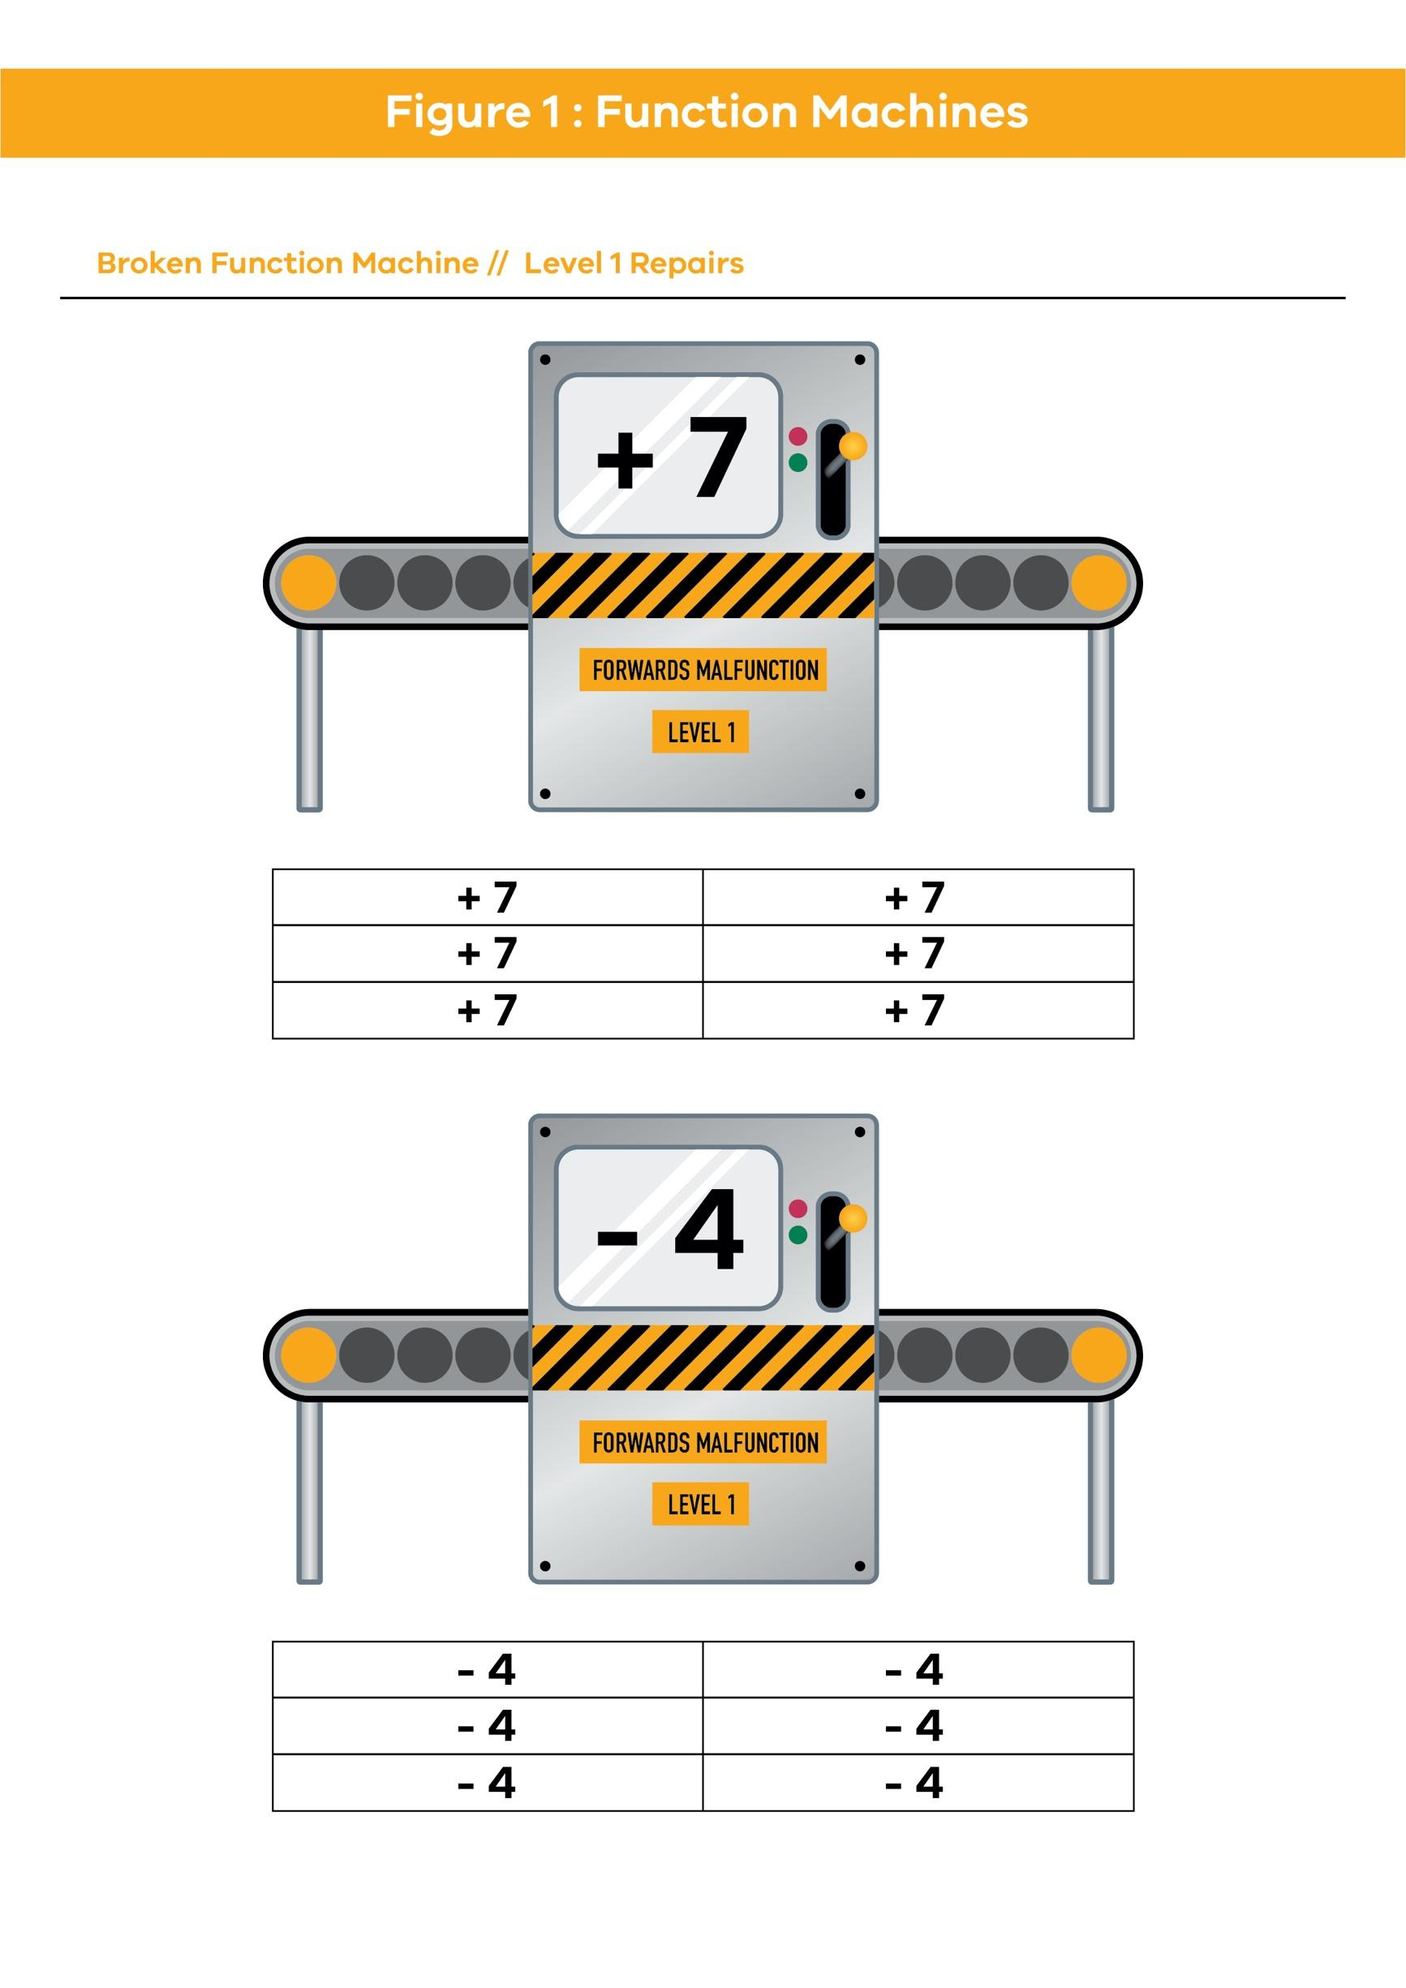

© Department of Education and Training [CC BY 4.0](https://aus01.safelinks.protection.outlook.com/?url=https%3A%2F%2Fcreativecommons.org%2Flicenses%2Fby%2F4.0%2F&data=04%7C01%7CSam.Hayman%40education.vic.gov.au%7Ccd6ddd9b6e6042d1ada808d9c391ae3d%7Cd96cb3371a8744cfb69b3cec334a4c1f%7C0%7C0%7C637755852896089454%7CUnknown%7CTWFpbGZsb3d8eyJWIjoiMC4wLjAwMDAiLCJQIjoiV2luMzIiLCJBTiI6Ik1haWwiLCJXVCI6Mn0%3D%7C1000&sdata=PaDFVUZjp2iTpczZK8nJomuJnfo7Qza%2BQDu6VaGziL4%3D&reserved=0)

