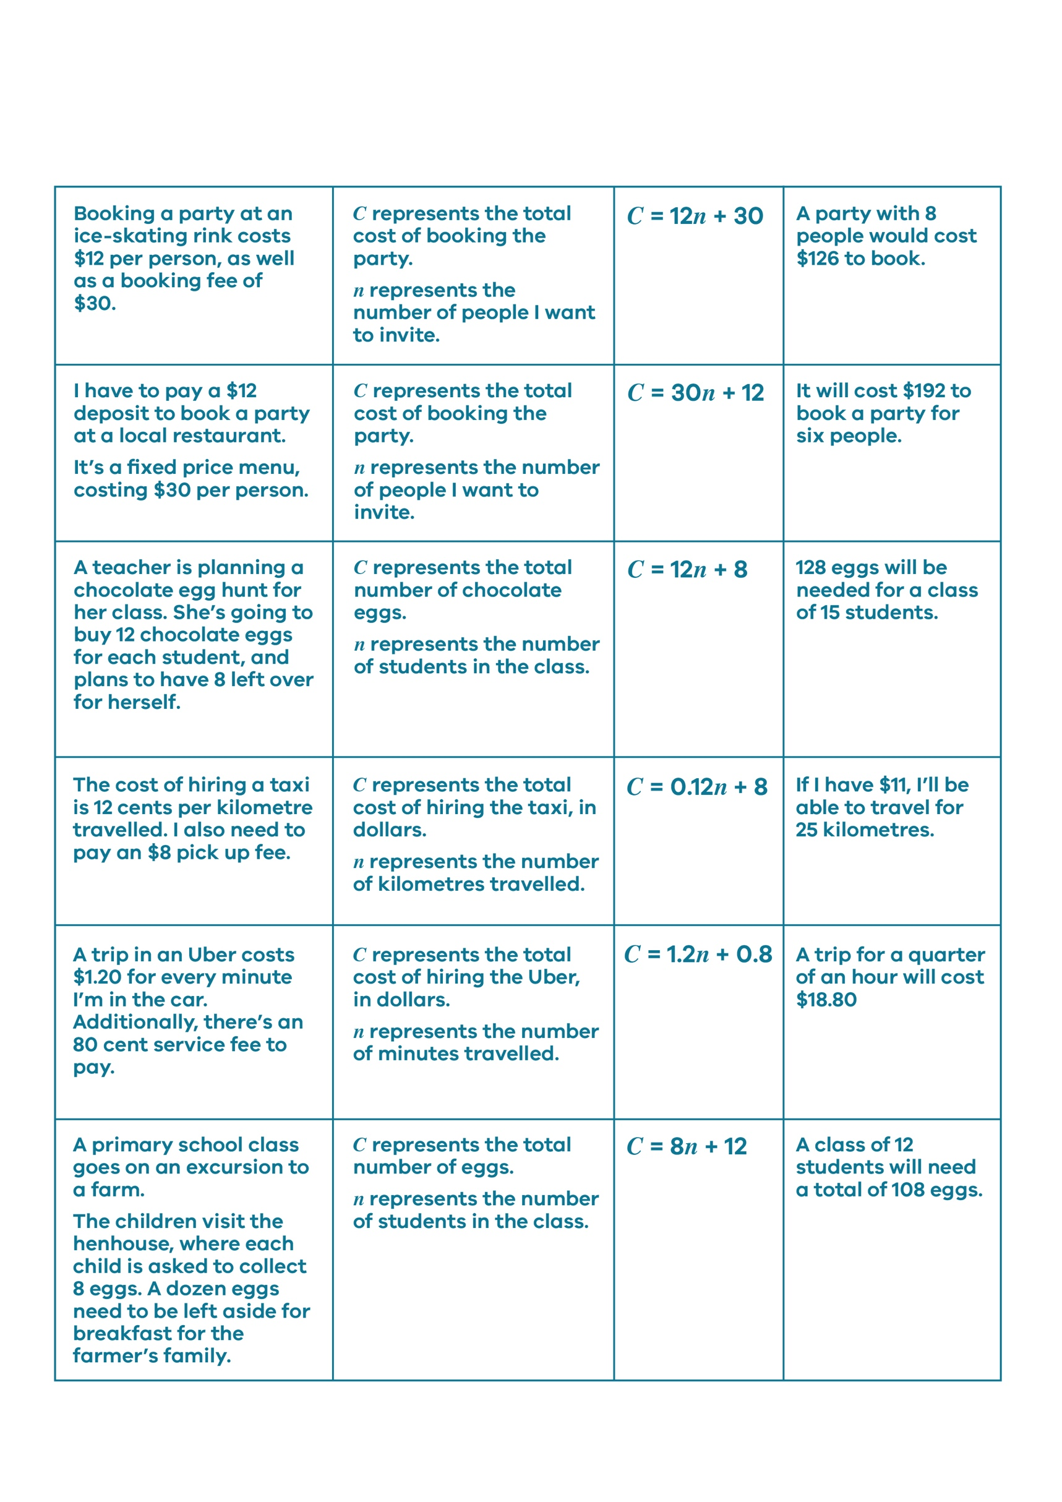
Card Match Activity Set

© Department of Education and Training CC BY 4.0

